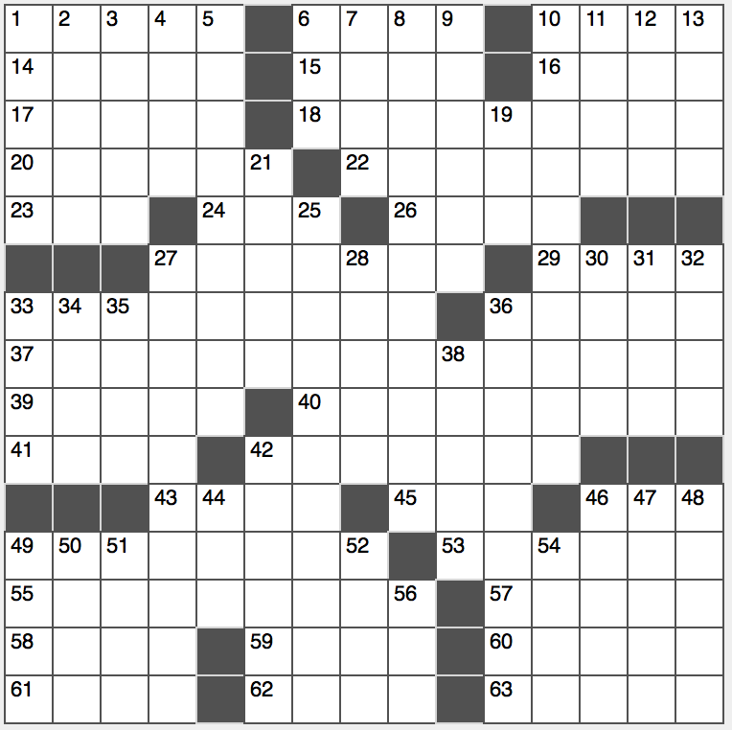**Across**

1. Over-knight mail?

6. She succeeded Eleanor

10. Glance over quickly

14. “So ____!”

15. Entranced

16. Staff worker

17. Sacred tribal pole

18. Area conquered by Alexander the Great

20. Progress

22. It’s right in the Pythagorean theorem

23. Volcano center?

24. Sharp yank

26. Part of MIT: Abbr.

27. Rudely confronts

29. Targets of pulldowns

33. Lid decoration?

36. Rolls with rice

37. Part of a nerd’s attire

39. Finicky sort

40. Utterly revolting

41. Genesis creator?

42. Erstwhile Asian lake

43. Time for giving up?

45. ___ Moines

46. Worldwide agcy. for labor rights

49. Party bowlful

53. “Yours truly” alternative

55. Like some premium roasts

57. Homer’s tale of Troy

58. Cantina platter item

59. It vies with Vogue

60. Not just plump

61. Snowman in “Frozen”

62. Use a blowtorch, perhaps

63. Four-time presidential candidate Ralph

**Down**

1. Web site, often
2. River past Arles
3. Poetic rhythm
4. Cookie that may be stacked
5. Losers’ requests
6. “Training” garment
7. “The ____ and the west are mine…” (Walt Whitman)
8. Realm of the dead
9. Blemishes
10. Its capital is Castries
11. Double-decker checker
12. One with a fan club
13. Parisian mother

19. More, to Jorge

21. Gold coin of yesteryear

25. Another name for the Higgs boson particle

27. Exacts

28. Kind of, in slang

30. Regarding, in a memo

31. You, poetically

32. Dubbed men

33. “House” costar Omar

34. Years past

35. Vaper’s item, informally

36. Withdrawal

38. Where captains go

42. Two-time presidential first name

44. Charlotte-to-Raleigh dir.

46. Covered in creeper

47. Tenant’s form

48. “Harry Potter and the ____ of the Phoenix”

49. Decem minus duo

50. Sci-Fi author Stephenson

51. Ancient Peruvian

52. Synonym for 24-Across

54. Exile isle for Napoleon

56. “Ideas worth spreading” online talk