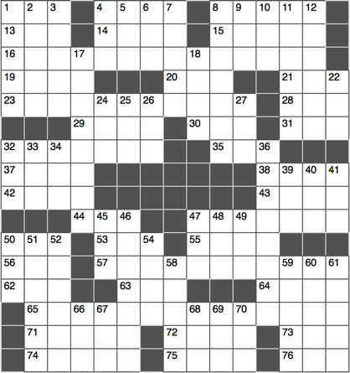**Across**

1. However, to texters

4. With 8- and 65-Across, famous last words said in a play by 23-Across

8. See 4-Across

13. “The pit and the Pendulum” monogram

14. First of two choices

15. Conspicuous recognition

16. Date best known as the catalyst for the beginning of the 57-Across, as described in a play by 23-Across

19. Merit

20. “In the”: It.

21. Galumpher

23. See 4- and 16-Across

28. Three on a 6?

29. ____ Rabbit

30. Old Olds

31. ____ Lingus

32. With 47-Across, a description of many a Swarthmore student

35. Forensic ID

37. Butter alternative

38. Fancy topping for a cracker

42. Cut a paragraph, say

43. ____ Fixe

44. Call for help

47. See 32-Across

50. Superlative suffix

53. “Eureka”

55. New parents’

selection

56. Locale for phalanges

57. See 16-Across

62. Hyperbola part

63. It’s squirted on squeaks

64. Head light?

65. See 4-Across

71. NBA’s Shaquille

72. “My mistake”

73. Verizon competitor

74. With 75-Across, year in which the utterer of 4- and 8-Across was slain

75. See 74-Across

76. Slangy agreement

**Down**

1. Dijon heads
2. Audible “LOL”
3. “Carmen” or “Aida”
4. You might arrive 90 mins. prior to this
5. Widely read article?
6. “____ well” (George Washington’s last words)
7. Highway stretching from Maine to Florida
8. Covered with mud
9. Company that introduced color TV
10. Uninsured loss recovery or University of La Rochelle, abbr.
11. City that shares Seattle’s airport

12. Colorless, odorless fuel gas

17. Rorschach test features

18. Apprehension

22. In the pros?

24. “Before” in verse

25. Part of a geom. line

26. Lead-in to heat or view

27. Eternity

32. Miler Sebastian

33. “… an ____ dog new tricks”

34. Flowery Hawaiian souvenir

36. Quintessentially American order

39. Exist

40. “____ for tat”

41. Common programming file ending

45. Sculling tool

46. ____ pie (molasses laden dessert)

47. Raggedy doll?

48. ____-bo

49. Thinking sound

50. 7th Greek letter

51. Not quite, but almost

52. Dance music genre

54. “What ____ mind reader?”

58. “____ the Lights”: Kanye West song

59. “In my opinion”

60. Line at a rodeo?

61. Sagan’s “very small stage in a vast cosmic arena”

66. “I do not see why I should ____ turn back”: Robert Frost

67. Slave revolt leader Turner

68. Lav, to a chav

69. Apple core?

70. “The eighteenth letter is known ____”