Alex Robey

500 College Ave.

Swarthmore, PA 19081

[arobey1@swarthmore.edu](mailto:arobey1@swarthmore.edu)

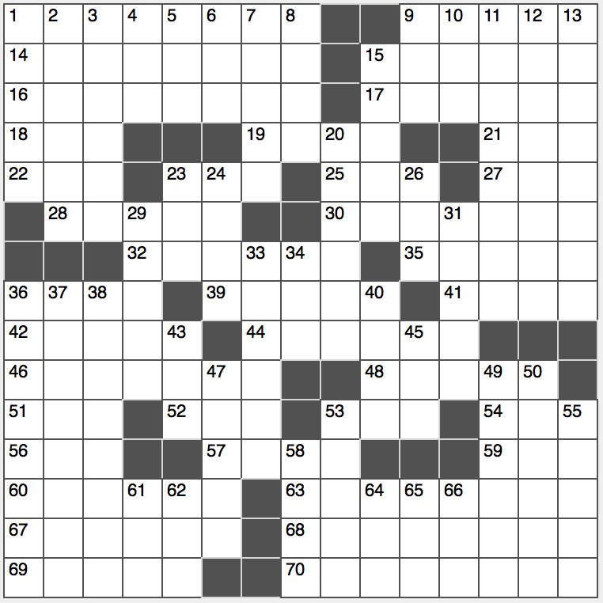

Alex Robey

500 College Ave.

Swarthmore, PA 19081

[arobey1@swarthmore.edu](mailto:arobey1@swarthmore.edu)

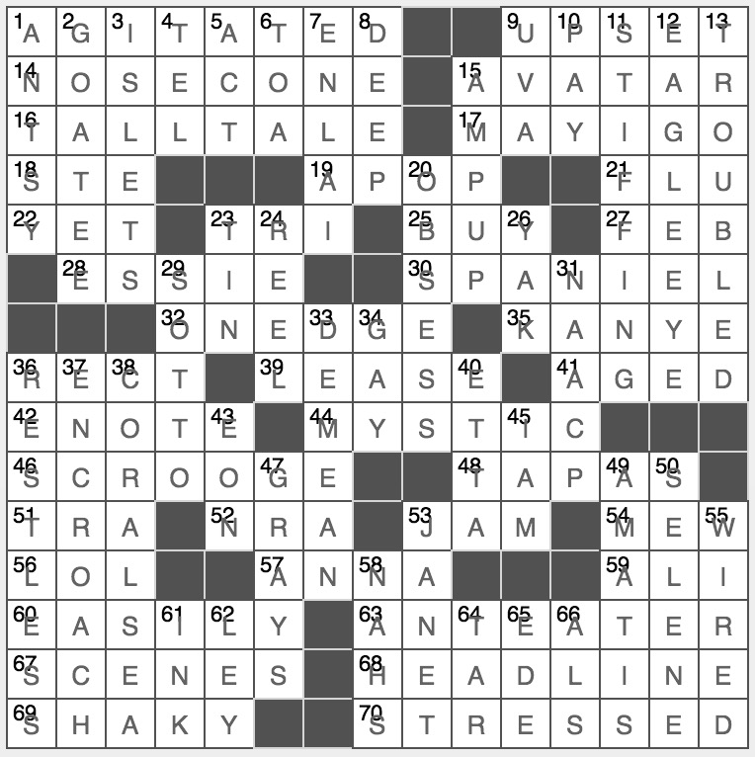

ACROSS

1 32-Across

9 32-Across

14 Rocket section

15 Incarnation

16 Flight of fancy

17 Request to be excused

18 Catholic honoree: Abbr.

19 Each

21 Target of some fall shots

22 Until now

23 Square root of “-nona”

25 Believe

27 Second of twelve, for short

28 Nail polish brand

30 Hunter’s companion

32 Anxious…or a description of the locations and clue to the answers to eight of this puzzle’s clues

35 “Yeezus” rapper

36 Parallelogram, e.g.: Abbr.

39 Paper for a letter?

AGITATED

UPSET

NOSECONE

AVATAR

TALLTALE

MAYIGO

STE

APOP

FLU

YET

TRI

BUY

FEB

ESSIE

SPANIEL

ONEDGE

KANYE

RECT

LEASE

41 Stored in a cask

42 Online reminder

44 Of an occult nature

46 Miserly character

48 Cantina offerings

51 Refrain word

52 “Fire” men?

53 Rush hour tie up

54 Kitty’s call

56 Cyber giggle

57 ____ Karenina

59 “The Greatest” fighter

60 Without trouble

63 Aardvark lookalike

67 Play parts

68 Lead the cast, say

69 32-Across

70 32-Across

DOWN

1 32-Across

AGED

ENOTE

MYSTIC

SCROOGE

TAPAS

TRA

NRA

JAM

MEW

LOL

ANNA

ALI

EASILY

ANTEATER

SCENES

HEADLINE

SHAKY

STRESSED

ANTSY

2 Feature of Uncle Sam or Colonel Sanders

3 Keys or cays

4 Resume no.

5 Work on a soap, say

6 Suit ___ tee

7 China’s Zhou ____

8 Quite profound

9 Inst. founded by Thomas Jefferson

10 Treat to dinner

11 Not tipping

12 One looking sharp?

13 32-Across

15 Vitalize

20 Dwell unceasingly (on)

23 Like some ears or cans

24 Spool for a fishing line

26 Shaggy mammal

29 ____ voce (under one’s breath)

31 Civil rights org. since 1909

33 Humiliate

GOATEE

ISLETS

TEL

ACT

TOA

ENLAI

DEEP

UVA

PAY

STIFFING

EAGLEEYE

TROUBLED

AMPUP

OBSESS

TIN

REEL

YAK

SOTTO

NAACP

DEMEAN

34 The “G” of LGBTQ

36 32-Across

37 Infringe or impinge upon

38 World War II battle site

40 Soulful James

43 Eternity

45 “I think, therefore ___” – Rene Descartes

47 Suit shades

49 Some prized violins

50 Greek moon goddess

53 Fed chair Yellen

55 32-Across

58 Slangy turndowns

61 Squid secretion

62 ESPN anchor Bob

64 Cigarette goo

65 Back of a stamp?

66 Disease for which the Ice Bucket Challenge raised money: Abbr.

GAY

RESTLESS

ENCROACH

CORALSEA

ETTA

EON

IAM

GRAYS

AMATIS

SELENE

JANET

WIRED

NAHS

INK

LEY

TAR

EDE

ALS