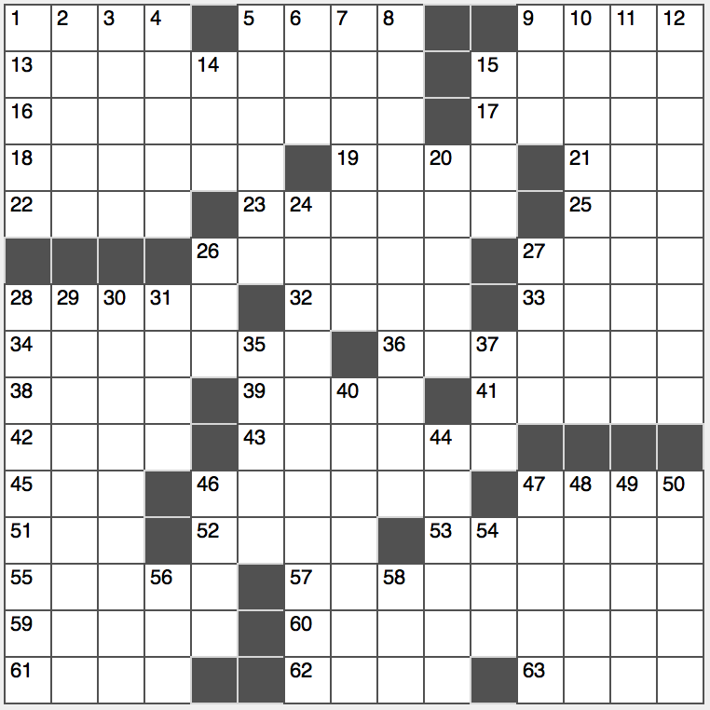**Across**

1. Spirit of Saint-Louis?

5. About 1/11 of the globe

9. Foot long meal, perhaps

13. Unburdening

15. Delano : FDR :: ___ : Garfield

16. Albuquerque’s river

17. Strength

18. Philosopher Camus

19. Legal memo heading

21. It’s crude, yet valuable

22. WWI Belgian battle site

23. “Knocked Up” director Judd

25. San Francisco’s ___ Valley

26. Mars and others

27. On its way

28. Arizona State locale

32. Like some steak orders

33. Suit ___

34. Charleston forerunner

36. “Broadly speaking…”

38. Singles’ grp.?

39. Money man Greenspan

41. Bridge positions?

42. Guitar great Atkins

43. Golf’s Garcia

45. Date for him

46. Do a cobbling job

47. Peak in “The Odyssey”

51. Water turbine setting

52. Bread spread?

53. “Because you’re worth it” brand

55. Sea of Japan port

57. Implied

59. Querulous tone

60. Behave boisterously

61. “___ Declassified School Survival Guide”: 2000s Nickelodeon sitcom

62. Head of the French department?

63. Place to test reflexes

**Down**

1. Wide selection
2. Simon and Armstrong, for two
3. Geography aid
4. Swiss Alpine peak
5. James Cameron megahit of 2009
6. One of a deadly septet
7. Henry Jones Jr.’s nickname
8. Deadly defoliator used in Vietnam
9. “Last Week Tonight” channel
10. Fallacious
11. Logical basis
12. Folded breakfast offerings

14. Exemplify humanity, in a way

15. Just a handful

20. Kentucky Derby winner’s wreath

24. United States military honor

26. Enter a pool, maybe

27. Houston athlete, for short

28. Gridiron six-pointer

29. Return to a scabbard

30. The Beatles’ Rita, e.g.

31. Natl. Merit Scholarship qualifier

35. Stand for a portraitist

37. Decada division

4o. Pupil-surrounding rings

44. Maltreatment

46. Debauched man

47. Electrolux rival

48. Auto variety

49. Avant-garde composer Erik

50. With no escort

54. Extolling work

56. IV adjusters, often

58. Ablaze