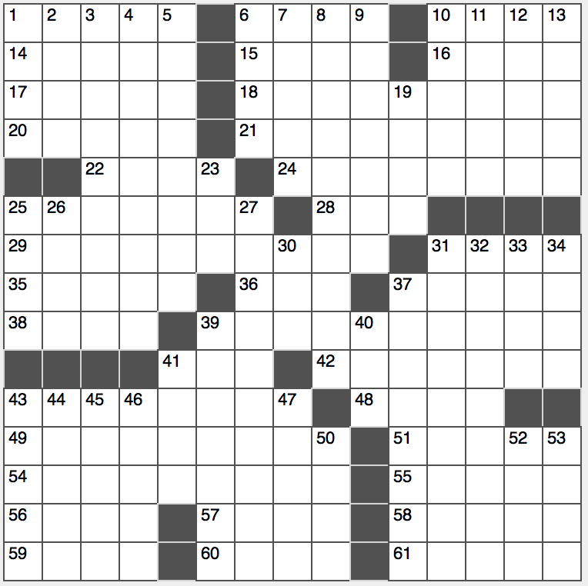**Across**

1. Less trustworthy

6. Flakes in geology class

10. ____ B’rith

14. Sierra ____

15. “When I was ____”: “H.M.S Pinafore” lyric

16. Metallica drummer Ulrich

17. Polemics

18. Literary potboiler

20. Mini, e.g.

21. Simulcrum

22. Ghostly radiance

24. Letter opening

25. Evening utterance in 47-Down

28. End for elephant or serpent

29. Neighbor of Newark

31. Engulfed by

35. Eddy Murphy’s role in “Coming to America”

36. “The Da Vinci Code” author Brown

37. ____ Gay

38. Twosome

39. “Back to the Future” subject

41. “Homeland” airer

42. Mass per volume

43. Object of contempt

48. Evening, in adspeak

49. Samaritans

51. Some bridge-seat occupants

54. “What is a friend? A single soul dwelling in two bodies” philosopher

55. Makeup mogul Lauder

56. Ashen

57. Stare at lasciviously

58. Fact fudgers

59. “You,” in times of yore

60. Gaelic tongue

61. Punjabi attire

**Down**

1. Camera choices, briefly

2. White house worry

3. Ithica’s waters

4. Charged (with)

5. Number one place?

6. Anti-DWI grp.

7. Homer’s name for ancient Troy

8. Ran

9. “Sweet” lady of song

1o. Allied groups

11. Like marine forces

12. Ratio words

13. Cay, e.g.

19. River through Rwanda

23. It’s mostly nitrogen

25. Droplet of persperation

26. Like some cabs

27. Device for measuring the intesity of radiation

30. Hippy-protested war

31. Oscar-winning Ingrid Bergman role

32. Stellar success?

33. “Hey, before ___ you go…”

34. New Year’s Eve host Carson

37. Golf’s “Big Easy”

39. Government largesse

40. Neymar Jr.’s number

41. Completely busted

43. Get with the program

44. “Don’t Know Why” singer Jones

45. Fleet-footed

46. “We’re off ____ the wizard…”

47. Setting for Van Gogh’s “The Yellow House”

50. Drought-ridden

52. Garr of the screen

53. Brief meeting?