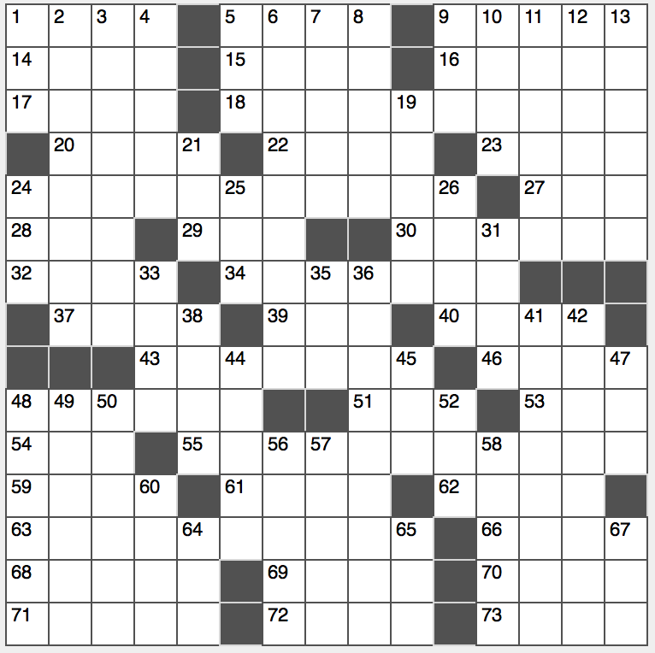**Across**

1. Ohm’s law units

5. The Divine Comedy, e.g.

9. Seatbelt component

14. Expert on meters and feet

15. Spanish wine descriptor

16. He-Man’s twin sister

17. Take a hit

18. Publication about mathematical building blocks, with “the?”

20. Director Ephron

22. Tennis game units

23. Reasons to repent

24. Publication about a western European nation, with “the?”

27. Christmas party drink

28. A small speck

29. You, to Yvette

30. “They made me do it!”

32. Lobster corals

34. Exchange

37. With 40-Across, subject of Donald Trump’s Twitter, or a hint to 18-, 24-, 55-, 63-Across

39. Yale student, informally

40. See 37-Across

43. How business executives are often positioned

46. Bloody conflicts

48. Striped gems

51. Fannie ____

53. Favela city

54. Peace, in Acapulco

55. Publication about hard alcohol, with “the?”

59. Jai ____

61. Seth’s first son

62. Director Kazan

63. Publication about a street intersection, with “the?”

66. Over

68. Winch up

69. Some: Sp.

70. Eats at

71. Les ____ Unis

72. Start for “vision” or “port”

73. Those, in Guadalajara

**Down**

1. Germane
2. Transparent auto option
3. Drink often exported from 42-Down
4. Harsh
5. Mystic’s “gift”
6. Worked up a sweat
7. Not as congenial
8. Monte Cristo, par exemple
9. Onetime J.F.K. sight
10. Not that or the other thing
11. Ring a bell
12. Cry of denial
13. Complete a Monopoly circuit

19. Big name in nail polish

21. “Hamlet” division

24. Only four-term prez

25. Like Arizona in August

26. Place for a guard in soccer

31. Back to the start

33. Game in which sevens are low

35. Many a draft selection

36. Marching orders

38. Senegal summers

41. NBA team for Kevin Durant and Steph Curry

42. So-called “teardrop of India”

44. By command of

45. Kit-____

47. Rolled lawn

48. Boeing military copter

49. Lummox

50. “The Simpsons” voice man Hank

52. Fleecy mama

56. Contribution of ideas

57. 37-time Emmy winner Arledge

58. 45 from the ‘50s, e.g.

60. M.I.T. part: Abbr.

64. “Independence Day” baddies, briefly

65. Dangerous fly, when doubled

67. Tee’s forerunner