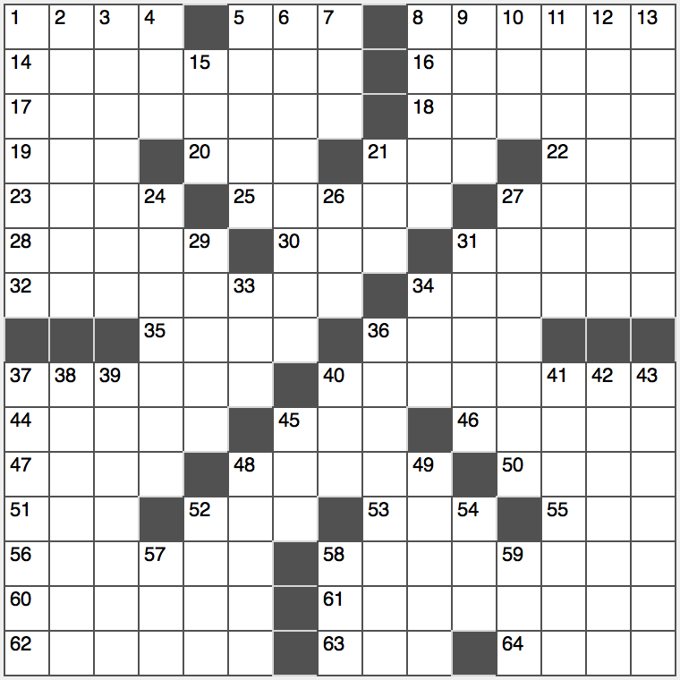**Across**

1. Delivery people?

5. Absorb, as a financial loss

8. Round third base

14. Rain forest menace

16. Gift giver’s prompt

17. Home heater

18. Nobel winning Mother

19. Summer cooler

20. Prefix to “plunk”

21. Bridge offer

22. HPV, for one

23. Biblical exile

25. Noodle dish popular in dorms

27. Slanted text: Abbr.

28. Body chambers

30. Halloween flyer

31. Bushfire haze

32. Driver’s protection

34. Spruce

35. Beverage that’s sometimes boxed

36. Cosmic phenomenon

37. Inhabit

40. Wife of Odysseus

44. Paperless party summons

45. “Homeland” spy org.

46. 5k participant, e.g.

47. Roams around

48. Non-reflective finish

50. Penn of Hollywood

51. Primo pitcher

52. Messy locks

53. Location of a small canal?

55. Enzyme’s end

56. University of Arizona locale

58. TV aerials

60. Something to get a spot out of?

61. Threatening position

62. Put the pop in pop

63. Military mail abbr.

64. Western defense alliance

**Down**

1. Mariachi instruments
2. Out for dinner, perhaps
3. Portuguese archipelago
4. Phys. or chem., for short
5. Infiltrate
6. So darn cute
7. Gooey road cover
8. Slipped past the bouncer, maybe
9. Pundit’s essay
10. ____ Majesty Queen Elizabeth II
11. Like easy shopping
12. Error
13. Cyber Monday beneficiary

15. Acorn’s tree

21. Wager

24. No-brainers?

26. Gymnasium pad

27. Graceful grazers

29. Follow, with “by”

31. Person of interest?

33. Summer sunrise dir.

34. King of the ring?

36. Declutter

37. Yachting carnival

38. One fleeing a storm

39. Motorbike attachment

40. Prune center

41. Superstate in “1984”

42. Feudal farm laborer

43. Automaker Maserati

45. Golfer’s hat

48. Game for hustlers

49. “Jack Sprat could ____ fat…”

52. Debatable

54. House figure, briefly

57. Beauty retreat

58. Ankara notable, once

59. “Absolument pas!”