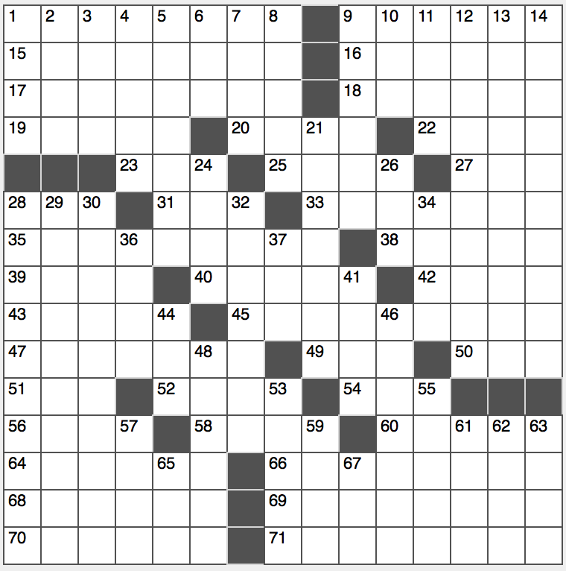**Across**

1. Madonna hasn’t used one in years

9. Gets lippy with

15. Red army’s enemy?

16. Swipe

17. Actor who interviewed the drug lord “El Chapo” in 2015

18. Event won by Roger Federer for five consecutive years

19. Leash, e.g.

20. “Full Metal Jacket” grp.

22. Child tender

23. Citi Field ballplayer

25. Genius Bar worker

27. Queue after Q

28. For

31. Fam. member

33. “You had your chance!”

35. “Janie’s Got a Gun” rock band

38. Carryall bags

39. Knight’s trainee

40. Toy with, kitty-style

42. Tear to pieces

43. Impala cousin

45. It’s under Italy’s boot

47. Louvre Impressionist collection

49. Affirm one’s humanity?

50. Explosive sold by Acme

51. Abbr. in cookbooks

52. Academic, as a point

54. Couple of swimmers?

56. “Put ____ writing!”

58. Dram or gram, for two

60. Riverine mammal

64. Eye in awe

66. Nobel person

68. Everlasting, in verse

69. Thought highly of

70. Does a landscaper’s work

71. Like some grapes or watermelons

**Down**

1. Glasgow girl
2. Grateful Dead album “Without ____”
3. Top-of-the-bill artist
4. Midmorning break time, briefly
5. Siesta takers
6. Broke fast?
7. List with sides
8. German Surrealist painter Max
9. Plasterwork
10. Vocal light bulbs
11. Priory of ____: “The Da Vinci Code” conspirators
12. Sectarian
13. Commensurate
14. Hill slot

21. Coal miner’s concern

24. Sub, e.g.

26. Like the dog days

28. All bark, no bite type

29. Home business?

30. They may stand tall in a church

32. Illicit relationship

34. Abandoned

36. Wine opener?

37. Smallest prime number

41. Torus on a Taurus

44. Dampen, as a headlight

46. Thick-skinned

48. Sales trails

53. Roof slates

55. Mill metal

57. Plucky emperor?

59. Charge a criminal?

61. Hardly heart-pounding

62. Times for many Tours tours

63. Wine shop array

65. Pairing word

67. Cheyenne’s foes, once