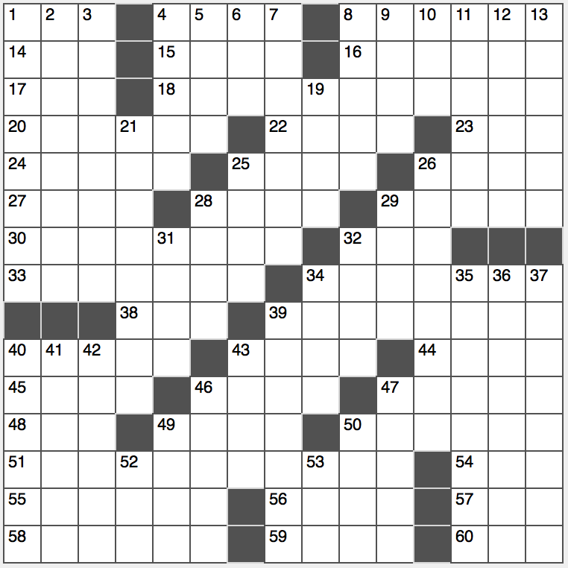**Across**

1. Roller on a dinner plate

4. Wound from a boxer?

8. 1967 hit for the Spencer Davis Group

14. Tee’s forerunner

15. On ____ with

16. Experience anew

17. Subj. with a lab, often

18. Fountain treat with cherries on top

20. Sampled

22. Doesn’t stand

23. Highlander’s headwear

24. Duel-purpose tools?

25. Allot, with “out”

26. ____ d’Ivoire

27. Actresses Charlotte and Cassidy

28. Ancient wisdom

29. Material for bedsheets and pillow cases

30. Versions

32. Common type of loop in computer programming

33. Motor City

34. Elaborate piano piece

38. Lodging choice

39. Sent a different way

40. Base balancers

43. Change jar item

44. 2016 Best Picture nominee “____ Land”

45. Challenge

46. Piqued

47. Bewitching place?

48. A year in the Yucatan

49. King of the gods, in Egyptian myth

50. Tied-on toppers

51. Atlantic-Pacific conduit

54. Concealed carry org.

55. Torrid Zone parallel

56. Tapering shape

57. Chess grandmaster Mikhail

58. Church gatherings

59. Three, in Tijuana

60. Soul: Fr.

**Down**

1. Bothered
2. Adventurous incident
3. “In my opinion…”
4. Ones up in arms?
5. Apple tablet
6. Summer skin shade
7. They’ll remove bad marks
8. 46-Across
9. Total pigsty
10. Matterhorn, e.g.
11. “Paradise Lost” author
12. Emulate Earhart
13. Some tennis players

19. Evening, in ad-speak

21. New car tryout

25. 10-Down, e.g.

26. Round

28. Choice pork piece

29. Insane in Spain

31. Accelerator particles

32. Strategic position

34. Care for

35. Only female Argonaut

36. Text ancestor

37. Water, facetiously

39. Stage, as a historical battle

40. Conforms to

41. Often-caged songbird

42. Easy to attach, as a patch

43. Gator’s cuz

46. Apples you can’t eat

47. They get walked on

49. Surrounded by

50. Hamlet, e.g.

52. Mil. Mail center

53. Neither’s partner