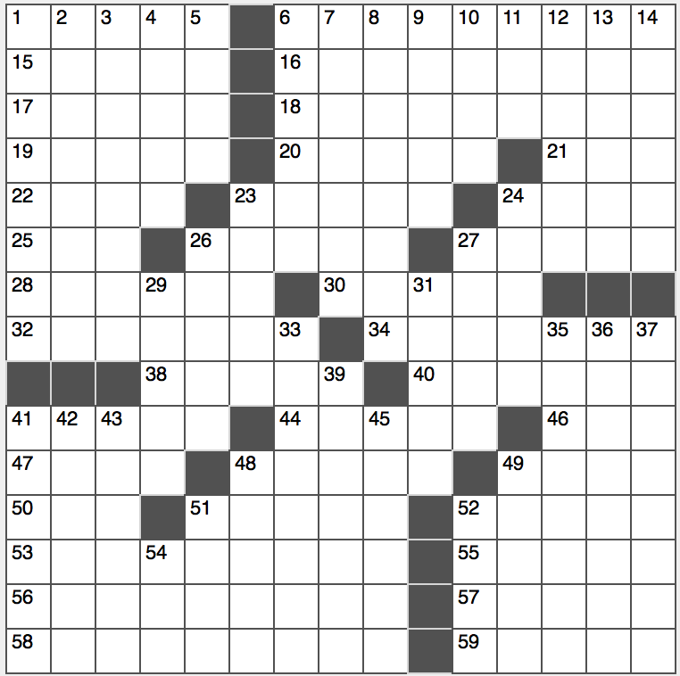**Across**

1. Santa’s reindeer, not counting Rudolph

6. Sputnik started it

15. Scrutinize syntactically

16. Sandwich scoopful

17. Raise spirits?

18. World’s first roofed sports stadium

19. Bad basement gas

20. Selling points?

21. Kings and knights

22. Home of Iowa State University

23. Gather, as grads

24. Spydom’s Mata

25. What’s left on a farm?

26. Far from mellifluous

27. Glacial ice mass

28. Where the Ark landed

30. Insignificant

32. Polemics

34. Greet graciously

38. Frequent presidential candidate Ralph

40. Sight in le ciel

41. TV dog trainer Millan

44. Mesmerizes

46. One’s lowest digit?

47. Found a roost

48. Barack nominated her

49. Guitar great Atkins

50. Tatter

51. Not 4-Down or 10-Down

52. Musical note also known as a double whole note

53. Batting connection

55. Like perfect games vis-à-vis no-hitters

56. Outhouse, usually

57. Earlier, archaically

58. Reels

59. Million-dollar strings

**Down**

1. Part of a Met fan’s outfit?
2. Trattoria entrée
3. Reciprocal raising of tariffs, e.g.
4. “Los de aquí”
5. First time voter, typically
6. Motionless conditions
7. Exercises your prone to do?
8. Lost and found, e.g.
9. Seize, to Caesar
10. Those south of the border?
11. It was terrific in the ‘90s
12. 10-time Gold Glove winner Roberto
13. Snapper’s device
14. Unspoiled

23. Valuated

24. 2015 Adele hit

26. Aid in storm-tracking

27. Aperture

29. Blitzed, e.g.

31. Protozoa

33. Miss living in Mexico

35. “It’s your choice”

36. Emollient juice

37. Was on the brink

39. Steamroll

41. Rocker Santana

42. “Seinfeld” copy editor

43. One of 56 in 1776

45. Real keepers?

48. Fender guitar, familiarly

49. Cunning

51. Grandiloquent prose

52. 7-Down and others

54. There’s one in every RSVP