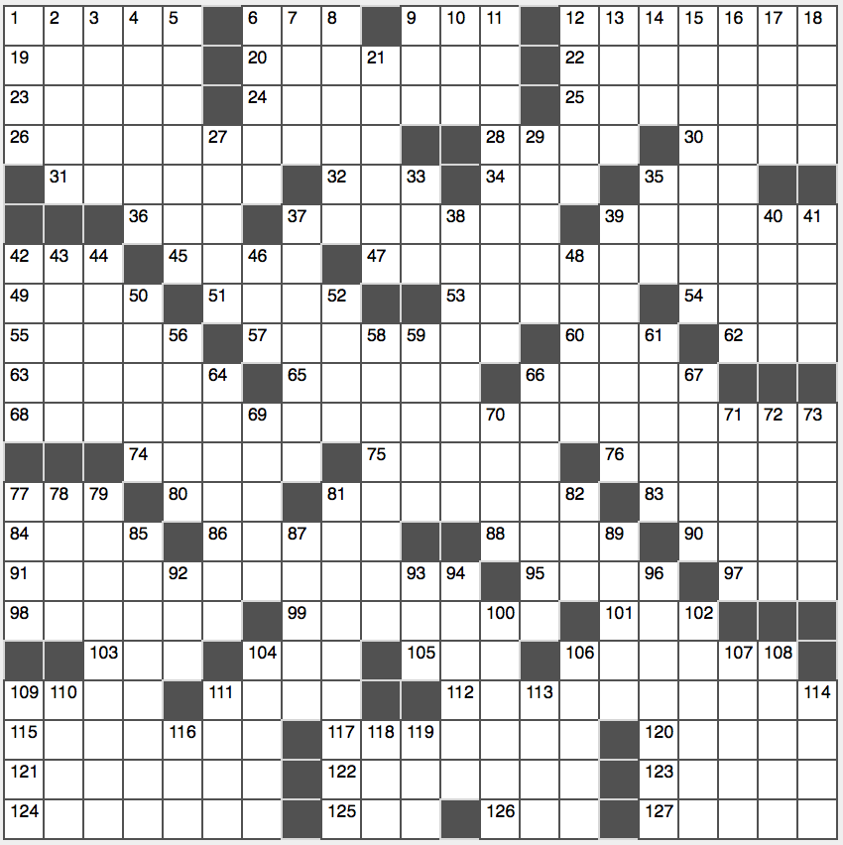**Across**

1. Publicly humiliate

6. Al Green’s “____-La-La” (Make Me Happy)

9. Home for a houseplant

12. “Moonlight” and others

19. Vaclav who was the first president of the Czech Republic

20. Former no. 1-ranked men’s tennis player Rios

22. Fertile ground layer

23. Ancient Greek goddess of peace

24. Security issues?

25. From theoretical deduction*

26. Tangy topper for toast

28. Sinks like the sun

30. Agenda, briefly

31. Effigy

32. Traffic-battling org.

34. Caesar’s “hail”

35. “____ culpa”

36. Rent out

37. Stadium’s standing area

39. Position in Quidditch

42. Nordic carrier’s letters

45. Fawn or buck

47. Symbol of dependency

49. Some lethal slitherers

51. Low horse cart

53. “The magic word,” to a Berliner

54. Udder extension

55. Editor’s leave-ins

57. Its face is almost vertical

60. Dungeons & Dragons, e.g.: Abbr.

62. Back to school?

63. Get reports about

65. Crazy escapade

66. SI unit of energy

68. 1974-2016 radio show hosted by Garrison Keillor

74. Town maps

75. Book that’s often locked

76. Candle-holder

77. Magazine edition, for short

80. “Chandelier” songstress

81. 45-Across defenses

83. Cream of the crop

84. Beaded shoes

86. Woolly creature

88. Wet-Nap, e.g.

90. The teeniest bit

91. Considerable sum

95. G-rated oath

97. Devious

98. Quasimodo portrayer in 1923

99. Will-checking process

101. Carbon dioxide, for example

103. Severely criticize

104. “Anna and the King” actress Ling

105. Operator’s org.

106. Money-back incentive

109. “Just ____” (Nike slogan)

111. Prereq. for college-level math

112. Prank ridden day…or when reinterpreted and abbreviated, a hit to the starts of each of the starred answers

115. Concerning

117. Fool

120. Beethoven’s “Fur ____”

121. Scenic model

122. Old Basque kingdom

123. Sega’s blue hedgehog

124. Voluptuous

125. Texting format, briefly

126. His or her, in Sceaux

127. Endeavors

**Down**

1. A main branch of Islam
2. Pluckable instruments
3. Ward off
4. Lowly
5. Picked at the polls
6. Strike, Bible-style
7. Trek to Mecca
8. Gaming center
9. A head
10. Overused, as jokes
11. Let fate decide, say
12. Aver
13. “Sorry, my mistake!”
14. “Wait Wait … Don’t Tell Me!” broadcaster
15. “In my opinion…”
16. Ran the clock down, in football
17. Gazillion add-on
18. Experienced a dis-traction?

21. Shutterbug’s tool

27. Exposed one’s secrets

29. You might be invited to one on Facebook

33. Dad artist Jean

35. La Mediterranee, e.g.

37. Dazes

38. Tree-related

39. Increases

40. “Holy moly!” relative

41. Post-Q string

42. Younger Obama girl

43. Took ____ in the right direction

44. Primitive kind of poker?

46. Suffix for “ranch”

48. Thurmond of politics

50. Looped band

52. Grammy-winning 2004 Usher song

56. Seeds’ needs

58. Jogger’s accessory

59. Provide the payment

61. Iced, as a cake

64. Infirmity

66. Driving the wrong way?

67. WWII bomber ____ Gay

69. Campania’s country

70. Hands on board

71. HST and DDE, e.g.

72. Kind of system in which 64 is 100

73. Desperate for cash

77. Apple desktop since 1998

78. Frosh superior

79. Junkyard metal

81. Citizens of the land of the free

82. Restful place

85. Capitol hill lawmakers

87. Terrify

89. Winged one, in Berlin

92. X

93. LeBron’s league: Abbr.

94. Big name in keys

96. Talk-a-thon

100. Becomes narrower

102. Member of a 70-Down

104. At the lowest level

106. Six Flags attractions

107. Songbird Lopez

108. Big name in nail polish

109. Many parents

110. “The Andy Griffith Show” kid played by Ron Howard

111. Abnormally deep sleep

113. Seldom-found

114. Sleuths, in slang

116. 92-Down star Gasol

118. Descartes’ sum

119. Camper’s vehicles, for short