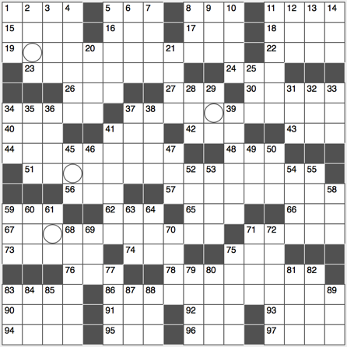**ACROSS**

1. Preschool song opener

5. Wanna -____ (copycats)

8. Chocolate pet

11. Great Depression drifter

15. When doubled, a common dolphin fish

16. Channel for cinephiles

17. “Are you a mouse ____ man?”

18. Actor Wilson of “Marley and Me” and “Zoolander”

19. Common retort aimed at popular activist organization BLM

22. Nantes noodle?

23. Launch

24. “Breaking ____”

26. ____ Auto (VW slogan)

27. Work week starter, briefly

30. Sheriff’s gang

34. Word after Ferris or pin

37. Surgical open-heart procedure

40. Speed vector: abbr.

41. Rat tail?

42. Dashed (away)

43. One of five on a foot

44. Bird representing a three-under-par score in golf

48. What la Tierra orbits

51. Scientific instruments that measure relative concentrations of atoms and molecules

56. Frequent target of ID thieves

57. Protein component

59. ____-la-la

62. The South in the Civil War, abbr.

65. Undesired picnic visitor

66. Santa ____, CA

67. Globular electrical phenomenon

71. Using as a source, with “on”

73. Philadelphia train system

74. “How revolting!”

75. Whom Uncle Sam wants, on old posters

76. Ice Bucket Challenge cause, briefly

78. Utterly preoccupied

83. Airline grounded on the Sabbath

86. Words on a certain Scrabble board square … or a hint to 19-, 37-, 51- and 67-Across

90. Cab

91. Part of Q&A, for short

92. Slippery fish

93.

94. Blueprint figure

95. Genre for Drake and J. Cole

96. World’s largest package delivering company

97. Lioness in “The Lion King”

**DOWN**

1. “I ____ Rock” (1966 Simon & Garfunkel hit)
2. Exotic Java Sea island
3. Front part of the jaw
4. Opposite of multiply
5. On a first-name-____
6. 72-Down title heroine
7. “Beat it!”
8. Auctioneer’s unit
9. Is for more than one person?
10. Part of a fishhook
11. Baseball game snack
12. Be in debt
13. Transaction that a bookie might handle
14. “____ if by land, two if by sea”

20. List ending abbreviation

21. Short term worker, for short

25. Fourth month, abbr.

28. Rowing implement

29. Edward Snowden headline org.

31. Game, ____ and match

32. “Sorry, we’re full” sign

letters

33. Pupil’s place?

34. Mountain State: abbr.

35. Sea captain’s spot

36. Third largest island of Italy, after Sicily and Sardinia

37. Coalition of countries

38. The day before today, for short

39. Like an email still in the outbox

41. Long, narrow ditch

45. Donkey

46. Covers with Charmin for a prank, for short

47. Mrs. in Malaga

49. Great Plains tribe

50. Meadow

52. Nation due south of Iran

53. Chinese dynasty until 1644

54. Some vintage TVs

55. Certain trigonometric ratio

58. Mate of Mom

59. “Conan” and “American Dad!” cable channel

60. Canadian singer Carly ____ Jepsen

61. Mont Blanc, for example

63. Man’s name that’s also an alphabet run

64. ____ Lee (“Life of Pi” director)

68. *Style in which this clue is written*

69. Guy’s partner at a hoedown

70. Pancake restaurant chain

71. Big name in audio speakers

72. “Pride and Prejudice” author Jane

75. Hollers

77. The Lone ____ State (Texas)

79. Sky color, in Cannes

80. Ooze

81. “Call My Name” singer James

82. “The Art of the ____” (Donald Trump book)

83. Sci-Fi movie extras

84. Once around a track

85. Lumberjack’s tool

87. Messenger of biochemistry

88. AOL or Comcast, for example

89. Mandela’s nation: abbr.