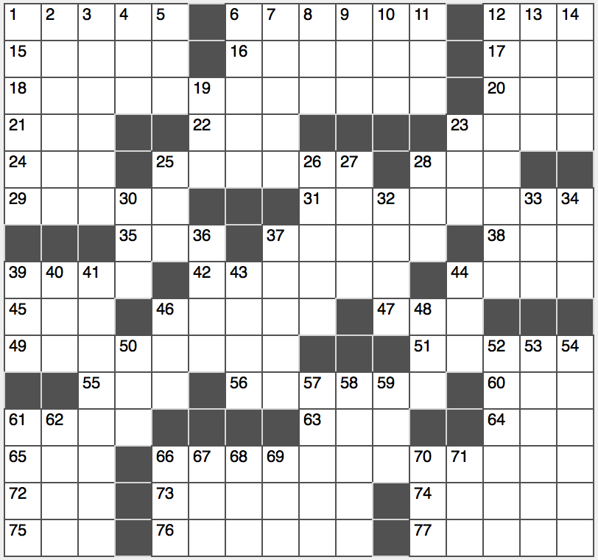**ACROSS**

1. Math columnist?

6. Only US President to ever be divorced

12. Concert tour booking

15. Former name of the Democratic Republic the of Congo

16. Shaggy South American llama-like animal

17. Dietary guideline: Abbr.

18. What one might give to go down in history?

20. Mont Blanc or the Matterhorn, for example

21. Ad-____ (improvise)

22. Canadian singer Carly ____ Jepsen

23. Seafaring affirmatives

24. Course that may aid in accent reduction, for short

25. Train service that operates in 46 states

28. Palindromic woman’s name

29. “Get ____ of yourself!”

31. Perpetual devil, perhaps, to Ceasar?

35. Upper-left keyboard key

37. Swallowed greedily

38. Canal site?

39. It becomes its own synonym when “cap” is added to the front

42. One of two numbers in a summation…or an instruction for obtaining the correct answers to 18-, 31-, 49- and 66-Across from the common phrases that appear

44. Zip, in Zaragoza

45. Gehrig who died of ALS

46. “Star Trek: TNG” actor and “Reading Rainbow” host Burton

47. Month fraction

49. Unfortunate apparel from a casual clothing retailer?

51. Radio pioneer Nikola

55. Partner of abet

56. Popular smartphone app that identifies prerecorded music

60. Not high

61. Alliance or treaty

63. Film director Anderson

64. ____ Green, 2006 Bond girl

65. It’s never in a vacuum

66. Sunday?

72. Prefix with “sex” or “corn”

73. Coffee liqueur

74. Retired Packers QB Brett

75. US Navy officers: Abbr.

76. Art supporters?

77. Lock of hair

**DOWN**

1. Rhododendron-like shrub
2. Like Hamlet or Kierkegaard
3. Dios’s enemy
4. Prove one’s fallibility
5. Sleep study acronym
6. Blitzed
7. Wood used to create the first of the deathly hallows in “Harry Potter and the Deathly Hallows”
8. Mental health org.
9. Guy’s date at a square dance
10. Royal-flush high card
11. Annoy with persistent fault-finding
12. Uncertain situation
13. Like some threats or chatter
14. Vacant areas
15. 52-Down filler

23. 5th or Lex.

25. Website pop-ups, e.g.

26. Middle Eastern sunflower cousin

27. Eagerly enthusiastic

28. “There’s an ____ for that” (former iPhone slogan)

30. “Chi-Raq” director Spike

32. California’s Harvey ____ College

33. It’s the latest thing

34. Lyricist Gershwin

36. D-Day city

37. “Add ____ of salt”

39. Minister’s attire

40. Scarf worn by Miss Piggy

41. Rapper with #1 hit “Money Maker”

43. Netflix rentals

44. “The Science Guy” Bill

46. Highland youngster

48. Bill issuer, for short

50. Flicked a Bic

52. See 19-Down

53. Romeo and Juliet, e.g.

54. Stirs from sleep

57. Exceptionally bad

58. Zeus and Zephyrus starters

59. ____ Wednesday

61. Ringo and John’s colleague

62. Informal opposite of “is”

66. Get by, but barely

67. Initials of first man to walk on the moon

68. Ballplayers who only bat, briefly

69. Futbol fan’s cheer

70. Baby newt

71. Civil or Trojan follower