Creative Brief

Andrew Rochat

November 7, 2018

Project Title: The Sport of Sailing

1. Project overview: The goal of this website is to talk about competitive sailing. It should be presented in a way that is informative to people who don’t know the first thing about sailing. It should also show flashier and mostly exciting images, since I want the page to be interesting/exciting and not just a research paper.
2. Resources:
   1. For the main sailing article, this is the link 🡪 <https://en.wikipedia.org/wiki/Sailing_(sport)>
   2. For the little section about Regatta’s, here is a useful link 🡪 <https://en.wikipedia.org/wiki/Regatta>
   3. For images about competitive sailing 🡪 literally google “competitive sailing” and choose cool photos from there. Most of competitive sailing is in smaller boats, so try to avoid the big yachts, even though they look cool.
   4. Images for sailing courses 🡪 <https://static1.squarespace.com/static/52ccb99ce4b065c5e52ae7c0/t/55497505e4b07eaae0da1a0f/1430877446089/>
      1. Something like that, easy to just look up sailing courses
3. Audience 🡪 This site is obviously going to be graded, so that is the primary audience. I may end up including it as a talking point for web development though, so it should be well made.
4. Message 🡪 I want the message to be centered around the basics of competitive sailing. I used to be a very competitive racer, so preferably the site should feel like its not coming from an outside observer, but actually someone who participates.
5. Content 🡪 To make it easier, I’m just going to put the content right in here.
   1. Overview 🡪 Sailing as a sport involves a variety of competitive sailing formats that are sanctioned through various sailing federations and yacht clubs. Racing disciplines include matches within a fleet of sailing craft, between a pair thereof or among teams. Racing formats include both closed courses and point-to-point contests; they may be in sheltered waters, coast-wise or on the open ocean.
   2. Racing Boats 🡪 There is a broad variety of kinds of races and sailboats used for racing from large yacht to [dinghy racing](https://en.wikipedia.org/wiki/Dinghy_racing). All kinds of boats are used for racing, including small [dinghies](https://en.wikipedia.org/wiki/Dinghy), [catamarans](https://en.wikipedia.org/wiki/Catamaran), boats designed primarily for [cruising](https://en.wikipedia.org/wiki/Cruising_(maritime)), and purpose-built race boats.
      1. Here, put an example of a dinghy with a caption of something like Dinghy’s are the most popular and competitive type of racing boat. And then do something similar for Yachts.
   3. Regatta 🡪 On water, a sailing competition among multiple vessels is a [regatta](https://en.wikipedia.org/wiki/Regatta), which usually consists of multiple individual races, where the boat crew that performs best in over the series of races is the overall winner.  Sailing race events are typically held for a single class (a single model of boat, such as the [Islander 36](https://en.wikipedia.org/wiki/Islander_36)) and usually last more than one day. Regattas may be hosted by a [yacht club](https://en.wikipedia.org/wiki/Yacht_club), sailing association, town or school as in the case of the UK's National School Sailing Association and [Interscholastic Sailing Association](https://en.wikipedia.org/wiki/Interscholastic_Sailing_Association) (high school) regattas or [Intercollegiate Sailing Association](https://en.wikipedia.org/wiki/Intercollegiate_Sailing_Association) (college) regattas.
   4. Types of competitions 🡪 Copy the Fleet Racing, Match Racing, and Team racing section from Wiki
   5. Courses 🡪 Harbor or buoy races are conducted in protected waters, and are quite short, usually taking anywhere from a few minutes to a few hours. All sorts of sailing craft are used for these races, including [keel-boats](https://en.wikipedia.org/wiki/Keel-boat) of all sizes, as well as dinghies, [trailer sailors](https://en.wikipedia.org/wiki/Trailer_sailor), [catamarans](https://en.wikipedia.org/wiki/Catamaran), skiffs, sailboards, and other small craft.
      1. This kind of race is most commonly run over one or more laps of a triangular course marked by a number of buoys. The course starts from an imaginary line drawn from a 'committee boat' to the designated 'starting' buoy or 'pin'. A number of warning signals are given telling the crews exactly how long until the race starts. The aim of each crew is to cross the start line at full speed exactly as the race starts. A course generally involves [tacking](https://en.wikipedia.org/wiki/Tack_(maneuver)) upwind to a 'windward' marker or buoy. Then bearing away onto a downwind leg to a second [jibe](https://en.wikipedia.org/wiki/Jibe_(sailing)) marker. Next another jibe on a second downwind leg to the last mark which is called the 'downwind mark' (or 'leeward mark'). At this mark the boats turn into wind once again to tack to the finish line.
      2. Show some pics of different types of courses
      3. Maybe include section on longer, offshore racing courses to show the difference
   6. Conclusion🡪 image with a motivational quote 🡪 Paul Elvström "You haven't won the race, if in winning the race you have lost the respect of your competitors."
      1. He has 4 Olympic gold medals and 19 medals at world championships
6. Tone 🡪 the tone should be modern, with a mix of cool, flashy images and informative headers / texts. I never want there to be more than a few sentences of text together. I want to highlight the most interesting aspects of the sport.
7. Visual style 🡪 I have sort of already explained this, but I want the website to be modern, with a mix of text and images. The content should be all on one page, however the user should be able to distinguish section from section. A soft white background will go well with a lot of water and outdoor images.

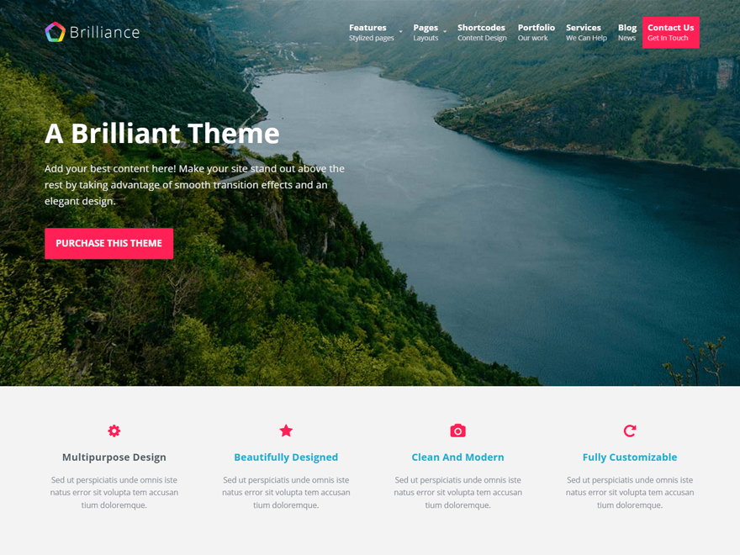

Even though this isn’t really the type of photo I would show, I like the light background and modern way they overlayed the text with the image. Also, this is sort of what I want the top of the page to look like, except the top nav-bar shouldn’t be so transparent.

I know that this website makes it look sort of complicated, but I like how they had a modern and plain style to it. Also, it is clear where the sections are, and they did not use too much text, which I liked.