CS 340 Project Two README
Grazioso Salvare Rescue Dashboard
Alberto Rodriguez
CS 340 Client Server Development

Purpose and functionality
This dashboard helps Grazioso Salvare identify shelter dogs that match its search-and-rescue training criteria. I reused my Project One CRUD module and Module Six table and map code to complete the Project Two starter notebook. The application reads the Austin Animal Center data from MongoDB and displays an interactive table, a breed distribution pie chart, and an animal location map.
The starting view displays all records. Water, Mountain or Wilderness, and Disaster or Individual Tracking radio options run category-specific database queries. Reset retrieves all animals and clears table searches, sorting, column selection, and pagination when selected after another category. The linked Grazioso Salvare logo opens the SNHU website, and the header identifies Alberto Rodriguez as the developer.

Rescue query requirements
- Water Rescue: Labrador Retriever Mix, Chesapeake Bay Retriever, or Newfoundland; Intact Female; 26 through 156 weeks.
- Mountain or Wilderness: German Shepherd, Alaskan Malamute, Old English Sheepdog, Siberian Husky, or Rottweiler; Intact Male; 26 through 156 weeks.
- Disaster or Individual Tracking: Doberman Pinscher, German Shepherd, Golden Retriever, Bloodhound, or Rottweiler; Intact Male; 20 through 300 weeks.
All rescue queries require animal_type to be Dog. Breed names match the specifications table exactly using $in. Age comparisons use the numeric age_upon_outcome_in_weeks field with inclusive $gte and $lte limits. Reset uses the empty query {} and includes non-dogs.

Using the widgets
The table shows ten rows per page and supports column searches, multiple-column sorting, column highlighting, and single-row selection. The pie chart counts breeds across all filtered table pages. Small labels are hidden when they cannot fit inside their slices; hovering reveals breed names and counts. The map displays the selected animal, or the first matching row if no selection remains. Missing or invalid coordinates show an Austin base map with an explanatory message. Empty results produce messages instead of chart errors.

Tools and design
MongoDB provides the model in the MVC design. Its document structure represents each shelter record, and compound query operators combine breed, sex, species, and numeric age conditions. PyMongo accepts Python dictionaries and returns documents that the AnimalShelter class exposes through create, read, update, and delete methods. The dashboard uses the read method to avoid changing shelter records.
Dash provides the view and controller. The layout defines the controls, table, and chart containers. Callbacks connect a rescue selection to the CRUD query and table update, then connect the table data and selected row to the charts. JupyterDash runs the dashboard from the course notebook. Pandas prepares records and counts breeds; Plotly Express creates the pie chart; Dash Leaflet supplies the map, marker, tooltip, and popup. NumPy validates coordinates. Base64 embeds the supplied logo. The starter also retains its OS and Matplotlib imports.

Reproduction instructions
1. Extract the ProjectTwo folder from the submitted ZIP. Keep ProjectTwoDashboard.ipynb, CRUD_Python_Module.py, and Grazioso Salvare Logo.png together in the Codio code_files folder. Preserve these filenames exactly.
2. Use the course Jupyter environment with jupyter-dash, dash, dash-leaflet, pandas, numpy, plotly, matplotlib, and pymongo installed. The Codio environment used for the screenshots already provided these packages; its exact package versions were not recorded. Avoid replacing it with a newer major Dash release without checking compatibility.
3. Reuse the existing Project One MongoDB database. The module connects to localhost on port 27017, database aac, collection animals. Confirm the course data is loaded and age_upon_outcome_in_weeks is numeric. Do not import the same CSV again into the populated collection, because that can duplicate records.
4. The notebook instantiates AnimalShelter with the aacuser course account and its existing password, as required by the assignment. Confirm the account and authentication database match the original Project One setup. Do not publish course credentials in a public repository.
5. Open ProjectTwoDashboard.ipynb and run its complete code cell from the top. JupyterDash.infer_jupyter_proxy_config configures the notebook proxy. The final app.run_server call starts the dashboard; open the link shown in the output.
6. Choose each rescue category and observe the table and both charts. Select another table row to inspect its location. Use searches, sorting, and pagination as needed. Choose a rescue category and then Reset to restore the unfiltered view. If Reset is already selected, switch to another category first to trigger it again.
7. Save the notebook after running it. Submit the code ZIP and this Word README. The dataset is available through the course and is not duplicated in the code package.

Development and troubleshooting
I replaced the starter CRUD import with CRUD_Python_Module, retained the existing course credentials, and reused the Module Six table controls. I added the supplied logo and developer name, completed the rescue query callback, and connected the filtered table to the pie chart and map.
Running the map callback by itself initially produced a NameError because app had not been created. Running the complete cell places imports, database setup, and app construction before callback registration. The original map used positional column numbers and assumed a selected row existed; the completed version uses named coordinate fields, checks empty results, and defaults safely when selection is absent.
The first unfiltered pie chart had overlapping percentage labels. I moved labels inside slices and hid labels that do not fit while preserving every breed and its hover details. The initial screenshots retain the earlier appearance; the four final filter screenshots show the corrected chart. The table and map layout uses flexible widths so the charts can wrap on smaller screens.
If the logo cannot be found, confirm the filename and notebook working directory. If the server port is occupied, stop the previous app or restart the kernel before rerunning. A connection or authentication failure is printed by the original CRUD module, whose read method returns an empty list on error; inspect notebook output before interpreting an empty dashboard as no matching animals. The map also needs internet access for its background tiles.

Validation and evidence
The saved notebook contains a Codio dashboard server URL. The following user-captured Codio screenshots document the initial view and all four filter states. The final Mountain view shows five records and the Disaster view shows four, with pie percentages matching the visible breed counts. Water shows two table pages and a 100% Labrador Retriever Mix chart. Reset restores dogs and cats, the initial first record, and the broad breed distribution.
Separate local checks validated the downloaded notebook structure and Python syntax, then exercised its callbacks with a mock MongoDB loaded from the supplied 10,000-row CSV. Those checks returned 17 Water, 5 Mountain, 4 Disaster, and 10,000 Reset records, with matching pie totals. Empty-result, invalid-coordinate, column-selection, and HTTP layout checks passed. Proxy/server startup was skipped locally; actual Codio execution is supported by the saved output and screenshots, not by these mock checks.
The Codio screenshot shows 1,001 unfiltered pages at ten rows per page, which differs from the 10,000-row reference CSV used in the local checks. An exact Codio collection count was not recorded. The screenshots do not independently establish every sorting, row-selection, or empty-search interaction; those behaviors are implemented in code and should not be described as fully browser-tested.

References
SNHU. CS 340 Project Two Guidelines and Rubric; CS 340 Dashboard Specifications Document, especially the rescue requirements on page 4. Course materials.
Austin Animal Center. (2020). Austin Animal Center Outcomes. https://doi.org/10.26000/025.000001
MongoDB PyMongo documentation: https://www.mongodb.com/docs/languages/python/pymongo-driver/current/
Dash interactive tables: https://dash.plotly.com/datatable/interactivity
Dash notebook environments: https://dash.plotly.com/dash-in-jupyter
Plotly Python: https://plotly.com/python/ | Dash Leaflet: https://www.dash-leaflet.com/
pandas: https://pandas.pydata.org/docs/ | NumPy: https://numpy.org/doc/

Figure 1 Initial unfiltered dashboard
Two original Codio captures show the initial header and table, followed by the charts below. The chart capture predates the label readability fix; the header capture supplies the logo and developer identifier for this paired figure.
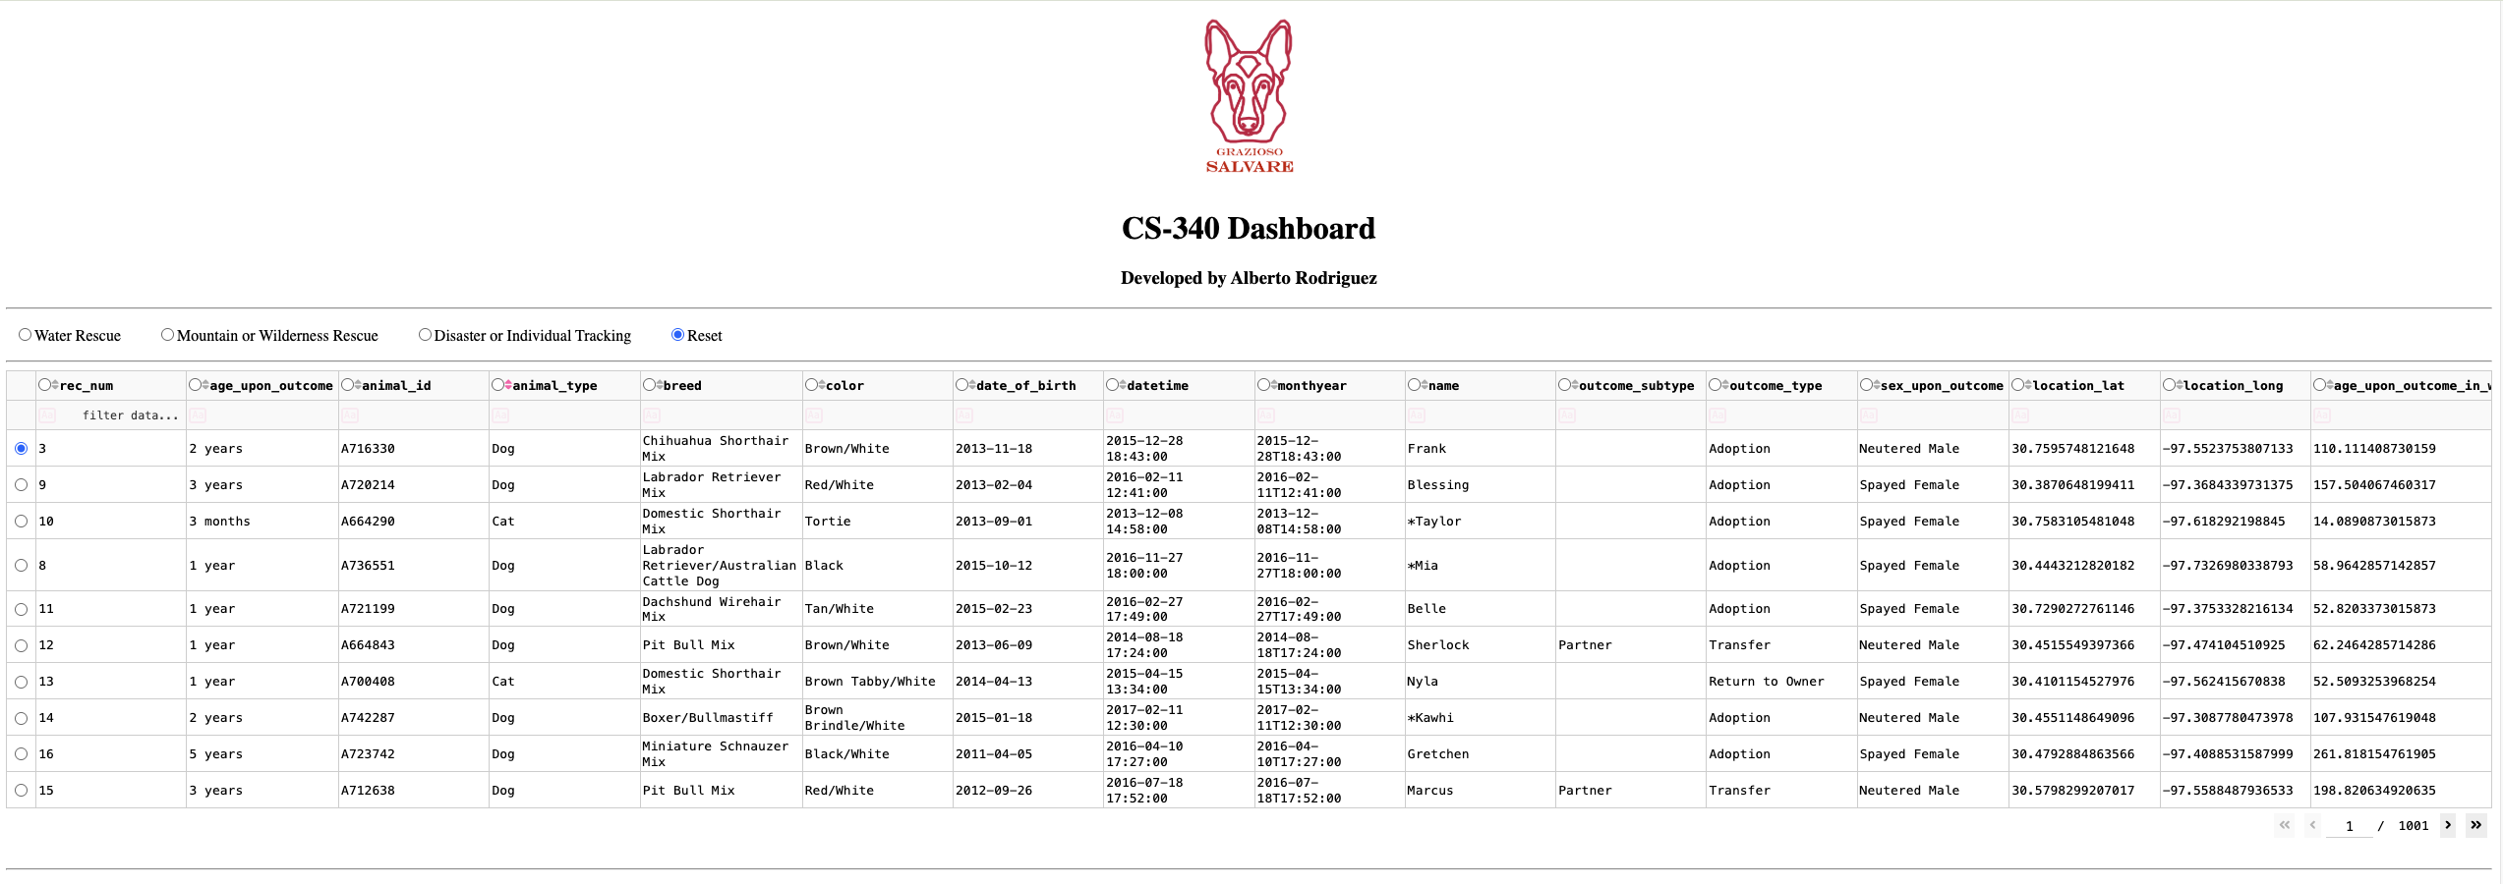
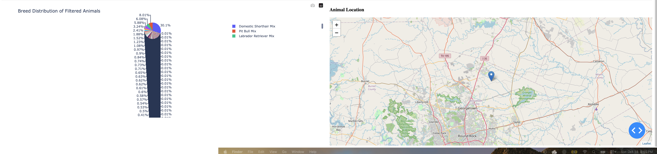

Figure 2 Water Rescue
Water Rescue selected. The table displays matching intact female dogs; the chart shows Labrador Retriever Mix at 100%, and the map displays the selected record.
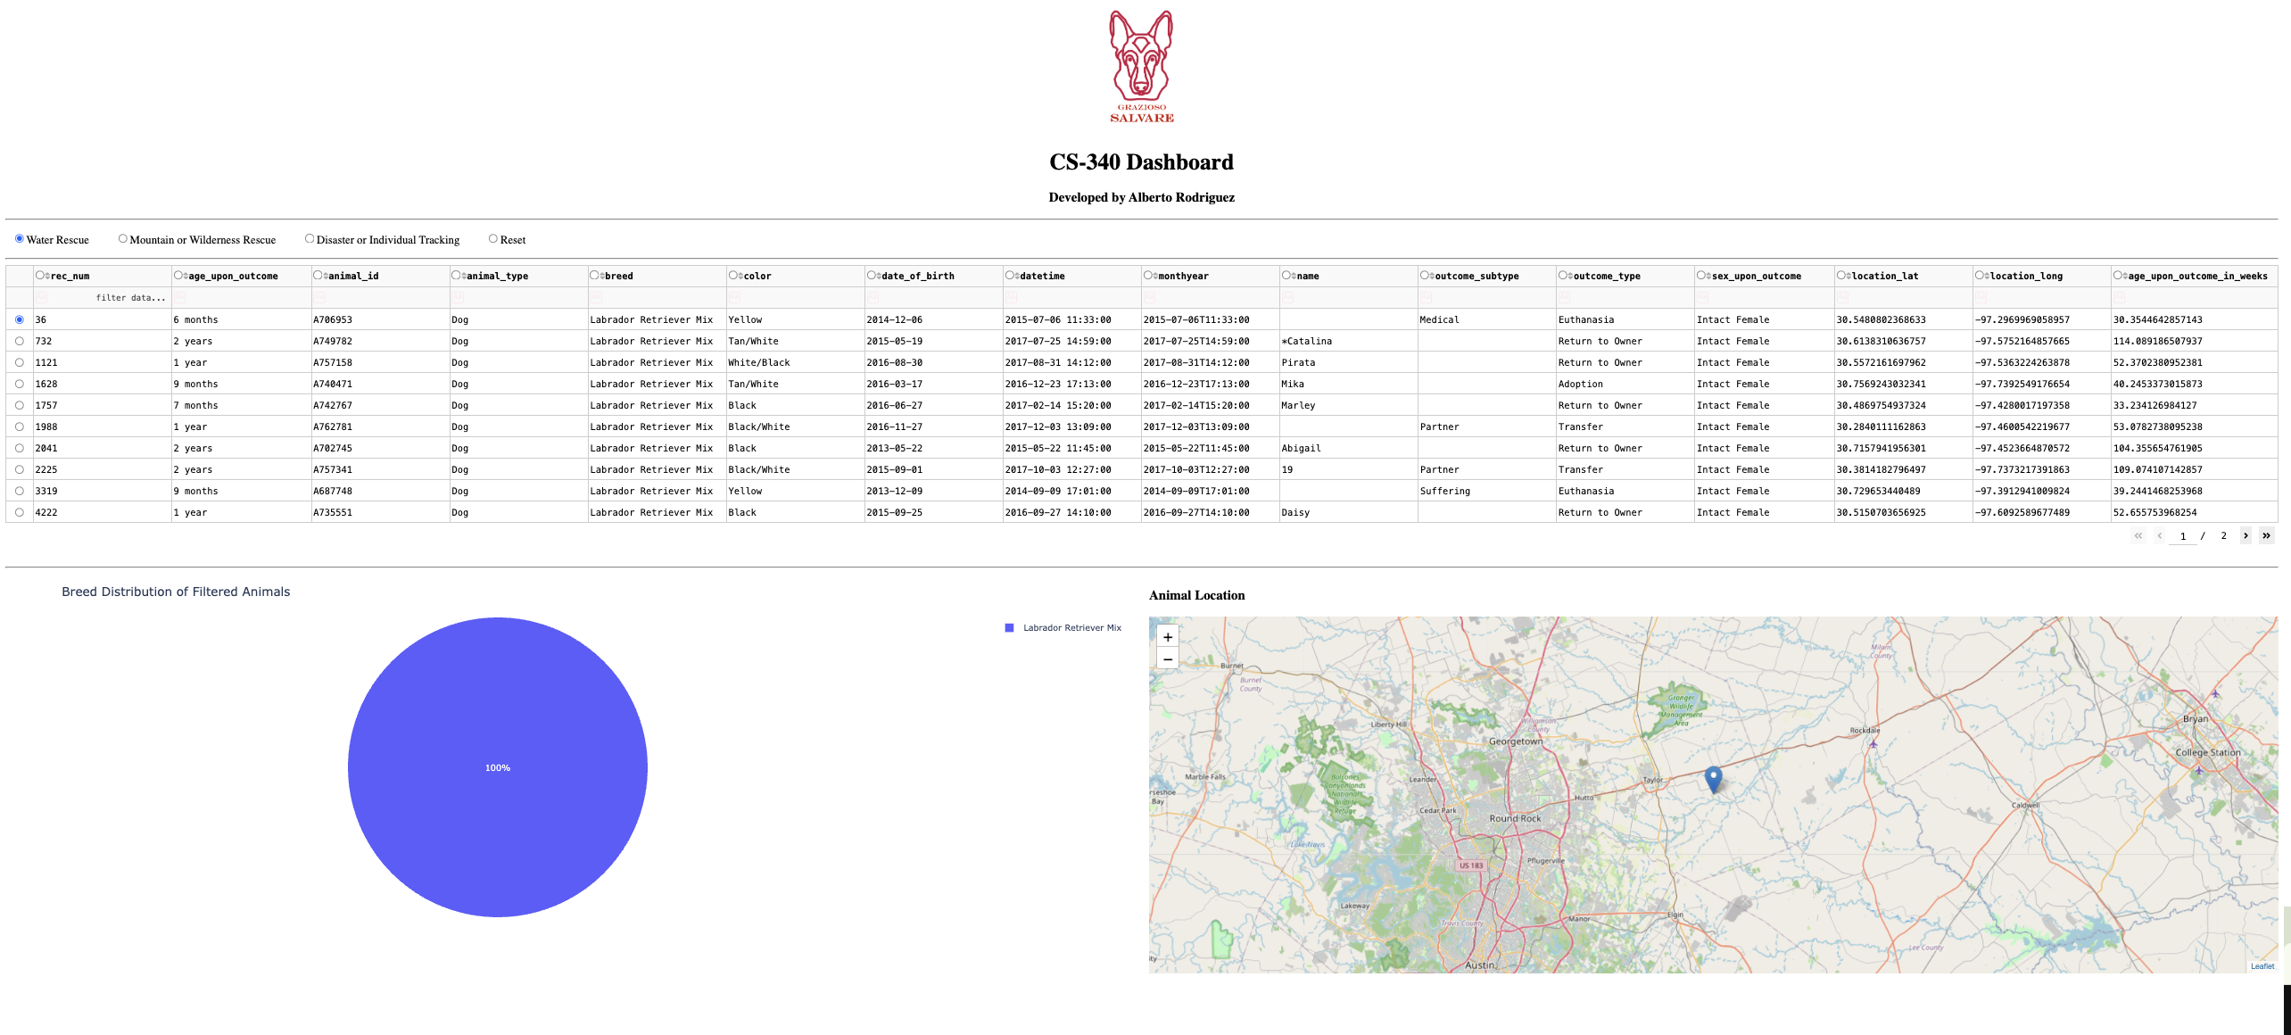

Figure 3 Mountain or Wilderness Rescue
Five matching intact male dogs: two Siberian Huskies and one each Alaskan Malamute, German Shepherd, and Rottweiler. The chart shows 40%, 20%, 20%, and 20%.
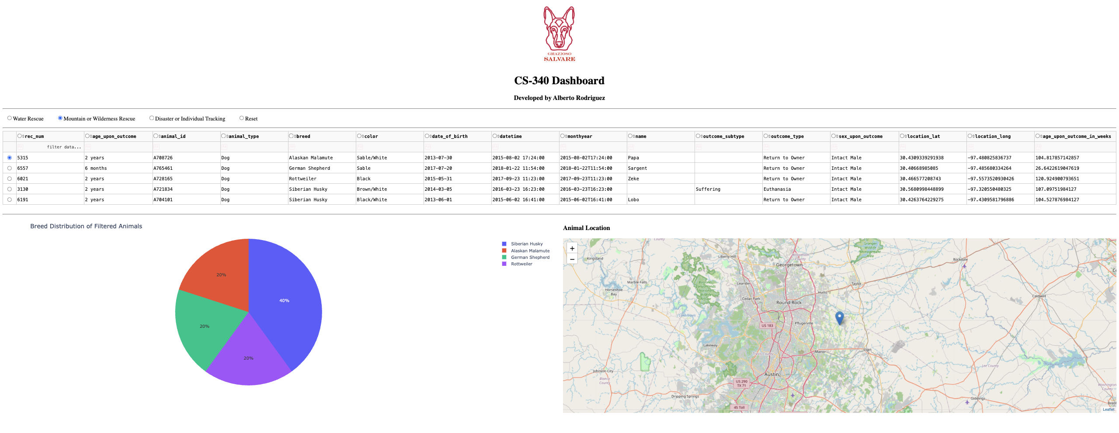

Figure 4 Disaster or Individual Tracking
Four matching intact male dogs: two Rottweilers, one Bloodhound, and one German Shepherd. The chart shows 50%, 25%, and 25%.
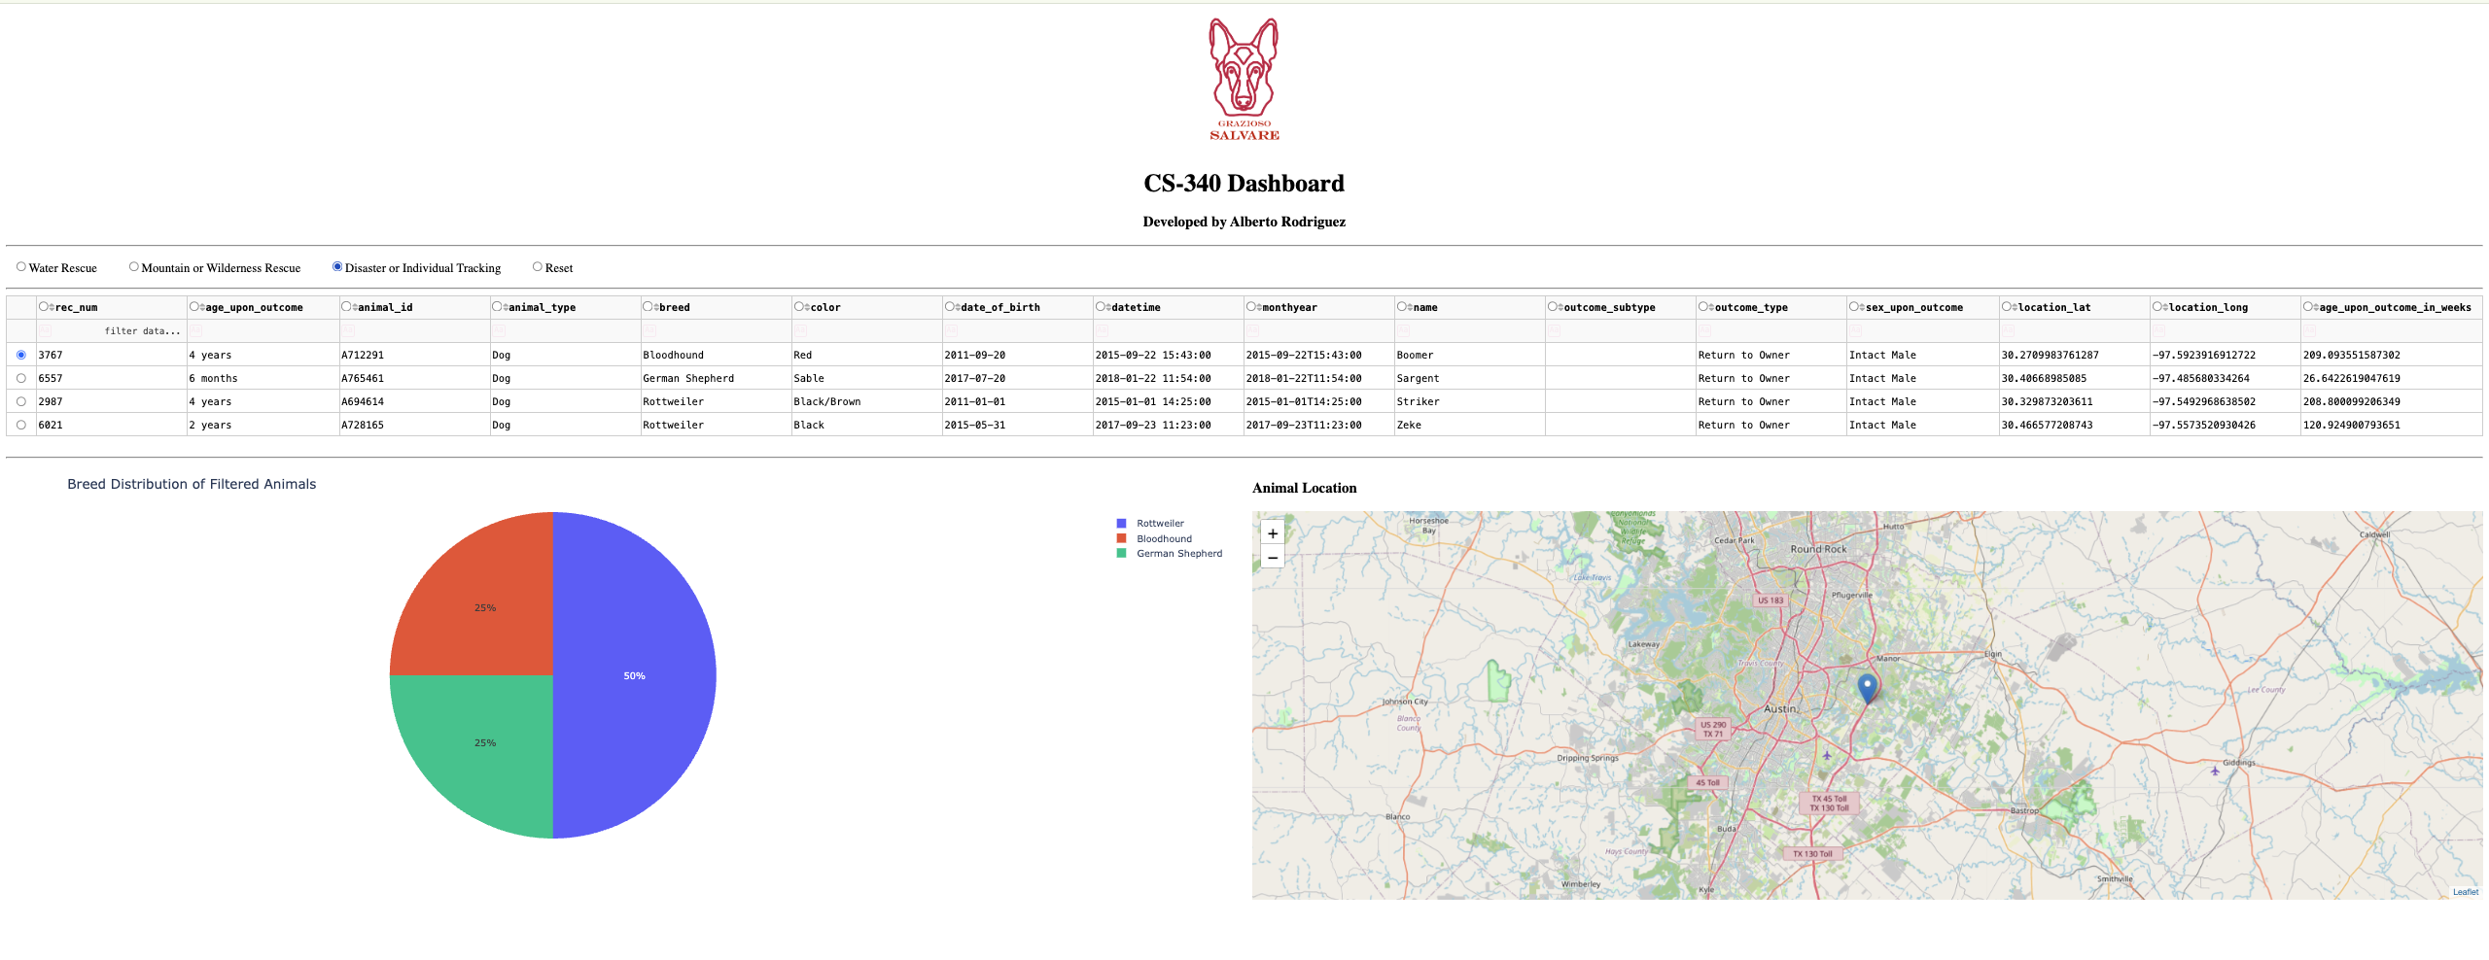

Figure 5 Reset
Reset restores the unfiltered table and charts after category filtering. This final capture shows the corrected pie labels, the logo, developer name, and both charts.
