Bob’s Computer Repair Shop

TECHNICAL DESIGN DOCUMENT

|  |  |
| --- | --- |
| **Author** | Adam Rodgers |
| **Last Updated** | 2/20/2022 2:47 PM |
| **Version Number** | 0.1 |

**Version History**

|  |  |  |  |
| --- | --- | --- | --- |
| Name | Date | Reason for Change | Version |
| Rodgers, Adam | 02/20/2022 | Initial planning | 0.1 |
|  |  |  |  |
|  |  |  |  |
|  |  |  |  |
|  |  |  |  |
|  |  |  |  |
|  |  |  |  |
|  |  |  |  |
|  |  |  |  |
|  |  |  |  |

Table of Contents

SECTION 1: INTRODUCTION 3

Purpose 3

Terminology 3

Related Documents 3

Reviewers 3

Required Skills 4

SECTION 2: Architecture 4

Physical Architecture 4

Logical Architecture 4

SECTION 3: PROCESS DESIGN 5

Object Relational Diagram(s) 5

NoSQL Data Structure 5

Wireframes 5

SECTION 4: REFERENCES 6

# SECTION 1: INTRODUCTION

## Purpose

This web application will allow customers of Bob’s Computer Repair Shop to select services and view prices. Employees will be able to update part and labor costs and produce a detailed invoice for the customer to view.

## Terminology

|  |  |
| --- | --- |
| **Name** | **Comments** |
| MEAN Stack | MongoDB, Express, Angular, and Node.js |
| SoapUI | API testing tool |
| MongoDB Compass | Database development IDE |
| Angular | https://angular.io/ |
| Angular Material | <https://material.angular.io/> |

## Related Documents

Color Palette

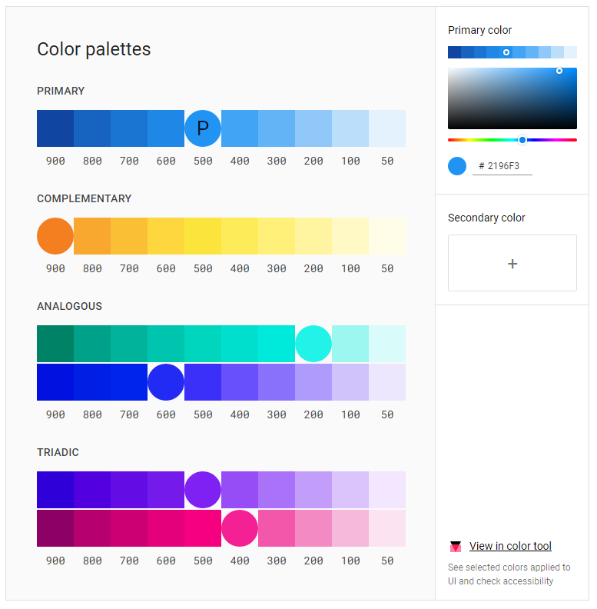

## Reviewers

|  |  |  |
| --- | --- | --- |
| **Approvers** | **Name** | **Date** |
| **Approved By (**Client Acceptors, can be more than one) | Bob | 2/22/2022 |
| **Approved By** (Solution Architect) | Professor Krasso | TBD |
| **Approved By (**Development Team) | Adam Rodgers | TBD |

## Required Skills

Knowledge in full-stack web development, including MEAN stack, required. Application will be built in Angular with Angular Material. Database will be built in NoSQL database MongoDB and hosted on MongoDB Compass. All APIs will be built in Express and tested with SoapUI.

# SECTION 2: Architecture

## Physical Architecture

## Logical Architecture

# SECTION 3: PROCESS DESIGN

## Object Relational Diagram(s)

## NoSQL Data Structure

Customer JSON

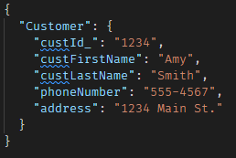

Employee JSON

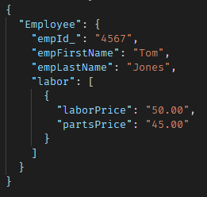

Services JSON

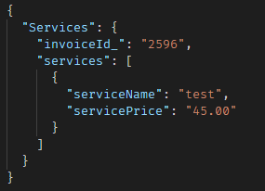

Invoice JSON

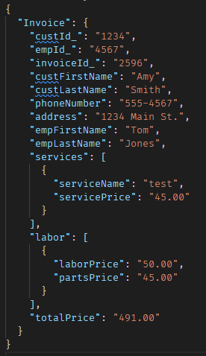

## Wireframes

Main Application

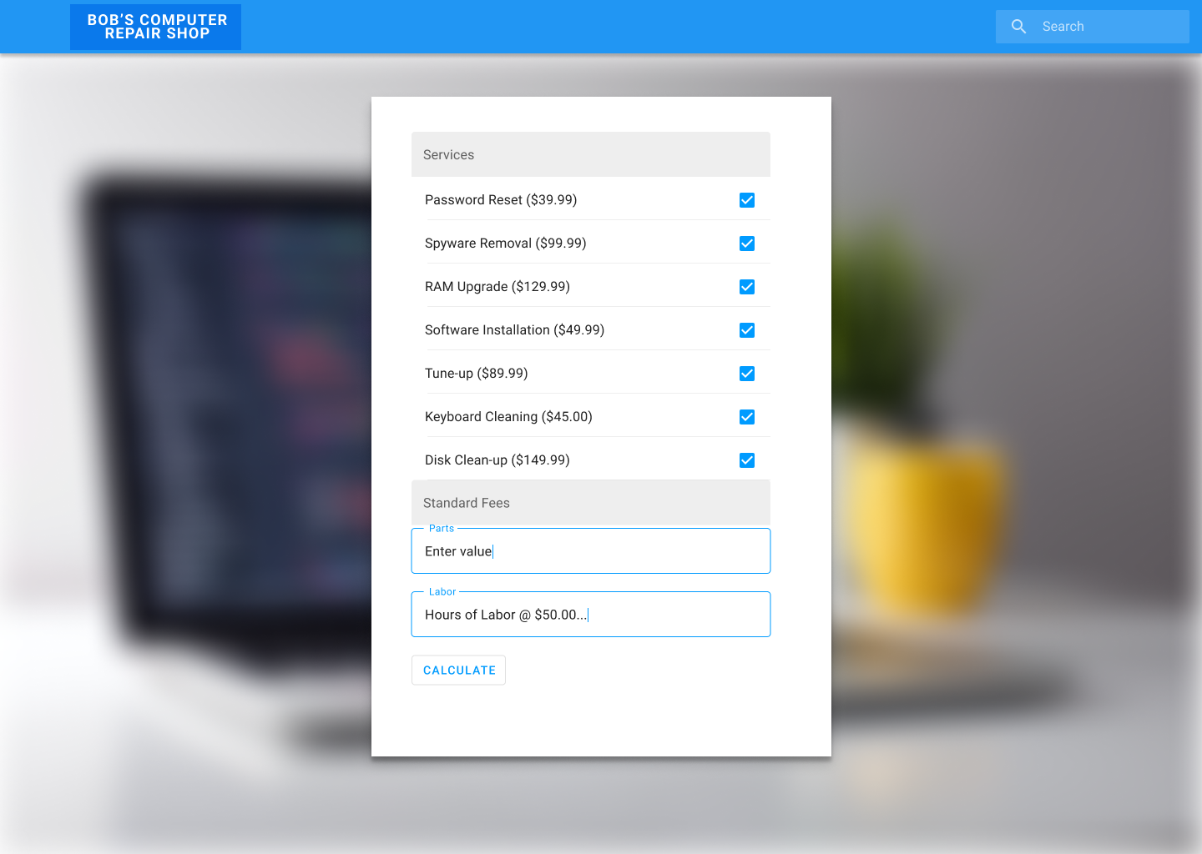

Invoice Summary

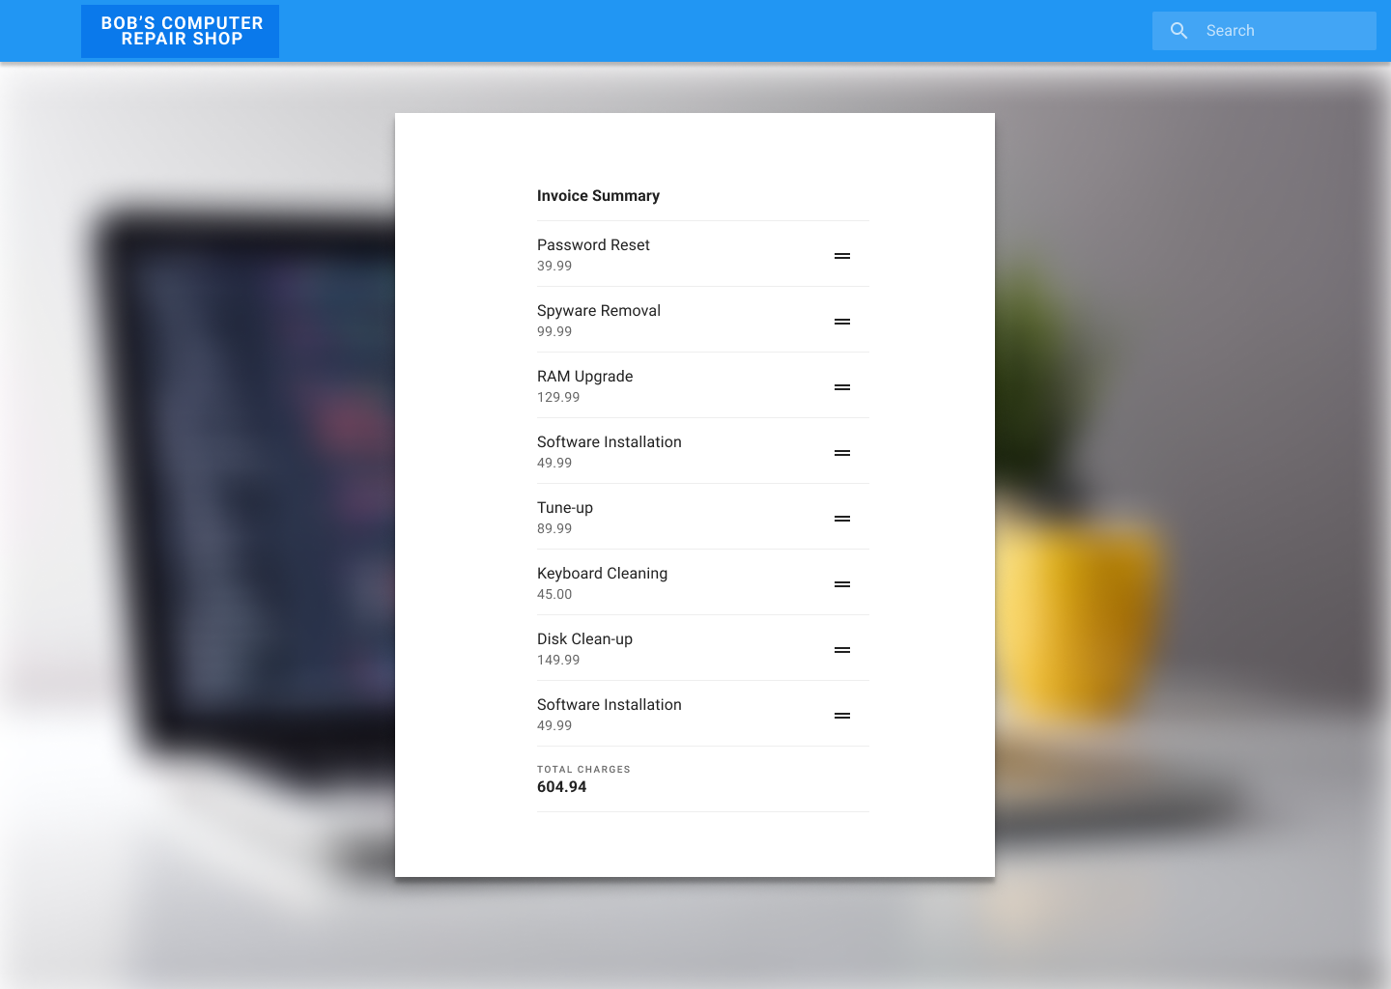

# SECTION 4: REFERENCES

Material. (n.d.). *Resources*. Https://Material.Io/Resources. Retrieved February 20, 2022, from https://material.io/resources

Material Design. (2021, October 27). *Material 2 Design Kit*. Figma. Retrieved February 20, 2022, from https://www.figma.com/community/file/778763161265841481