This small batch file is to automatically set up our SCCM reimaging USB drives with windows. A couple key things that need to be noted BEFORE running this application. Go to start menu and type in Device Manager, and make sure your USB device is labeled as “disk 1” and has at least 55GB of space. Mine Says “Unallocated” but if there’s blue on the bar and there is a drive there it is still fine.

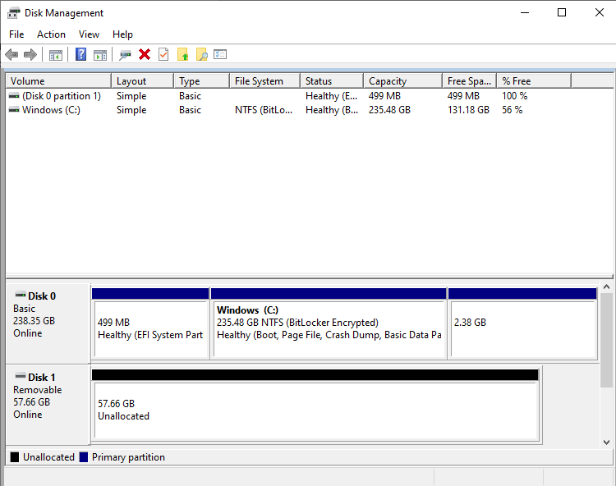

Now make sure the SCCM zip file is in the same folder as the “Boot_Drive_Setup” file.

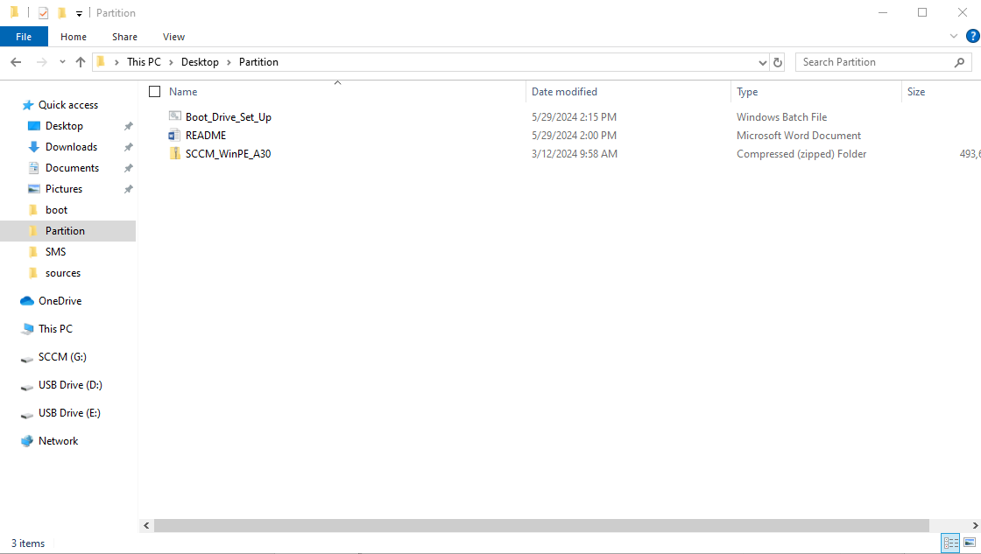

If all this is correct, right click “Boot_Drive_Setup” and choose “run as administrator” it will first create the partitions for drive. And there might be popups asking to format the newly created drives, you can just press the cancel button.

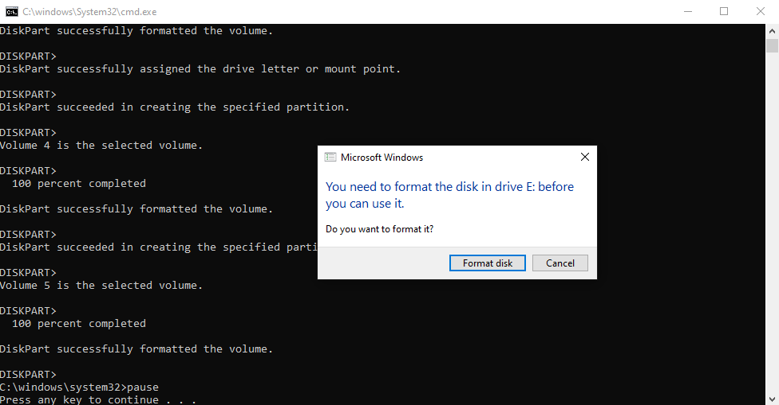

From here it will pause and wait for to press any key. When a key is pressed, if the SCCM zip file is in the same folder as the application, it should start transferring over the files automatically.

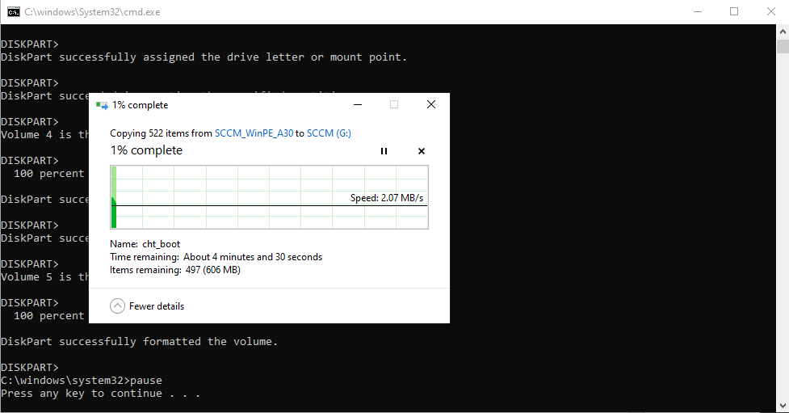

When the file transfers finish you can follow the rest of the workflow for the Mac portion of the setup.

TROUBLESHOOTING:

FORWARNING – DO NOT PUT “0” HERE

If in the disk manager, the USB device you want to set up is not on “disk 1” you can right click on the “Boot_Drive_Setup” and choose edit. It should pop up with a notepad.

Then on line 3 “echo Select Disk 1” you can change the “1” to the desired disk.

FORWARNING – DO NOT PUT “0” HERE

