|  |  |
| --- | --- |
| **Software Requirements** | **Requirements Met** |
| Requirement 1:   * Plan out the project. * Create a software requirement document (SRD) for the project listing all the requirements and how they were fulfilled. * Install Matplotlib |  |
| Requirement 2:   * Download Template files. * Data Visualization  1. Simple Line 2. Scatter |  |
| Requirement 3: Create Random walks.   1. It needs to choose a random direction 2. Styled 3. Start and end points. 4. Make multiple walks. |  |

|  |  |
| --- | --- |
| Requirement 4: Expand Environment   1. Install plotly |  |
| Requirement 5: Ending the game   1. Added lives  * Lives were added to allow an end to the game but there was no scoreboard to display them yet. |  |
| Requirement 6: Score   1. Play Button  * Made a play button and used it to reset the stats of everything when pressed  1. Level Up  * Added a feature that would increase game speed and difficulty when all aliens were destroyed.  1. Score Board  * Created a scoreboard that displayed at the top of the screen to show the lives left, high score, current score and level. |  |

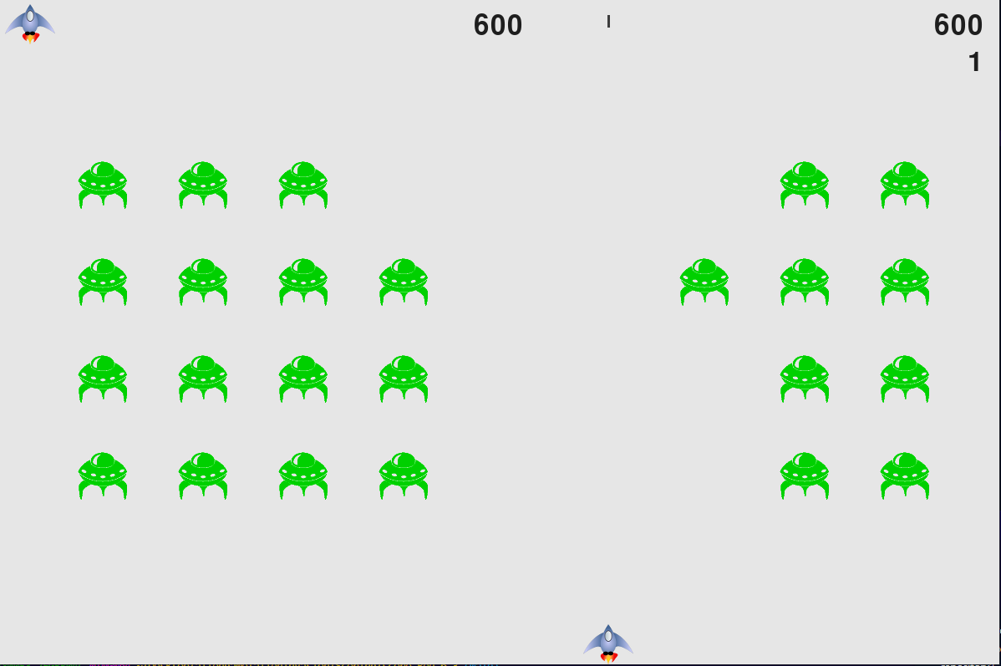

This final image is the screen as a whole with all parts working together. You can see the aliens have been shot while moving down the screen. Lives have been lost in the top right corner. Score has increased, as well as the high score is the current score. And there is a bullet going to the top of the screen.