**PAGE 1 – Professional Women in the workplace explained**

This page will bring to light the problems women face in the workplace whether that be discrimination, sexual harassment, motherhood, etc.

**Discrimination**

[**https://www.equalrights.org/issue/economic-workplace-equality/discrimination-at-work/**](https://www.equalrights.org/issue/economic-workplace-equality/discrimination-at-work/)

Sexism – prejudice or discrimination based on a person’s sex or gender

Things that gender discrimination affects for professional women:

* Wages
* Less potential for promotion
* Unfair perception that women are less competent
* Being held at different or higher standards for performance
* Being subject to unwelcome sexual advances
* Being rejected from a position

[**https://www.theladders.com/career-advice/workplace-gender-bias-is-very-much-alive-and-well-and-this-is-why**](https://www.theladders.com/career-advice/workplace-gender-bias-is-very-much-alive-and-well-and-this-is-why)

Researchers for the University of Exeter found that gender bias still exists due to managers and corporate leaders who believe gender bias is no longer a problem.

The study involved managers within the veterinary field.

A group of managers were given 2 identical candidates one female one male for a specific position.

Their findings included:

* Rating the male candidate more competent
* Suggesting an 8% higher salary to the male candidate
* Majority of the managers who deemed the female candidate less competent also said they did NOT believe gender bias still existed
* 2/3 of managers who said gender bias is not an issue were male

**Sexual Harassment**

It is impossible to talk about women in the workplace without discussing topics such as sexual harassment, discrimination, motherhood, etc. All professional women have unfortunately had to deal with at least one of these instances. This page will go into detail about each of these topics and discuss how intersectionality also effects professional women.

Possible page titles:

* **Should having children effect a women’s ability to pursue her career of choice and her ability be successful in the industry?**
* **The beauty of motherhood and the evilness that society has connected to it.**

Every website I have done research on has mentioned motherhood. Not only do men statistically excel in the workplace but they get to reap the benefits of having a family without it affecting their career.

<https://www.theatlantic.com/business/archive/2016/12/opting-out/500018/>

10% of highly educated mothers stay home

Essentially, women immediately connect with their child once he/she is born making it extremely difficult for them to give 100% of their efforts to either the child or their career. Children also brings less flexibility in a mother’s work schedule. Once a child is born their job either wasn’t flexible enough, didn’t pay enough, or wasn’t fulfilling enough.

“Women are promoted slower and are judged more harshly and they aren’t compensated the same”

If a woman is pregnant, they’re less likely to be promoted even if their competition is less experienced.

After the children enter their teen years it is difficult for the mother to fully reenter the professional world. You lose “professional currency and earning power” when you are out of the professional workplace for so long.

“The women who work feel badly about being disconnected from their children, the ones who stay home dream about going back to work”

Admits a global pandemic, working from home has become normal. Maybe, in the near future it will become normalized to carry on a full-blown career while raising children at the same time.

<https://corporatespring.com/men-say-yes-women-say-not-yet/>

Women are more self-aware of their abilities. Men often exaggerate their abilities.

Men: if them…why not me?

Women: if not them…why me?

<https://www.americanprogress.org/issues/women/reports/2020/03/24/482141/quick-facts-gender-wage-gap/>

**PAGE 2 – Data**

This page will include graphs, charts, statistics pertaining to professional women in the workplace.

The Gender Wage Gap – the difference in earnings between men and women

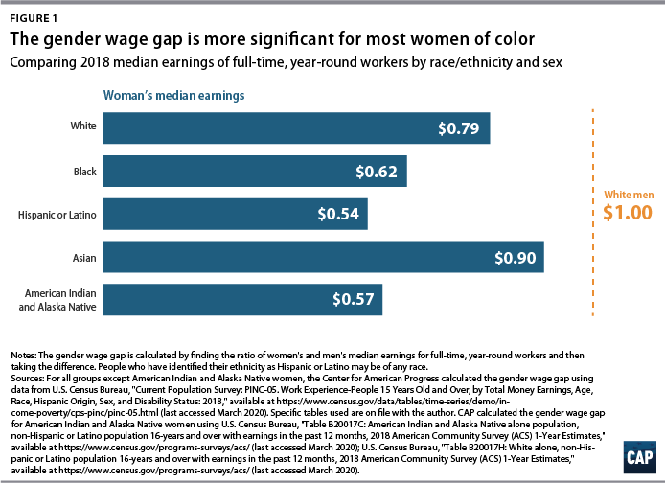

Reasons for the wage gap:

* Discrimination. Gender bias is still very much alive whether people are conscious of it or not.
* “Only 19% of civilian workers had access to paid family leave through their employers and only 40% had access to short-term disability insurance benefits to deal with their own medical needs” 🡪 this leads to men having more years of experience.
* Industries that are predominately women such as childcare, education etc. tend to pay lower wages than industries dominated by men including trading, construction, etc.

<https://futurewomen.com/hotlists/5-reasons-gender-pay-gap-exists/>

The world economic forum predicts that it will take another 217 years before the gender pay gap finally closes.

Female dominated industries: childcare, social work, teaching and nursing.

Having a family effects how much time a mother can work. Having children can be the deterring factor if a woman succeeds in her career or not.

Intersectionality:

<https://www.nytimes.com/2018/09/30/us/the-effect-of-intersectionality-in-the-workplace.html>

The concept of intersectionality — referring to the complex and cumulative way different forms of discrimination like racism, sexism and classism overlap and affect people — seems have popped up relatively recently.

<https://www.catalyst.org/wp-content/uploads/2019/02/emotionaltax.pdf>

• Asian, Black, Latinx, and multiracial professionals pay an Emotional Tax at work when they feel they must be on guard to protect against racial and gender bias.

• This experience was shared by nearly 60% of the women and men of color we surveyed.

• Employees who feel on guard are most likely to want to leave their employers and face challenges to their well-being.

• A majority of those who are on guard have a strong drive to contribute and succeed—suggesting that the loss of their talent would be detrimental to the organization.

• To retain these valuable employees and address potential reasons for being on guard, leaders must cultivate inclusive workplaces.

^^^ the entire study linked above has a multitude of data in regard to intersectionality and how different individuals feel throughout their workdays

**PAGE 3 – Successful women in the workplace**

The idea for this page is to have a small blurb on the top and then have a bunch of boxes showcasing different professional women with their name, a photo, their titles, accomplishments and possibly a quote.

RBG

First Jewish women and second women to serve as a Supreme Court Justice.

 "Women belong in all places where decisions are being made. It shouldn't be that women are the exception."

Michelle Obama

First African American first lady of the United States, American attorney, author

"Strong men, strong men, men who are truly role models, don’t need to put down women to make themselves feel powerful,"

Alice Guy Blache

First women to direct a film, Co-founder of Solax Studios in Flushing, NY.

“There is nothing connecting with the staging of a motion picture that a women cannot do as easily as a man.”

Bobbi Brown

American professional makeup artist, bestselling author, public speaker, entrepreneur, and the founder of Bobbi Brown Cosmetics

“I believe all women are pretty without makeup- but with the right makeup can be pretty powerful.”

Sara Blakely

American businesswoman, entrepreneur, and philanthropist. She is the founder of Spanx

**“**I think my story says that, when women are given the chance and the opportunity, that we can achieve a lot. We deliver.”

Oprah

American talk show host, television producer, actress, author, and philanthropist.

*“It doesn’t matter who you are, where you come from. The ability to triumph begins with you – always.”*

Reece Witherspoon

American actress, producer, and entrepreneur. Co-founded Hello Sunshine, a production company dedicated to telling female stories

“My whole drive to be an actor was finding roles that I really believed represent modern women, the struggles that we deal with. Women who are strong and capable and in control of their own lives.”

Alexandria Ocasio-Cortez (AOC)

 Youngest woman ever to serve in the United States Congress. American politician serving as the [U.S. Representative](https://en.wikipedia.org/wiki/United_States_House_of_Representatives) for [New York's 14th congressional district](https://en.wikipedia.org/wiki/New_York%27s_14th_congressional_district)

“The idea that a woman can be as powerful as a man is something that our society can’t deal with. But I am as powerful as a man and it drives them crazy.”

Viola Davis

American actress and producer  known for her precise, controlled performances and her regal presence.

"The internal sexism within womanhood is very ­predominant in Hollywood, because we all want to be ­successful. There's a plug to it: You all have to be skinny! You all have to be pretty! You all have to be likable, because that's the ­formula that works. On an ­executive level. On a power level. And it's not always the same working with black people, because of the internalized racism. The colorism."

Angela Merkel

First female Chancellor of Germany

“I might bend, but I will NEVER break it’s in my nature as a strong women.”

Serena Williams

American professional tennis player and former world No. 1 in women's single tennis. She has won 23 Grand Slam singles titles, the most by any player in the Open Era, and the second-most of all time behind Margaret Court

“The success of every woman should be the inspiration to another. We should raise each other up. Make sure you’re very courageous: be strong, be extremely kind, and above all be humble.”

Malala Yousafzai

Pakistani activist for female education and the youngest Nobel Prize laureate.

“No struggle can ever succeed without **women** participating side by side with men. There are two powers in the world; one is the sword and the other is the pen. There is a third power stronger than both, that of **women”**

Kimberle Crenshaw

American lawyer, civil rights advocate, philosopher, and a leading scholar of critical race theory who developed the theory of intersectionality

“Sexism isn’t a one-size-fits-all phenomenon. It doesn’t happen to black and white women the same way.”

Toni Morrison

American novelist, essayist, book editor, and college professor. She won the **Pulitzer Prize for Fiction** for her novel 'Beloved' in 1988. She was awarded the **Nobel Prize** in Literature in 1993 for her novels

#### “Women’s rights is not only an abstraction, a cause; it is also a personal affair. It is not only about us; it is also about me and you. Just the two of us.”

Vera Wang

Arguably the most prominent designer of bridal wear in America, **Wang** has been honored with a number of accolades for her achievements, including the 1993 Chinese American Planning Council's Honoree of the Year Award and the 1994 Girl Scout Council's Woman of Distinction Award

“That was a major goal for me – to be able to reach and encourage more women, to encourage them to express themselves and be what they want to be. People get very trapped where they are.”

Page 1

Page 2

Page 3

Site Map

