 

**Four Guys**

**CompuCount**

Table of Contents

**Cover Page 1**

**Cover Page 1**

**table of contents 2**

**Table of contents 2**

**Introduction 3**

**introduction 3**

**Purpose 3**

**purpose 3**

**system overview 4**

**Basic system design 4**

**Architecture – mvc 4**

**Functionality 4**

**Non-functional requirements 4**

**DataBase design 5**

**Localized Files 5**

**system security 5**

**Password protection 5**

**System requirements 5**

**hardware 5**

**software 5**

**Project references 5**

**References 5**

**Roles and Responsibilities 6**

**Josh 6**

**Auston 6**

**Seth 6**

**Ali 6**

**git repository 7**

**location 7**

**Introduction**

CompuCount bookkeeping software is a software system designed by the 4Guys company. The software was created and designed specifically for use in the Department of Computer Science at the University of Montana. This system is designed to reduce the effect of restrictions set forth by the University of Montana onto its departments. Currently the administrator for the department of computer science is using Excel spreadsheets and hand calculated totals.

**Purpose**

This software will keep track of the multiple separations in the single account provided to the Department of Computer Science. This software will achieve these results by using a customized set of tools required by the office administrator. By writing to files that will individually keep track of each account members balance, the Department will be able to comply with the restrictions set forth by the University of Montana. This will allow the administrator to keep each account member separate, while utilizing only one account. Through this separation, the administrator can track, update, and report on all transactions made by each account holding member. This software will eliminate the need to hand calculate deposits, withdrawals, totals, and fees.

**System Overview**

*System Design*

Below is a class diagram with included MVC structure designation.

Our inheritance comes from the AccountMember class inheriting from the Account class, hence the double sided arrow indicating the relationship.

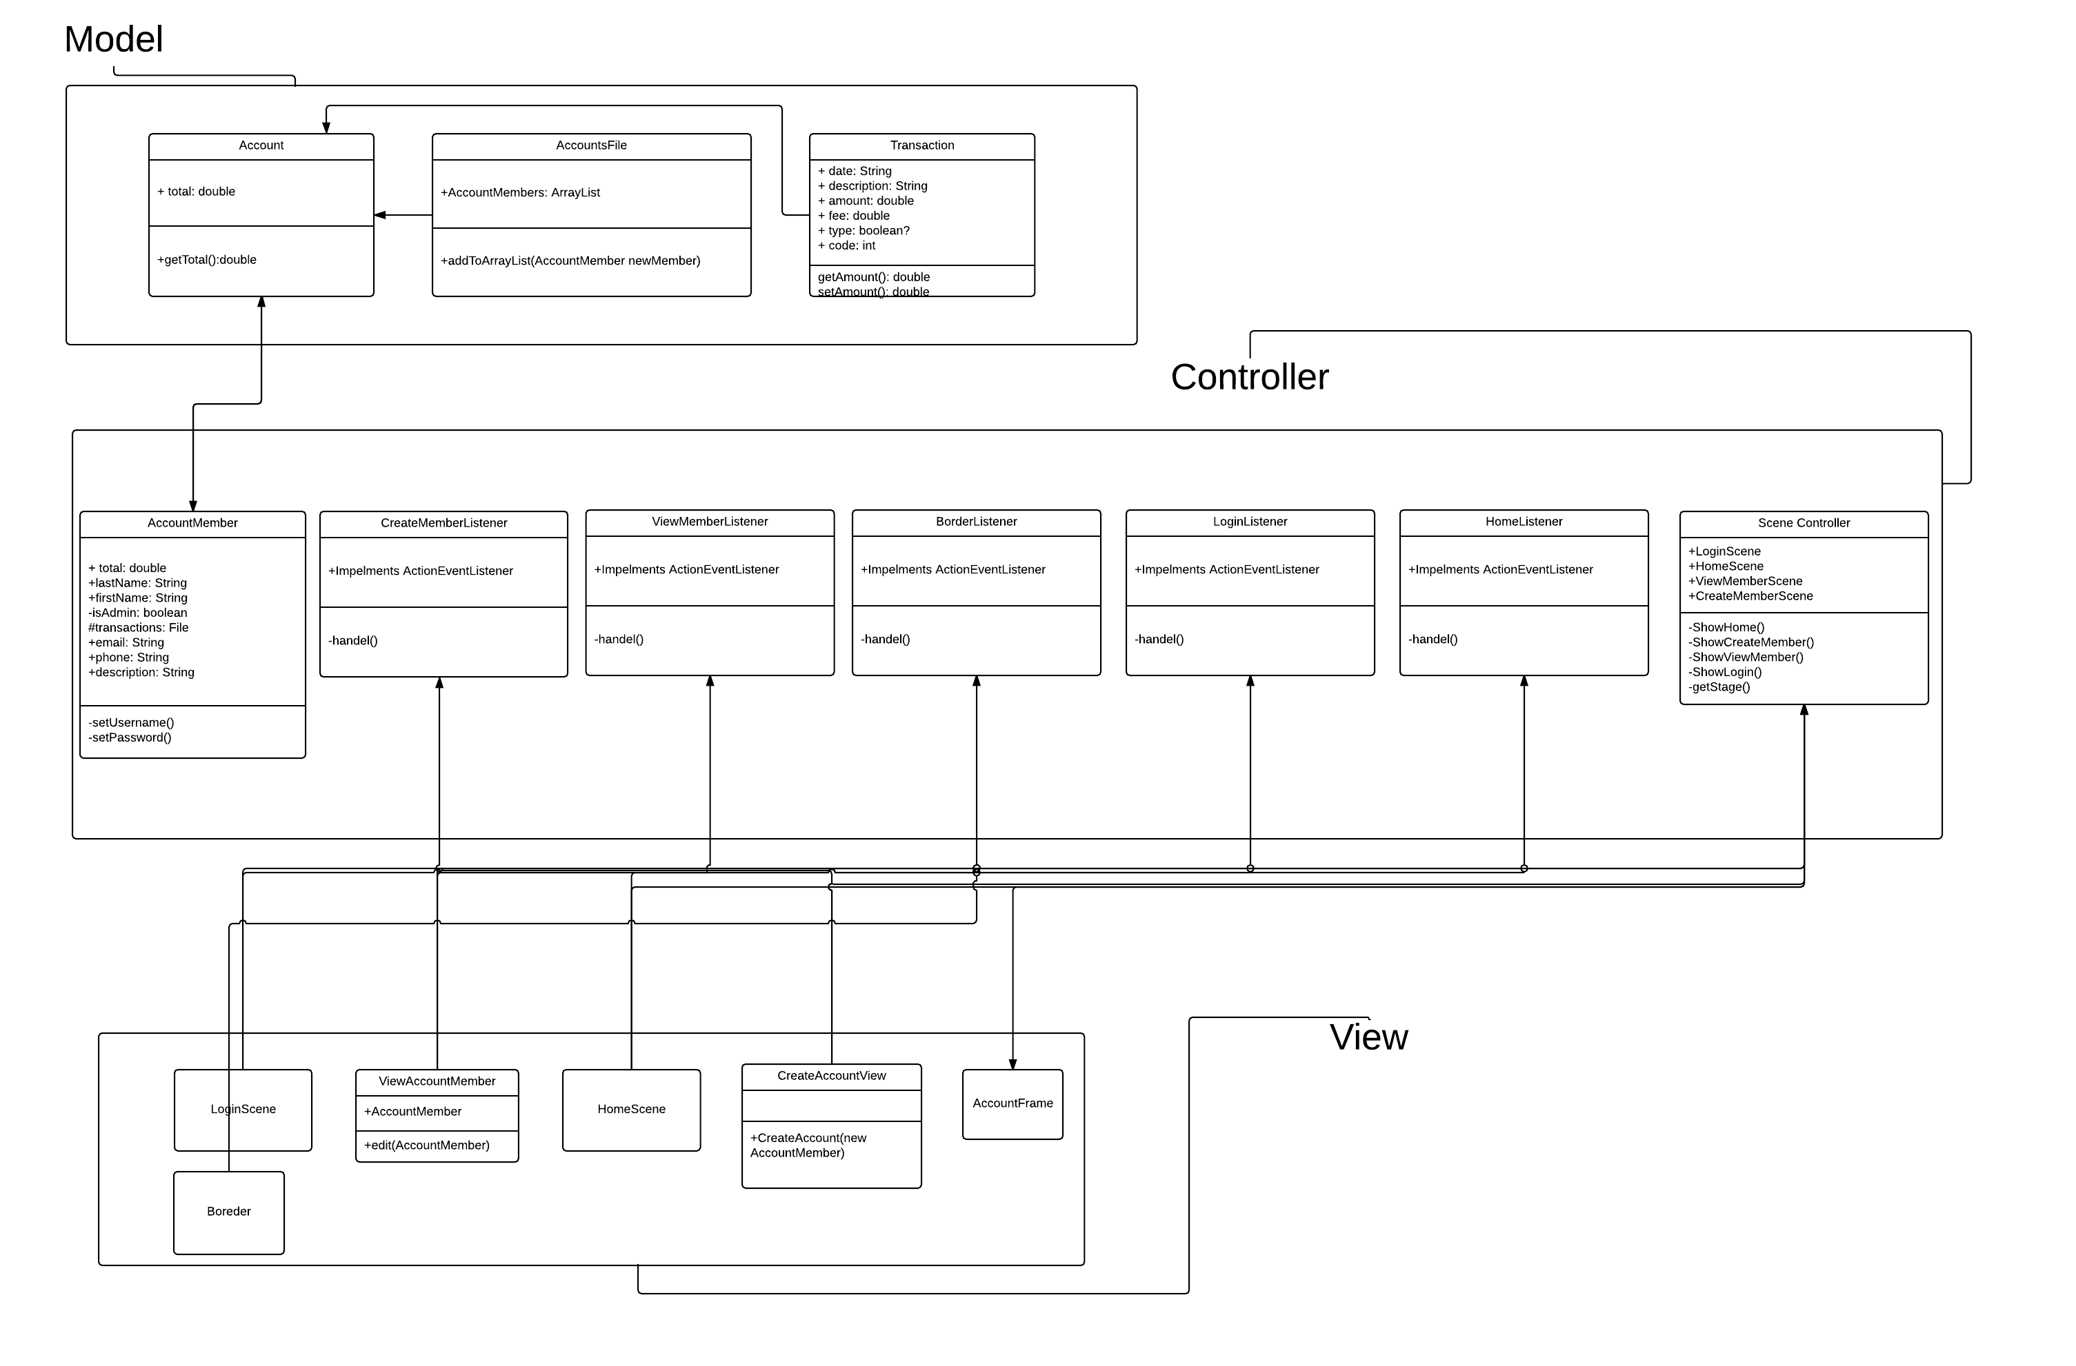

**Database Design**

CompuCount does not utilize a database structure. Instead, CompuCount writes locally to the user’s machine by creating a text file for each member created and holding a text file master list of all account holding members.

**System Security**

Security on this software is password protected. There is no encryption or any other security system in place at this time.

**System Requirements**

* Hardware
  + Hardware requirements are minimal. A typical computer that can run and operating system can handle this program.
* Software
  + Any modern operating system can run this program. MacOS, Windows, or Linux
  + The user will need to install on his or her machine the JDK (Java SE Development Kit), JVM (Java Virtual Machine), and JRE (Java Runtime Environment)

**Project References**

Java FX, JDK, JVM, JRE

**Roles and Responsibilities**

* Josh
  + Scrum Master
  + Transactions, Home Scene
* Seth
  + Programmer
  + Create Member, Home Scene
  + Documentation
* Auston
  + Programmer
  + Accounts, File, Class
  + Something
* Ali
  + Company Name, Company Logo
  + Calculator

**Git Repository**

Location

* <https://github.com/arogers4495/323CompuCount.git>

Name

* 323CompuCount