1、添加Clion启动文件进入环境变量：

sudo vim .bashrc

export PATH=”/opt/Clion/clion-2018.1.3/bin/:$PATH”

2、找到ros工程 先catkin_make 编译后生成工程

3、source 你要打开的工程：

source ～/catkin_ws/devel/setup.bash

4、在终端中输入如下

clion.sh

启动clion，打开工程中含有CMakeList.txt的目录

5、选择相应工程既可编译调试，操作方式与vs差不多

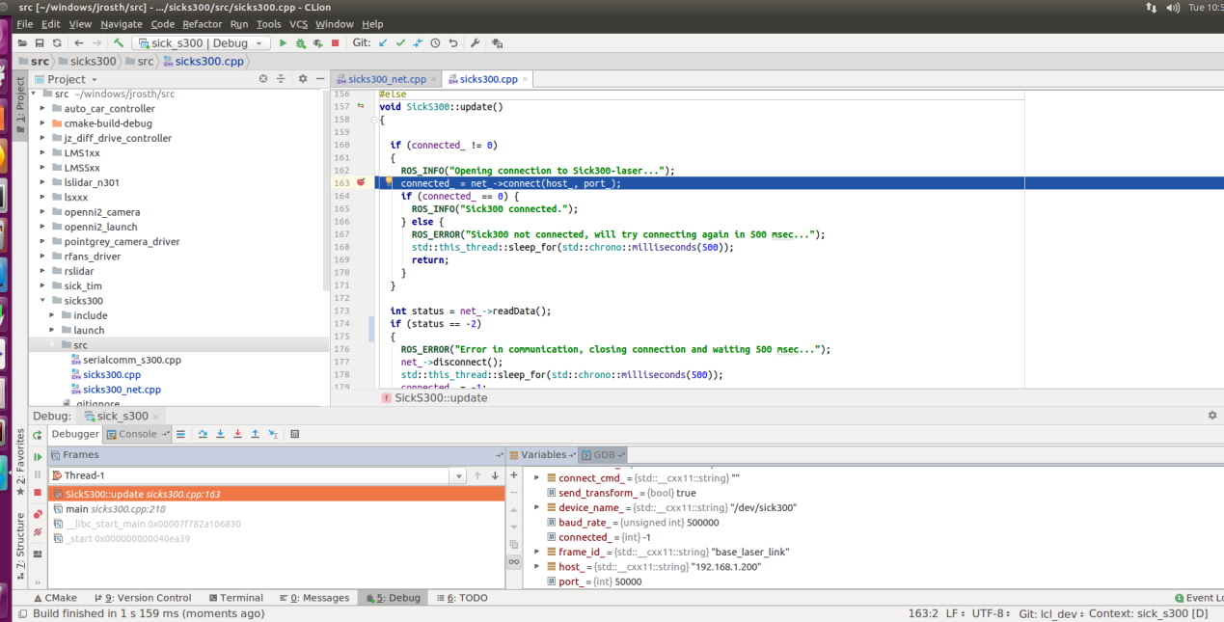

With your console, go into your ROS workspace and source the respective setup.bash file. for instance: source devel/setup.bash

Go to the src directory of your workspace.

Start CLion from the console from your src directory. for instance: type the command in the terminator: clion.sh

Close any open projects in CLion and select Import Project from Sources

Select ONLY the src directory in your workspace for the import.

If CLion complains about CMakeList.txt already existing simply click Open Project

CLion will build symbols for several minutes, then you should be ready to go.