***OS PROJECT REPORT***

**INTRODUCTION**

This report details the development and evaluation of a multi-threaded, graph-based traffic management system. Designed for a simplified road network, the system aims to optimize traffic flow. The following sections present the system's functionalities, visualizations of its performance, and comparisons of key metrics measured during implementation.

**SYSTEM IMPLEMENTATION**

The system is built using C and leverages a graph data structure to represent the road network. This allows for efficient modelling of intersections, roads, and traffic flow. Core functionalities include:

* **Wait Nodes:** These simulate traffic congestion points like intersections. Each wait node has a limited capacity, restricting the number of vehicles it can hold simultaneously.
* **Traffic Nodes:** These represent road segments within the network. Vehicles traverse the network through these nodes.
* **Access Token Allocation:** A mechanism is implemented to control access to wait nodes, preventing gridlock. Vehicles acquire tokens before entering congested areas.
* **Traffic Flow Management:** The system dictates how vehicles move through the network, considering factors like wait node capacity and destination points.
* **Multithreading:** To handle traffic flow simulation efficiently, the system utilizes multithreading. This allows for parallel processing, enhancing performance.
* **Mutex Handling:** Mechanisms like mutexes are employed to ensure synchronized access to shared resources, preventing data corruption during concurrent operations.

The system accepts input through an adjacency matrix, which defines the connections between different road segments in the network. Additionally, it takes parameters like wait node capacities, designated traffic controller nodes (potentially for signal management), initial traffic distribution across the network, and destination nodes for each vehicle.

**SAMPLE INPUT:**

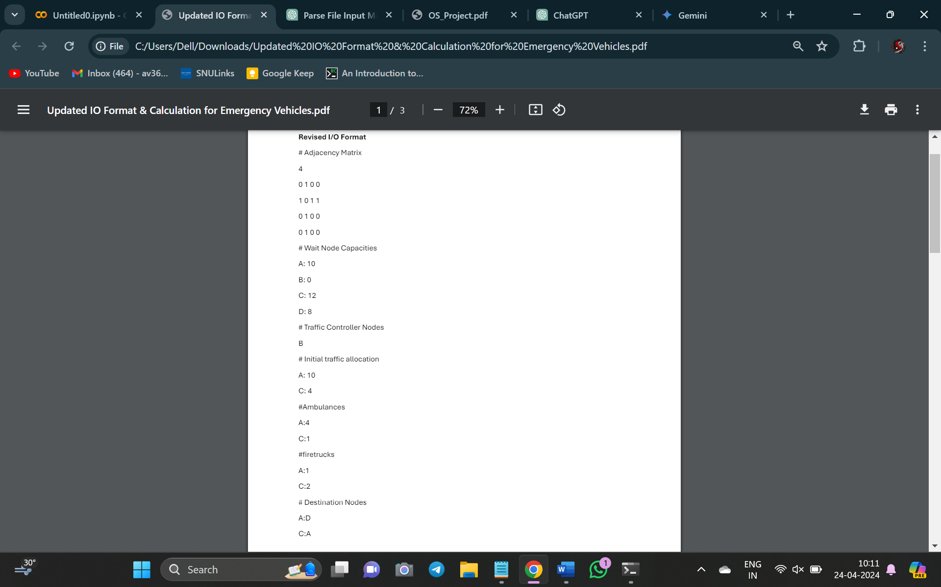

**EVALUATING SYSTEM PERFORMANCE**

To assess the effectiveness of the traffic management system, we analyse various performance metrics:

* **Wait Time:** This measures the average time vehicles spend at each node waiting for access tokens before proceeding. Visualization: A bar chart will compare average wait times across different nodes.
* **Congestion Hotspots:** The system identifies the node with the highest traffic density, indicating the busiest and most congested area. Visualization: A pie chart will depict the distribution of traffic density across all nodes.
* **Travel Efficiency:** We calculate the time taken for the first and last sets of vehicles entering the network from each node to reach their destinations. Visualization: A line chart will track the time it takes vehicles from each node to reach their destinations.
* **Throughput:** This metric represents the average number of vehicles processed per unit of time at each node, indicating how efficiently vehicles move through the network. Visualization: A bar chart will showcase the average throughput for different nodes.
* **Token Utilization:** We measure the average duration for which access tokens are held by vehicles at each node and overall. Visualization: A bar chart will compare token allocation times across different nodes and overall.
* **Congestion Prevalence:** This metric determines the percentage of nodes where the number of vehicles reached maximum capacity, indicating congestion levels within the network. Visualization: A pie chart will display the percentage of nodes experiencing congestion.
* **Traffic Density:** We calculate the average number of vehicles present at each node, providing insights into traffic distribution across the network. Visualization: A bar chart will depict the average traffic density for different nodes.

**GRAPH IMAGES/COMPARISON:**

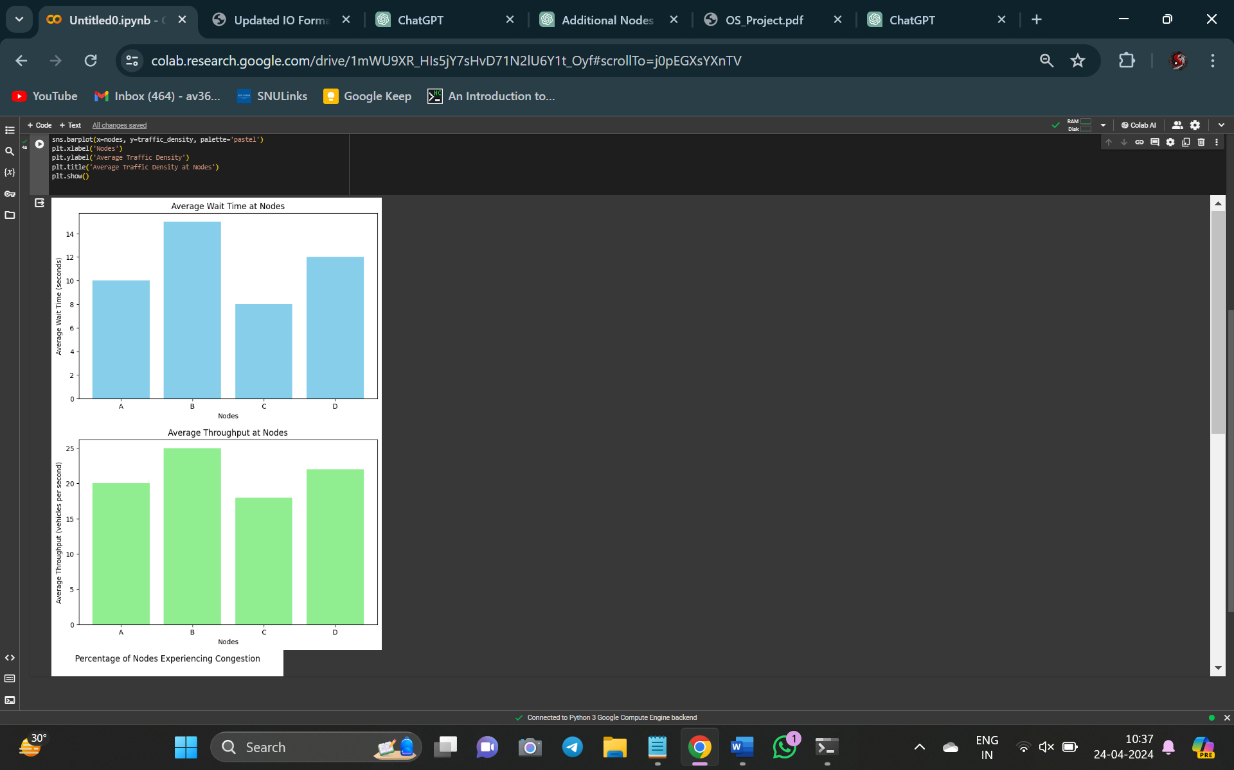

**OUTPUT:**

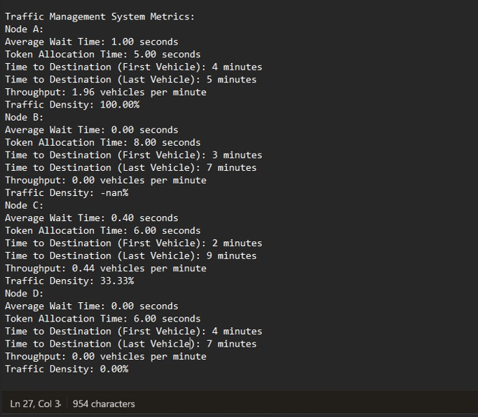

Overall, this program provides a framework for analysing various metrics related to a traffic simulation system.