CS 601.471/671 NLP: Self-supervised Models
Homework 4: Neural Language Modeling + Fixed-Window LMs
For homework deadline and collaboration policy, check the calendar on the course website
Name: Albert Rojas De Jesus
Collaborators, if any: ____________________________________________________
Sources used for your homework, if any: _______________________________________
- Goodfellow, Ian, et al. Deep learning. Vol. 1. No. 2. Cambridge: MIT press, 2016.
- Bishop, Christopher M. Pattern Recognition and Machine Learning. New York :Springer, 2006.
- K. He, X. Zhang, S. Ren and J. Sun, "Deep Residual Learning for Image Recognition," 2016 IEEE Conference on Computer Vision and Pattern Recognition (CVPR), Las Vegas, NV, USA, 2016
This assignment focuses on language modeling, while continuing to build up on our prior knowledge of neural networks. We will review several aspects about training neural nets and also extend it to modeling sequences in language.
Homework goals: After completing this homework, you should be comfortable with:
- thinking more deeply about training neural networks; debugging your neural network
- getting more engaged in using PyTorch for training NNs
- training your first neural LM

Concepts, intuitions and big picture

Multiple-choice questions.
- Select the sentence that best describes the terms “model”, “architecture”, and “weights”.
$▫$ Model and weights are the same; they form a succession of mathematical functions to build an architecture.
$✔️$ An architecture is a succession of mathematical functions to build a model and its weights are those functions parameters.
- During forward propagation, in the forward function for a layer $l$ you need to know what is the activation function in a layer (Sigmoid, tanh, ReLU, etc.). During Backpropagation, the corresponding backward function does not need to know the activation function for layer $l$ since the gradient does not depends on it.
$▫$ True
$✔️$ False
- You have built a network using the tanh activation for all the hidden units. You initialize the weights to relative large values, using randn(..,..)*1000. What will happen?
$▫$ It doesn’t matter. So long as you initialize the weights randomly gradient descent is not affected by whether the weights are large or small.
$▫$ This will cause the inputs of the tanh to also be very large, thus causing gradients to also become large. You therefore have to set the learning rate to be very small to prevent divergence; this will slow down learning.
$▫$ This will cause the inputs of the tanh to also be very large, causing the units to be “highly activated” and thus speed up learning compared to if the weights had to start from small values.
$✔️$ This will cause the inputs of the tanh to also be very large, thus causing gradients to be close to zero. The optimization algorithm will thus become slow.
- What is the “cache" used for in our implementation of forward propagation and backward propagation?
$▫$ It is used to cache the intermediate values of the cost function during training.
$✔️$ We use it to pass variables computed during forward propagation to the corresponding backward propagation step. It contains useful values for backward propagation to compute derivatives.
$▫$ It is used to keep track of the hyperparameters that we are searching over, to speed up computation.
$▫$ We use it to pass variables computed during backward propagation to the corresponding forward propagation step. It contains useful values for forward propagation to compute activations.
- Among the following, which ones are "hyperparameters"? (Check all that apply.) $▫$ size of the hidden layers.
$✔️$ learning rate
$✔️$ number of iterations
$✔️$ number of layers in the neural network
- True/False? Vectorization allows you to compute forward propagation in an $L$-layer neural network without an explicit for-loop (or any other explicit iterative loop) over the layers $l=1,2,…,L$. $▫$ True $✔️$ False
- True or false? A language model usually does not need labels annotated by humans for its pretraining. $✔️$ True $▫$ False
- What is the order of the language modeling pipeline?
$▫$ First, the model, which handles text and returns raw predictions. The tokenizer then makes sense of these predictions and converts them back to text when needed.
$▫$ First, the tokenizer, which handles text and returns IDs. The model handles these IDs and outputs a prediction, which can be some text.
$✔️$ The tokenizer handles text and returns IDs. The model handles these IDs and outputs a prediction. The tokenizer can then be used once again to convert these predictions back to some text.

Short answer questions
- Look at the definition of [Stochastic] Gradient Descent in PyTorch: https://pytorch.org/docs/stable/generated/torch.optim.SGD.html. You will see that this is a bit more complex than what we have seen in the class. Let’s understand a few nuances here.
  - Notice the maximize parameter which controls whether we are running a maximization or minimization. In the algorithm the effect of this parameter is shown as essentially a change in the sign of the gradients:
  - 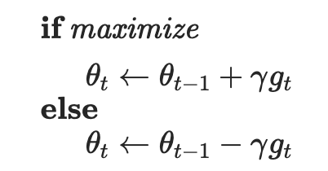
  - How do you think this change leads to the desired outcome (maximization vs minimization)?
The gradient tells us which direction makes the function grow the fastest. In the standard case of gradient descent which is a minimization algorithm, the parameters are updated in the opposite direction of the gradient․ This update rule takes a step in the direction of the loss function's gradient, seeking to reduce its value to minimize it․ On the other hand to maximize the objective function, we take the opposite direction of the gradient․ This is because the gradient points in the direction of the maximum increase of the output of the object function․Therefore for minimization we move in the negative direction while for maximization we move in the positive direction.
  - The next set of parameters momentum, dampening, weight_decay. What do you think the impact of these parameters are? Read the documentations and interpret their roles.
- momentum can help accelerate the learning․ It helps the optimizer build up velocity in directions where the gradient points consistently in the same direction The optimizer remembers part of the previous update, converging faster in valleys and oscillating less in steep dimensions․
- Dampening reduces the effect of momentum by controlling the how current gradient affects the accumulated momentum. This occurs by multiplying by a factor, reducing its effect․
- Weight decay has a similar effect to regularization in that the penalty for large weight values prevents overfitting this occurs by limiting the coefficient values, it prevents overly complex models and encourages low values of the weights improving generalization․
- What are few benefits to using Fixed-Window-LM over $n$-grams language models? (limit your answer to less then 5 sentences).
The scarcity problem is reduced by using neural networks and word embeddings. This works because they share information between similar words. This is especially useful in n-gram models that suffer from the scarcity problem when certain combinations of words are rare and not seem. This also makes it so they don’t require a lot of memory. All these benefits allowed it to generalize better for new or unseen words sequences by not relying on exact matches but rather continuous representations.
- When searching over hyperparameters, a typical recommendation is to do random search rather than a systematic grid search. Why do you think that is the case? (less than 2 sentences).
Even though grid search can be useful to finding parameters it can waste computation by testing combinations that will not impact the results. On the other hand random search can explore diverse options across different spaces because not all hyperparameters affect performance the in same way.
- Remember the normalization layer that we saw during the class. Here is the corresponding PyTorch page: https://pytorch.org/docs/stable/generated/torch.nn.LayerNorm.html. In the normalization formula, why do we use epsilon $ϵ$ in the denominator?
It prevents division by zero on the formula
$$y=\frac{x-E\left[x\right]}{\sqrt{Var\left[x\right]+ϵ}}*γ+β$$
Since we divide by the standard deviation, and sometimes it is possible that the variance will be very close to zero which in turn makes the standard deviation very small. This can cause instability or undefined values therefore as in the formula adding by a small epsilon prevents this from happening.

Softmax Smackdown: Squishing the Competition

Softmax gradient
You might remember in the midterm exam that we saw a neural network with a Softmax and a cross-entropy loss:
$$\hat{\text{y}}=\text{Softmax}\left(\text{h}\right), J=\text{CE}\left(y,\hat{y}\right), \text{h},y,\hat{y}∈R^{d}.$$
Basically here $\hat{y}$ is a $d$-dimensional probability distribution over $d$ possible options (i.e. i​yi=1 and $∀i:y_{i}∈\left[0,1\right]$). $y$ is a $d$-dimensional one-hot vector, i.e., all of these values are zeros except one that corresponds to the correct label.
Here we want to prove the hint that was provided in the exam, which was:
$$∇_{h}J=\hat{y}-y.$$
Prove the above statement. In your proof, use the statement that you proved in HW3 about gradient of Softmax function: $\frac{d{\hat{\text{y}}}_{i}}{d{\text{h}}_{j}}={\hat{\text{y}}}_{i}\left(δ_{ij}-{\hat{\text{y}}}_{j}\right),$ where $δ_{ij}$ is the Kronecker delta function and ${\hat{\text{y}}}_{i}$ is the value in the $i$-th index of $\hat{\text{y}}$.

Softmax temperature
Remember the softmax function, $σ\left(z\right)$? Here we will add a temperature parameter $τ∈R^{+}$ to this function:
$$\text{Softmax: }σ{\left(z;τ\right)}_{i}=\frac{e^{z_{i}/τ}}{\sum_{j=1}^{K}{e^{z_{j}/τ}}} \text{ for }i=1,…,K$$
Show the following:
- In the limit as temperature goes to zero $τ→0$, softmax becomes the same as greedy action selection, argmax.
$$Prove: ∇_{h}J=\hat{y}-y.$$

Given that:
$$y^{hat}=Softmax\left(h\right), J=CE\left(y, y^{hat}\right)$$
Cross entropy is:
$$J= -Σ_{i}y_{i}\log{y_{i}^{hat}}$$
We want to show:
$$\frac{∂J}{∂h_{j}}$$
Using the chain rule:
$$\frac{∂J}{∂h_{j}}=\frac{Σ_{j}∂J}{∂y_{i}^{hat}}×\frac{∂y_{i}^{hat}}{∂h_{j}}$$
$$\frac{∂J}{∂y_{i}^{hat}}= -\frac{y_{i}}{y_{i}^{hat}}$$
$$\frac{∂y_{i}^{hat}}{∂h_{j}}=y_{i}^{hat}\left(δ_{ij}-y_{j}^{hat}\right)$$
$$\frac{∂y_{i}^{hat}}{∂h_{j}}=Σ_{i}\left(-\frac{y_{i}}{y_{i}^{hat}}\right)×y_{i}^{hat}\left(δ_{ij}-y_{i}^{hat}\right)$$
$$\frac{∂y_{i}^{hat}}{∂h_{j}}= -Σ_{i}y_{i}δ_{ij}+Σ_{i}y_{i}y_{j}^{hat}$$
$$\frac{∂y_{i}^{hat}}{∂h_{j}}=-y_{j}+y_{i}^{hat}$$
$$\frac{∂y_{i}^{hat}}{∂h_{j}}={\hat{y}}_{j}-y_{j}$$
Therefore
$$∇_{h}J=\hat{y}-y$$

$$σ{\left(z;τ\right)}_{i}=\frac{e^{\frac{z_{i}}{τ}}}{Σ_{j}e^{\frac{z_{j}}{τ}} }$$
As T goes to 0, the largest $z_{k}$ dominates, and $\frac{z_{k}}{τ}$ becomes very large compare to others. $e^{\frac{z_{k}}{τ}}$becomes much larger than all other exponentials.
For instance, the denominator is dominated by that largest term:
$$σ{\left(z;τ\right)}_{k}=1$$
And all other probabilities
$$σ{\left(z;τ\right)}_{i}=0$$
Therefore, the distribution becomes one hot vector at the index of the largest $z_{i}$
Which translate into $argmaxX_{i}Z_{i}$
Finally, we can conclude that as $τ$ goes to 0, SoftMax becomes a greedy action selection which is argmax.

- In the limit as temperature goes to infinity $τ→+∞$, softmax gives equiprobable selection among all actions.
$$σ{\left(z;τ\right)}_{i}=\frac{e^{\frac{z_{i}}{τ}}}{Σ_{j=1}^{K}e^{\frac{z_{j}}{τ}} }$$
As $τ$ so goes to infinity $τ$ becomes very large, each term $\frac{z_{i}}{τ}$ goes to 0
$$e^{\frac{z_{i}}{τ}}=e^{0}=1$$
This will happen for each $i$in the sequence, the numerator becomes 1, and the denominator becomes:
$$Σ_{j=1}^{K}1=K$$
Therefore, for all $i$ SoftMax becomes:
$$σ{\left(z;τ\right)}_{i}=\frac{1}{K}$$
Finally, we can conclude that as $τ$ goes to infinitive, softmax gives equal probability to all actions.

Backprop Through Residual Connections
As you know, When neural networks become very deep (i.e. have many layers), they become difficult to train due to the vanishing gradient problem – as the gradient is back-propagated through many layers, repeated multiplication can make the gradient extremely small, so that performance plateaus or even degrades. An effective approach is to add skip connections that skip one or more layers. See the provided network.
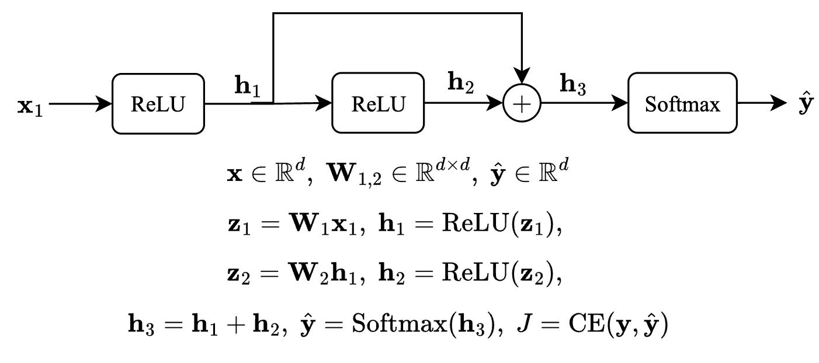
- You have seen this in the quiz, but lets try again. Prove that: $\frac{∂}{∂{\text{z}}_{i}}\text{ReLU}\left(\text{z}\right)=1\{{\text{z}}_{i}>0\}$ where $1\{x>0\}=\left\{\begin{matrix}1 & \text{if} x>0 \\ 0 & \text{if} x≤0 \\ & \end{matrix}\right.$. More generally, $∇_{\text{z}}\text{ReLU}\left(\text{z}\right)=\text{diag}\left(1\{\text{z}>0\}\right)$ where $1\{.\}$ is applied per each dimension and $\text{diag}\left(.\right)$ turns a vector into a diagonal matrix.
As we know ReLU is:
$$ReLU\left(z_{i}\right)=\max\left(0, z_{i}\right)$$
For each i:
$$ReLU\left(z_{i}\right)=\left\{\begin{aligned}z_{i}, &if z_{i}>0 \\ 0, &if z_{i}≤0\end{aligned}\right.$$
Taking the derivative with respect to $z_{i}$:
$$\frac{∂}{∂z_{i}}=ReLU\left(z_{i}\right)=0$$
$$\frac{∂}{∂_{z_{i}}}ReLU\left(z\right)=1 \{z_{i}>0\}$$
This is specifically where $1 \{z_{i}>0\}$ equals 1 if $z_{i}>0$ else is 0.
On the other hand, we also have a vector case where ReLU is applied to each $i$ of $z∈R^{d}$. Since each output dimension is dependent only on the corresponding input dimension, so the Jacobian matrix will be
- 1 on the diagonal when $z_{i}>0,$another case is 0 on the diagonal when $z_{i}≤0,$ and finally 0 everywhere else since there is no cross dependence.
Therefore
$$∇_{z}ReLU\left(z\right)=diag\left(1\left\{z>0\right\}\right)$$
where the indicator function is applied at each $i$ and diag(.) forms a diagonal matrix from the vector.

- As you see, a single variable ($h_{2}$ in the example) feeds into two different layers of the network. Here we want to show that the two upstream signals stemming from this node are merged as summation during Backprop. Specifically prove that:
$$\frac{∂h_{3}}{∂h_{1}}=\text{I}+\frac{∂h_{2}}{∂z_{2}}\frac{∂z_{2}}{∂h_{1}}$$
From the given:
$$h_{3}=h_{1}+h_{2}$$
$$h_{2}=ReLU\left(z_{2}\right), z_{2}=W_{2}h_{1}$$
So we differentiate $h_{3}$ with respect to $h_{1}$
$$h_{3}=h_{1}+h_{2}$$
$$\frac{∂h_{3}}{∂h_{1}}=\frac{∂h_{1}}{∂h_{1}}+\frac{∂h_{2}}{∂h_{1}}$$
$$\frac{∂h_{1}}{∂h_{1}}=I since each component of h_{1} depends on itself.$$
Chain rule to the second term we get:
$$h_{2}=ReLU\left(z_{2}\right)$$
$$z_{2}=W_{2}h_{1}$$
$$\frac{∂h_{2}}{∂h_{1}}=\frac{∂h_{2}}{∂z_{2}}×\frac{∂z_{2}}{∂h_{1}}$$
We substitute and Finally
$$\frac{∂h_{3}}{∂h_{1}}=I+\frac{∂h_{2}}{∂z_{2}}×\frac{∂z_{2}}{∂h_{1}}$$

- In the given neural network your task is to compute the gradient $\frac{∂J}{∂x}.$ You are allowed (and highly encouraged) to use variables to represent intermediate gradients.
- Hint 1: Compute these gradients in order to build up your answer: $\frac{∂J}{∂{\text{h}}_{3}}$, $\frac{∂J}{∂{\text{h}}_{2}}$, $\frac{∂J}{∂{\text{z}}_{2}}$, $\frac{∂J}{∂{\text{h}}_{1}}$, $\frac{∂J}{∂{\text{z}}_{1}}$, $\frac{∂J}{∂\text{x}}$. Show your work so we are able to give partial credit!
- Hint 2: Recall that downstream = upstream * local.
As given the network is:
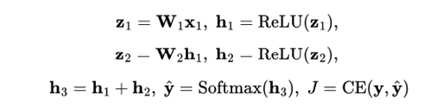
For $\frac{∂_{J}}{∂h_{3}}$ here we are in the softmax + cross entropy
$$\frac{∂_{J}}{∂h_{3}} =\hat{y}-y$$
$$δ_{3}= \hat{y}-y$$
For $\frac{∂J}{∂h_{2}}$here after $h_{3}=h_{1}+h_{2}$
$$\frac{∂_{J}}{∂h_{3}}=I$$
$$\frac{∂_{J}}{∂h_{2}}=δ_{3}$$
For $\frac{∂_{J}}{∂z_{2}}$ here since $h_{2}=ReLU(z_{2})$
$$\frac{∂_{h_{2}}}{∂z_{2}}=diag(1\{z_{2}>0\})$$
$$\frac{∂J}{∂z_{2}}=δ_{3}⊙1\{z_{2}>0\}$$
$$δ_{2}=\frac{∂J}{∂z_{2}}$$
From here we have two path as in the image above. The direct path from the skip connection and the path through $z_{2}$
Skipping we get
$$\frac{∂J^{skipping}}{∂h_{1}}=δ_{3}$$
Second layer
$$\frac{∂J^{l2}}{∂h_{1}}=W_{2}^{T}δ_{2}$$
$$\frac{∂J}{∂h_{1}}=δ_{3}+W_{2}^{T}δ_{2}$$
$$δ_{1}=δ_{3}+W_{2}^{T}δ_{2}$$
$\frac{∂J}{∂z_{1}} here where h_{1}=ReLU\left(z_{1}\right)$
$$\frac{∂J}{∂z_{1}}=δ_{1} ⊙1\left\{z_{1}>0\right\}$$
$\frac{∂J}{∂x}$ here where $z_{1}=W_{1}x$
$$\frac{∂J}{∂x}=W_{1}^{T}\left(δ_{1}⊙1\left\{z_{1}>0\right\}\right)$$
Therefore where $δ_{2}and δ_{3}$ are the expressions highlighted above.
$$\frac{∂J}{∂x}=W_{1}^{T}\left(\left(δ_{3}+W_{2}^{T}×δ_{2}\right)⊙1\left\{z_{1}>0\right\}\right)$$

- Based on your derivations, explain why residual connections help mitigate vanishing gradients.
The skip nature of the residual connections help mitigate vanishing gradients by creating a path where the gradients can flow back via an express line back via back propagation without being stop and multiplied by the weight of the specific stops matrices and non-linearities from the derivation we saw that
$$\frac{∂J}{∂h_{1}}=δ_{3}+W_{2}^{T}δ_{2}$$
This term $δ_{3}$ is the term coming from the skip connection which preserves the original gradients in deeper layers so terms like $W_{2}^{T}δ_{2}$ will become very small due to multiplication by weights and ReLU derivatives. This makes it less likely that gradients will disappear.

Programming
In this programming homework, we will
- implement your own subword tokenizer.
- implement fixed-window MLP language models

Skeleton Code and Structure:
The code base for this homework can be found at this GitHub repo under the hw3 directory. Your task is to fill in the missing parts in the skeleton code, following the requirements, guidance, and tips provided in this pdf and the comments in the corresponding .py files. The code base has the following structure:
- tokenization.py implements the Byte-Pair Encoding algorithm for subword tokenization.
- mlp_lm.py implements a fixed-window MLP-based language model on a subset of Wikipedia.
- main.py provides the entry point to run your implementations in both tokenizatiton.py and mlp_lm.py.
- hw4.md provides instructions on how to setup the environment and run each part of the homework in main.py
TODOs — Your tasks include 1) generate plots and/or write short answers based on the results of running the code; 2) fill in the blanks in the skeleton to complete the code. We will explicitly mark these plotting, written answer, and filling-in-the-blank tasks as TODOs in the following descriptions, as well as a # TODO at the corresponding blank in the code.

Submission:
Your submission should contain two parts: 1) plots and short answers under the corresponding questions below; and 2) your completion of the skeleton code base, in a .zip file

Tokenization Algorithms
All NLP systems have at least three main components that help machines understand natural language:
- Tokenization
- Embedding
- Model architectures
Models like BERT, GPT-2 or GPT-3 all share the same components but with different architectures that distinguish one model from another. We are going to focus on the first component of an NLP pipeline which is tokenization. An often overlooked concept but it is a field of research in itself. Though we have SOTA algorithms for tokenization it’s always a good practice to understand the evolution trail.
Here’s what we’ll cover:
- What is tokenization?
- Why do we need a tokenizer?
- Types of tokenization - Word, Character and Subword.
- Byte Pair Encoding Algorithm
- Other tokenization algorithms:
  - Unigram Algorithm
  - WordPiece - BERT transformer
  - SentencePiece - End-to-End tokenizer system

What is Tokenization?
Tokenization is the process of representing raw text in smaller units called tokens. These tokens can then be mapped with numbers to further feed to an NLP model.
Read and run the full_word_tokenization_demo in tokenization.py for an overly simplified example of what a tokenizer does.
This is a very simple example where we just split a text string in to “whole words” on white spaces, and we have not considered grammar, punctuation, or compound words (like “test”, “test-ify”, “test-ing”, etc.).

Problems with word tokenization:

- Missing words in the training data: With word tokens, your model won’t recognize the variants of words that were not part of the data on which the model was trained. So, if your model has seen ‘foot‘ and ‘ball‘ in the training data but the final text has “football”, the model won’t be able to recognize the word and it will be treated with a “<UNK>” token. Similarly, punctuations pose another problem, “let” or “let’s” will need individual tokens and it is an inefficient solution. This will require a huge vocabulary to make sure you’ve every variant of the word. Even if you add a lemmatizer to solve this problem, you’re adding an extra step in your processing pipeline.
- Not all languages use space for separating words: For a language like Chinese, which doesn’t use spaces for word separation, this tokenizer will fail.

Character-based tokenization
To resolve the problems associated with word-based tokenization, an alternative approach of character-by-character tokenization was tried. This solves the problem of missing words as now we are dealing with characters that can be encoded using ASCII or Unicode and it could generate embedding for any word now.
Every character, be it space, apostrophes, or colons, can now be assigned a symbol to generate a sequence of vectors. But this approach had its cons. Character-based models will treat each character and will lead to longer sequences. For a 5-word long sentence, you may need to process 30 tokens instead of 5 word-tokens.

Subword Tokenizaiton
To address the earlier issues, we could think of breaking down the words based on a set of prefixes and suffixes. For example, we can build a system that can identify subwords like “##s”, “##ing”, “##ify”, “un##” etc., where the position of double hash “##” denotes prefix and suffixes. So, a word like “unhappily” is tokenized using subwords like “un##”, “happ”, and “##ily”.
BPE (Byte-Pair Encoding) was originally a data compression algorithm that is used to find the best way to represent data by identifying the common byte pairs. It is now used in NLP to find the best representation of text using the least number of tokens.
Here’s how it works:
- Add a “</w>” at the end of each word to identify the end of a word and then calculate the word frequency in the text.
- Split the word into characters and then calculate the character frequency.
- For a predefined number of iterations (set by you), count the frequency of the consecutive tokens and merge the most frequently occurring pairings.
- Keep iterating until you have reached the iteration limit or if you have reached the token limit.
We will now go through this algorithm step by step.
Read the get_word_freq function in tokenization.py that implements the step 1 above to preprocess each word and count its frequency.
TODOs: Read and complete the missing lines in the get_pairs function in tokenization.py to implement the step 2 above. This function takes the word frequency record returned from get_word_freq as input, split the words into tokens (characters at this initial step), and counts token-pairs frequency.
Hint: follow the comments in the code for specific requirements.
Read the get_most_frequent_pair and merge_byte_pairs functions in tokenization.py that implements the step 3 above, merge the top-1 frequent token-pairs in all the words.
In practise, after iterating over the input text for a desired number of times, we extract the resulting tokenization as our subword dictionary. For this purpose, we provide get_subword_tokens function in tokenization.py
With all these functions, we can now run one step of the BPE algorithm!
Read and run the test_one_step_bpe.py in main.py to test the BPE algorithm for one step. A correct implementation of get_pairs should pass all the tests.

Complete the BPE Algorithm
With the above implementations, we can complete all the steps of the BPE algorithm that iterates over the input corpus.
TODOs: Read and complete the missing lines in the exract_bpe_subwords function in tokenization.py that implements the full BPE algorithm. Once you finished, run the test_bpe function in main.py, a correct implementation of exract_bpe_subwords should pass all the tests.
Hint: follow the comments in the code and you can reuse the helper functions provided/you implemented above.
So as we iterate with each best pair, we merge (concatenating) the pair and you can see as we recalculate the frequency, the original character token frequency is reduced and the new paired token frequency pops up in the token dictionary.

Running BPE on a subset of Wikipedia
Now, let’s run this algorithm on a larger scale. In particular, we will run on many Wikipedia paragraphs. As usual, let’s use the Huggingface library to download the data (the load_bpe_data function).
TODOs: Read and run the bpe_on_wikitext in main.py that iterates the BPE algorithm on a subset of Wikipedia, and interprets the final subwords extracted from the Wikipedia documents. In particular, identify examples of subwords that correspond to
- complete words
- part of a word
- non-English words(including other languages or common sequence special characters)
Explain why these subwords have come about. (no more than 10 sentences)
After reviewing the Final sub word token I have observe a number of full words, prefixes, and suffixes and other words that might not be of English origin.
Complete Words:
On the full words we can see words like Character, American, given, Morrison, fail, December … etc. We can conclude this appears frequently in the test which is why they appear as full tokens. This means that bpe processes the characters and continuously merge these characters into words because of the frequency in which they appear in the text.
Part of a word
On the other hand, prefixes and suffixes like, ex, ult, ble, jects, tation, reduc, are parts of words as mentioned before this are common prefixes and suffixes that appear often in the English language in different part of a words whether it is at the beginning or at the end. This make this character’s sequences appear frequently across the Wikipedia excerpt.
Non-English-words.
Characters and words like ჸ, ã, 機, 隊, ā, ó, Б, ჺ, й, ჲ, Bolívar</w>, Márquez</w>, FRELIMO</w>. here we can identify some non-English characters and words for example Bolívar</w> with a punctuation in the í. We can also see 機 which a Chinese character for Han and can mean machine, device, mechanism, etc. as well as 隊 which can mean team, squad or troop other characters mentioned above are Latvian, Māori, Cyrillic, Latin, and Georgian letters. We can assume that this appear because Wikipedia is a multilingual platform and some proper names keep their original form when mentioned in the English language. So, BPE learns different character combinations for those languages as well.

Additonal Readings: Other Tokenization Algorithms

WordPiece
WordPiece is the subword tokenization algorithm used for BERT, DistilBERT, and Electra. The algorithm was outlined in and is very similar to BPE. WordPiece first initializes the vocabulary to include every character present in the training data and progressively learns a given number of merge rules. In contrast to BPE, WordPiece does not choose the most frequent symbol pair, but the one that maximizes the likelihood of the training data once added to the vocabulary.
So what does this mean exactly? Referring to the previous example, maximizing the likelihood of the training data is equivalent to finding the symbol pair, whose probability is divided by the probabilities of its first symbol followed by its second symbol is the greatest among all symbol pairs. E.g. “u”, followed by “g” would have only been merged if the probability of “ug” divided by “u”, “g” would have been greater than for any other symbol pair. Intuitively, WordPiece is slightly different from BPE in that it evaluates what it loses by merging two symbols to ensure it’s worth it.

Unigram
Unigram is a subword tokenization algorithm introduced in . In contrast to BPE or WordPiece, Unigram initializes its base vocabulary to a large number of symbols and progressively trims down each symbol to obtain a smaller vocabulary. The base vocabulary could for instance correspond to all pre-tokenized words and the most common substrings. Unigram is not used directly for any of the models in the transformers, but it’s used in conjunction with SentencePiece([paragraph:sentetncepiece]).
At each training step, the Unigram algorithm defines a loss (often defined as the log-likelihood) over the training data given the current vocabulary and a unigram language model. Then, for each symbol in the vocabulary, the algorithm computes how much the overall loss would increase if the symbol was to be removed from the vocabulary. Unigram then removes p (with p usually being 10% or 20%) percent of the symbols whose loss increase is the lowest, i.e. those symbols that least affect the overall loss over the training data. This process is repeated until the vocabulary has reached the desired size. The Unigram algorithm always keeps the base characters so that any word can be tokenized.
Because Unigram is not based on merge rules (in contrast to BPE and WordPiece), the algorithm has several ways of tokenizing new text after training. As an example, if a trained Unigram tokenizer exhibits the vocabulary:
[“b”, “g”, “h”, “n”, “p”, “s”, “u”, “ug”, “un”, “hug”],
“hugs” could be tokenized both as [“hug”, “s”], [“h”, “ug”, “s”] or [“h”, “u”, “g”, “s”]. So which one to choose? Unigram saves the probability of each token in the training corpus on top of saving the vocabulary so that the probability of each possible tokenization can be computed after training. The algorithm simply picks the most likely tokenization in practice but also offers the possibility to sample a possible tokenization according to their probabilities.
Those probabilities are defined by the loss the tokenizer is trained on. Assuming that the training data consists of the words $x_{1},…,x_{N}$ and that the set of all possible tokenizations for a word $x_{i}$ is defined as $S\left(x_{i}\right)$, then the overall loss is defined as
L=-i=1Nlogx∈Sxi​px

SentencePiece
All tokenization algorithms described so far have the same problem: It is assumed that the input text uses spaces to separate words. However, not all languages use spaces to separate words. One possible solution is to use language-specific pre-tokenizers, e.g. XLM uses a specific Chinese, Japanese, and Thai pre-tokenizer). To solve this problem more generally, treats the input as a raw input stream, thus including the space in the set of characters to use. It then uses the BPE or unigram algorithm to construct the appropriate vocabulary.
The XLNetTokenizer uses SentencePiece for example, which is also why in the example earlier the “” character was included in the vocabulary. Decoding with SentencePiece is very easy since all tokens can just be concatenated and “” is replaced by a space.
All transformer models in the library that use SentencePiece use it in combination with unigram. Examples of models using SentencePiece are ALBERT XLNet,Marian, and T5.

Fixed-Window MLP Language Models
In the second part of the homework, we will build, train, and evaluate fixed-window MLP language models as we learned in class: given the context words in the fixed-size window on the left hand side, predict the next word continuation.
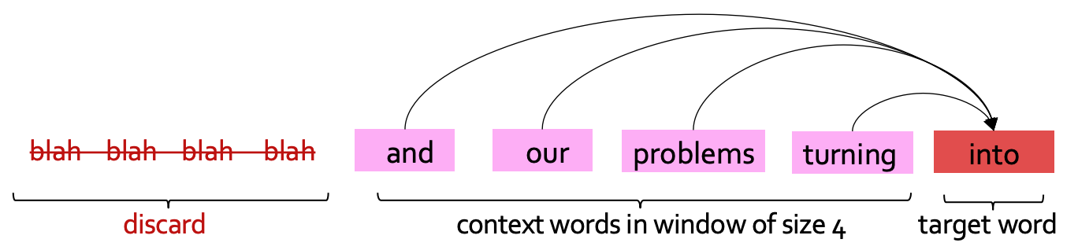
Fixed-window LM

Data Loading and Preprocessing
We will be using the same WikiText dataset we used for building n-gram LM in homework 2. We follow similar preprocessing steps to split paragraphs into sentences followed by tokenization (Now we have learned more about subword tokenization in class and the previous question!).
TODOs read the preprocess_data function in ngram_lm.py and complete the missing lines to prepare input-output pairs for training fixed-window LMs.
Hint: follow the requirements in the code comments.

Build our LM
Let’s now turn to building our model. Here, we are following the footsteps of the neural probabilistic language model (NPLM) , which is extending earlier studies such as .
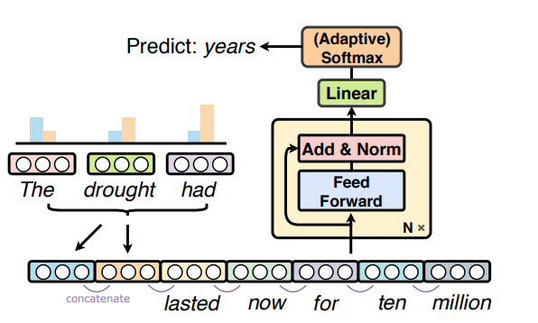
NPLM Architecture
We will follow a modular design for our implementation to make it more interpretable. In particular, will implement 3 layers:
- The input layer which loops up word embeddings, concatenates them, and transforms them into a hidden representation.
- The middle layer transforms the representation with a non-linearity.
- The output layer which transforms a hidden vector to a probability distribution over the words
Let’s get to work!
TODOs: read and complete the forward functions for the following classes
- NPLM_first_block: input layer that embeds the input token ids into embedding vectors, concatenates the embeddings, applies linear transformation, layer normalization, and dropout
- NPLM_block: middle layers with linear transformation, tanh activation, residual connection, layer normalization, and dropout.
- NPLM_final_block: output layer that transforms hidden representation to log probability over the vocabulary with log softmax.
Hint: check out nn.LayerNorm and nn.Dropout, torch.tanh and nn.functional.log_softmax for more details on these layers and operations. For embedding concatenation, you may find torch.Tensor.view useful. Also, follow the step-by-step comments in the code for the requirements of the implementation.
TODOs: read and complete the __init__ and forward functions for the NPLM class, which is the final model that stacks all the above layers.
Hint: remember to apply ReLU non-linear activation after each middle layer, details at nn.functional.relu.

Train and Evaluate the LM
Now it’s time to train and evaluate it! Like the previous homework, we will use cross-entropy loss between the predictions of our language model and actual words that appeared in our training data. Note that we applied log softmax to the final output of the LM, as described in homework to, we will use negative log-likelihood loss as the training criterion to calculate the cross-entropy loss.
As introduced in the class, we will use Perplexity to evaluate our LM, as a measure of predictive quality of a language model.
TODOs Read and complete the missing lines in train and evaluate functions in mlp_lm.py to calculate the perplexity.
Hint: remember in the class we discussed the connection between perplexity and cross-entropy loss, and note that in our implementation we took natural logarithm instead of the base of 2.
Note we are using Adam (Adaptive Moment Estimation) , which is a popular optimization algorithm used in deep learning and machine learning. It is a stochastic gradient descent (SGD) optimization algorithm that is well suited for training deep neural networks. The algorithm has some internal estimates to dynamically adjust the learning rates for each parameter based on its past gradients, which can result in faster convergence and improved performance compared to traditional SGD.
TODOs Once you finished all the implementations, run load_data_mlp_lm and single_run_mlp_lm in main.py to train and evaluate the model and paste the plots of loss and Perplexity here.
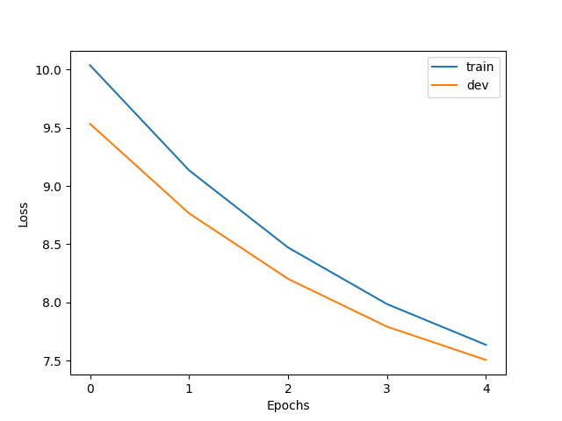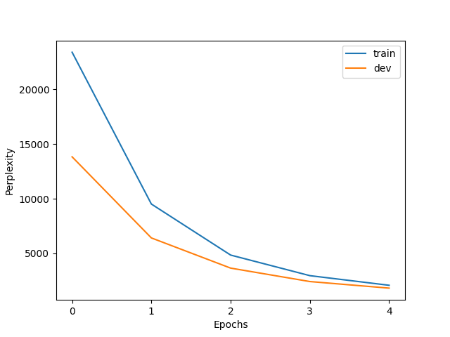

Sample From a Pre-trained LM
Note that compared with the original NPLM implementation, we reduce the model size by shrinking both the width and depth of our model, and we only use a small subset of the data. It is expected to take an hour or so to train the model on the CPU of your PC. Training the above LM with full size model and data might take hours to days. To save you time, we have trained a language model for you to play with. All you have to do is to download its weight parameters. Download the pre-trained weights and copy it to your local directory under /hw4/.
Now that we have the model weight downloaded, we can instantiate a model with these parameters. This will work in two steps.
- First we will need to create a new model (with potentially random weights).
- Then, we will copy the parameter values to the model using load_state_dict function.
We then evaluate the loaded model on the dev set. Now that we have loaded a pre-trained LM, how can we sample from it? We will implement two strategies, greedy decoding and top-p sampling that we briefly discussed in homework 2.
For greedy, we select the most probable words (argmax).
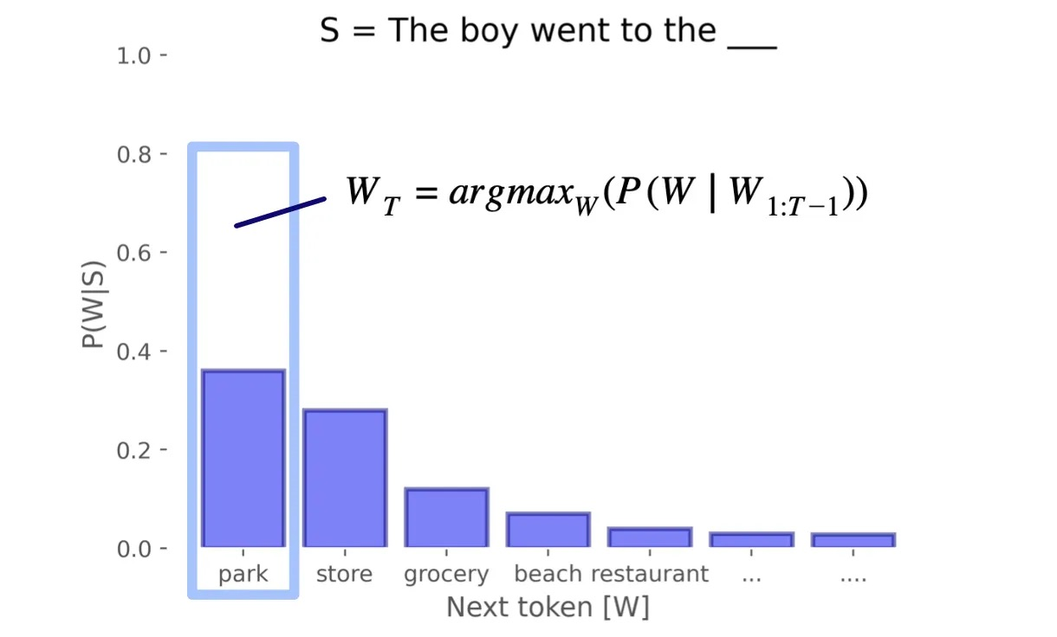
Greedy Decoding
For top-p, we sample from the distribution proportional to word probabilities. Words with higher probabilities will be more likely to be sampled. However, we also have an option of filtering the low-probability tokens, and instead retaining tokens that constitute top_p probability.

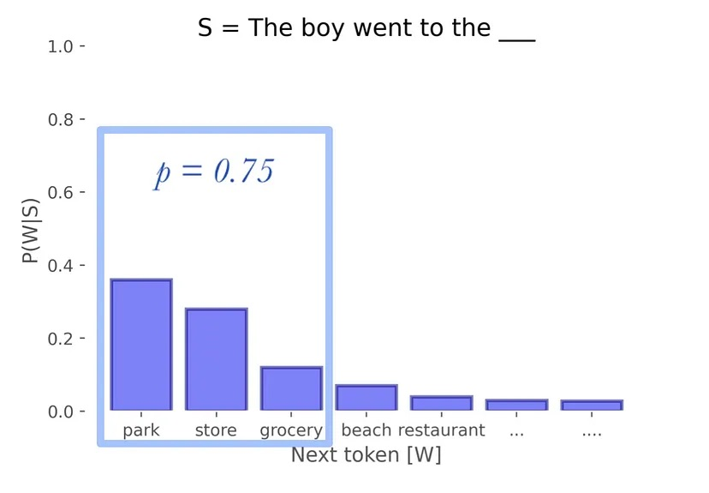
Greedy Decoding
Read generate_text and sample_from_mlp_lm in mlp_lm.py for more details about how to load the pre-trained model, evaluate on dev set and perform greedy/top-p sampling. You can learn more about top-p sampling implementation at TopPLogitsWarper.
TODOs Run the sample_from_trained_mlp_lm in main.py to sample from the pre-trained LM, paste the completion to the prefix under different sampling strategies here, and describe in 2-3 sentences your findings.
---------- Evaluate on the Dev Set ----------
100%|█████████████████████████████████████████████████████████████████████████████████████████████████████████████████████████████████████████████████████████████████████████| 3760/3760 [00:03<00:00, 1142.61it/s]
47it [00:49, 1.06s/it]
Dev Perplexity: 250.6714194800754; Dev Loss: 5.524142995793769
---------- Sample From the Model ----------
{'-' * 10} greedy {'-' * 10}
Generated text: The best perks of living on the east side of the city. ". "... ".... ". "... ".... ". "
---------- sampling with p=0.0 ----------
Generated text: The best perks of living on the east side of the city. ". "... ".... ". "... ".... ". "
---------- sampling with p=0.3 ----------
Generated text: The best perks of living on the east of the U. S. government had a year. ". ", the episode ' s very much of the most common age. "..

---------- sampling with p=1.0 ----------
Generated text: The best perks of living on the east slopes of Mexico and lip Germany was once over the 20th century but none of Rose concluded children, adopted with the frame of the magnificent Age by trees.
Findings:
Greedy decoding p=0.0 generates the tokens that are the most probable following the previous work. This can be harmful because it can become repetitive and have not that much diversity in the text. On the other hand, Top p sampling with a value of 0.3 balances the coherence and it much more diversifies by restricting what’s been chosen next to a high probability of tokens, this choice produces a more natural variation even though the sentence is not saying anything it sounds a bit more like a human sentence rather than just words been attached because one more makes more sense next to the other. Finally with P=1.0 the model samples from full distribution, this can lead to better and more creative but occasionally less consistent outputs. This makes us think what should be the best options stability or diversity for language? If I had to make a choice, I will choose p=0.3 since its more diverse and makes sense in its own way.
Hint: compare the output of the above generations, which one is your favorite? Explain why this choice of sampling leads to better text generation.

Optional Feedback
Have feedback for this assignment? Found something confusing? We’d love to hear from you!

https://self-supervised.cs.jhu.edu/sp2024/

