**UNIVERSITY OF DAR ES SALAAM**

**COLLEGE OF INFORMATION AND COMMUNICATION TECHNOLOGY**

**DEPARTMENT OF COMPUTER SCIENCE AND ENGINEERING**



**PROJECT REPORT IS 335**

**PROJECT TITLE: PAROKIA INFORMATION MANAGEMENT SYSTEM**

**Name of Candidate: RWEHUMBIZA ARON**

**Registration Number: 2018-04-01662**

**Name of Supervisor: DR. MASOUD MAHUNDI**

**Supervisor Signature: ……...…………**

**Submission Date: ……………………**

# **INTRODUCTION**

## **1.1 General Introduction**

Catholic church in Tanzania is among the religious institution that provides spiritual and social services. It has been divided into administrative areas like Archdiocese, diocese, parish (Parokia), and sub-parish.

In this project focuses on Parish in Archdiocese of Dar es salaam. The parokia has parish priest(Paroko) who has all administrative power and in charge of all activities at parokia. together with him, there is believers’ leadership which form a committee to supervise all necessary and projects at the Parokia.

The believers pay different contributions in accordance to the church rules and regulations. So most of the revenue raised at Parokia comes from believers some few coming from donors.

Currently, all the information related to believers are kept in files and some in spreadsheets, Announcements are posted on notice board at the church or being announced during mass sessions. Contributions are directed payed to leaders by cash or via mobile money or via Parish bank account, financial reports are prepared manually in spread sheets.

This project intends to create a system that will provide some improvement and some of this will be: A database to store information, accounting module to manage financial data and auto generated financial reports, a way to notify and send notification and announcement via emails and SMS, online payment.

## **1.2 Statement of the Problem**

Believers are important for the development of the parish(parokia). Large number of people who are active believer makes easy for the parokia to fulfill the plans and run parokia smoothly. But unfortunately, the parokia has no good way of storing information of believers which make it difficult to know exact number of its active believers.

Management of collections and expenses at the parokia is also the issue that challenge the parokia.

Financial committee struggles in preparing financial reports which shows the revenues and expenditures of the parish.

Sometimes people(believers) do not get necessary announcements when they do not attend at the church, this make it difficult for them to know what is going on at their parokia. In order to collect many contributions form believers there should be the easiest way of making payment. From the current situation, believers have to pay by cash.

Reports are prepared and written manually which sometimes may result in providing wrong information to believers,

## **1.3 Main Objectives**

The aim of this project is to develop a database that will keep/ believers’ information and payment history, accounting module to manage all financial data of the parish and generating reports

## **1.4 specific Objectives**

1. Collecting requirements from the parokia
2. Designing the database to store information for the parokia and believers
3. Designing and integrating the system with SMS API for sending notification
4. Designing and integrating the system with online payment gateways to enable payment online
5. Design accounting module for managing financial data.

## **1.5 Significance of The Project**

The project is focused on helping the parokia to raise high revenue from its believers as they will be reminded via notifications sent to them also through the integrated online money gateways, it will be easier for them to pay for a specific contribution and thus, a primary goal of providing spiritual social services will be reached.

Some services are provided in such a way that only believers whom they show a good tendency of paying contributions, so sometimes conflicts occurs between leaders and believers when a proper believer information’s for proving that tendency are misplaced or get lost, thus this project will help to ensure a specific information is available anytime.

Reducing time for preparing reports that involves contributions, expenditure and revenues.

Increasing engagement and active believers as they will be notified time to time to know what is going on at the parokia.

## **1.6 Project Scope**

The system is meant to be used in catholic church in Tanzania particularly in Dar es Salaam arch-diocese to solve the problem of managing of parishioners’ and financial information.

## **1.7 Project limitation**

# **CHAPTER TWO**

# **LITERATURE REVIEW**

## **2.0 Introduction**

This chapter presents literature review concerned with the solutions that relate to my solution to the specified problem. So, in this chapter will expose some of the previously and currently related works to solution for this project which is designing of web based system that will manage parishioners accounting information of the parish.

## **2.1 Related Works**

In order to solve a problem of keeping parishioners or peoples’ information and management of the collections and expenses of a particular religious or any other institution, several countries have implemented or developed similar projects to solve the problem depending on nature and practices of their particular society.

The following presents projects developed to solve the problem of managing peoples’ and accounting information of a particular religious or any other institution particularly in Tanzania

## **2.2 Sadaka digital**

This project is developed to facilitate the collection of contribution such 10%(zaka). It is web based system that enables payment of contribution online as it is uses USSD from MNO for payments.

**Project limitation**

The system only facilitates the payment of contribution but it does not help the parokia to manage the collected money

## **2.3 Parokia yetu**

is an electronic system that coordinates the handling and access of information (Information) of the parish and thus facilitates the management of various parish activities by preserving parish data and providing various information when needed.

**Project limitation**

The project only stores the information of the parish but it lacks accounting module to help the parish to manage collections and expenses.

It has no mechanism to send notification to parishioners

# **CHAPTER THREE**

# **METHODOLOGY**

## **3.1. Overview**

This chapter presents the methods and tools used to capture and analyses user requirements, and the development of the solution to the research problem/questions identified in chapter one. The complete definition and the way in which the project to be conducted and completed will be discussed. Methodology is the manner in which a certain process is carried out in different stages or the way the in which certain practices can be applied to a specific event or procedure

## **3.2. Software Development Methods and Tools**

Object Oriented Software Development Method (approach), using Object modelling techniques, was adopted. Object Oriented Analysis and design uses the object modelling technique to analyses the requirements for the context and design of a solution. Object analysis and design methods are “use case” driven across requirements, design, implementation, testing, and deployment. The Unified Modelling Language (UML) (Booch et al. 1999), which is the standard modelling language, was used in the analysis and design to graphically illustrate the system concepts (models).

**Agile methodology:** In this project Agile methodology is used, this methodology will help to add some increment to the project because this methodology allows the customers, developers and testers to constantly interact with each other.

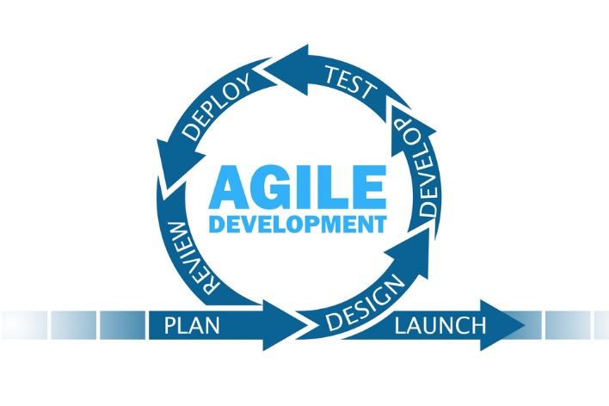

Figure 1 agile methodology