Tests on training parameters

For the training parameters learning rate = 0.001, iterations = 1 and epochs = 1 were chosen. Parameter space tested was [0.001, 0.0025, 0.005] for learning rates, [1, 3, 5] for iterations and [1, 2, 5] for epochs. The chosen parameters seemed to perform best on average based on evaluations.

Description of the simulated usage

Simulations were conducted by taking shortened series from the whole dataset. The series were used to simulate progression of the stock market over time and the application was used in the simulated situation in determined intervals. For each test interval, the data used for training of the model did not include future values and normalization was made for the invidual serie before the model training.

The basic simulation sequence included 30 series, each having been shortened by 30 more data entries than their corresponding earlier serie. In total the simulation spans back 900 stock market days and the most recent prediction made is the last day of the whole dataset. For example, if last (closest to present) data serie would have 2660 datapoints, if the original data had 2690. With sequence length of 150, the model would use datapoints 2510-2660 to make the prediction for data the point 2690. The serie before the last would have 2630 data points and so on. Companies going below sequence length threshold for the model training were excluded when needed.

For each simulated time interval a set amount of stocks predicted to gain most value would be bought and set amount of stock predicted to lose most value would be sold. For simplicity it was assumed that anything can be sold without requirements for ”owning” it before. Also the money used would be same amount every interval and for both buying and selling. After each interval bought stocks would be sold and ”sold” stocks would be bought back at current actual prices and profits or losses counted. Any real-world taxes or expenses related to operations were excluded. Also possible dividends distributed during short periods of simulated ownership were not included.

Results:

On average the application makes most profit when choosing just 1 best performing stock to buy and 1 worst performing stock to sell per time interval. Choosing more than 1 tended to move average profit towards zero.

Chosen sequence length affects the accuracy of the predictions. For the simulation with target offset of 30 days, the best length was observed to be 150. Lengths 30, 60, 100 and 200 were also tested.

The actual numerical predictions tend to be rather inaccurate. The model seems to be better predicting that a stock’s value is likely to go further up or down than providing accurate actual values. Also while the profit stays generally positive for long chain of events for the best performing models, the variation is great.

A twice longer target offset of 60 stock market days was also tested for the simulations. As sequence length, the best performer of the 30 days target offset models was chosen (150). The predictions were made every 60 stock market days using otherwise same principles as for the shorter offset. The variation of results between interwalls seemed to increase with the longer model. The performance was in line with the shorter model, but with more variance. Model with even longer target offset (90) seemed to also perform well on average, but with even larger variation between intervals.

Standard deviation of the profits per iteration is lowest for 30 and 60 days sequence lengths. However they anyway perform worse profitwise compared to 100, 150 and 200 days sequence lengths, at least for the 30 days target offset. The 60 days target offset model had much higher standard deviation than any of the 30 days target offset models.

Based on the simulation it seems reasonable to use model with 30 days target offset and 150 days sequence length.

It appeared that the model benefitted from having 2 quite volatile companies in the input data. It was also tested how the model would behave if its ”favourites” were eliminated from the data. They were still however present in the training of the models, since training and testing additional models was deemed to be too time consuming at this point. On average the profit margins get smaller with the exclusion of the companies with tickers ”SUMMA” and ”BRETEC”.

Model results with different parameters (all companies choosable):

target_offset 30, sequence_length 30:
Mean total profit per time period: -2.45%
Mean buying profit per time period: -2.80%
Mean selling profit per time period: -2.10%

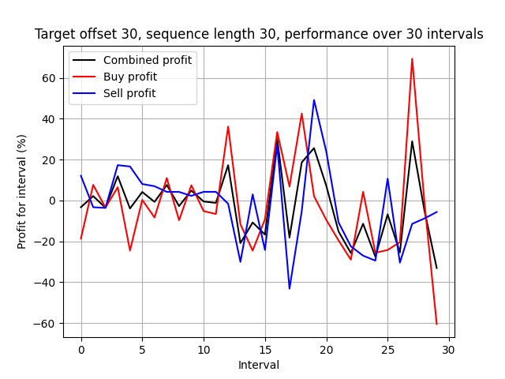

target_offset 30, sequence_length 60:
Mean total profit per time period: +0.20%
Mean buying profit per time period: +0.17%
Mean selling profit per time period: +0.22%

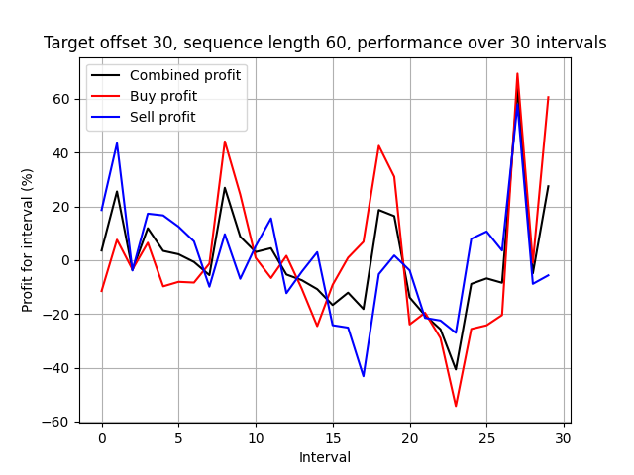

target_offset 30, sequence_length 100:
Mean total profit per time period: +4.49%
Mean buying profit per time period: +3.50%
Mean selling profit per time period: +5.49%
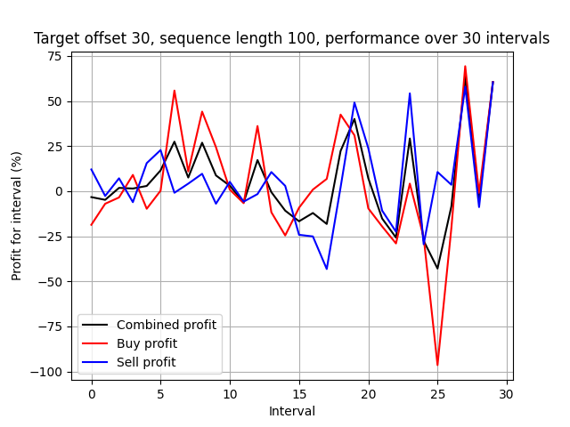

target_offset 30, sequence_length 150:
Mean total profit per time period: +5.90%
Mean buying profit per time period: +2.63%
Mean selling profit per time period: +9.17%
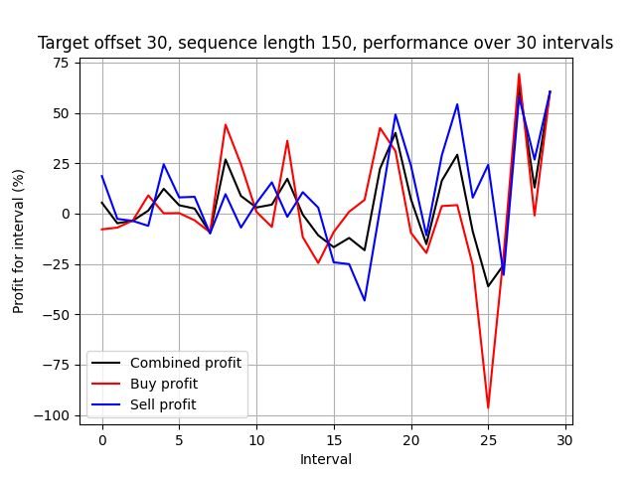

target_offset 30, sequence_length 200:
Mean total profit per time period: +5.09%
Mean buying profit per time period: +0.81%
Mean selling profit per time period: +9.36%
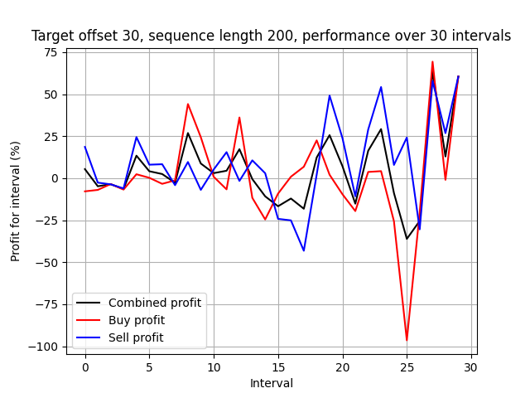

target_offset 60, sequence_length 150:
Mean total profit per time period: +6.14%
Mean buying profit per time period: +3.18%
Mean selling profit per time period: +9.09%
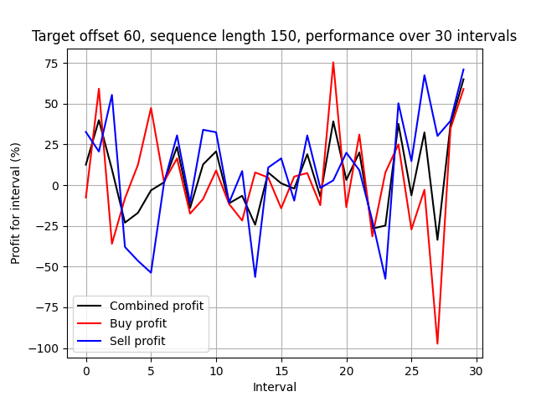

Model results with different parameters (SUMMA and BRETEC excluded):

target_offset 30, sequence_length 30:
Mean total profit per time period: -0.09%
Mean buying profit per time period: +1.25%
Mean selling profit per time period: -1.44%
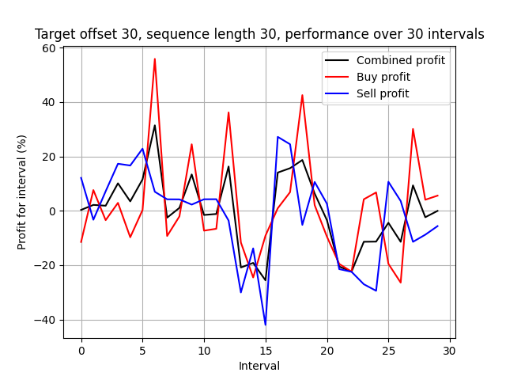

target_offset 30, sequence_length 60:
Mean total profit per time period: +1.55%
Mean buying profit per time period: +5.26%
Mean selling profit per time period: -2.17%
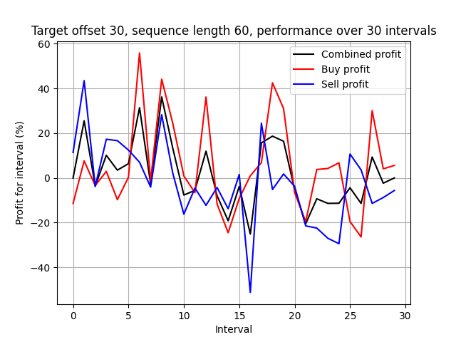

target_offset 30, sequence_length 100:
Mean total profit per time period: +2.11%
Mean buying profit per time period: +4.52%
Mean selling profit per time period: -0.31%
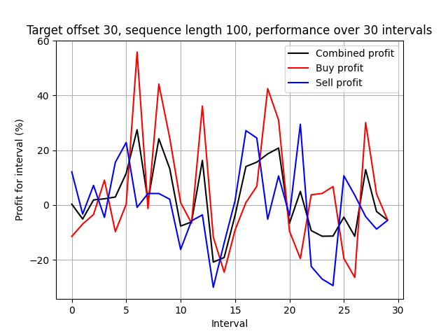

target_offset 30, sequence_length 150:
Mean total profit per time period: -0.55%
Mean buying profit per time period: +1.25%
Mean selling profit per time period: -2.35%
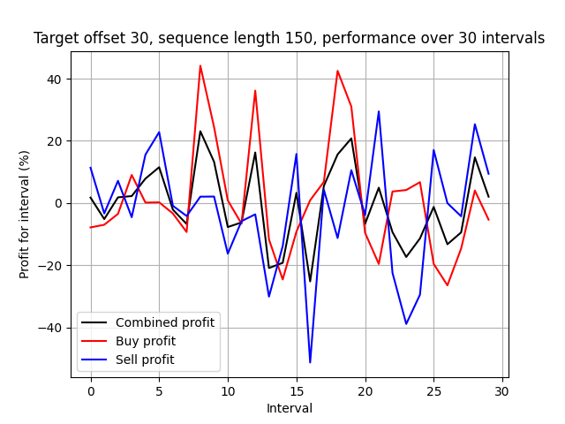

target_offset 30, sequence_length 200:
Mean total profit per time period: -0.13%
Mean buying profit per time period: +0.01%
Mean selling profit per time period: -0.27%
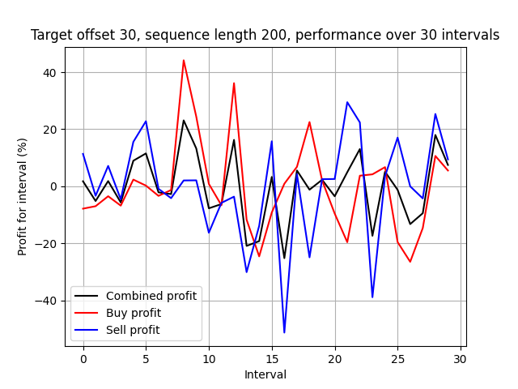

target_offset 60, sequence_length 150:
Mean total profit per time period: +1.11%
Mean buying profit per time period: +3.49%
Mean selling profit per time period: -1.26%
