CMSC 204

Huffman Lab

1. Create a Huffman Tree and generate the codes for each character of the following input:

“create a huffman tree”

For consistency:

1. If same frequency – put in priority queue alphabetically; put space before other characters of the same frequency
2. Add subtrees to end of group with same priority
3. Lower number has higher priority (goes to front)

Now encode “create a huffman tree”

c r e a t e [Sp] a [Sp] h u f f

0100 1110 110 100 000 110 101 100 101 0101 0110 001 001

m a n [sp] t r e e

0111 100 1111 101 000 1110 110 110

Code:

0100 1110 110 100 000 110 101 100 101 0101 0110 001 001 0111 100 1111 101 000 1110 110 110 =

0100111011010000011010110010101010110001001011110011111010001110110

1. Based on the following Huffman tree and binary sequence, what is the text

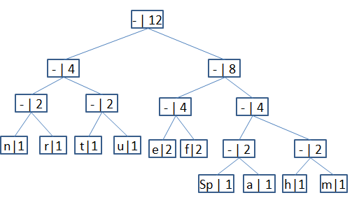

1110011101101111111010001100010001100100

Character codes:

n: 000

r: 001

t: 010

u: 011

e: 100

f: 101

[Space]: 1100

a: 1101

h: 1110

m: 1111

1110011101101111111010001100010001100100 =

1110 011 101 101 1111 1101 000 1100 010 001 100 100

h u f f m a n [Sp] t r e e

Message: “huffman tree”