Computer Science and Cognition

- Group Projects -

# Main Task

In groups of **5-6 people** you must process one of the given datasets containing EEG and behavioral data using your choice of any of the algorithms taught in this course. You should use at least one supervised or unsupervised method, and optionally PCA to aid in plotting. Make sure to apply the appropriate pre-processing steps to the data before applying the algorithms.

After applying these analyses, prepare some clearly labelled plots showing the results. using both behavioral and EEG aspects of data.

# Evaluation

To show your work, prepare

1. A **15 minute** presentation **due in one of the last 2 seminars** containing the following:
   1. **Introduction**: The question you were trying to answer, what algorithm you chose and why you chose the algorithm that you chose.
   2. **Implementation**: What steps did you include in your analysis pipeline (pre-processing, data handling, main analysis, etc.)? What challenges did you encounter(bugs, hang-ups), and how did you solve them? Here you can show snippets of code.
   3. **Results:** Show the results of your analysis using appropriate plots.
2. A file containing the code you used **due before the first presentations** which should generate the plots in your presentations when applied to the data you were given.

# Practical Aspects

You should organize yourselves into groups and sign up to the seminar you want to present in within the **next 2 weeks**.

**2 weeks before** the code is due, there will be a seminar where I will help those who are struggling with aspects of the code.

You will be graded on the logic of your approach, the quality of your code, and the clarity of your presentation.

# Experiment and Data description

The data comes from an experiment where we wanted to study how the visual system integrates information during visual exploration and processing. In order to slow down this usually rapid process, we prepared a set of stimuli where we could vary the amount of information present in the images. This was done by deforming a lattice of points by pulling them towards areas of high contrast in the source image. The force of this deformation was variable, and the effect can be seen in **Figure 1**. Participants were asked to respond by pressing keys on the keyboard to indicate whether they had identified the object, whether they could detect an object but were unsure of its identity, or if they were sure that there was no object in the image (for more information, see [the original study](https://journals.plos.org/plosone/article/file?id=10.1371/journal.pone.0022831&type=printable)).

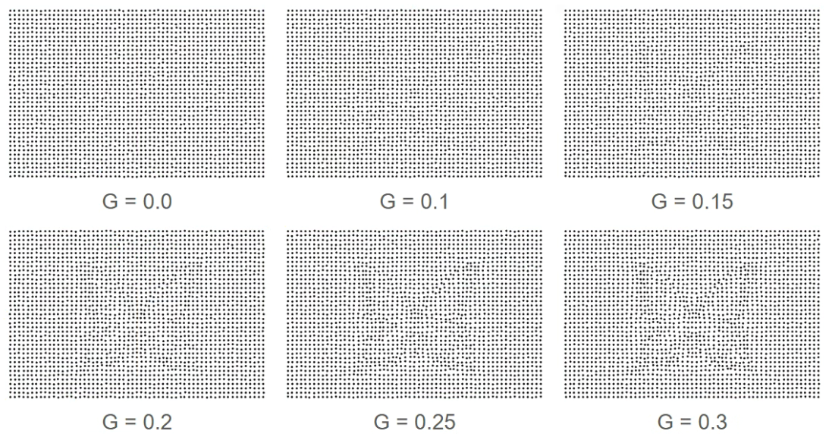

**Figure 1:** The stimuli generated from the same photo at different levels of difficulty. The lower the G, the higher the difficulty.

I applied the normal EEG pre-processing steps (which I will not go into or ask for) and extracted the channel average and variation per trial for 5 areas (frontal, central, temporal left, temporal right, occipital) after stimulus presentation and before the participants response. Furthermore, for each trial you will have the participants response, their response time, and the difficulty of the stimulus.

Provided files:

Dots_30_..._data.csv or .npy: trials by eeg features file as a .csv (open with pandas) or numpy

Dots_30_..._trial_info.csv : behavioral information as a .csv