**Enantioselective OSN process prediction on osndatabase.com**

1. **New link**

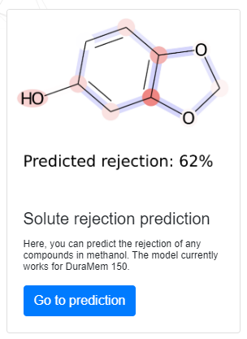

**A4**

**A3**

**A2**

**A1**

Elements:

**A1:** picture – graphical abstract

**A2:** text – Process performance prediction for enantioselective OSN

**A3:** text – In this section you can use our process modeling tools to predict the performance of a hypothetical enantioselective OSN process with a chiral membrane.

**A4:** text – Go to prediction

1. **Webpage**

**B4**

**B3**

**B2**

**B1**

**B1:** Title row -Process performance prediction for enantioselective OSN

**B2:** Description:

**Process performance prediction for enantioselective OSN**

Demonstrative page for the application of dynamic models in predicting enantioselective organic solvent nanofiltration performance.

Our model predicts the enantiomeric excess and recovery of major solutes in the product streams as a function of stage cut. The enantiomer excess and the recovery of the solutes only depend on the stage cut, the rejection of the two enantiomers and the ratio of their concentration in the feed. Stage cut is defined as the ratio of the permeate and total output volumetric flow:

$$θ=\frac{F_{permate}}{F_{retentate}+F_{permeate}}$$

Rejection is expressed with the concentration of the solute in the permeate and retentate:

$$ρ_{i}=1-\frac{c_{permeate}^{i}}{c_{retentate}^{i}}$$

Enantiomeric excess is used to describe the chiral purity of a solution with the concentration of the enantiomers *R* and *S*, while recovery describes the percentage of the target solute mass flow recovered from the feed solution.

$$ee= \frac{\left|c^{R}-c^{S}\right|}{c^{R}+c^{S}}×100$$

$$η= \frac{{\dot{m}}_{out}}{{\dot{m}}_{in}}$$

The enantiomeric excess and recovery values are calculated for three different OSN configurations:

* Single stage nanofiltration
* Single stage nanofiltration with retentate stream racemization and recycling (SRR). Calculations assume 99% racemization in the reactor.
* Two-stage permeate cascade with recycling (where the volumetric flow of the permeate stream of the first stage is equal to the feed flow). In this case the stage cut is defined for the overall process.

To calculate an analysis, please enter the rejection values of the two enantiomers and the ratio of the R solute in the feed stream.

The process schemes for the different configurations can be found below. For more details, please visit the corresponding article at DOI: (*to be submitted*). Please use the article as a reference when using the performance prediction tool. Thank you!

**B3: Three text boxes**

Instruction1: Please the enter the rejection values of the two enantiomers in percentages (max. 100%)

Box1: R: [box]%

Box2: S: [box]%

Instruction2: Please enter the ratio of the R solute in the feed stream in percentages (between 0% and 100% excluding boundaries, 50% for racemate feed).

Box3: Ratio of R: [box]%

Button: “Calculate analysis”

**B4:** Process schemes + Results

PROCESS SCHEMES: Under the boxes, from left to right, always visible (pics attached later)

RESULTS: Under the process schemes, appear when clicking on button

If invalid input (e.g., R > 100%), then a text appears instead: “Invalid input. Please enter rejection values equal to or lower than 100%”.

Example output (Rejections: R 60%, S 20%, 45% R 55% S in feed):

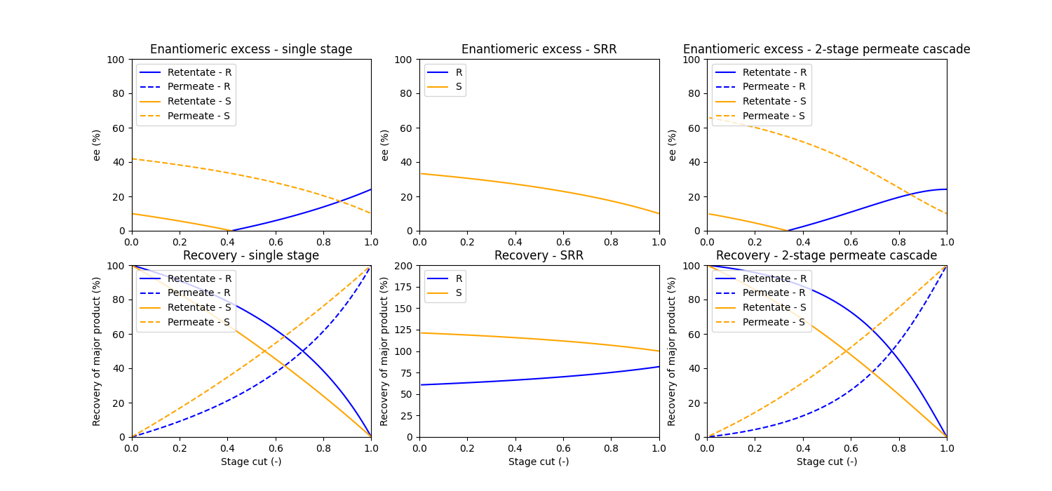

To be implemented:

* Downloadable dataset (.csv file)