RSA Sandbox User Manual

Created by Aron Schwartz and Professor John Acken  
Portland State University | Winter 2020 | ECE Department

**Table of Contents** FIX PAGE NUMBERS EVENTUALLY

1. Overview --------------------------------------------------------------------------------- 3
2. System Data Management ------------------------------------------------------------- 4

2.1 Septuple Management ------------------------------------------------------------- 5

2.2 Prime Number Management ------------------------------------------------------ 6  
2.3 Key Management------------------------------------------------------------------- 7  
2.4 Saving/Loading Data -------------------------------------------------------------- 8

1. Saving/Loading Data -----------------------------------------------------
2. Encrypting/Decrypting Plaintext and Strings
3. Fixed Point Analysis
4. Output Files
5. Help Menu

**1.0 RSA Sandbox Overview**

The RSA Sandbox is a research tool developed to enable smoother and more efficient experimentation with regards to fixed point occurrence in RSA encryption. The program allows a user to create RSA encryption objects, prime numbers, and encryption keys with ease. More over, it allows the user to create and experiment with arbitrary combinations of these three parameters to test for the occurrence of fixed points and more.

The tool is written in Python 3, and is intended to be run from the windows command line. A screenshot of the main menu of the program can be seen below:

REDO THIS INTRO?

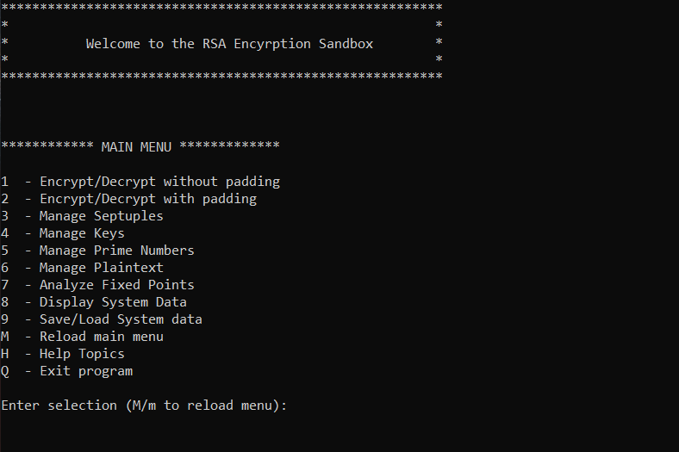

**Figure 1:** The main menu is loaded upon initialization of RSA_Sandbox.py

To run the program, navigate to the directory housing the repository from the command line and run the RSA_Sandbox.py file. A screenshot illustrating initialization of the program can be seen below.

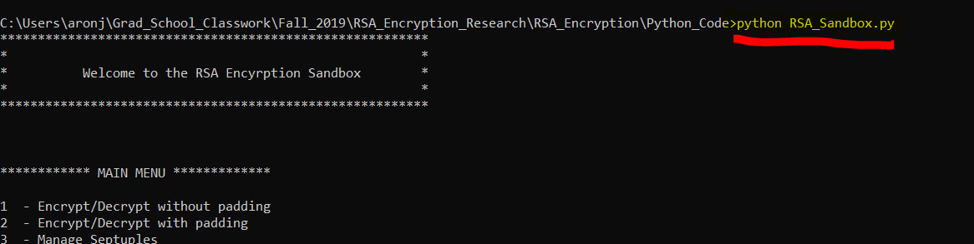

**Figure 2:** Run the program by initializing RSA_Sandbox.py from the command line

The following sections provide a detailed functionality overview for all components of the RSA sandbox program.

**2.0 System Data Management**

The RSA Sandbox allows creation and manipulation of septuples, encryption keys, and prime numbers. A description of each of these three elements, their respective relationships, and the mechanisms for properly utilizing them can be seen in the following sections.

**2.1.0 Septuple Management**

Performing encryption in the RSA Sandbox is accomplished by the creation of “septuple” objects, a python object that houses the 7 parameters and internal functionality needed to perform RSA encryption and decryption. The 7 parameters of a septuple and a brief description can be seen below.

* **P and Q:** Two initially chosen prime numbers which govern other parameter choices
* **N:** Product of P and Q
* **Totient**: Product of (P-1)*(Q-1)
* **E:** Encryption exponent, part of the public encryption key **(E, N)**
* **D:** Decryption exponent, part of the private decryption key **(D, N)**
* **K:** Internal parameter related to choosing D

For simplicity and consistency, septuples are represented in this manual, the RSA Sandbox program, and in output files in the following format: **Septuple format: [P, Q, N, Totient, E, K, D]**

**2.1.1 The Septuple Management Menu**

The Septuple Management menu allows the creation, viewing, and manipulation of Septuple objects as described previously. The septuple management menu can be accessed from the main menu by pressing ‘3’ as seen below.

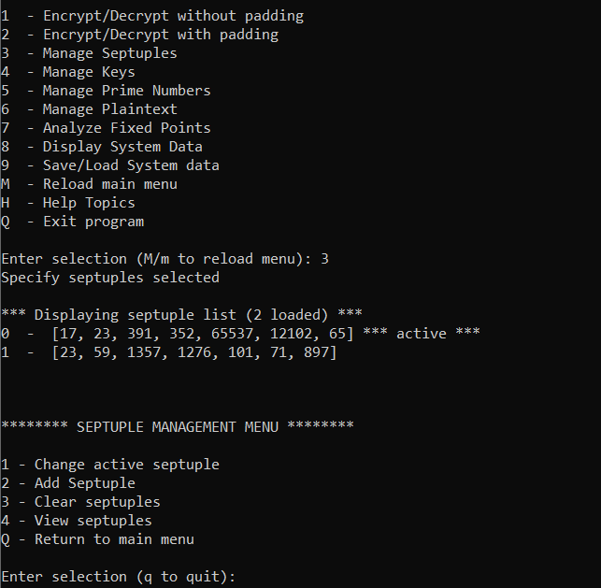

**Figure 3:** Septuple management menu accessed by pressing ‘3’ from main menu

As shown in the screenshot, initializing the septuple menu first displays all septuples loaded in the program, with a descriptor string accompanying the “active” septuple. The “active” septuple is the septuple that will be used by default when performing plaintext and/or input string encryption. The user can choose a new active septuple from among the loaded septuples at any time by pressing ‘1’ in the septuple management menu. There is an opportunity to specify a septuple other than the active one when performing plaintext encryption as well.

Option ‘2’ allows a new septuple to be generated from user input and added to system whilst ensuring proper values are input for P, Q, and E (if the user wishes to specify a custom E value). A screenshot of a typical septuple creation flow can be seen below.

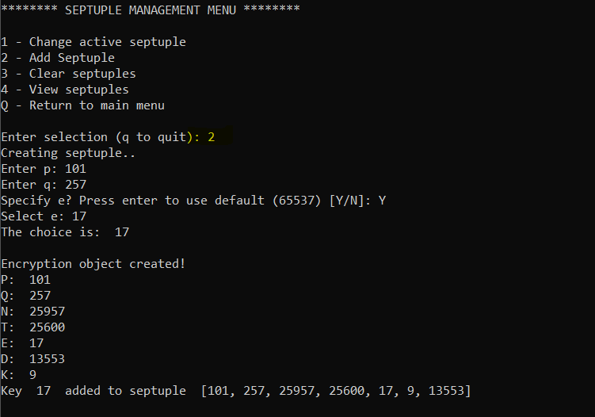

**Figure 4:** Septuples can be created from the command line by inputting P, Q, and E

As shown in the screenshot, the program will prompt the user to input P and Q. The user can also input E, or use the default value of 65537. Error messages will be generated and the object creation will fail if bad values are provided.

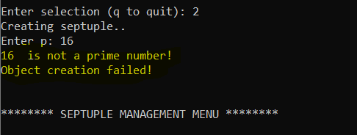

**Figure 5:** System will prevent incorrect P, Q, or E input values

MENTION SEPTUPLE CREATION FROM PRIMES LIST? IMPLEMENT THIS

Options ‘3’ can be used clear the septuple list, and option ‘4’ can be used to view all septuples currently loaded into the program.

**2.2.0 Prime Number Management**

The program maintains a list of prime numbers that can be used to generate keys and septuples. The prime number management menu can be accessed by pressing ‘5’ from the main menu, as shown below.

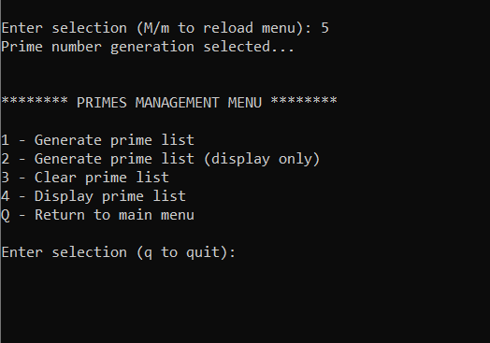

**Figure 6:** The prime number management menu allows creation of internal primes list

Both options ‘1’ and ‘2’ will create prime numbers, however option ‘2’ will only display the list and will not append it to the internal data. To generate primes, the user simply inputs a starting and ending value. The program will generate a list of every prime number between the two provided values. The following screenshot shows an example process of generating all prime numbers between 2 and 5000.

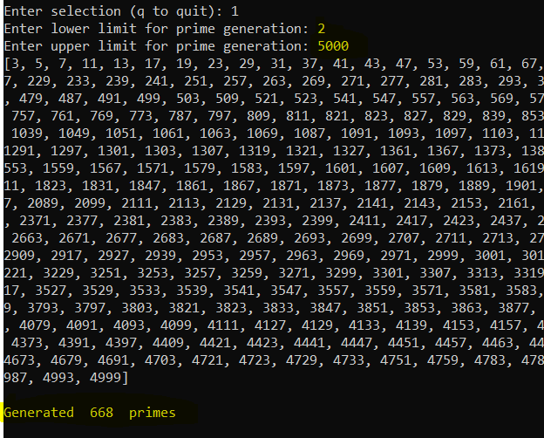

**Figure 7:** 668 primes are generated for the input range 2 to 5000

As shown, the system will generate the primes within the given input range. A final message depicting the total number of primes created is also generated, in this case 668 values. As with the septuple menu, other options exist to simply view the prime list or to clear it away entirely.

**2.3.0 Key Management**

The program maintains an internal dictionary associating a list of encryption keys with each septuple. The initial key used in septuple creation is first added to the dictionary, and the user can add more keys to any septuple from custom input as well as directly from the internal prime number list. The key management menu can be accessed by pressing ‘4’ from the command line as seen below.

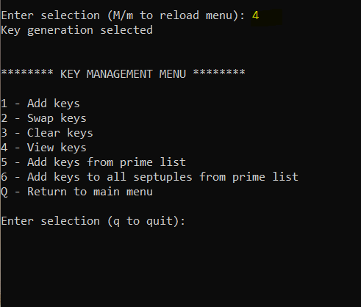

**Figure 8:** The key management menu allows creation and manipulation of public keys

An example of option ‘4’, i.e. “View Keys” following creation of a single septuple is shown below.

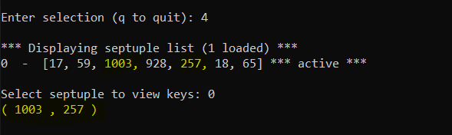

**Figure 9:** Single septuple with a single key

As one can see, the key list is shown in the form (N, E), and in this case the N and E values are identical to the values occupying the septuple object itself since no other keys exist yet.

Option ‘1’ allows a user to append a new key to a septuple via command line input. For more expansive key generation, option ‘5’ can be used to append the entire prime list to the key list of a chosen septuple, and further still, option ‘6’ can be used to append the prime list to every single septuple loaded in the program. The following screenshots illustrate an example of this mechanism. This assumes that prior to entering the key management menu, the user has already generate an internal prime list of all primes between 2 and 100.

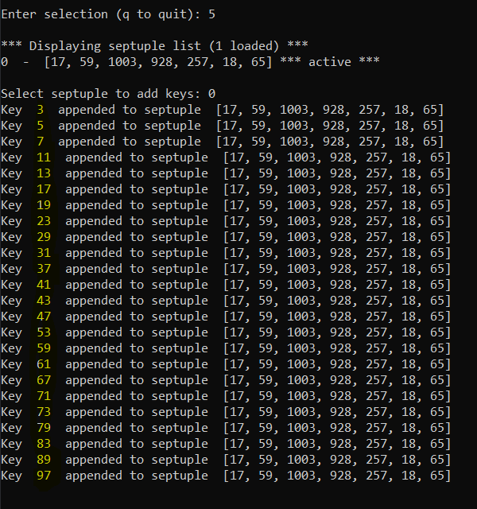

**Figure 10:** Prime list can be appended to key list of a septuple

As shown, the primes between 2 and 100 are added to the chosen septuple. In contrast with **Figure 9**, the following screenshot shows the new output upon viewing the keys for the same septuple.

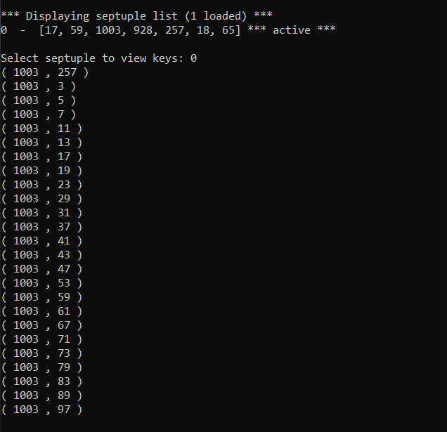

**Figure 11:** Twenty four additional keys now exist in the key list

It is worth noting that the loaded key in the septuple is 257. Option ‘2’ in the key management menu allows choosing a new key from a septuples key list. The septuple object will regenerate the D and K values accordingly upon swapping of the key value.