Balance by Gate of Steiner
Team: Lim Ze Heng, Tan Yi Ming, Chong Zhi Xuan, Matthew Thien Yung En
Problem Statement:Stress & Workload Manager
Video Presentation: https://www.youtube.com/watch?v=JVw0jTaCICs
Presentation Slides:
https://docs.google.com/presentation/d/1_ctq2F96NrVD1dD9PSV1PLKwfyI83E4G-brSaejZjLE/edit?usp=sharing

1. Project Overview

The Problem
University students often manage assignments, examinations, part-time shifts, family responsibilities, club activities, group work and personal rest within the same limited period. The core problem occurs when the time and energy required by these commitments exceed the student's actual capacity. Contributing causes include overlapping deadlines, incomplete task estimates, unclear flexibility, unprotected sleep or recovery limits, and shared commitments that cannot be changed without another person's agreement.
Students may recognise that they are overloaded but still cannot answer three practical questions: What must remain protected? What can be adjusted? What consequences will each adjustment create? Moving one task may protect tonight's sleep while increasing tomorrow's workload, creating deadline risk or affecting teammates. Students are the primary stakeholders; secondary stakeholders include teammates, family members, club members and university support services affected by or supporting the student's decisions.
Existing products address parts of the problem. Todoist supports task organisation, replanning, collaboration and progress tracking, while Finch provides self-care features. Based on the public feature descriptions reviewed, Balance focuses on a specific combination: protected commitments, destination-day capacity, agreement requirements and recovery time within one plan-comparison flow.

Our Solution
Balance is a stress and workload management application that helps university students create a realistic plan when every commitment cannot fit within their available time. It follows a Detect -> Decide -> Recover -> Reflect process: the system identifies overload, protects non-negotiable commitments, and compares possible adjustments before the student confirms any change. Each option explains its effects on deadlines, future workload, rest and collaboration. Once a confirmed plan creates genuine free time, Balance helps the student protect that time for optional recovery and later reflect on recurring workload patterns.

Feature Set
Practical feature | RPG label | Purpose
Workload Overview | World Status | Shows available and planned time, five workload dimensions and an illustrative cumulative workload trend; the model remains to be validated.
Optional Check-in | Status Appraisal | Records optional sleep and self-reported energy. Missing input remains Unknown.
Tasks and Protected Commitments | Quest Board and Sacred Contracts | Records duration, deadline, flexibility (Fixed / Flexible / Needs Agreement), protection status and a separate optional-commitment flag.
Overload Alert | Calamity Alert | Shows the difference between genuinely available time and planned task time.
Plan Comparison | War Council | Compares valid adjustments and explains deadline, future-load, rest and collaboration effects.
Recovery Nudge | Sanctuary | Offers optional recovery only after a confirmed plan creates genuine free time.
Weekly Reflection | Journey | Summarises private weekly patterns, protected time and conflicts handled early.
Sustainable Achievements | Journey Milestones | Recognises safe planning without leaderboards, streak penalties or rewards for overwork.

2. Ideation & Process

2.1 Ideas We Considered

Direction | Decision | Reason
Debt-based Workload Model + Load Balancer + Recovery Nudge | Chosen | Connects cumulative workload detection, a concrete planning decision and protected recovery time.
RPG framing | Refined and retained | Makes the experience memorable while keeping practical labels visible and avoiding a complex game economy.
Journey and Sustainable Achievements | Added | Responds to mentor feedback on retention by rewarding safe planning and private reflection without streak pressure.
Negotiation AI | Refined | Changed from generated external messages into user-confirmed plan comparison and a Needs Agreement state.
Energy Currency | Dropped | Too difficult to explain credibly in a 3-5 minute demo and shifted attention toward a game economy.
Peer Comparison | Dropped | Added privacy and multi-user complexity; comparison could also increase anxiety.

2.2 Ideation Boards

Early Problem and Solution Exploration
These three original handwritten pages record early problem framing, proposed solutions and unresolved questions in Chinese. The English summaries below describe the legible content rather than provide a word-for-word transcription. They document design exploration, not user interview findings or validated outcomes. Their order follows the supplied scan; it does not establish separate dated iterations.

Early draft A (7/9/2026) — Practical constraints and continued use
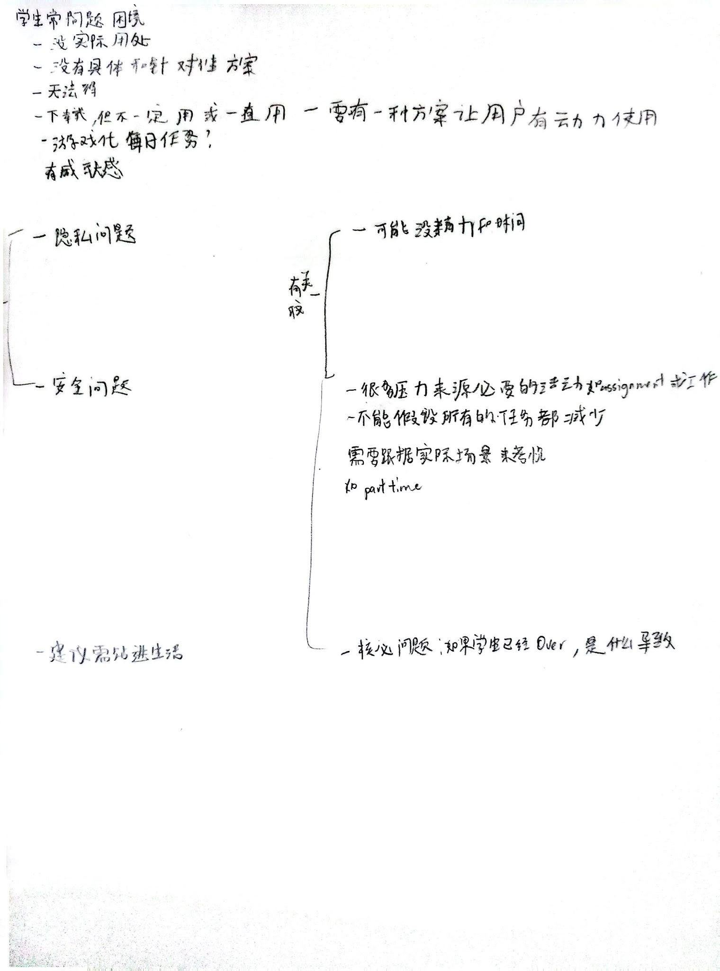
Early draft A. Original Chinese handwritten notes
English summary: The notes consider why students may not continue using an app and explore gamification, daily tasks and a sense of achievement. They also raise privacy and security concerns. A key observation is that stress can arise from necessary commitments, including assignments and part-time work: the system cannot assume every task can be reduced. Advice should fit real circumstances.
Connection to the current design: protected commitments and consequence-aware trade-offs address the concern that necessary responsibilities cannot simply disappear. Journey Milestones retain the achievement idea while avoiding compulsory daily tasks and streak penalties.

Early draft B (7/9/2026) — Proposed responses to student needs
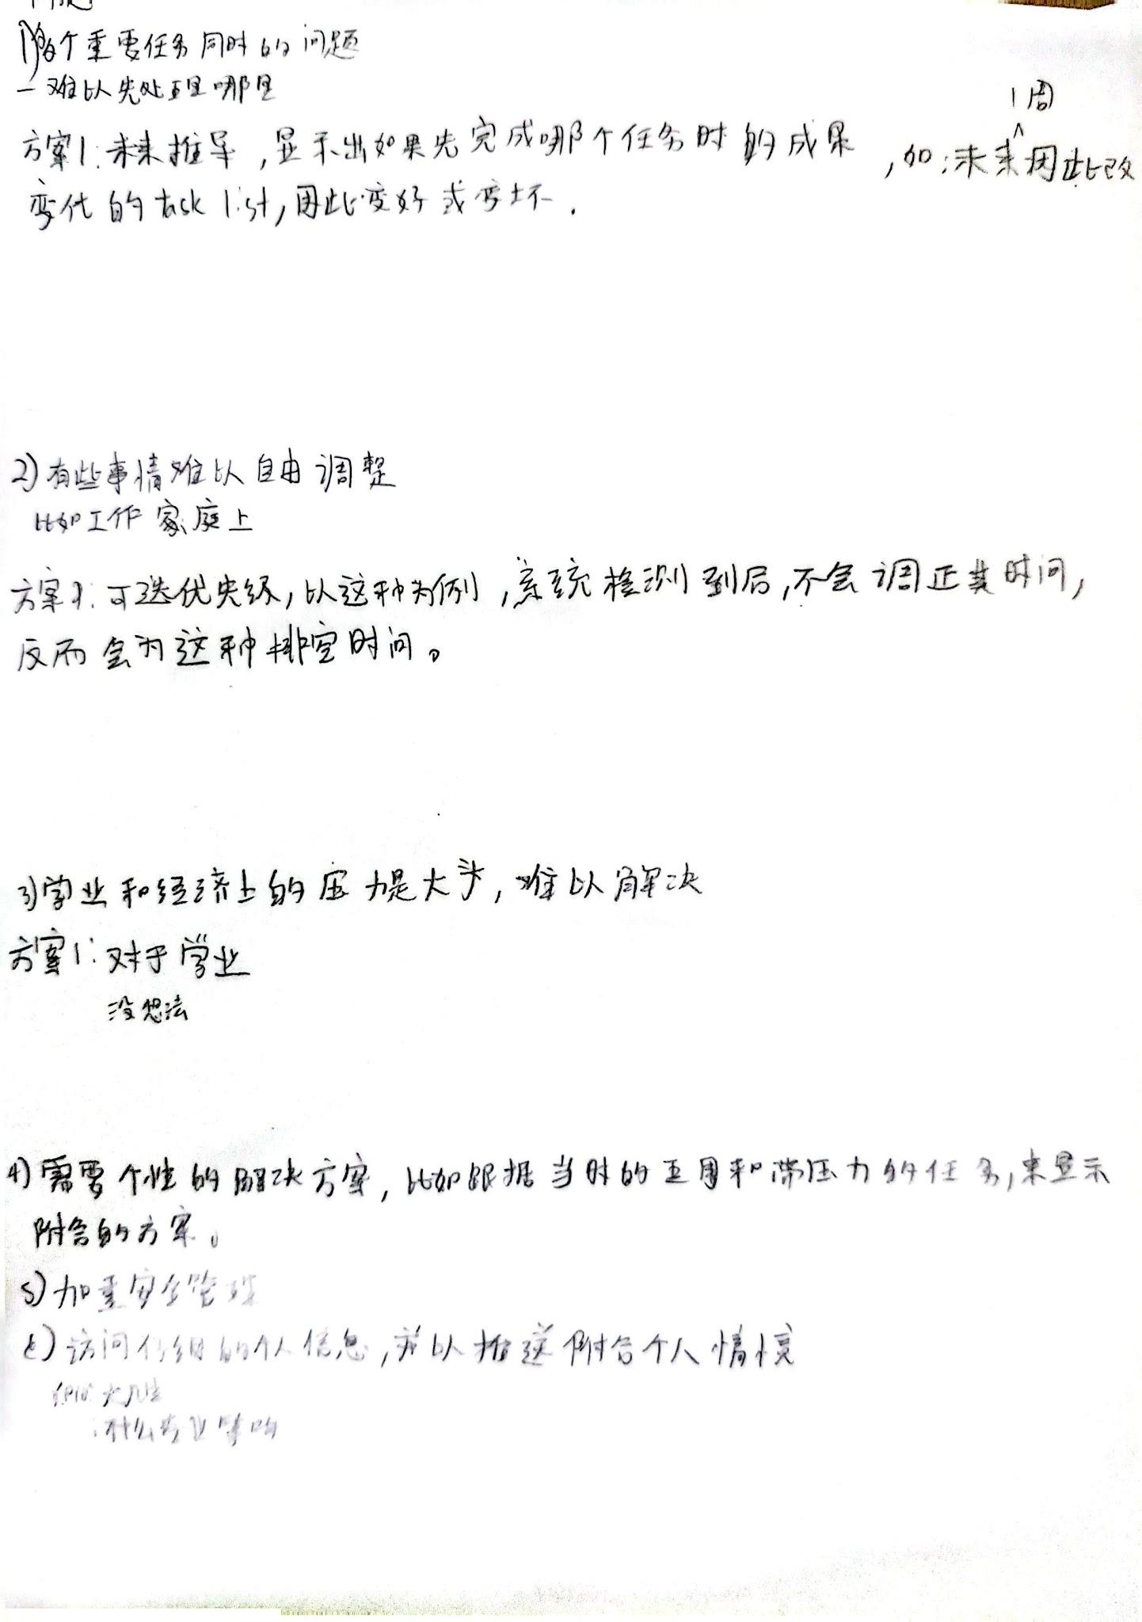
Early draft B. Original Chinese handwritten notes
English summary: The notes explore showing the effects of completing tasks, protecting work and family time, providing personalised suggestions based on available time and stressful tasks, and strengthening security. They acknowledge academic and financial pressures that may be difficult for the app to resolve. Collecting profile information such as year of study and field of study is considered as a possible basis for personalisation.
Connection to the current design: fixed and protected commitments, capacity checks and plan comparison make these proposals more specific. Profile-based personalisation remains an early proposal rather than a committed feature. The current scope focuses on workload decisions and does not claim to resolve financial or academic pressures themselves.

Early draft C (7/9/2026) — Scheduling rules and unresolved questions

Early draft C. Original Chinese handwritten notes
English summary: The notes propose keeping daily input short, including the previous night’s sleep duration, setting a daily task limit and moving work to a suitable day within its deadline. They recognise cases requiring user input. They explicitly leave open what happens if the student rejects a schedule change, question the credibility of a calculated stress score, and consider asking returning users for updated information when check-ins are missing.
Connection to the current design: changes require confirmation; rejection preserves the current plan; missing information remains Unknown or Needs Review; and pending agreement does not count as freed time. The credibility question remains relevant: cumulative workload rules require definition and validation, and the prototype does not claim a clinically valid stress score.
The following mind map and problem tree organise the problem and design relationships more explicitly. The original notes above are retained as evidence of the earlier questions and proposals, including ideas that were later narrowed or left unresolved.

Mindmap

Draft version
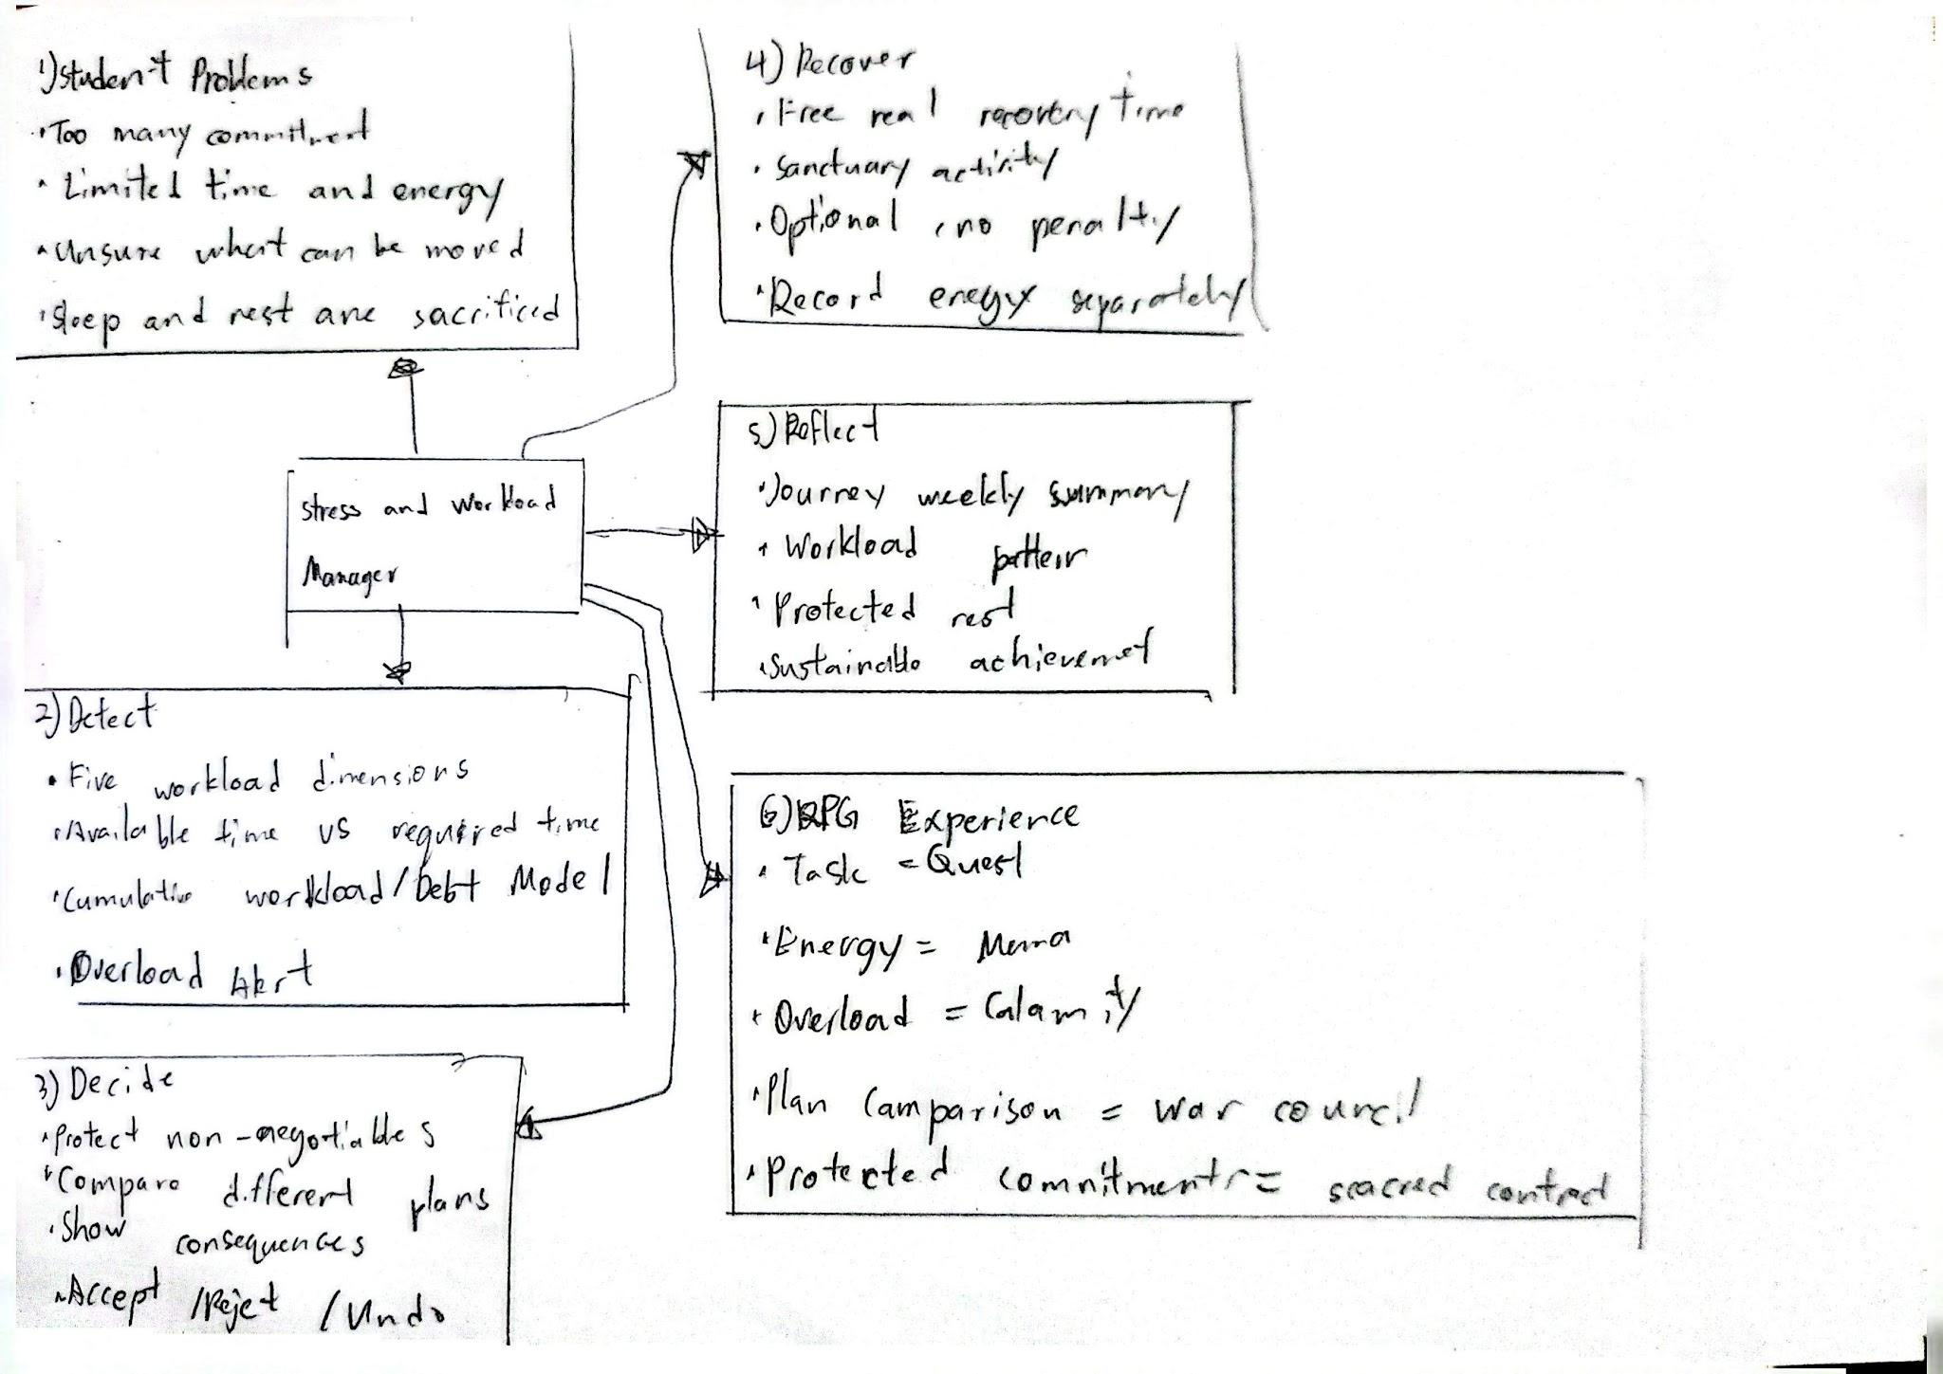
Figure 1. Original hand-drawn mindmap

Final version
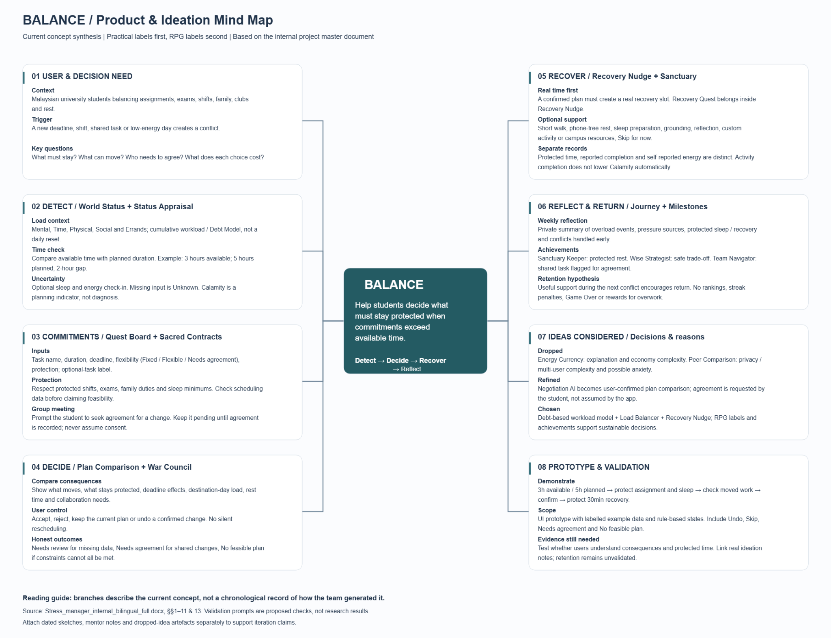
Figure 2. Refined mind map connecting the user problem, core product flow, considered ideas, trust rules and prototype validation needs.
The mind map connects student workload conflicts to the Detect → Decide → Recover → Reflect journey. It links capacity awareness to protected commitments and consequence-aware plan comparison, then connects genuine free time to optional recovery and private reflection. Practical feature names accompany RPG labels to explain their purpose.

Problem Tree

Draft version
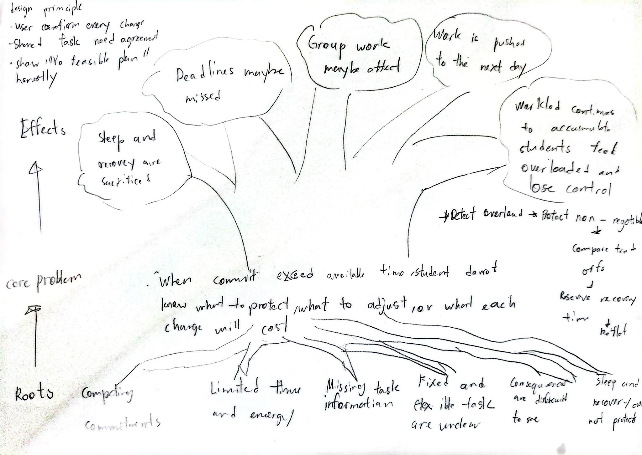
Figure 3. Original hand-drawn problem tree showing causes, the core decision problem, possible effects and early design principles.

Final version
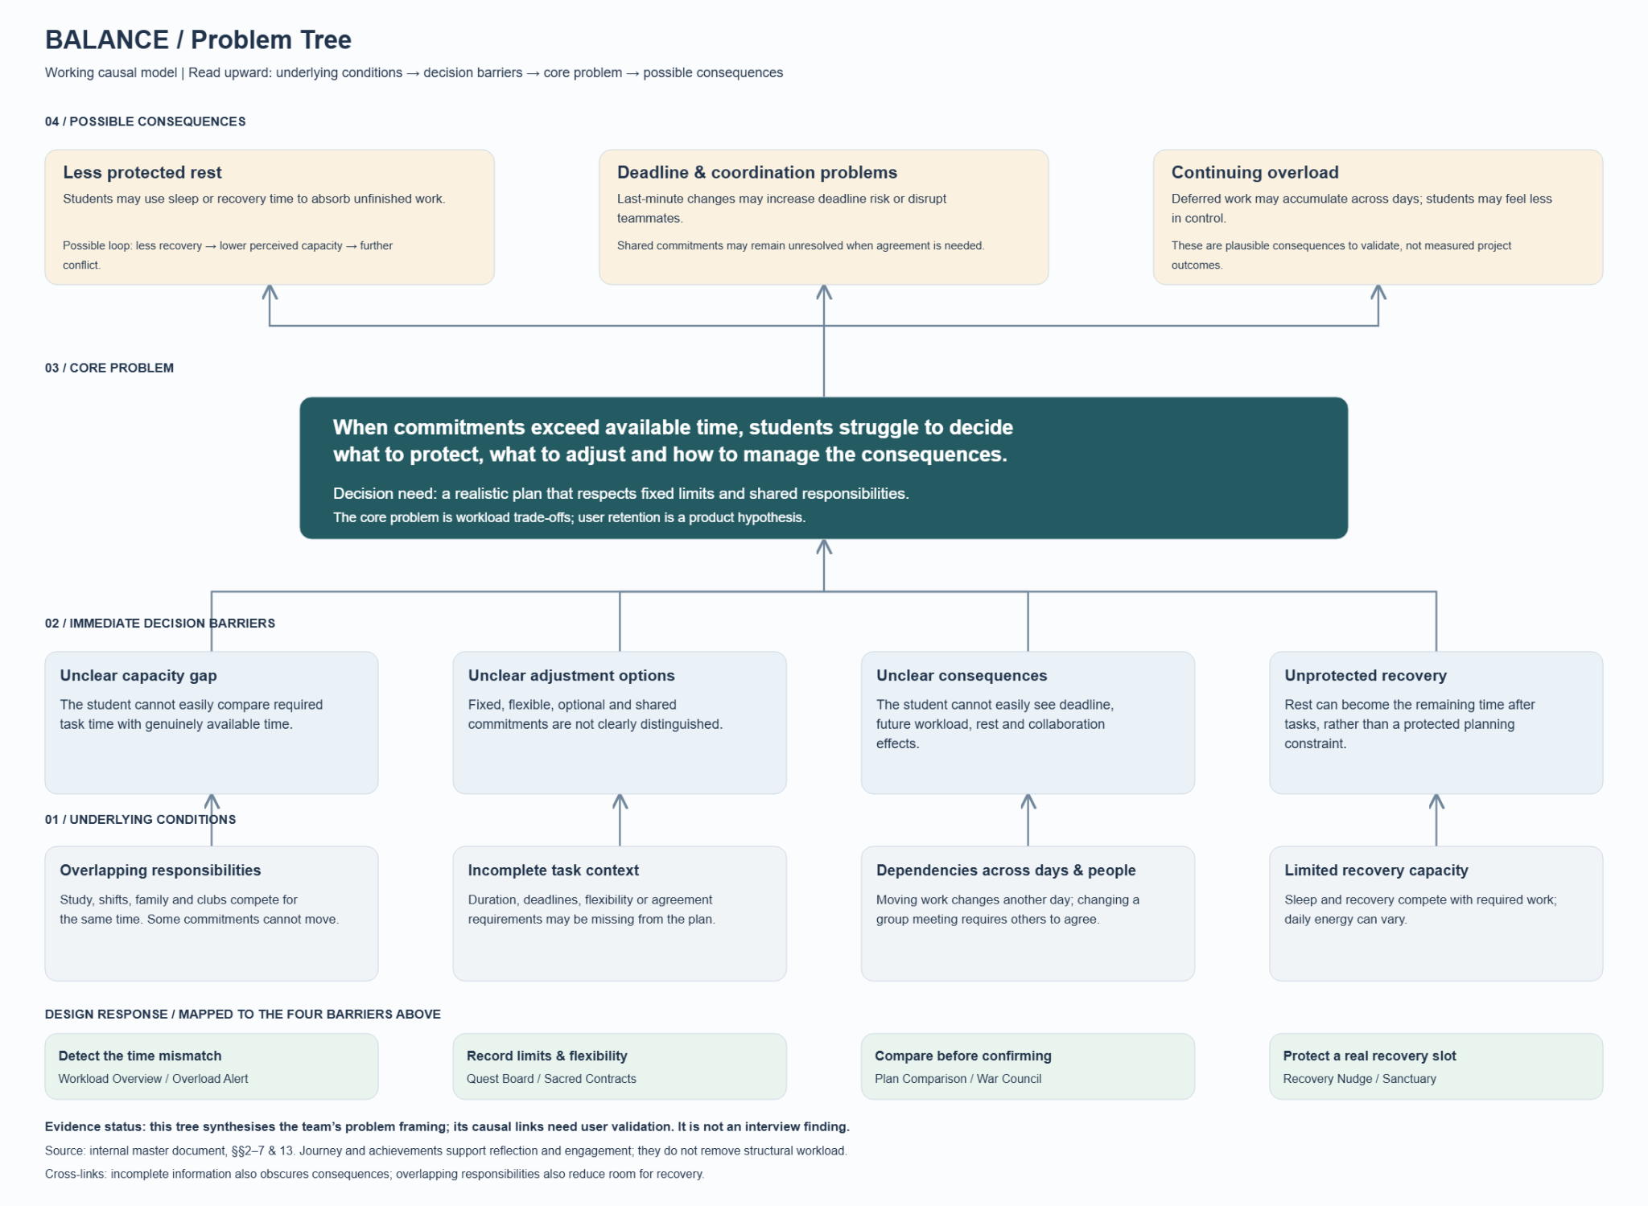
Figure 4. Refined working causal model. Its causal links remain hypotheses to validate and are not presented as interview findings.
The problem tree links overlapping responsibilities, incomplete task information and dependencies across days and people to four decision barriers: an unclear capacity gap, uncertain adjustment options, hidden consequences and unprotected recovery time. These barriers informed Workload Overview, Quest Board and Sacred Contracts, War Council, and Sanctuary. The causal links are working hypotheses to validate, rather than confirmed interview findings.

2.3 Mentor Consultation
Date | Mentor | Feedback received | What changed
6 Sep 2026 | Lim Zi Yang | Develop a distinctive response beyond reproducing the problem statement. Consider multi-device use, privacy and security, and avoid relying on AI for the team's original brainstorming. | Added protected commitments and consequence-aware trade-offs; removed peer comparison; made self-reporting optional; limited the prototype to rule-based example data and avoided medical claims.
8 Sep 2026 | Lim Zi Yang | Define a specific use case, examine existing stress and workload apps, and decide how physical or mental wellbeing and gamification support that use case. | Defined the 3-hours-available versus 5-hours-planned scenario. Recovery now appears only after real capacity is freed, while RPG labels support the planning flow.
11 Sep 2026 | Lim Zi Yang | Reconsider how group meetings are changed. Address retention, progress reflection, expanded Sanctuary support and game elements. | Added Needs Agreement for shared commitments; Journey as a private weekly reflection; sustainable planning achievements; and broader optional Sanctuary activities. Workload trade-offs remain the core user problem; retention features support continued use.

3. Design & Prototype
UI Prototype:
https://www.figma.com/design/oLcPugPWy5bqWTTPPxmYtm/Balance-%E2%80%94-RPG-Workload-Manager?node-id=0-1&t=TJToq2FSosvTu5Mh-1
The current Figma prototype presents eight ordered mobile UI screens illustrating a university student with three hours available tonight and five hours of planned tasks. These are static reference screens showing the intended decision journey. Clickable transitions, working confirmation and undo, and rule-based calculations are planned for implementation.
The experience follows the Detect → Decide → Recover → Reflect journey:
Detect — The intended interface combines a calculated time-capacity gap with self-reported information across Mental, Time, Physical, Social and Errands. Task flexibility is Fixed, Flexible or Needs Agreement; protection status and whether a commitment is optional are recorded separately. The example shows a two-hour capacity gap.
Decide — Proposed adjustments explain what moves, what stays protected, deadline effects and destination-day capacity before confirmation. A shared commitment remains unchanged until the student records that the required agreement has been obtained; pending agreement does not count as freed time.
Recover — In the corrected scenario, moving 90 minutes of reading and 60 minutes of draft work removes 150 minutes from tonight. The remaining 150 minutes of tasks fit within 180 available minutes, leaving 30 minutes for optional recovery or unstructured rest.
Reflect — The weekly screen illustrates private patterns using example data. Working history tracking and milestone rules are planned; the current screens do not demonstrate measured retention or wellbeing outcomes.
The intended naming convention pairs practical feature names with RPG labels: Tasks / Quest Board, Protected Commitments / Sacred Contracts, Plan Comparison / War Council, and Recovery Nudge / Sanctuary.

Key Screen Flow

Step | Practical feature / RPG label | Intended interaction
1 | Optional Check-in / Status Appraisal | The student may record current energy and rest information. These optional readings inform the status view but do not automatically change the schedule.
2 | Workload Overview / World Status | The interface compares 3 available hours with 5 planned hours, states the 2-hour capacity gap, and displays Mental, Time, Physical, Social and Errands separately.
3 | Commitment Map / Quest Board | Protected sleep and family commitments are separated from fixed and flexible tasks, so essential commitments cannot be moved merely to make the plan appear feasible.
4 | Plan Comparison / War Council | The reference screen illustrates proposed adjustments. Implementation must validate duration, deadlines, destination-day capacity, protection and agreement before labelling an option feasible.
5 | Confirmed Plan / Plan Updated | The intended confirmation state lists the two moved task portions and protected commitments. Undo will restore both changes and the prior recovery reservation.
6 | Recovery Nudge / Sanctuary | The corrected scenario leaves 30 minutes after moving 150 minutes of tasks from a 300-minute plan into a 180-minute window. The student can reserve this time or leave it unplanned.
7 | Weekly Summary / Weekly Reflection | A private weekly view presents workload patterns, protected recovery time and sleep protection without comparing the student with other users.
8 | Planning Achievements / Journey Milestones | Cumulative milestones recognise sustainable decisions such as protecting sleep, keeping recovery time clear and rebalancing early, without streak penalties or peer rankings.

Core Interaction Principles
- User control: no task or commitment moves without confirmation.
- Protected constraints: sleep, family responsibilities and other non-negotiable commitments cannot be sacrificed simply to make the schedule appear feasible.
- Visible consequences: every proposed adjustment explains its cost before the student decides.
- Optional recovery: Sanctuary protects genuine free time without turning recovery into another compulsory task.
- Clear terminology: practical feature names appear together with their RPG equivalents.
- Honest feedback: calculations, self-reports and example data are distinguished. The product makes no medical, diagnostic or therapeutic claims.

Selected UI Reference Screens
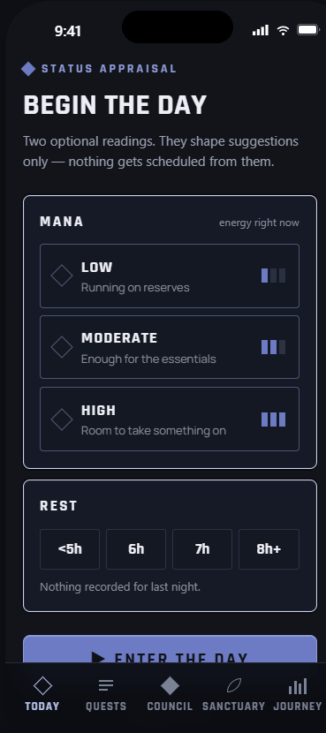  1. Optional Check-in / Status Appraisal  Optional energy and rest inputs inform suggestions without changing the schedule. | 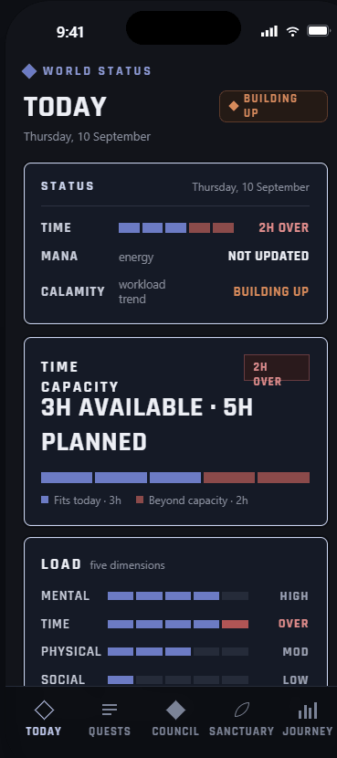  2. Workload Overview / World Status  The screen compares three available hours with five planned hours and shows the two-hour gap.
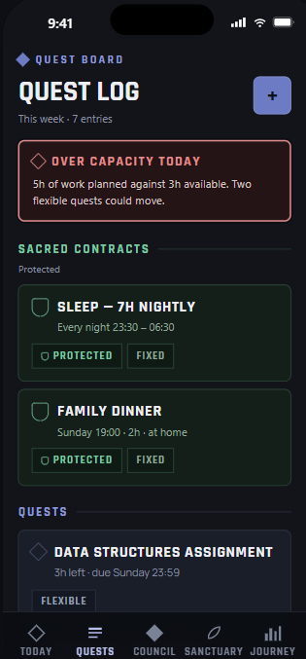  3. Commitment Map / Quest Board  Protected commitments remain fixed. The Data Structures task is due Sunday at 23:59. | 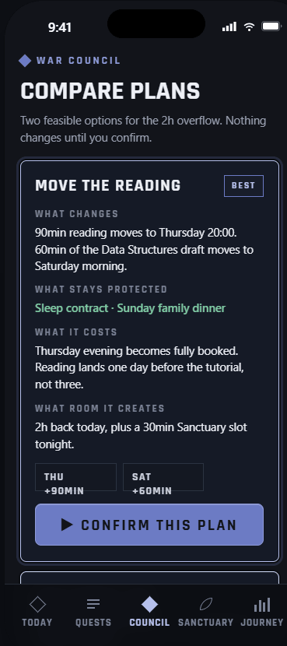  4. Plan Comparison / War Council  The proposed plan states what moves, what stays protected and what each choice costs.
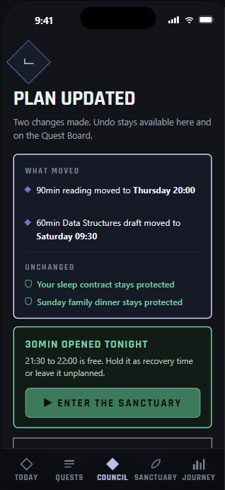  5. Confirmed Plan / Plan Updated  Moving 150 minutes of work leaves 30 minutes tonight; Undo remains available. | 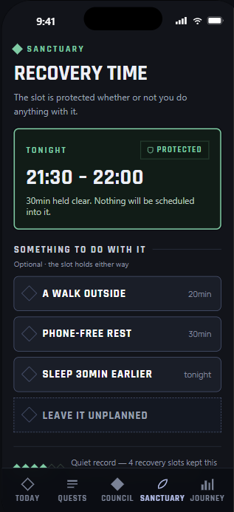  6. Recovery Nudge / Sanctuary  The corrected protected period runs from 21:30 to 22:00 and may remain unplanned.
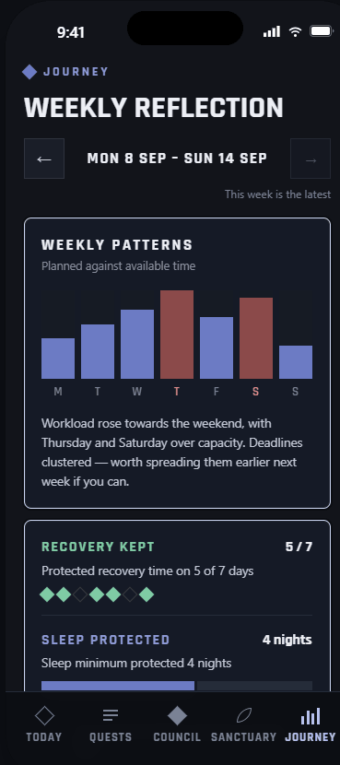  7. Weekly Summary / Weekly Reflection  Illustrative private data shows patterns without comparing the student with other users. | 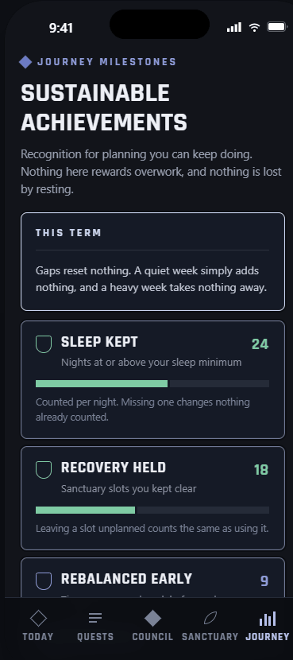  8. Planning Achievements / Journey Milestones  Milestones recognise sustainable planning without streak penalties or peer rankings.

4. What Makes It Different

Distinctive mechanism | Why it matters
Non-negotiable Commitments | Students protect a shift, exam, family duty, shared task or sleep minimum. The plan cannot sacrifice these simply to appear successful.
Consequence-aware Trade-offs | Balance previews what changes, what remains protected, destination-day capacity, deadline effects, rest effects and agreement needs before confirmation.
Recovery Follows Real Capacity | Recovery appears only after a confirmed change creates time. Protected time, reported completion and self-reported energy remain separate.
Honest Uncertainty | Missing information becomes Needs Review; shared changes become Needs Agreement; impossible constraints return No Feasible Plan.
Light RPG Framing | Every RPG label is paired with a practical name. Milestones reward sustainable decisions without leaderboards, streak penalties or Game Over states.

5. Technical Architecture & Feasibility

Tech stack

Layer | Planned choice | Reason and constraint
Prototype | Figma static screen flow | Eight ordered reference screens illustrate intended states. Clickable navigation, confirmation, undo and calculations are not implemented in this deliverable.
Product frontend | React, TypeScript and Tailwind CSS | Supports a responsive mobile-first web interface with one codebase.
Decision engine | Client-side rule-based checks | Checks duration, deadlines, destination capacity, protected commitments and agreement status without machine learning.
MVP data | Seeded example data / in-memory browser state | Planned local demo state resets on refresh. Persistence will be added through a repository adapter after the flow is validated.
Stretch data and authentication | Supabase PostgreSQL and Supabase Auth | Adds per-user persistence after the interaction flow is stable; row-level access policies would be required.
Hosting | Vercel | Provides a straightforward deployment path for the React application.

Architecture Patterns
The planned product uses a modular monolith with layered responsibilities. MVVM separates views from presentation state; application use cases coordinate Detect, Decide, Recover and Reflect; the domain core contains workload, constraint, trade-off and recovery rules; and Repository interfaces isolate storage. The Trade-off Strategy can evolve without changing the UI, while explicit UI states keep confirmation, agreement and failure conditions visible.
The architecture follows three SDA principles used by the team: Separation of concerns, Dependency direction toward core policies, and Abstraction through application-owned ports. Calendar, notification, campus-resource and cloud adapters remain optional until implemented and tested.

Confirmation and undo behaviour
The planned Confirm Plan use case revalidates durations, deadlines, destination-day capacity, protected commitments and agreement status. If any required information is missing or a constraint fails, it returns Needs Review, Needs Agreement or No Feasible Plan without changing the schedule. A valid confirmation stores the previous plan, applies the selected changes and updates the UI. Undo restores the previous task placements and recovery reservation together.

Workload model and data boundaries
The time-capacity gap is calculated as max(0, planned task minutes − available minutes), without double-counting commitments already excluded from availability. Other workload dimensions use labelled self-reports; missing input remains Unknown. The prototype uses illustrative historical data. The accumulation and update rules for the Debt-based Workload Model still require definition and validation before a working cumulative score is claimed. Scheduling or completing a recovery activity does not automatically lower workload or demonstrate improved energy.

System Architecture
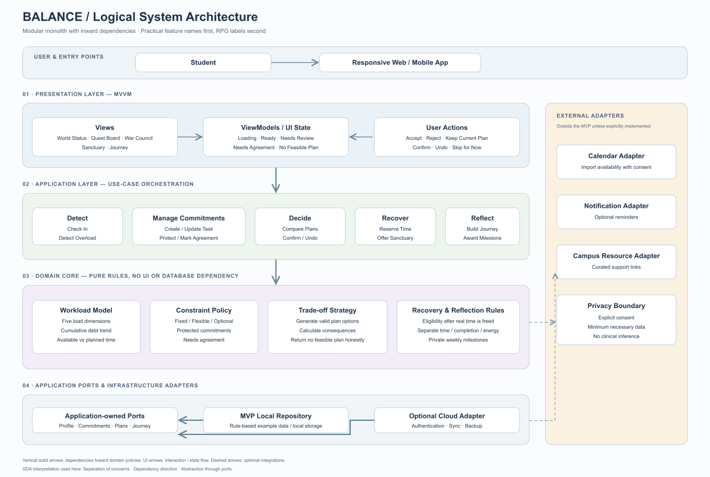

Build plan & scope
The committed build focuses on one complete local decision journey. The current deliverable is a static Figma screen flow. The planned first implementation uses seeded example data and in-memory browser state; changes reset on refresh until a persistence adapter is implemented. Authentication and per-user cloud storage remain stretch work.
Phase | Deliverable | Scope
1. Foundation | Set up the responsive app shell, navigation, shared components and consistent practical/RPG terminology. | Committed
2. Detect | Build task entry, optional check-in, protected commitments, five load dimensions and the capacity-gap state. | Committed
3. Decide | Implement rule-based plan options, consequence summaries, Needs Review, Needs Agreement, No Feasible Plan, Confirm and Undo. | Committed
4. Recover | Reserve genuine free time and provide optional Sanctuary activities with Skip for Now. | Committed
5. Reflect | Create the Journey weekly summary and non-repeatable sustainable planning milestones. | Committed
6. Validate and polish | Test the 3-hour versus 5-hour scenario for comprehension, navigation and consistency; fix unclear copy and states. | Committed
7. Persistence | Add Supabase authentication and per-user storage only after the complete local flow works reliably. | Stretch

Out of Scope for This Build
Machine learning, burnout diagnosis or prediction, therapy claims, automatic messages to lecturers or teammates, live calendar integration, push notifications, social comparison, multiplayer systems, combat mechanics and an equipment economy are outside this build.

References
Features | Todoist. (n.d.).
https://www.todoist.com/features

Finch. Finch Features.
https://help.finchcare.com/hc/en-us/categories/37934152903309-Finch-Features

