Balance — User Guide for Judges
Balance helps a university student whose plan no longer fits the day. It shows how far the day is over capacity, compares safe ways to fix it, changes nothing until the student confirms, protects real free time for rest, and lets the student reflect privately.
Time needed: about 15 minutes for the full walkthrough. Help needed: none.
This guide has three parts:
- Part A — Walkthrough (steps 1–8): do these in order to see the whole journey.
- Part B — Page reference: every button and label on every page, for checking details.
- Part C — Glossary, privacy, troubleshooting and limitations.
About the screenshots. They were taken on a team test account that holds the same sample data as the judge account, on a day called Sunday 11 October. On the judge account the sample day is Sunday 1 November 2026; everything else looks the same.

Part A — Walkthrough

Quick path
Step | Page | What you will do | Time
1 | — | Install, sign in, read the three-page introduction | 2 min
2 | TODAY | See a 2-hour overload, the day's free time and tasks, and five workload bars | 3 min
3 | QUESTS | Open the two tasks behind the overload | 1 min
4 | COUNCIL | Read the suggested fix and confirm it | 2 min
5 | COUNCIL | Check the result, then undo the plan from Plan history | 2 min
6 | SANCTUARY | Protect 30 minutes of rest from a suggested free time, then remove it | 2 min
7 | JOURNEY | See the weekly summary, the achievement wall and a new badge | 2 min
8 | PROFILE | Optional: sound, reminders and overload alerts | 1 min

Before you start
You need | Details
An Android phone | Android 8.0 or later, with internet.
Malaysia time on the phone | Settings → System → Date & time → use automatic time zone. Balance shows times in the phone's time zone.
The Balance app | Latest release → download app-release.apk.
The judge account | Email and password are in our submission form. They are never stored in this repository.
The sample day | Sunday 1 November 2026. On that date Balance opens directly on it.

Shared account. All judges use the same account. Please undo any plan you confirm and remove any recovery time you add (steps 5 and 6), so the next judge sees the same day.

Step 1 — Install, sign in and read the introduction
- On the phone, open the release link and download app-release.apk.
- Open the downloaded file. If Android asks, allow installing apps from this source, then tap Install. If an older Balance build is installed, uninstall it first.
- Open Balance. Enter the judge Email and Password and tap Sign in. Forgot password or need verification? and Create an account are not needed.
- The first time, a three-page introduction appears: Detect, Decide and Recover and reflect. Read each page and tap Next, then Get started. Skip closes it at any time. You can reopen it later from Profile → How Balance works.
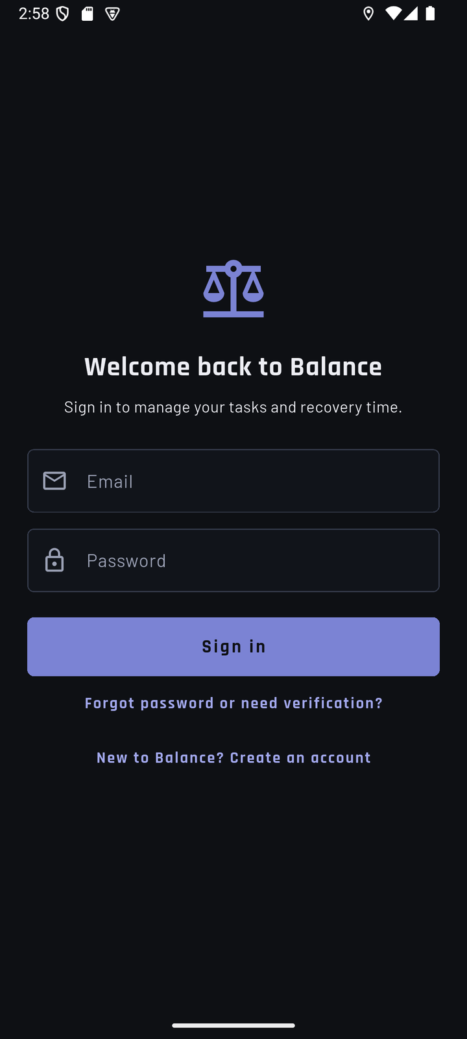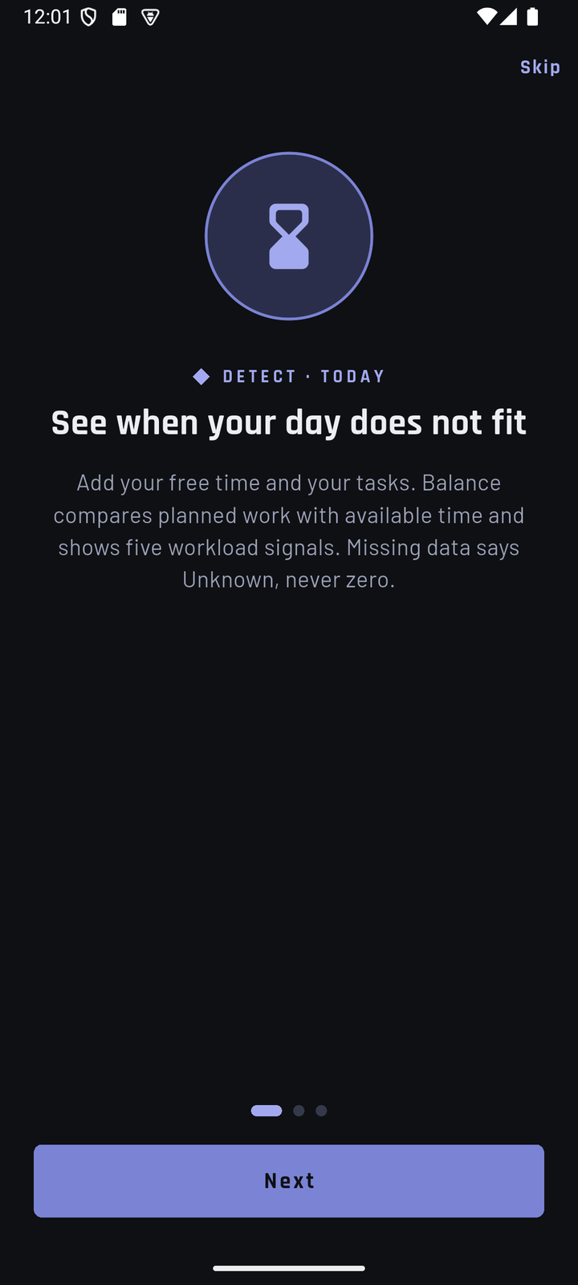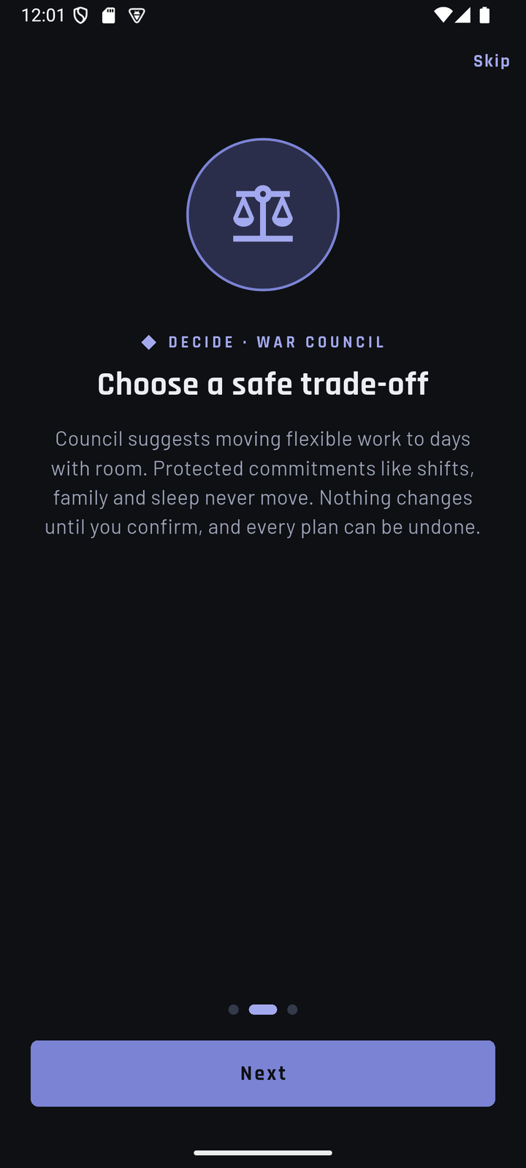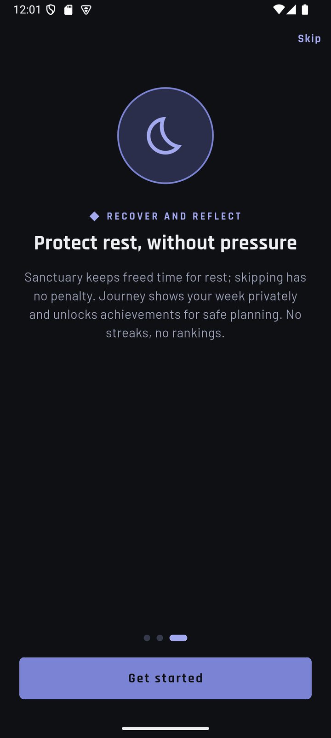
Sign-in screen | Introduction, page 1 of 3 | Introduction, page 2 of 3 | Introduction, page 3 of 3
You now see the TODAY page. If a yellow "Local preview" banner appears, this is not the release build; reinstall from the release link.

Step 2 — See the overload (TODAY)
What you see first. The top of Today answers one question: does the day fit?
- If the date under TODAY is not the sample day, tap the → (Next day) arrow until it is. The middle label says Viewing today, Viewing tomorrow or the date.
- Time capacity shows 3h available and 5h planned. The bar shows the part that fits (blue) and the part beyond capacity (red). The red tag says 2H OVER.
- Below it, the red Capacity gap card states the consequence: 120 minutes must be moved, reduced or recovered. When a day fits, this card is green and says Plan is balanced instead.
- The badge at the top right, LOAD: BUILDING (or Low, High, Over capacity), summarises the five workload bars further down. It is about workload, not about whether time fits.
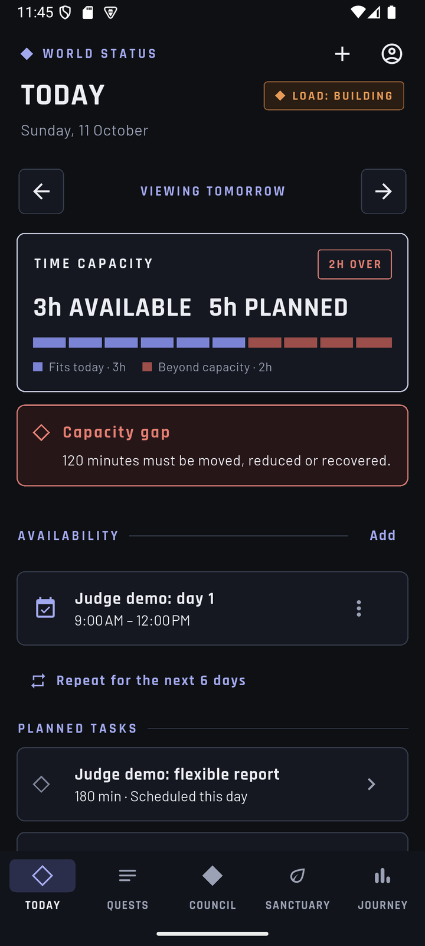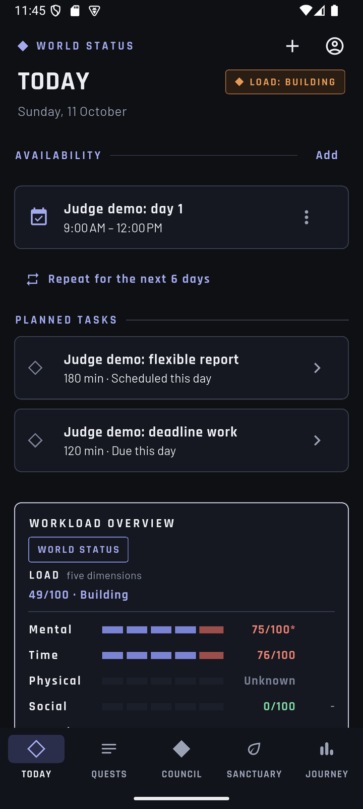
Today: capacity and verdict | Today: availability and planned tasks
The day's time and work. Scroll down a little.
- Availability lists the free time on this day: Judge demo: day 1, 9:00 AM – 12:00 PM.
  - Add (or + at the top) adds another time block.
  - The ⋮ menu on a block offers Edit and Delete.
  - Repeat for the next 6 days copies this day's time to the coming days. An empty day shows Copy from (previous day) instead. On the shared judge account, please only look at these two buttons, so the sample week stays the same.
- Planned tasks lists what counts on this day: Judge demo: flexible report (180 min, scheduled this day) and Judge demo: deadline work (120 min, due this day). Tap a task to see why it counts on this day.
The five workload bars. Scroll further.
- Workload Overview · World Status shows the Load total (for example 49/100 · Building) and five bars in a fixed order: Mental, Time, Physical, Social, Errands.
  - Each bar is a score from 0 to 100; higher means more planning pressure.
  - A bar with no data says Unknown. Balance never treats missing data as zero.
  - An asterisk (∗) after a score means it is partial: some of its inputs are unknown.
  - ▲ / ▼ next to a bar shows its change since yesterday (▲ more pressure, ▼ less), only when the previous day also has a record. A dash means no change.
  - Calamity · workload trend says Rising, Stable, Easing or Not enough history.
- Tap How is this calculated? to open one line per bar: the score and its main reason (for example Time · 76/100 — 300 min planned; 180 min available). Tap a bar's line for the full breakdown. The last line reminds you that this is a planning aid, not a health assessment.
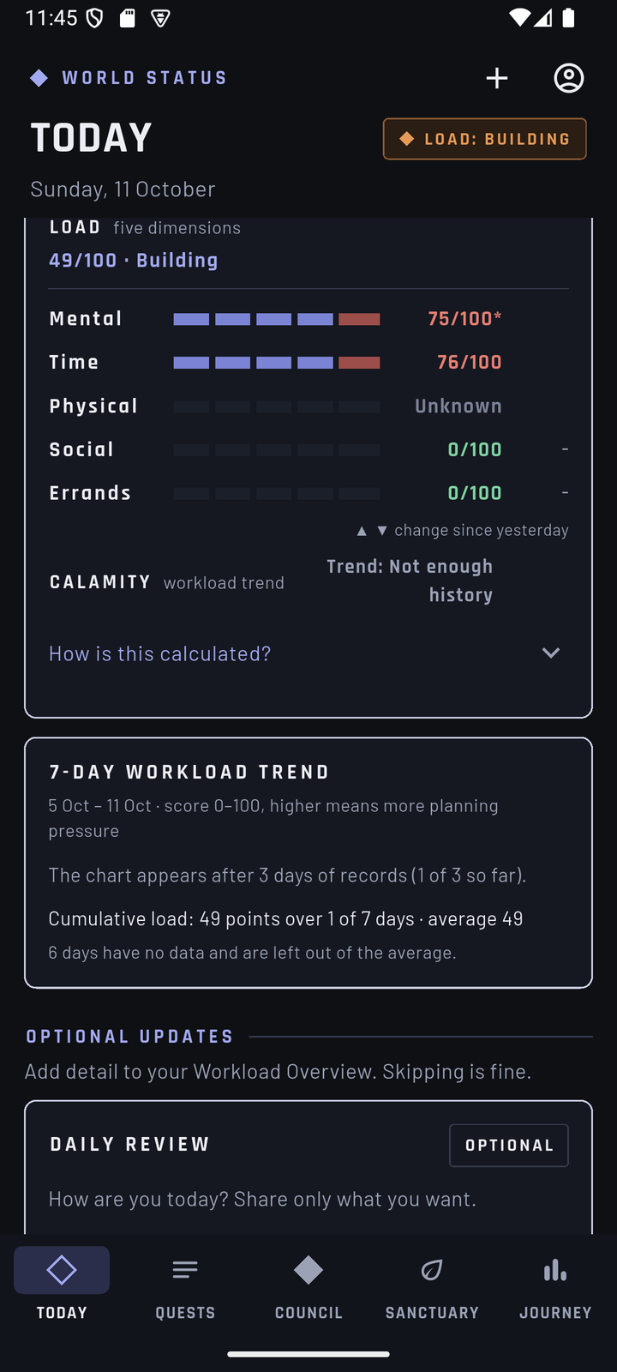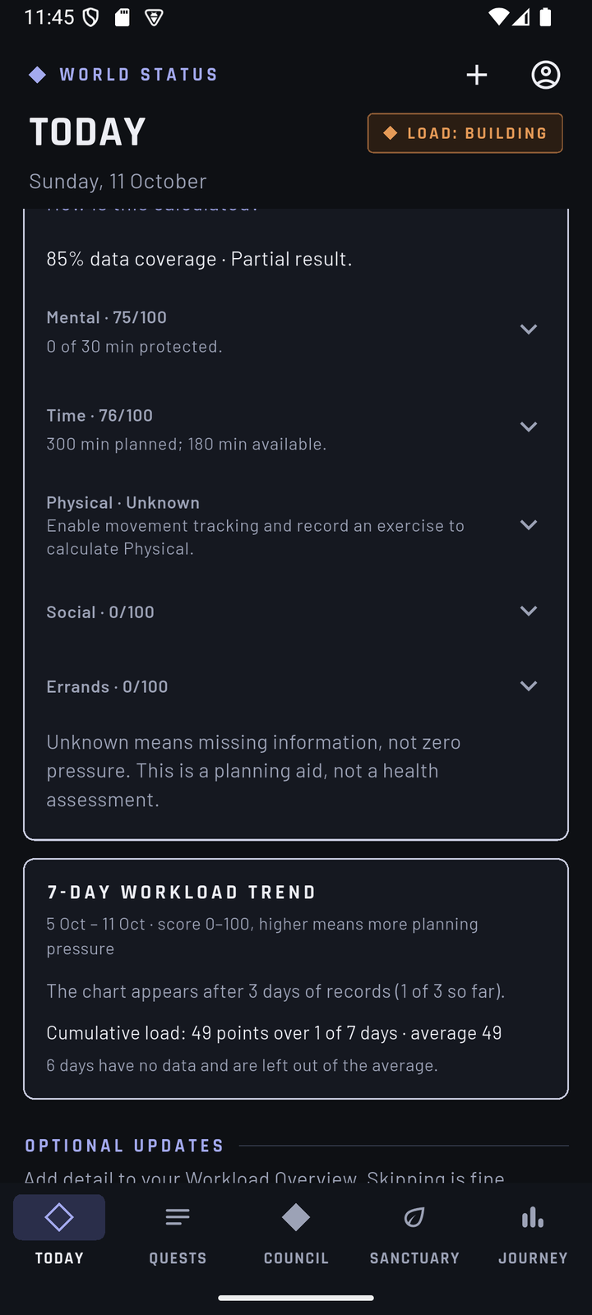
Today: five workload bars | Today: how the scores are calculated
Optional updates. At the bottom of Today.
- 7-day workload trend shows each day's total once at least three days are recorded; before that it says how many days are recorded so far. Missing days are never invented.
- Optional updates add detail to the workload bars. Skipping them has no penalty.
  - Daily Review — Add review asks for mental energy, physical energy and hours of rest; Skip for now is always available.
  - Movement — Track movement turns on the Physical bar, with a preferred interval and Record exercise.
  - Social — expand it to add a social event or mark No commitments this week.
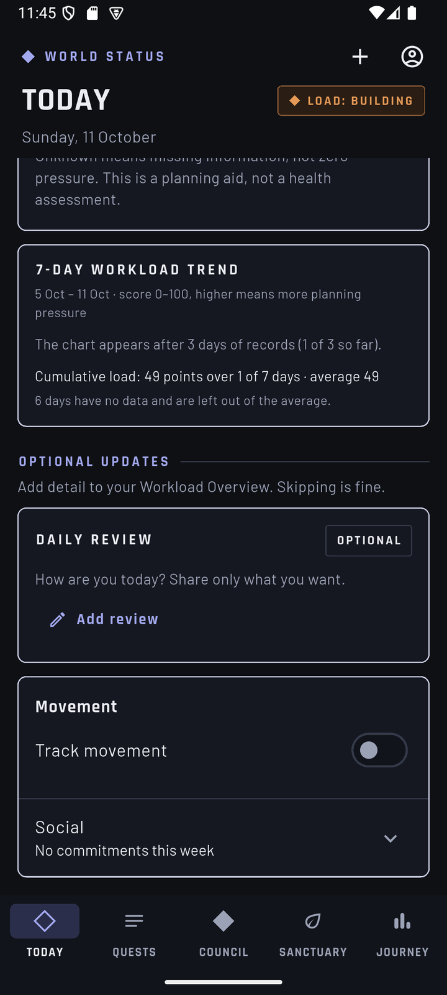
Today: trend and optional updates

Step 3 — Look at the tasks (QUESTS)
- Tap QUESTS in the bottom bar. The page title is TASKS (Quest Board), with a count such as 2 entries · 0 protected.
- The sample tasks are below. Together they need 5 hours, but the sample day has only 3 hours free.
Task | Length | Scheduled | Deadline
Judge demo: flexible report | 3h | 9:00 AM – 12:00 PM on the sample day | The next day, 5:00 PM
Judge demo: deadline work | 2h | Not scheduled | The sample day, 5:00 PM

- Tap a task card to open its details: remaining time, due date, scheduled time, category, flexibility and status, with an Edit task button.
- Optional: tap + to see the new task form, then close it without saving. A task needs a Title, Estimated minutes, Due date and time and a Task category; the form explains each category. Flexibility (Flexible, Fixed, Needs agreement), Protected task, Optional task and Schedule work time are set here too.
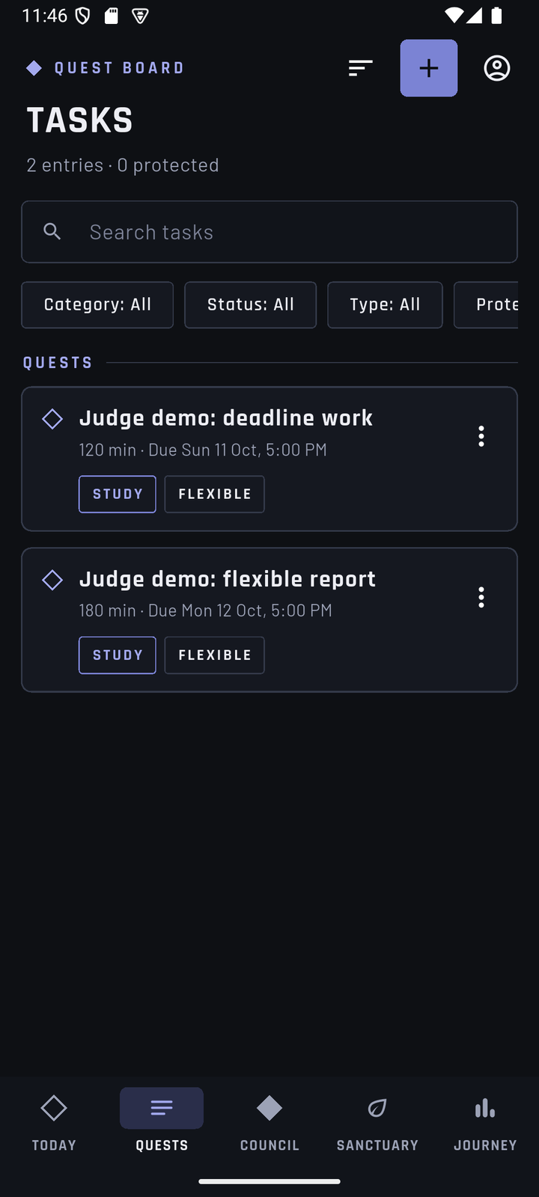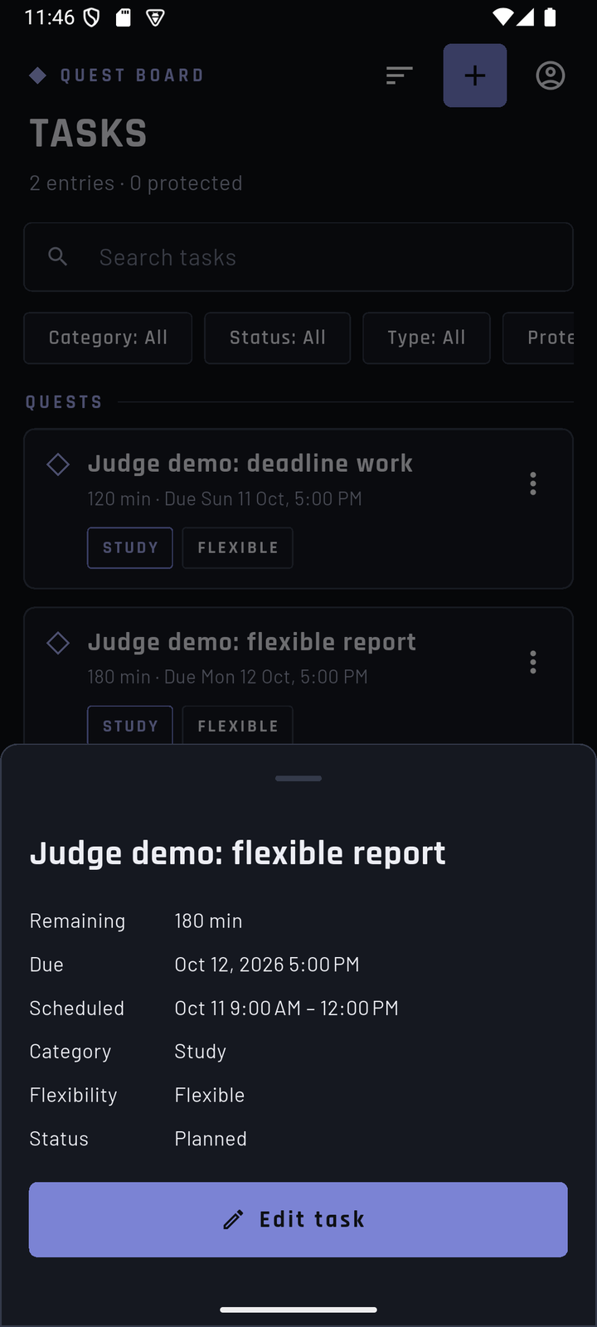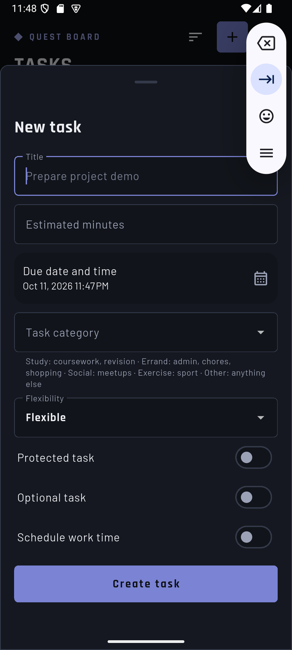
Quest Board | Task details | New task form

Step 4 — Read the suggested fix and confirm it (COUNCIL)
- Tap COUNCIL. The page is COMPARE PLANS (War Council). Use the arrows so the date reads the sample day.
- The top repeats the problem: Over capacity, 300 MIN planned → 180 MIN available, Capacity gap: 120 minutes. What stays protected lists anything Council will never move (none on the sample day). The tag FEASIBLE means at least one safe option exists.
- Under Choose a plan — Suggestions only. Nothing moves until confirmed. — the option reads Move Judge demo: flexible report to (the next day): Move 120 minutes, 9:00 AM – 11:00 AM, before the deadline. Tap See trade-offs on the card to read the cost on the next day, what stays protected, the room created and anything to check.
- Tap the option to select it (it shows SELECTED), then tap Confirm selected plan. The plan is saved at once; the server checks every rule again before saving. A soft chime plays if sound effects are on.
- Plan confirmed lists what moved and offers Undo this plan and Return to Today.
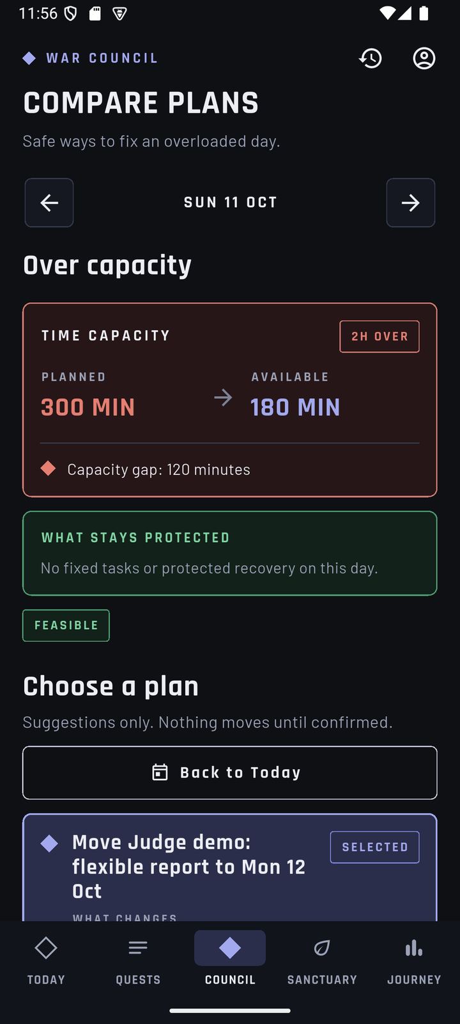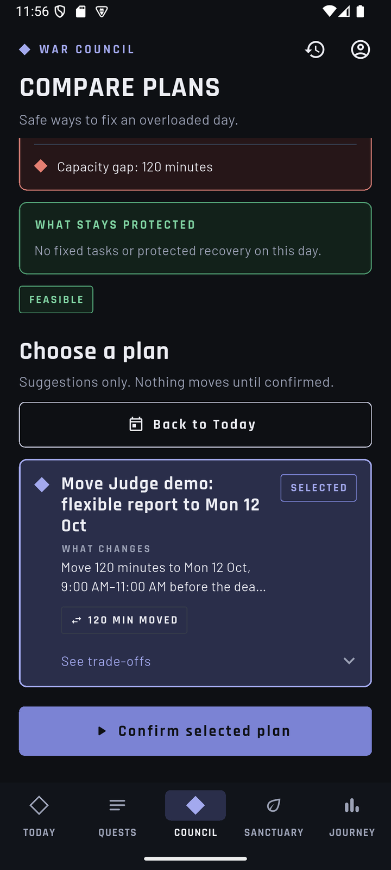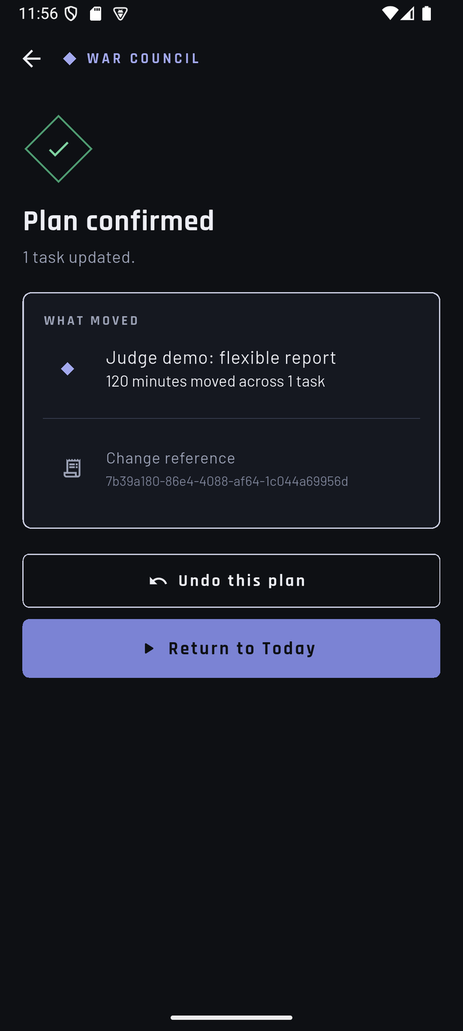
Council: the problem | Council: the suggested option | Plan confirmed
- Tap Return to Today and move to the next day: it now shows the 2 moved hours and still fits. The sample day is no longer over capacity.
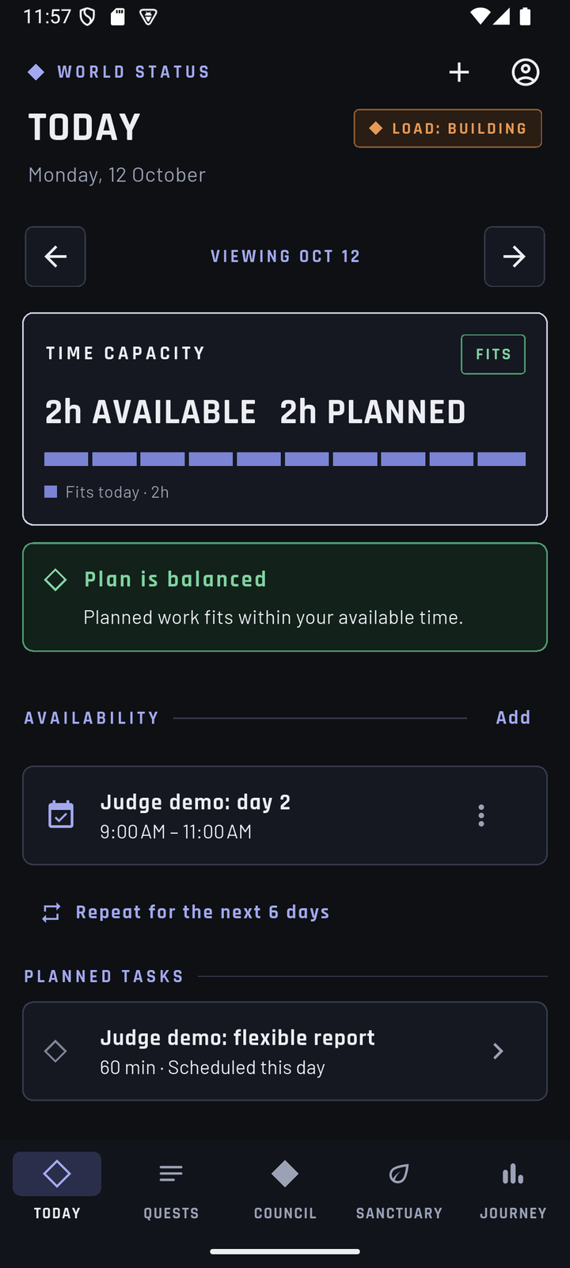
The next day after confirming

Step 5 — Undo the plan (COUNCIL → Plan history)
Any confirmed plan can be undone, even after leaving the result screen.
- Open COUNCIL and tap the Plan history icon (clock) at the top right.
- Tap the plan marked Confirmed. Its screen shows what moved; tap Undo this plan.
- Changes were undone confirms the task was restored. On TODAY, the sample day is 2H OVER again and the next day is free.
If the task was edited after the plan was confirmed, Undo is refused with an explanation instead of overwriting the newer change.
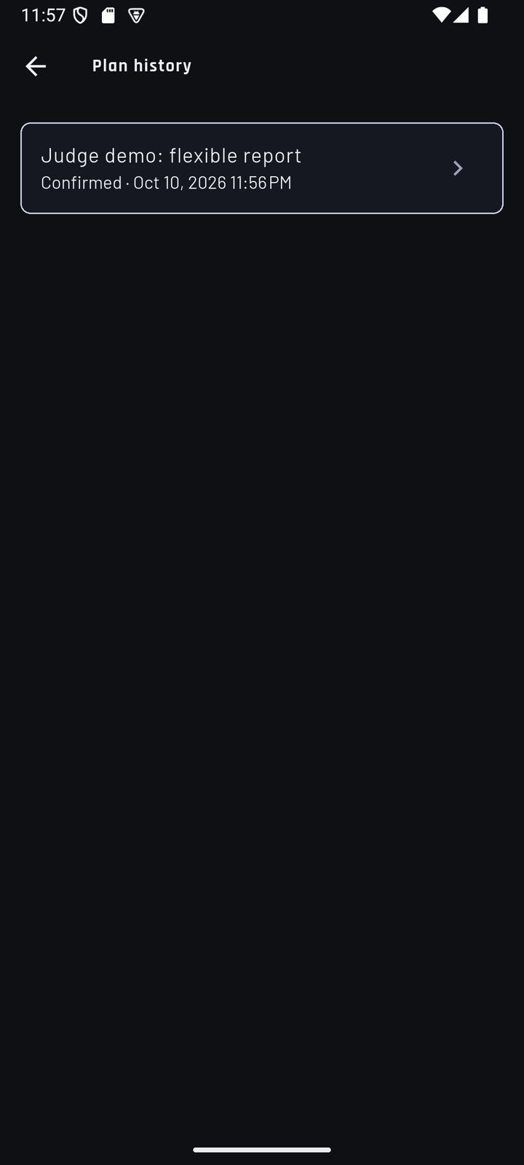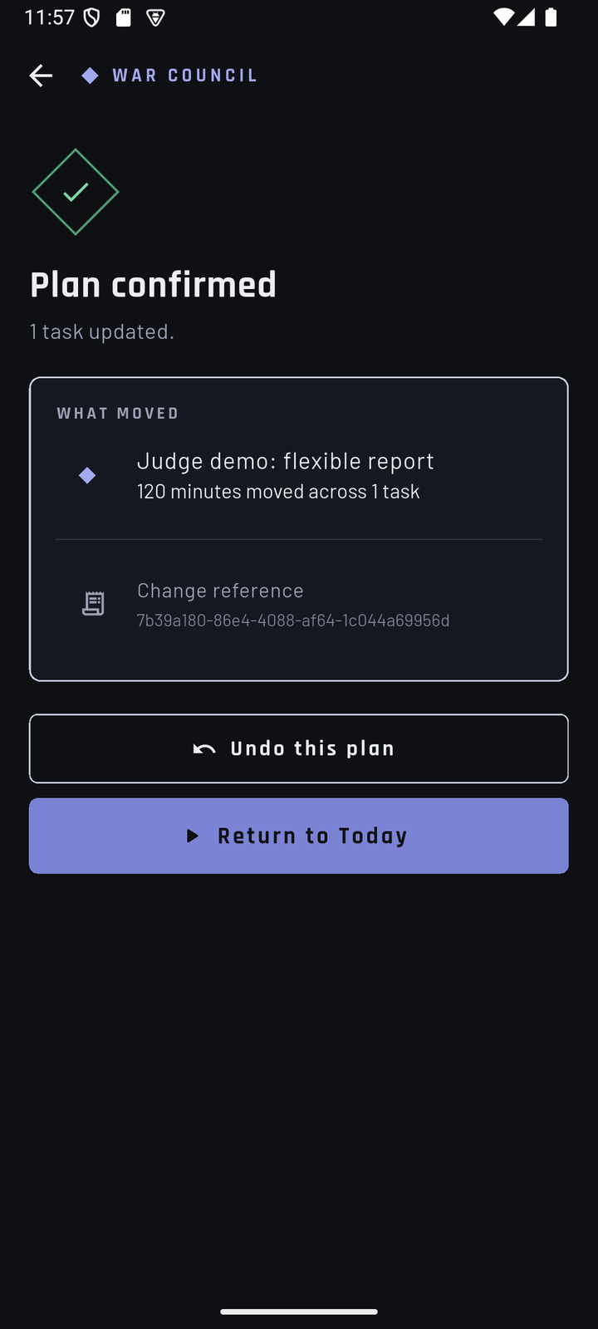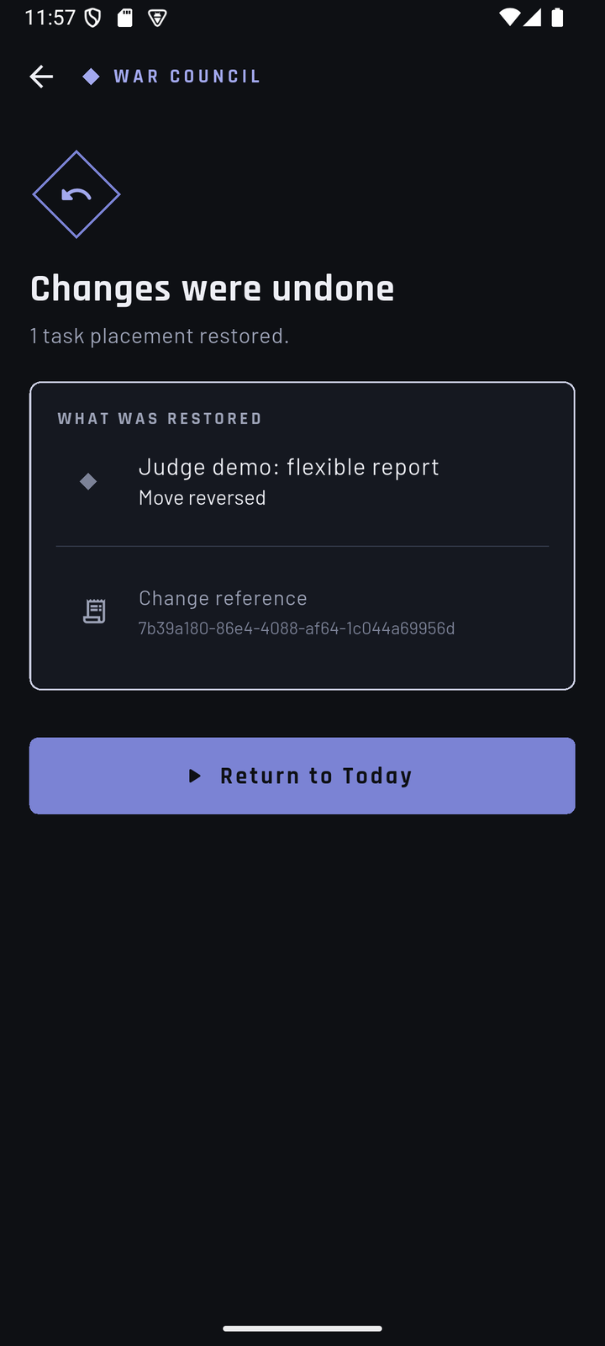
Plan history | A confirmed plan with Undo | Changes were undone
Please always undo your plan, so the sample day stays ready for the next judge.
On a day that already fits, Council shows one line instead of options: No changes needed. Your plan fits this day.
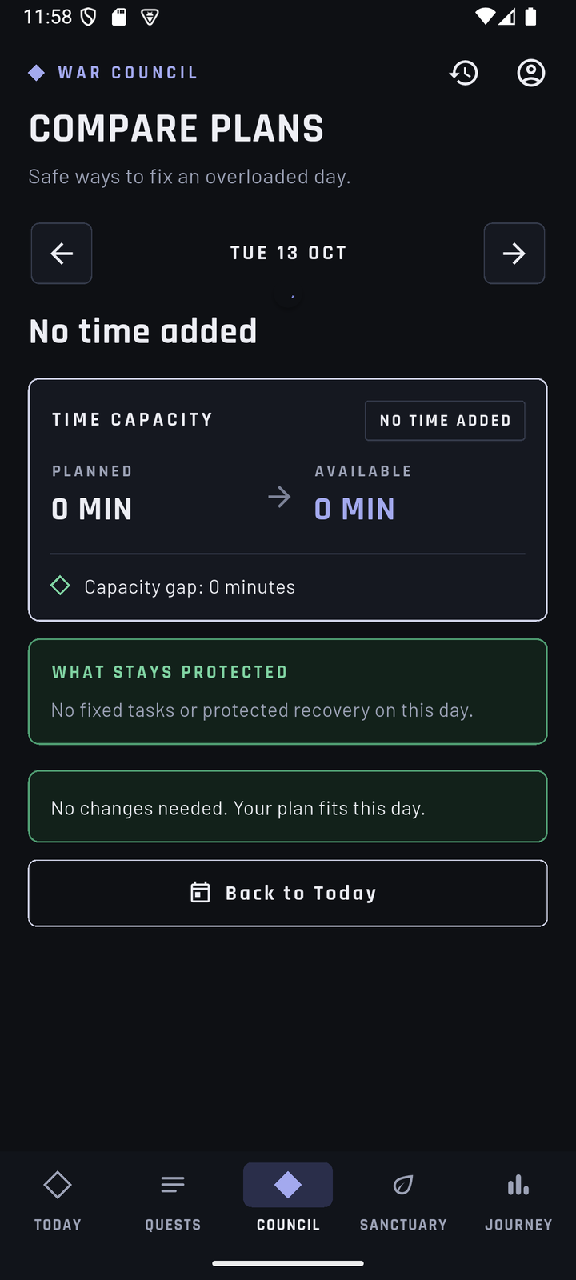
Council on a day that fits

Step 6 — Protect rest time (SANCTUARY)
Recovery time is optional, and Balance only lets you protect time that is genuinely free.
- Tap SANCTUARY. The page is RECOVERY TIME. With no slots yet it says No recovery time yet and offers Add recovery time (also the + at the top).
- Tap Add recovery time. The form Protect recovery time finds free time for you: the sample day is fully booked, so it shows Free on (the next day) with the suggestion 9:00 AM – 11:00 AM · 2h free, already selected as Start 9:00 AM and End 9:30 AM. Tap another suggestion, or tap Start or End to pick a time yourself.
- Something to do with it lists optional ideas (Short walk, Phone-free rest, Sleep preparation, Grounding exercise, Reflection prompt, Visit a campus support service, Something else). The slot is protected whether or not you choose one.
- Tap Save. The slot appears as Protected time · TIME RESERVED.
- Please remove it afterwards: open its ⋮ menu → Remove → Remove. A slot on the next day would use the free time that the Council plan in step 4 needs.
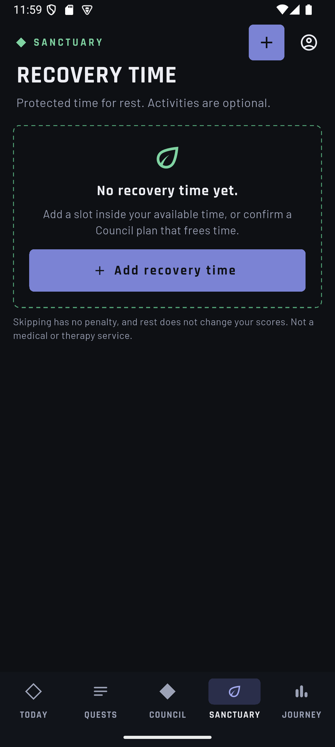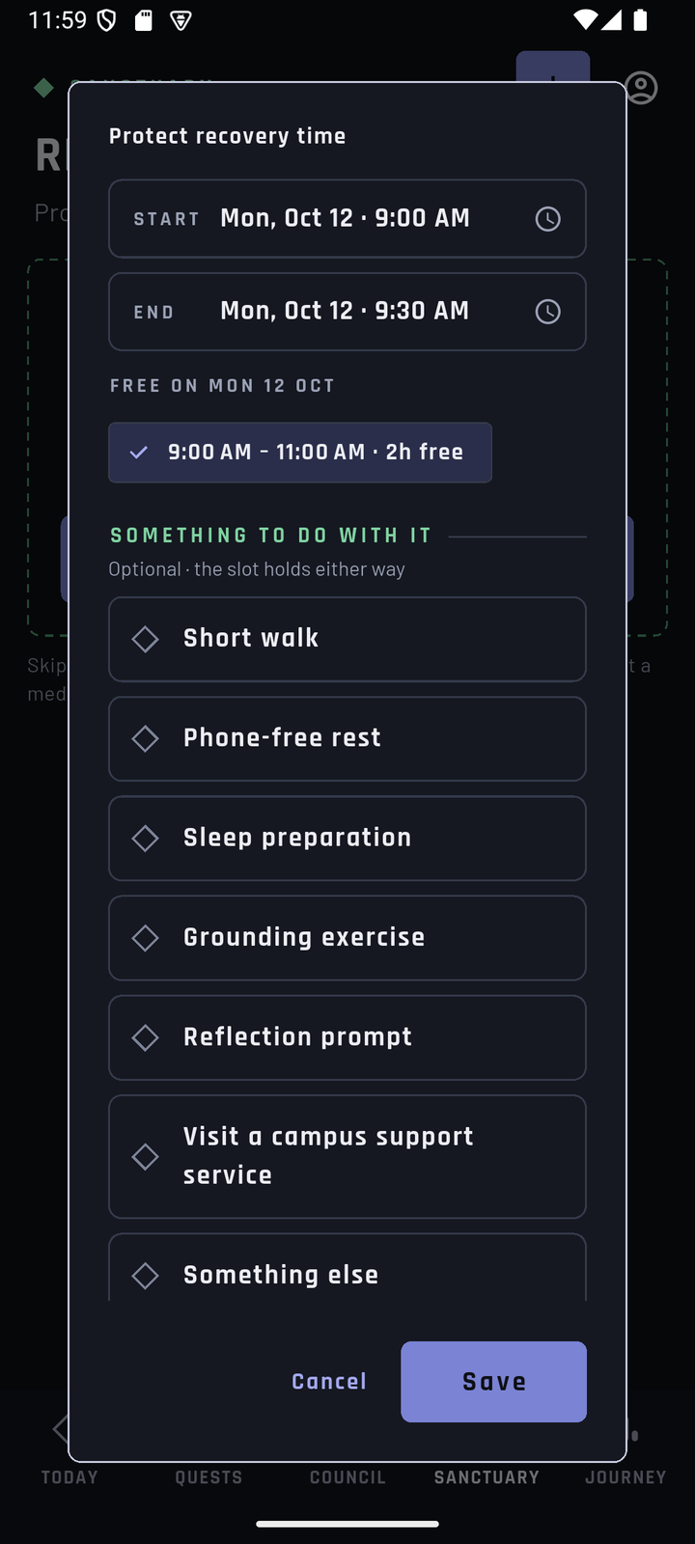
Sanctuary with no slots | Protect recovery time with suggestions
If you choose a time outside the available time, Balance explains why and offers Go to Today or Choose another time. Marking an activity done never changes a workload score; rest is not graded, and skipping it has no penalty.

Step 7 — Weekly summary and achievement wall (JOURNEY)
- Tap JOURNEY. The page is WEEKLY REFLECTION. Use the week arrows to reach the week of the sample day.
- Weekly pattern shows the recorded World Status score for each day; days without a record show no bar, and past scores are never invented. Recovery kept counts days with protected recovery.
- Optional: Add optional reflection opens a short private note (What worked for you this week?). The My reflections icon (clock) at the top lists earlier reflections.
- Achievements is a wall of seven badges. Earned badges glow gold with their date; locked badges are dimmed with a lock. Tap a badge to see how it is earned.
- Confirming the plan in step 4 can earn Safe Trade-off (Wise Strategist) and Deadline Safety (Deadline Guardian). A newly earned badge is celebrated once with an ACHIEVEMENT UNLOCKED animation and a chime. Badges are earned once per account, so some may already be unlocked if another judge used the account first.
- Team Coordination stays Locked: it needs shared tasks, planned for a later version.
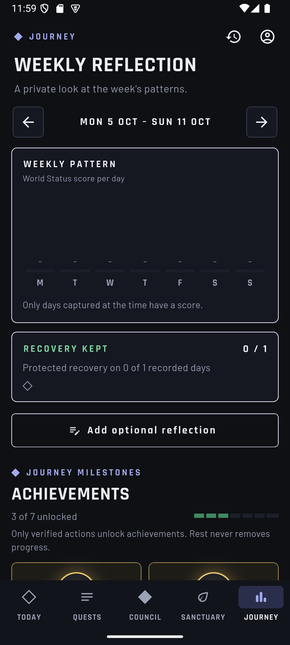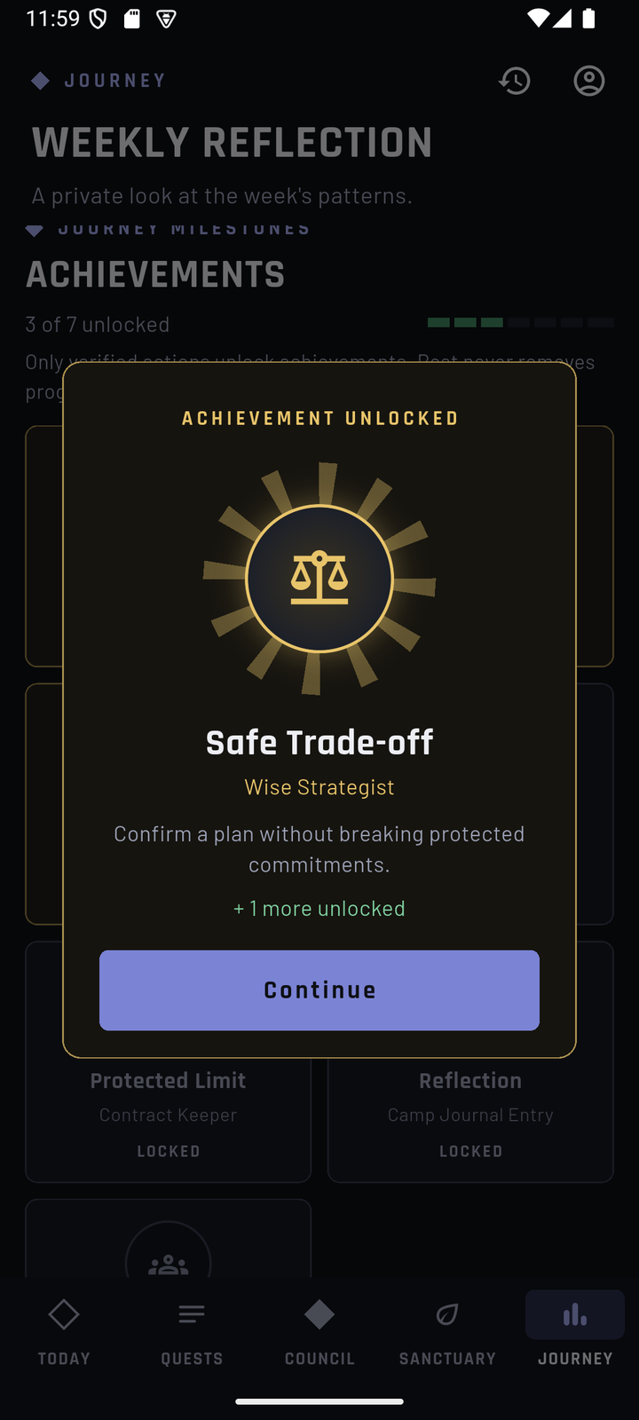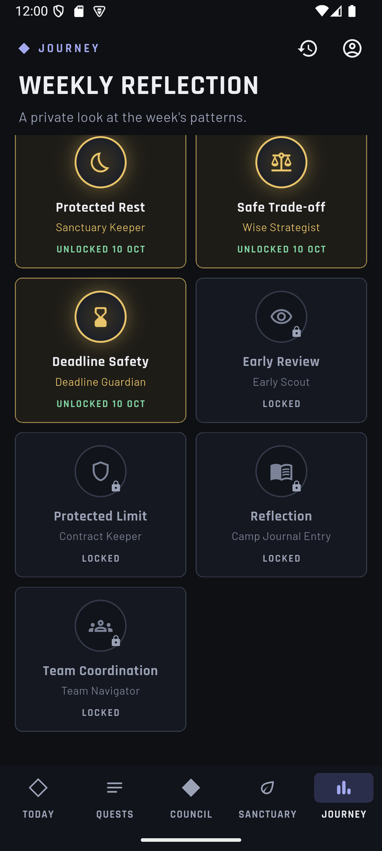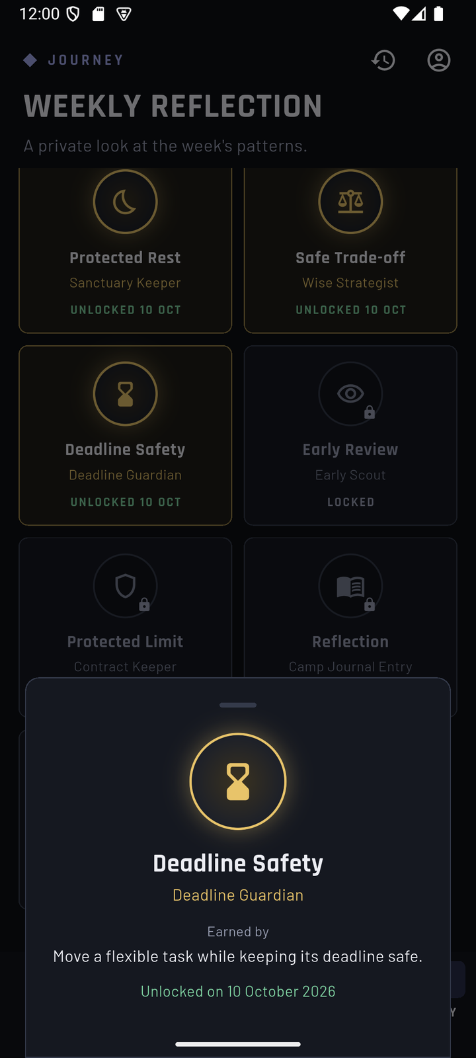
Journey weekly summary | Achievement unlocked | Achievement wall | Badge details
There are no streaks, rankings or penalties for skipping.

Step 8 — Profile, sound, reminders and alerts (optional)
- Tap the round profile icon at the top right of any main page.
- Profile shows the signed-in account, Signed in · Changes are saved to your account, the Planning time zone (Asia/Kuala_Lumpur), a Plan summary and the same World Status score as Today.
- How Balance works reopens the introduction.
- Sound effects (on by default) plays chimes for confirmed plans and new achievements. Relaxing background music (off by default) plays a calm ambient loop and pauses when the app is in the background. All audio is original to Balance.
- Reminders and alerts:
  - Deadline reminders — a reminder a set time before each task deadline.
  - Overload alerts — a notification the evening before a day with more planned work than available time; Alert time defaults to 8:00 PM.
  - Quiet hours — reminders and alerts are skipped between Start and End.
  - Both are off by default and ask for notification permission when turned on.
- Sign out ends the session on this phone.
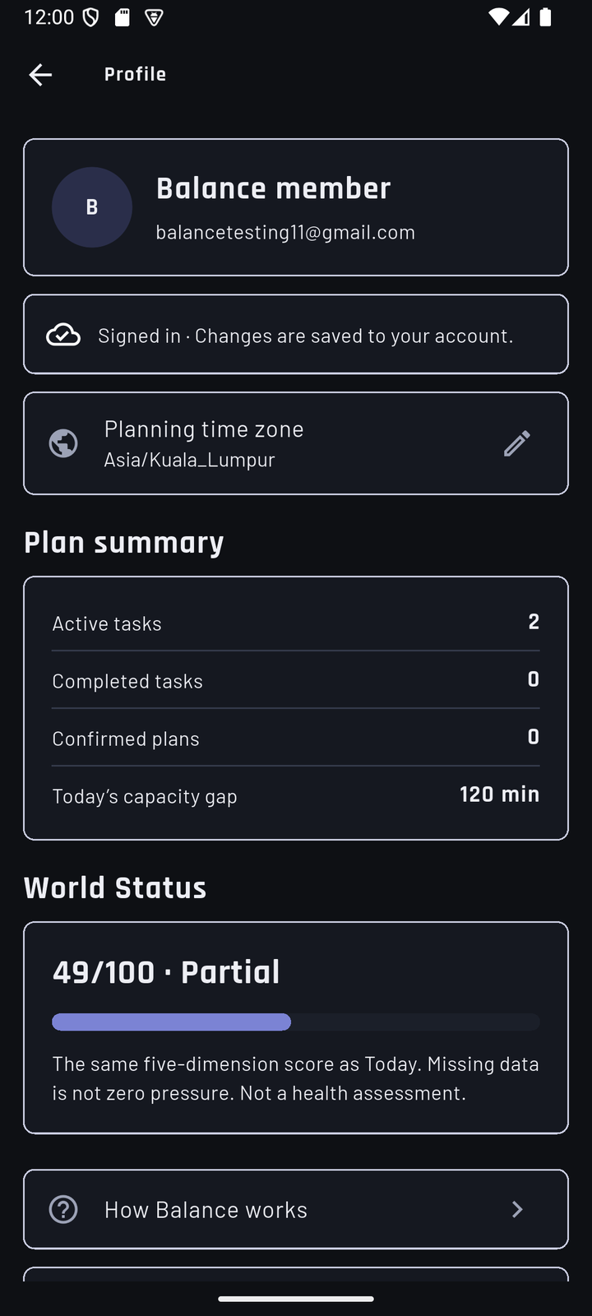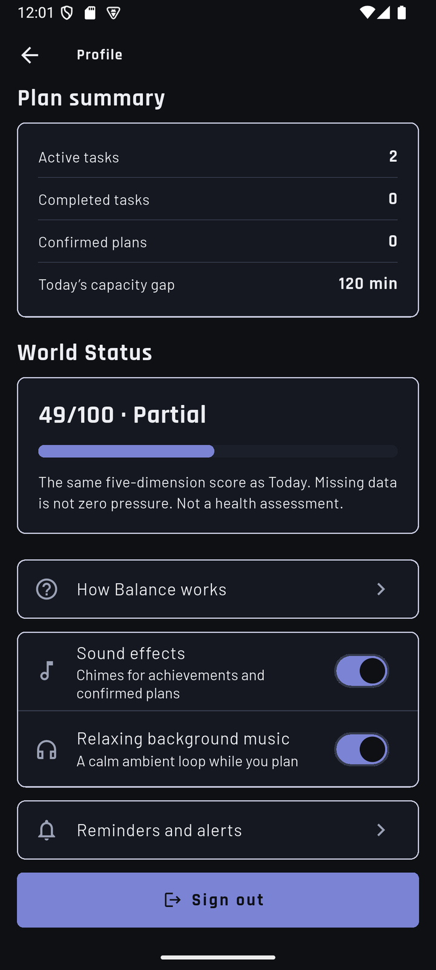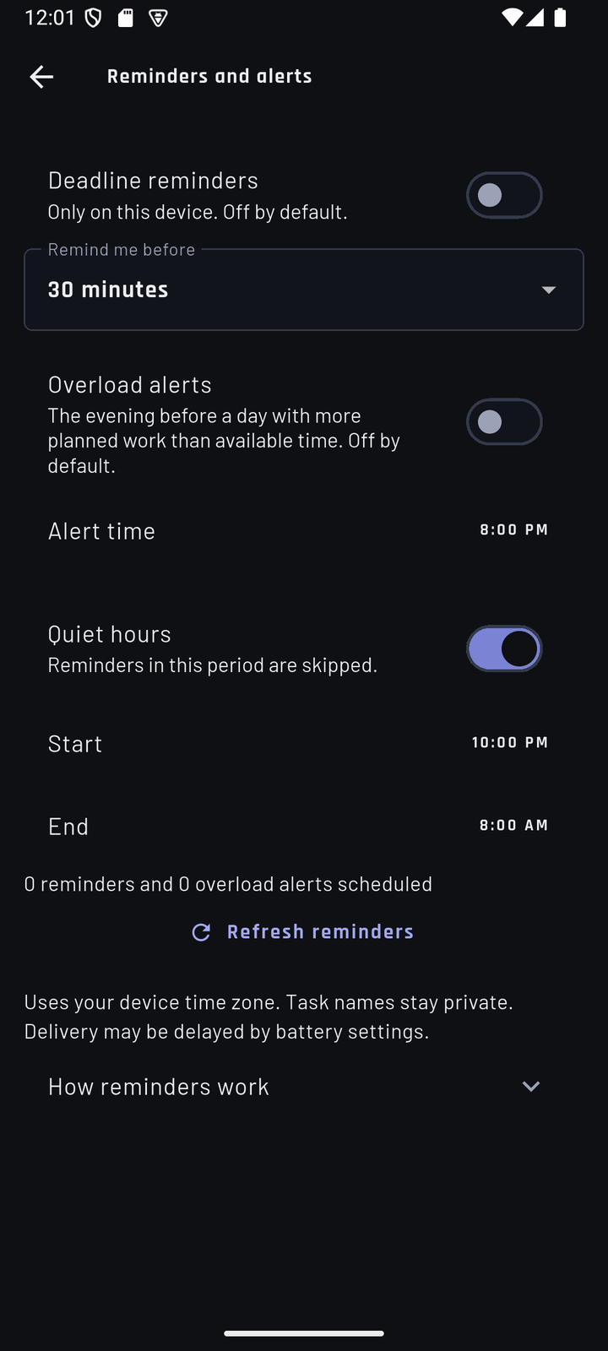
Profile | Profile settings | Reminders and alerts

Part B — Page reference

Bottom bar and header
Element | What it does
TODAY, QUESTS, COUNCIL, SANCTUARY, JOURNEY | The five main pages. The phone's Back gesture returns to Today, then leaves the app.
Eyebrow label (e.g. WORLD STATUS) and title (e.g. TODAY) | The game-style label and the practical page name.
Round profile icon | Opens Profile.
Clock icon | Plan history on Council; My reflections on Journey.
+ | Today: add a time block. Quests: add a task. Sanctuary: add recovery time.

TODAY (World Status)
Element | Meaning
LOAD: Low / Building / High / Over capacity / No data | Summary of the five workload bars (0–24 Low, 25–49 Building, 50–74 High, 75–100 Over capacity).
← Viewing … → | Change the day shown.
Time capacity | Planned vs available time; tag FITS, NO TIME ADDED or …H OVER.
Capacity gap / Plan is balanced | The verdict for the day.
I reviewed this overload | Appears for an overload with a later deadline; recording it early can earn Early Review.
Availability | Free time blocks; Add, ⋮ Edit/Delete, Copy from, Repeat for the next 6 days.
Planned tasks | Work that counts on this day; tap for details.
Workload Overview | Load total and the five bars, ▲/▼ changes, Calamity trend, How is this calculated?
7-day workload trend | Daily totals for the last seven days once three are recorded.
Optional updates | Daily Review, Movement, Social.

QUESTS (Quest Board)
Element | Meaning
Sort icon | Sort tasks (for example Due soonest).
Search | Filter by title.
Category / Status / Type / Protection chips | Filters; Clear filters resets them.
Sections | Sacred contracts (protected), Quests, Finished.
Tags | OVERDUE, the category (STUDY, ERRAND, SOCIAL, EXERCISE, OTHER), flexibility (FLEXIBLE, FIXED, NEEDS AGREEMENT), PROTECTED. An old task without a category shows Uncategorized · Needs Review.
⋮ menu | Mark as done / Mark as not done, Edit, Delete. Marking an Exercise task done asks whether to record the exercise; Skip records nothing.
Tap a card | Task details with Edit task.

COUNCIL (War Council)
Element | Meaning
Status tag | FEASIBLE (a safe option exists), NEEDS REVIEW (information missing), NEEDS AGREEMENT (someone else must agree), NO FEASIBLE PLAN (no safe move).
What stays protected | Fixed and protected tasks and protected recovery that will not move.
Option card | What moves, where and when; See trade-offs shows cost, protection, room created and checks.
Confirm selected plan | Saves the selected option after the server re-checks it.
No safe move found | Explains why (for example a task with no start time, or recovery time using the only free time) and offers Review tasks or Add free time on Today.
Plan history | Every confirmed plan; open one to Undo this plan.

SANCTUARY (Recovery time)
Element | Meaning
Add recovery time | Opens Protect recovery time with free-time suggestions.
Slot card | Protected time, the time, TIME RESERVED; ⋮ Edit/Remove; Activity done once it has started.
Footer | Skipping has no penalty; rest does not change scores; not a medical service.

JOURNEY (Weekly reflection)
Element | Meaning
Week arrows | Change the week shown.
Weekly pattern | Recorded daily scores; no bar means no record.
Recovery kept | Days with protected recovery out of recorded days.
Add optional reflection / My reflections | Write and read private notes.
Achievements | Seven badges; tap one for its condition and date.

The seven achievements
Badge | RPG name | Earned by
Protected Rest | Sanctuary Keeper | Protecting a sleep or recovery slot.
Safe Trade-off | Wise Strategist | Confirming a plan without breaking protected commitments.
Deadline Safety | Deadline Guardian | Moving a flexible task while keeping its deadline safe.
Early Review | Early Scout | Reviewing an overload before the deadline day.
Protected Limit | Contract Keeper | Protecting a work shift, family duty or sleep minimum.
Reflection | Camp Journal Entry | Saving an optional reflection.
Team Coordination | Team Navigator | Marking a shared task as Needs Agreement (later version).

Part C — Glossary, privacy, troubleshooting and limitations

Glossary
Practical name | RPG label | Meaning
Workload Overview | World Status | Today's capacity, verdict and five workload bars.
Tasks and protected commitments | Quest Board, Sacred contracts | Your tasks; protected ones never move.
Plan comparison | War Council | Safe ways to fix an overloaded day.
Recovery time | Sanctuary | Protected free time for optional rest.
Weekly reflection | Journey | Private weekly summary and achievements.
Overload alert | Calamity Alert | Optional evening notification before an overloaded day.
Unknown | — | No data yet. Never treated as zero.
Partial (∗) | — | Some inputs of a score are unknown.

Privacy and safety
- Each account sees only its own data; the database enforces this.
- Reflections and the weekly summary are private. There are no rankings or comparisons.
- Notifications use generic wording without task titles.
- Crash reports contain errors only: no screenshots, IP address or email.
- Balance is a planning aid. Its scores describe recorded planning data; it is not a medical, diagnostic or mental-health tool.

If something goes wrong
What you see | What to do
"Could not connect" with Try again | Check the internet connection, then tap Try again. Data already on screen stays visible.
The sample day is not 2h over | Check that you are on the sample day. If a plan is still confirmed, undo it in COUNCIL → Plan history.
Times look several hours off (for example availability at 1:00 AM) | Set the phone to Malaysia time (Settings → System → Date & time → automatic time zone), then reopen Balance.
Council shows No Feasible Plan on the sample day | A recovery slot is using the next day's free time; the explanation names it. Remove it in SANCTUARY (step 6.5).
The introduction does not appear | It shows once per phone. Open Profile → How Balance works.
No sound | Check Profile → Sound effects and the phone's media volume.
Sign-in fails | Check the email and password from the submission form for typing errors.
"Can't install app" | Uninstall any earlier Balance build first, then install again.

What Balance does not claim
- Android is the supported platform. iOS has not been tested on a device, and the web build is not part of this submission.
- Every task needs a deadline; a "No deadline" option is not available yet.
- Shared tasks and the Team Coordination badge are planned for a later version.
- The app is currently English-only. Bahasa Melayu and Chinese are planned.

