# Coursera Data Science Capstone Project

## Airbnbs in Staten Island

**Introduction/Business Problem**: As a topic for my capstone project I choose to analyse the Airbnb market in New York. I will try to find the connection between prices and some features as minimum nights, venues nearby the flat and the number of reviews the flat takes. It will help the investors to decide weather buy a flat with lower airbnb prices or higher prices. They can consider the number of venues in the district and so on.

**Data**: The data that I will be using is coming from some different sources. Firstly from Kaggle I got a .csv file that contains information about the Airbnb data. I will use the Foursquare API to obtain data about the venues, etc.

Here is a bit of the Airbnb data:

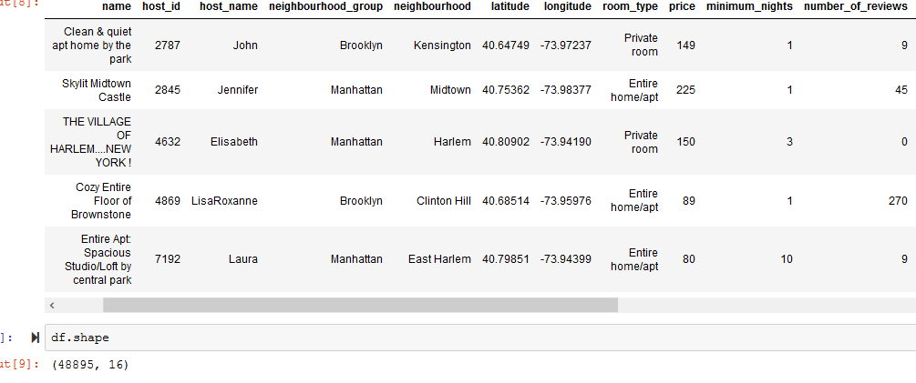

From Foursquare API:

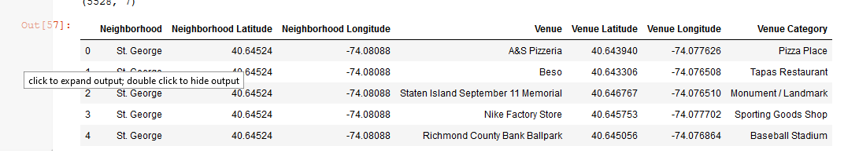

For the final analysis my dataframe is the following:

