MINOR: COMPUTATIONAL MATHEMATICS
Transcendental Equations

Q.1) Finding Real Root using Bisection Method in C Programming.
AIM: To write a C program to find the real root of an equation using the Bisection Method.
Formula:
$$x_{r}=\frac{a+b}{2}$$
Programming Formula:
xr = (a + b) / 2;

Program:
#include <stdio.h>
#include <math.h>
#include <conio.h>
float f(float x) {
return (x * x * x - 4 * x - 9);
}
int main() {
float a = 2, b = 3, xr, fx, fb, fxr;
int intr = 0;
float eps = 0.001;
float prev1 = 0.0, prev2 = 0.0;
int same_count = 0;
clrscr();
fx = f(a);
fb = f(b);
if (fx * fb > 0) {
printf("Root not found in the given interval.\n");
return 0;
}
printf("\nItr\t a\t b\t xr\t f(a)\t f(b)\t f(xr)\n");
printf("-------------------------------------------------------\n");
do {
intr++;
xr = (a + b) / 2;
fxr = f(xr);
fx = f(a);
fb = f(b);
printf("%2d\t%.4f\t%.4f\t%.4f\t%.4f\t%.4f\t%.4f\n",
intr, a, b, xr, fx, fb, fxr);
if (fx * fxr < 0)
b = xr;
else
a = xr;
float xr3 = floor(xr * 1000 + 0.5) / 1000;
if (fabs(xr3 - prev1) < 0.0001 && fabs(prev1 - prev2) < 0.0001)
same_count++;
else
same_count = 0;
prev2 = prev1;
prev1 = xr3;
if (same_count >= 1)
break;
} while (fabs(fxr) > eps);
printf("\nApproximate root (correct up to 3 decimal places) = %.3f\n", prev1);
getch();
return 0;
}

Output:
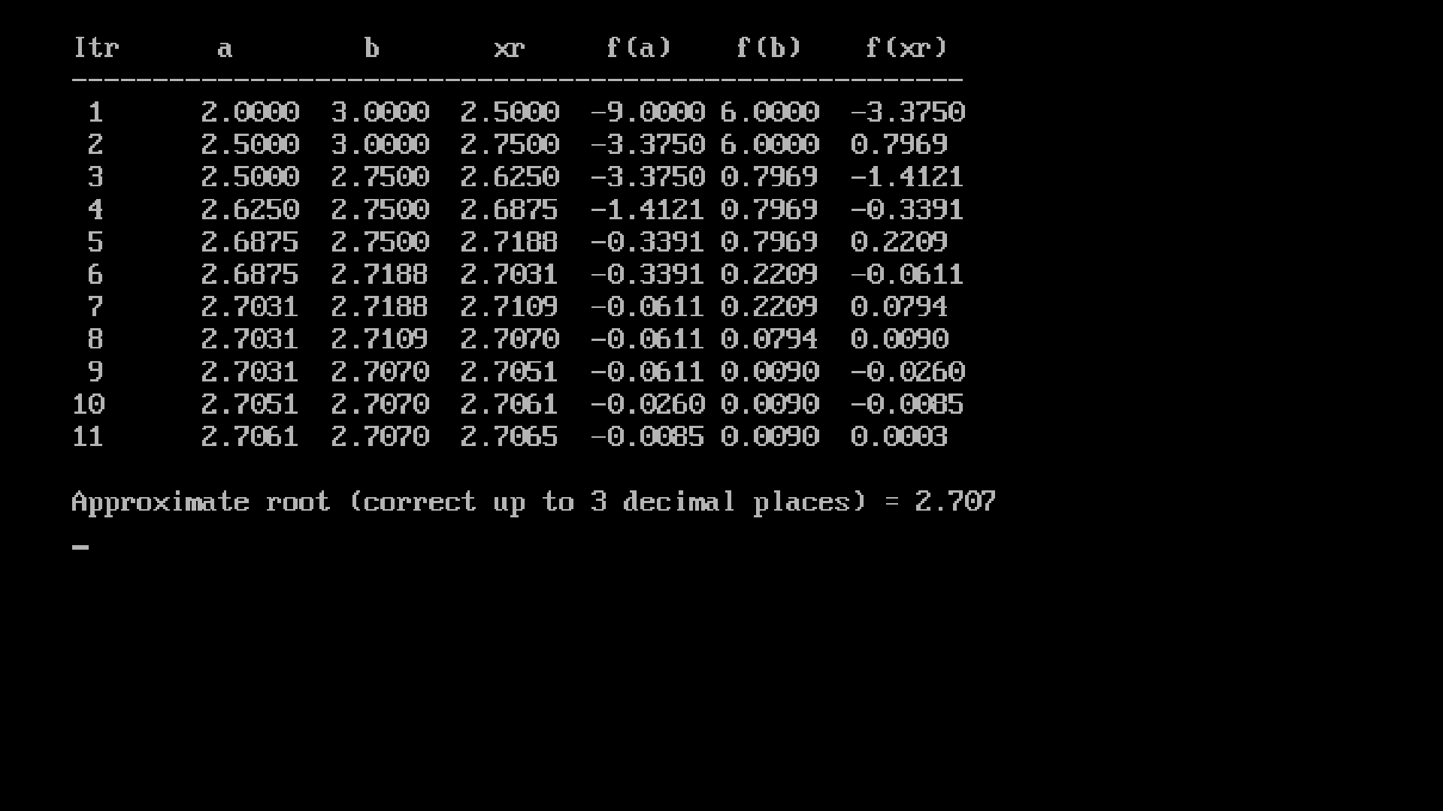
Conclusion: The program was executed successfully.

Q.2) Finding Real Root using Regular Falsi Method in C Programming.
Aim:To write a C program to find the real root of an equation using the Regular Falsi Method.
Formula:
$$x_{r}=\frac{a×f(b)-b×f(a)}{f(b)-f(a)}$$
Programming Formula:
xr = (a * f(b) - b * f(a)) / (f(b) - f(a));
Program:
#include <stdio.h>
#include <conio.h>
#include <math.h>
float f(float x) {
return (x * x * x - 4 * x - 9);
}
int main() {
float a = 2, b = 3, xr, fx, fb, fxr;
int i = 0;
float eps = 0.001;
float prev1 = 0.0, prev2 = 0.0;
int same_count = 0;
clrscr();
fx = f(a);
fb = f(b);
if (fx * fb > 0) {
printf("Root not found in the given interval.\n");
getch();
return 0;
}
printf("\nIter\t a\t\t b\t\t xr\t\t f(a)\t\t f(b)\t\t f(xr)\n");
printf("-----------------------------------------------------------------------------\n");

do {
i++;
xr = (a * fb - b * fx) / (fb - fx);
fxr = f(xr);
fx = f(a);
fb = f(b);
printf("%d\t %.6f\t %.6f\t %.6f\t %.6f\t %.6f\t %.6f\n", i, a, b, xr, fx, fb, fxr);
if (fx * fxr < 0)
b = xr;
else
a = xr;
float xr3 = floor(xr * 1000 + 0.5) / 1000;
if (fabs(xr3 - prev1) < 0.0001 && fabs(prev1 - prev2) < 0.0001)
same_count++;
else
same_count = 0;
prev2 = prev1;
prev1 = xr3;
if (same_count >= 1)
break;
} while (fabs(fxr) > eps);
printf("\nApproximate root (correct up to 3 decimal places) = %.3f\n", prev1);
getch();
return 0;
}

Output:
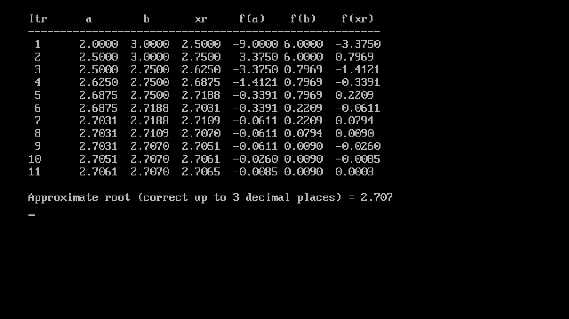
Conclusion: The program was executed successfully.

Q.3) Finding Real Root using Newton–Raphson Method in C Programming
Aim:To write a C program to find the real root of an equation using the Newton–Raphson Method.
Formula:
$$x_{i+1}=x_{i}-\frac{f(x_{i})}{f^{'}(x_{i})}$$
Programming Formula:
x1 = x0 - (f(x0) / f1(x0));
Program:
#include <stdio.h>
#include <conio.h>
#include <math.h>
float f(float x) {
return (x * x * x - 4 * x - 9);
}
float f1(float x) {
return (3 * x * x - 4);
}
int main() {
float x0 = 2, x1, f0, f1x;
int i = 0;
float eps = 0.001;
float prev1 = 0.0, prev2 = 0.0;
int same_count = 0;
clrscr();
printf("\nIter\t x0\t\t f(x0)\t\t f'(x0)\t\t x1\n");
printf("-------------------------------------------------------------\n");
do {
i++;
f0 = f(x0);
f1x = f1(x0);
x1 = x0 - (f0 / f1x);
printf("%d\t %.6f\t %.6f\t %.6f\t %.6f\n", i, x0, f0, f1x, x1);
float x13 = floor(x1 * 1000 + 0.5) / 1000;
if (fabs(x13 - prev1) < 0.0001 && fabs(prev1 - prev2) < 0.0001)
same_count++;
else
same_count = 0;
prev2 = prev1;
prev1 = x13;
if (same_count >= 1)
break;
x0 = x1;
} while (fabs(f0) > eps);
printf("\nApproximate root (correct up to 3 decimal places) = %.3f\n", prev1);
getch();
return 0;
}
Output:
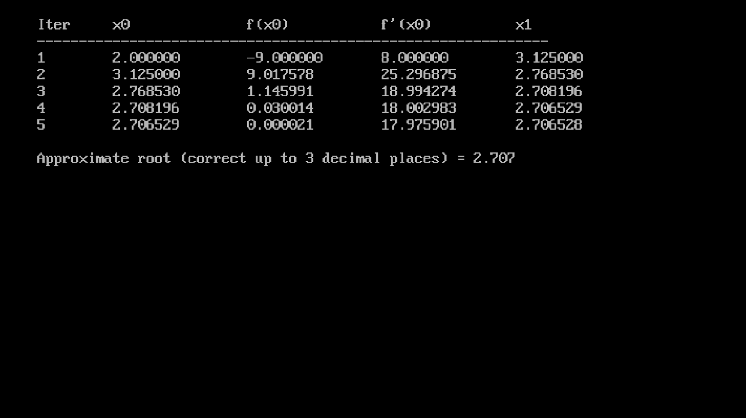
Conclusion: The program was executed successfully.
Interpolation

Q.1) Newton Forward Interpolation Table in C Programming
Aim:To create a Newton Forward Difference Table and interpolate a value using Newton’s Forward Interpolation Formula.
Formula:
$$y\left(x\right)=y_{0}+pΔy_{0}+\frac{i\left(p-1\right)}{2!}Δ^{2}y_{0}+\frac{p\left(p-1\right)\left(p-2\right)}{3!}Δ^{3}y_{0}+…$$
$$p=\frac{x-x_{0}}{h},h=x_{0}-x_{1}$$
Programming Formula:
y_int = y_int + (p_term * diff[0][i]) / fact(i);
p_term = p_term * (p - i);
Program:
#include <stdio.h>
#include <conio.h>
float fact(int num)
{
float f = 1;
int i;
for(i = 2; i <= num; i++)
f = f * i;
return f;
}
int main()
{
int n = 5;
float x[5] = {0, 1, 2, 3, 4};
float y[5][5] = {
{1}, {8}, {27}, {64}, {125}
};
float value = 2.5, h, p, y_int, p_term;
int i, j;
clrscr();
for(j = 1; j < n; j++)
for(i = 0; i < n-j; i++)
y[i][j] = y[i+1][j-1] - y[i][j-1];
printf("\nNewton Forward Difference Table:\n");
printf("x\tf(x)\ty\tDeltay\tDelta2y\tDelta3y\n");
for(i = 0; i < n; i++)
{
printf("%.1f", x[i]);
for(j = 0; j < n-i; j++)
printf("\t%.2f", y[i][j]);
printf("\n");
}
h = x[1] - x[0];
p = (value - x[0]) / h;
y_int = y[0][0];
p_term = 1;
for(i = 1; i < n; i++)
{
p_term = p_term * (p - i + 1);
y_int = y_int + (p_term * y[0][i]) / fact(i);
}
printf("\nValue at x = %.2f is %.4f\n", value, y_int);
getch();
return 0;
}

Output:
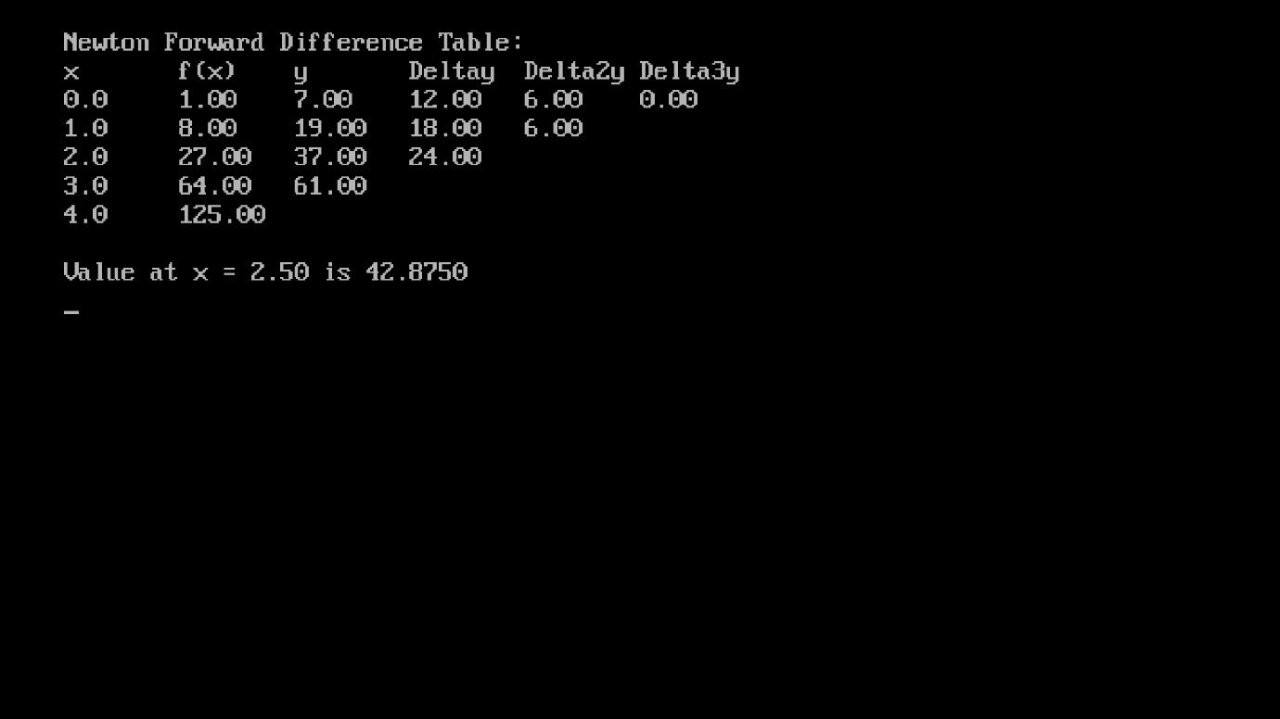
Conclusion: The program was executed successfully.

Q.2) Newton Backward Interpolation Table in C Programming
Aim:To write a C program to create a Newton Backward Difference Table and interpolate a value using Newton’s Backward Interpolation Method.
Formula:
$$y(x)=y_{n}+pΔy_{n}+\frac{p(p+1)}{2!}Δ^{2}y_{n}+\frac{p(p+1)(p+2)}{3!}Δ^{3}y_{n}+…$$
$$p=\frac{x-x_{0}}{h},h=x_{0}-x_{1}$$
Programming Formula:
y_int = y_int + (p_term * diff[n-i-1][i]) / fact(i);
p_term = p_term * (p + i);
Program:
#include <stdio.h>
#include <conio.h>
float fact(int num)
{
float f = 1;
int i;
for(i = 2; i <= num; i++)
f = f * i;
return f;
}
int main()
{
int n = 5;
float x[5] = {0, 1, 2, 3, 4};
float y[5][5] = {
{1}, {8}, {27}, {64}, {125}
};
float value = 3.5, h, p, y_int, p_term;
int i, j;
clrscr();
for(j = 1; j < n; j++)
for(i = n-1; i >= j; i--)
y[i][j] = y[i][j-1] - y[i-1][j-1];
printf("\nNewton Backward Difference Table:\n");
printf("x\tf(x)\tDelta y\tDelta^2 y\tDelta^3 y\tDelta^4 y\n");
for(i = 0; i < n; i++)
{
printf("%.1f", x[i]);
for(j = 0; j <= i; j++)
printf("\t%.2f", y[i][j]);
printf("\n");
}
h = x[1] - x[0];
p = (value - x[n-1]) / h;
y_int = y[n-1][0];
p_term = 1;
for(i = 1; i < n; i++)
{
p_term = p_term * (p + i - 1);
y_int = y_int + (p_term * y[n-1][i]) / fact(i);
}
printf("\nValue at x = %.2f is %.4f\n", value, y_int);
getch();
return 0;
}

Output:
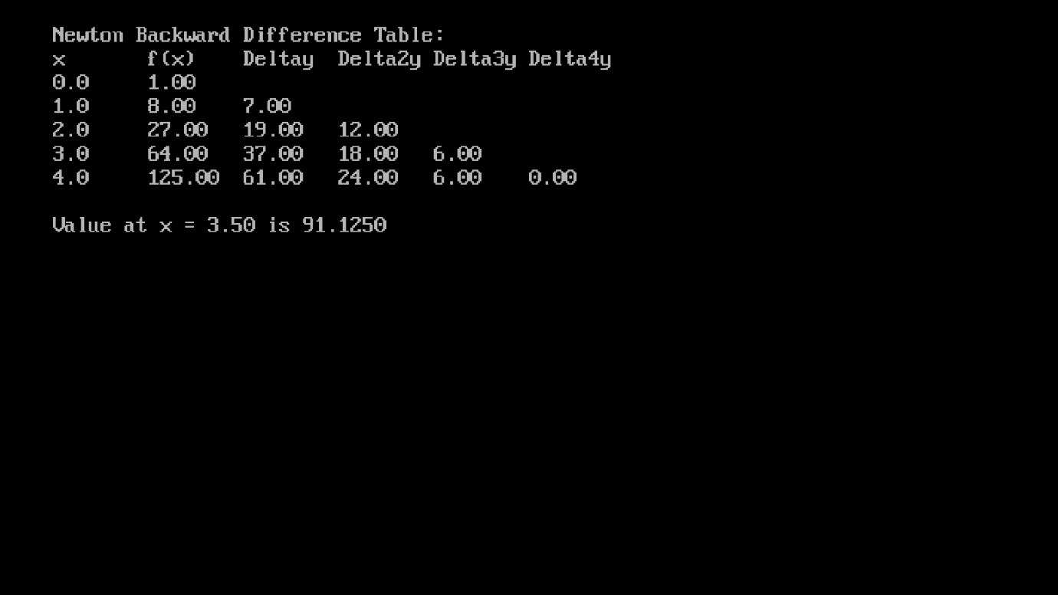
Conclusion: The program was executed successfully.

Numerical Integration

Q.1) To find the approximate value of a definite integral using the Trapezoidal Rule.
Aim:To find the approximate value of a definite integral using the Trapezoidal Rule.
Formula:
$$\int_{a}^{b}{}f(x) dx=\frac{h}{2}[y_{0}+2(y_{1}+y_{2}+y_{3}+⋯+y_{n-1})+y_{n}]$$
Programming Formula :
sum = y0 + yn;
for(i = 1; i < n; i++)
sum += 2 * yi;
area = (h / 2) * sum;
Program:
#include <stdio.h>
#include <math.h>
#include <conio.h>
float f(float x) {
return x*x;
}
int main() {
int n = 4;
float a = 0.0, b = 2.0;
float h, area, sum = 0.0;
int i;
clrscr();
h = (b - a) / n;
sum = f(a) + f(b);
for(i = 1; i < n; i++) {
sum += 2 * f(a + i*h);
}
area = (h / 2) * sum;
printf("Approximate value of the integral: %.4f\n", area);
getch()
return 0;
}
Output:
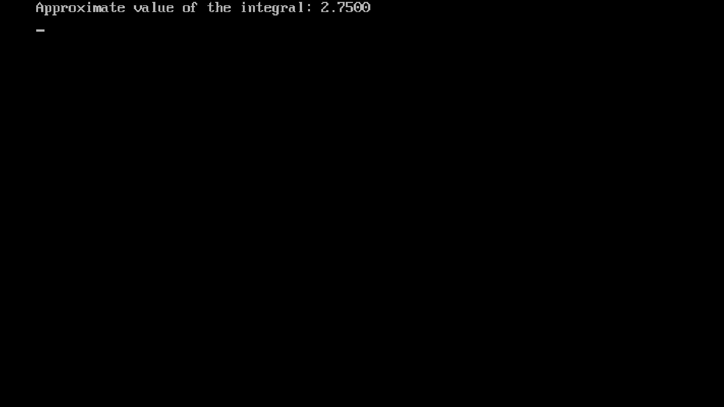
Conclusion: The program was executed successfully.

Q.2):To find the approximate value of a definite integral using Simpson’s 1/3 Rule.
Aim: To calculate the area under the curve using Simpson’s 1/3 Rule.
Formula:
$$\int_{a}^{b}{}f(x)dx≈\frac{h}{3}[y_{0}+4(y_{1}+y_{3}+⋯+y_{n-1})+2(y_{2}+y_{4}+⋯+y_{n-2})+y_{n}]$$
Programming Formula:
sum = y0 + yn;
for(i = 1; i < n; i++) {
if(i % 2 == 0)
sum += 2 * yi;
else
sum += 4 * yi;
}
integral = (h / 3) * sum;
Program:
#include <stdio.h>
#include <math.h>
#include <conio.h>
float f(float x) {
return x*x;
}
int main() {
int n = 4;
float a = 0.0, b = 2.0;
float h, area, sum = 0.0;
int i;
clrscr();
h = (b - a) / n;
sum = f(a) + f(b);
for(i = 1; i < n; i++) {
if(i % 2 == 0)
sum += 2 * f(a + i*h);
else
sum += 4 * f(a + i*h);
}
area = (h / 3) * sum;
printf("Approximate value of the integral (Simpson 1/3): %.4f\n", area);
getch();
return 0;
}
Output:
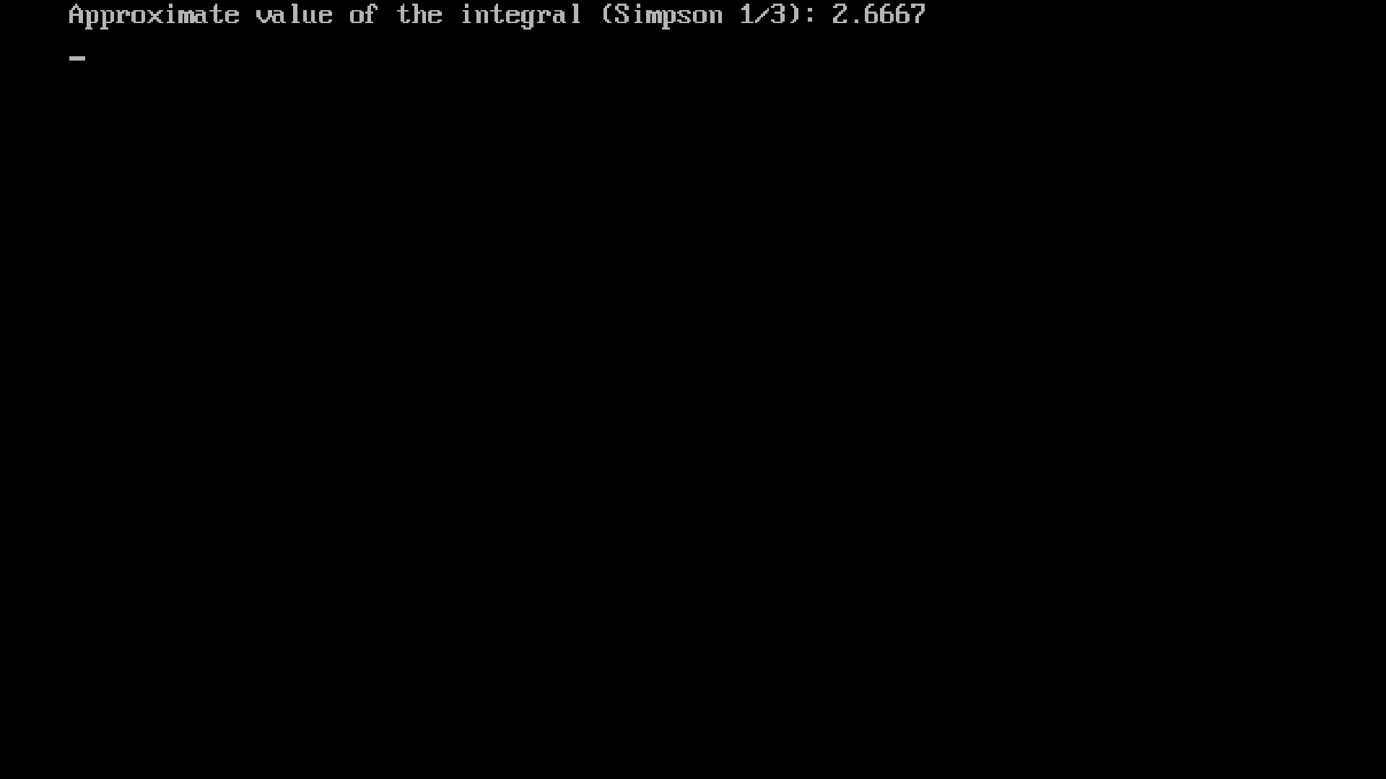
Conclusion: The program was executed successfully.

Q.3) To find the approximate value of a definite integral using Simpson’s 3/8 Rule.
Aim: To calculate the area under the curve using Simpson’s 3/8 Rule.
Formula:
$$\int_{a}^{b}{}f(x)dx≈\frac{3h}{8}[y_{0}+3(y_{1}+y_{2}+y_{4}+y_{5}+… )+2(y_{3}+y_{6}+… )+y_{n}]$$
where
- $n$is a multiple of 3
- $h=\frac{b-a}{n}$
Programming Formula:
sum = y0 + yn;
for(i = 1; i < n; i++) {
if(i % 3 == 0)
sum += 2 * yi;
else
sum += 3 * yi;
}
integral = (3*h/8) * sum;
Program:
#include <stdio.h>
#include <math.h>
#include <conio.h>
float f(float x) {
return x*x;
}
int main() {
int n = 6;
float a = 0.0, b = 2.0;
float h, area, sum = 0.0;
int i;
clrscr();
h = (b - a) / n;
sum = f(a) + f(b);
for(i = 1; i < n; i++) {
if(i % 3 == 0)
sum += 2 * f(a + i*h);
else
sum += 3 * f(a + i*h);
}
area = (3*h / 8) * sum;
printf("Approximate value of the integral (Simpson 3/8): %.4f\n", area);
getch();
return 0;
}
Output:
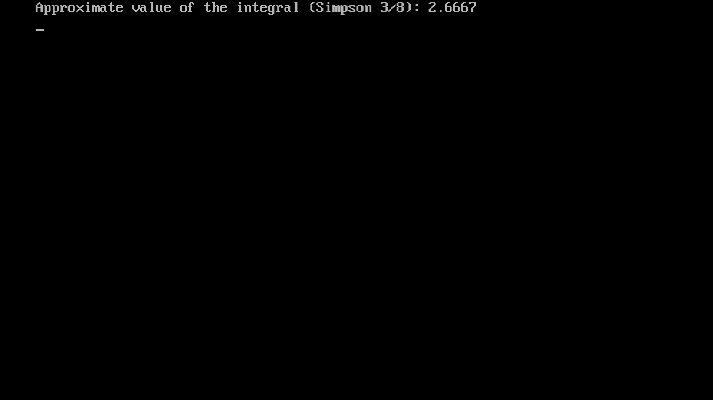
Conclusion: The program was executed successfully.

Curve fitting

Q.1) To find the best-fitting curve for a set of data points using the method of least squares.
Aim:To determine the quadratic curve $y=a+bx+cx^{2}$that best fits the given data points.
Formulas (Least Squares)
$$\{\begin{aligned}∑y_{i}=na+b∑x_{i}+c∑x_{i}^{2} \\ ∑x_{i}y_{i}=a∑x_{i}+b∑x_{i}^{2}+c∑x_{i}^{3} \\ ∑x_{i}^{2}y_{i}=a∑x_{i}^{2}+b∑x_{i}^{3}+c∑x_{i}^{4}\end{aligned}$$
Programming Formula :
sum_x = sum_x2 = sum_x3 = sum_x4 = 0;
sum_y = sum_xy = sum_x2y = 0;
for(i=0; i<n; i++){
sum_x += x[i];
sum_x2 += x[i]*x[i];
sum_x3 += x[i]*x[i]*x[i];
sum_x4 += x[i]*x[i]*x[i]*x[i];
sum_y += y[i];
sum_xy += x[i]*y[i];
sum_x2y += x[i]*x[i]*y[i];
}
a = Da / D;
b = Db / D;
c = Dc / D;

Program:
#include <stdio.h>
#include <conio.h>
int main() {
clrscr();
int n = 5;
float x[] = {1, 2, 3, 4, 5};
float y[] = {2.2, 2.8, 3.6, 4.5, 5.1};
float sum_x=0, sum_x2=0, sum_x3=0, sum_x4=0;
float sum_y=0, sum_xy=0, sum_x2y=0;
int i;
for(i=0; i<n; i++){
sum_x += x[i];
sum_x2 += x[i]*x[i];
sum_x3 += x[i]*x[i]*x[i];
sum_x4 += x[i]*x[i]*x[i]*x[i];
sum_y += y[i];
sum_xy += x[i]*y[i];
sum_x2y += x[i]*x[i]*y[i];
}
float D = n*(sum_x2*sum_x4 - sum_x3*sum_x3) - sum_x*(sum_x*sum_x4 - sum_x2*sum_x3) + sum_x2*(sum_x*sum_x3 - sum_x2*sum_x2);
float Da = sum_y*(sum_x2*sum_x4 - sum_x3*sum_x3) - sum_x*(sum_xy*sum_x4 - sum_x2y*sum_x3) + sum_x2*(sum_xy*sum_x3 - sum_x2y*sum_x2);
float Db = n*(sum_xy*sum_x4 - sum_x2y*sum_x3) - sum_y*(sum_x*sum_x4 - sum_x2*sum_x3) + sum_x2*(sum_x*sum_x2y - sum_y*sum_x2);
float Dc = n*(sum_x2*sum_x2y - sum_x3*sum_xy) - sum_x*(sum_x*sum_x2y - sum_x3*sum_y) + sum_y*(sum_x*sum_x3 - sum_x2*sum_x2);
float a = Da / D;
float b = Db / D;
float c = Dc / D;
printf("Quadratic curve fitting equation: y = %.4f + %.4fx + %.4fx^2\n", a, b, c);
getch();
return 0;
}

Output:
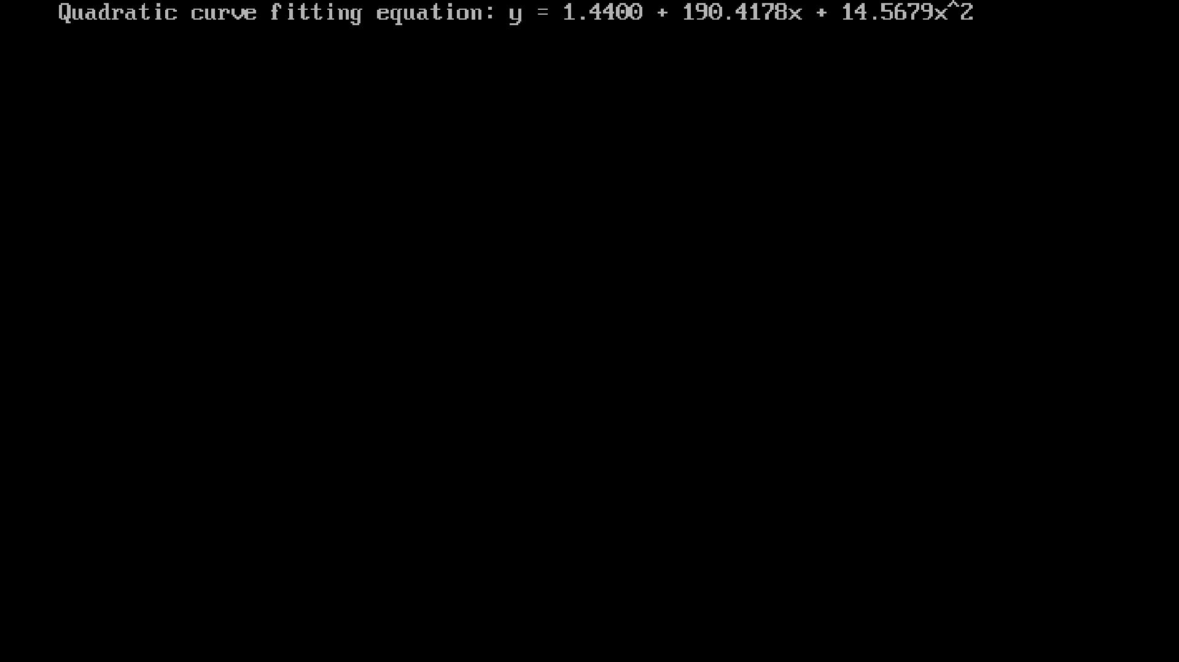
Conclusion: The program was executed successfully.

Q.1) Runge–Kutta 4th Order Method in C Programming.
Aim: To solve the differential equation $y^{'}=x+y$using the Fourth Order Runge–Kutta Method and compute the values of $y$for the given step size.
Formula:
$$k_{1}=h f(x_{0},y_{0}) \\ k_{2}=h f(x_{0}+\frac{h}{2}, y_{0}+\frac{k_{1}}{2}) \\ k_{3}=h f(x_{0}+\frac{h}{2}, y_{0}+\frac{k_{2}}{2}) \\ k_{4}=h f(x_{0}+h, y_{0}+k_{3})$$
Weighted average slope:
$$k=\frac{k_{1}+2k_{2}+2k_{3}+k_{4}}{6}$$
Final update formula:
$$y_{1}=y_{0}+k \\ x_{1}=x_{0}+h$$
Programming Formula:
k1 = H * f(x, y);
k2 = H * f(x + H/2, y + k1/2);
k3 = H * f(x + H/2, y + k2/2);
k4 = H * f(x + H, y + k3);

kavg = (k1 + 2*k2 + 2*k3 + k4) / 6;

y = y + kavg;
x = x + H;

Program:
#include <stdio.h>
#include <math.h>
#include <conio.h>
double f(double x, double y) {
return x + y;
}
void runge_kutta_4th_order_solve() {
const double X0 = 0.0;
const double Y0 = 1.0;
const double H = 0.1;
const int N = 5;
double x = X0, y = Y0;
double k1, k2, k3, k4;
int i;
clrscr();
printf("---- RK4 Method ----\n");
printf("y' = x + y , h=%.1f\n", H);
printf("Step | x | y | k1 | k2 | k3 | k4 | kavg\n");
printf("-----------------------------------------------------------------------\n");
printf("0 | %7.4f | %7.4f |\n", x, y);
for (i = 1; i <= N; i++) {
k1 = H * f(x, y);
k2 = H * f(x + H/2, y + k1/2);
k3 = H * f(x + H/2, y + k2/2);
k4 = H * f(x + H, y + k3);
double kavg = (k1 + 2*k2 + 2*k3 + k4) / 6.0;
y = y + kavg;
x = x + H;
printf("%-4d | %7.4f | %7.4f | %7.4f | %7.4f | %7.4f | %7.4f | %7.4f\n",
i, x, y, k1, k2, k3, k4, kavg);
}

printf("-----------------------------------------------------------------------\n");
printf("Final y(%.1f) = %.6f", x, y);
}
int main() {
runge_kutta_4th_order_solve();
getch();
return 0;
}
Code:
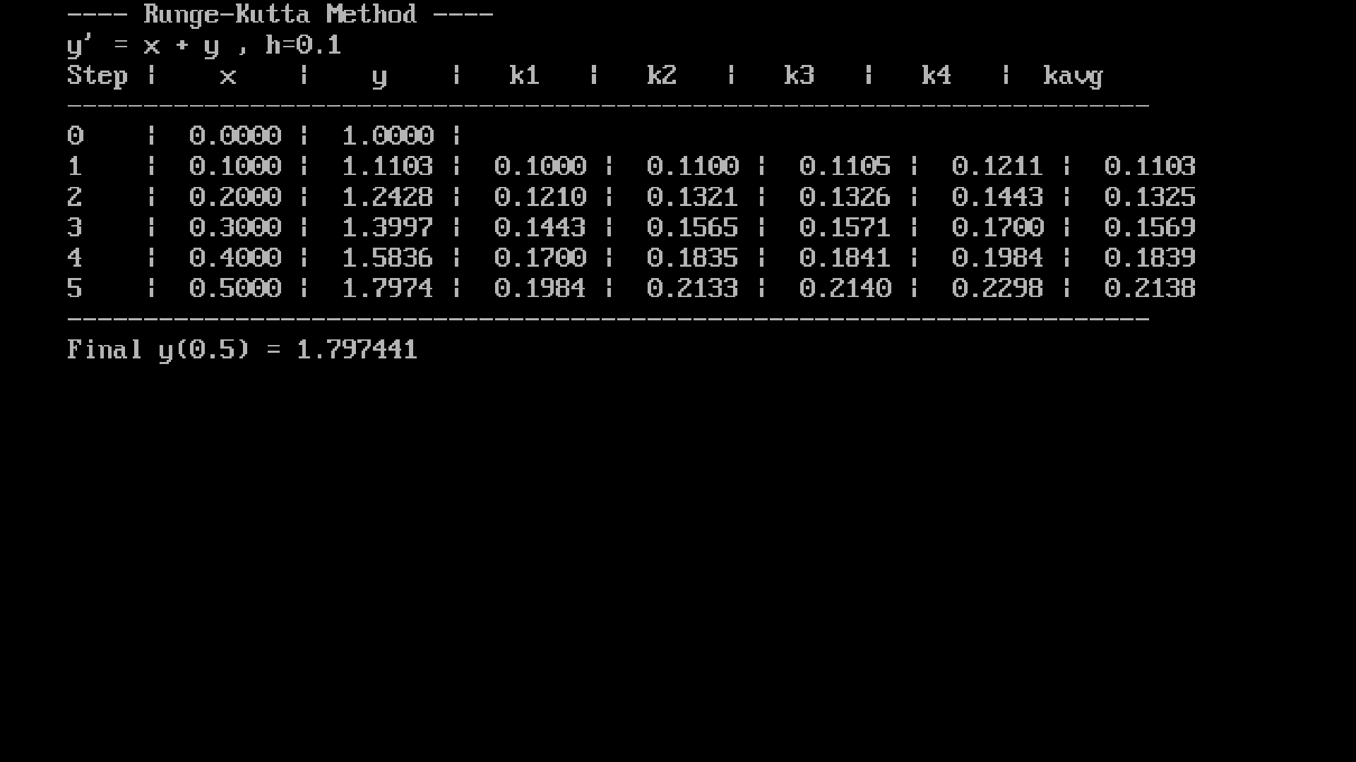
Conclusion: The program was executed successfully.

Solution Of Simultaneous Algebraic Equations

Q.1) Gauss Elimination Method.
Aim:To write a C program to find the solution of simultaneous algebraic equations using the Gauss Elimination Method.
Formula:
For a system of 3 equations:
$$\begin{matrix}a_{11}x_{1}+a_{12}x_{2}+a_{13}x_{3} & =b_{1} \\ a_{21}x_{1}+a_{22}x_{2}+a_{23}x_{3} & =b_{2} \\ a_{31}x_{1}+a_{32}x_{2}+a_{33}x_{3} & =b_{3}\end{matrix}$$
Row transformation used:
$$R_{j} → R_{j}-(\frac{a_{ji}}{a_{ii}})R_{i}$$
Programming formula:
ratio = a[j][i] / a[i][i];
a[j][k] = a[j][k] - ratio * a[i][k];

Program:
#include <stdio.h>
#include <conio.h>
#include <math.h>
int main()
{
float a[10][11] = {
{ 5, -3, 2, 12 },
{ -4, 6, 1, -7 },
{ 3, 2, -5, 10 }
};
float x[10], ratio, temp;
int n = 3;
int i, j, k, max_row;
clrscr();
printf("\nSolving the augmented matrix:\n");
for(i = 0; i < n; i++)
{
for(j = 0; j <= n; j++)
{
printf("%0.0f ", a[i][j]);
}
printf("\n");
}
for(i = 0; i < n; i++)
{
max_row = i;
for(k = i + 1; k < n; k++)
{
if(fabs(a[k][i]) > fabs(a[max_row][i]))
max_row = k;
}
for(k = 0; k <= n; k++)
{
temp = a[i][k];
a[i][k] = a[max_row][k];
a[max_row][k] = temp;
}
if(a[i][i] == 0.0)
{
printf("\nMathematical Error: No unique solution\n");
getch();
return 0;
}
for(j = 0; j < n; j++)
{
if(i != j)
{
ratio = a[j][i] / a[i][i];
for(k = 0; k <= n; k++)
{
a[j][k] = a[j][k] - ratio * a[i][k];
}
}
}
}
for(i = 0; i < n; i++)
{
x[i] = a[i][n] / a[i][i];
}
printf("\nThe solution is:\n");
for(i = 0; i < n; i++)
{
printf("x%d = %0.3f\n", i+1, x[i]);
}

getch();
return 0;
}

Output:
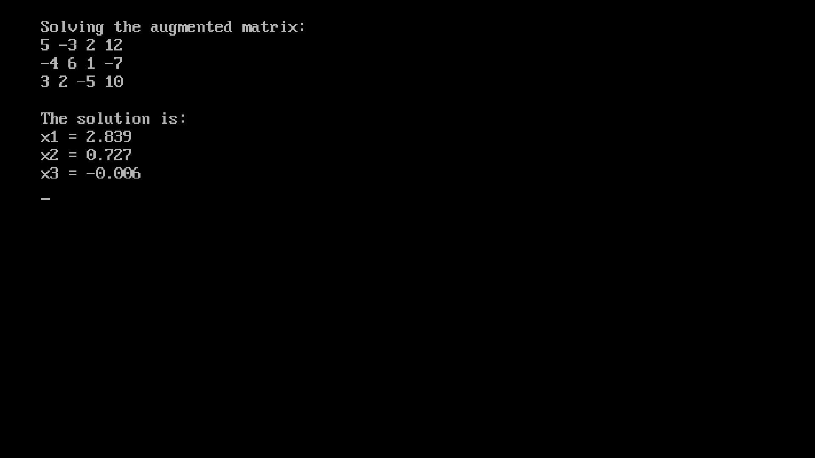
Conclusion: The program was executed successfully.

Numerical solutions of first and second order differential equation

Q.1) Euler’s Method in C Programming.
Aim: To solve the differential equation $y^{'}=x+y$using Standard Euler’s Method and compute the approximate values of $y$for a given step size.
Formula:
yn+1​=yn​+h⋅f(xn​,yn​)
Programming Formula:
slope = f(x, y);
y = y + STEP_SIZE * slope;
x = x + STEP_SIZE;
Program:
#include <stdio.h>
#include <math.h>
#include <conio.h>
double f(double x, double y) {
return x + y;
}
void eulers_method_solve() {
const double X_INITIAL = 0.0;
const double Y_INITIAL = 1.0;
const double STEP_SIZE = 0.1;
const int N_STEPS = 5;
double x = X_INITIAL;
double y = Y_INITIAL;
double slope;
int i;
clrscr();
printf("--- Standard Euler's Method (y' = x + y) ---\n");
printf("Initial Condition: y(%.1f) = %.1f, Step Size h = %.1f\n", X_INITIAL, Y_INITIAL, STEP_SIZE);
printf("Step | x | y | f(x, y)\n");
printf("--------------------------------------------------\n");
printf(" 0 | %10.6f | %10.6f |\n", x, y);
for (i = 1; i <= N_STEPS; i++) {
slope = f(x, y);
y = y + STEP_SIZE * slope;
x = x + STEP_SIZE;
printf(" %d | %10.6f | %10.6f | %10.6f\n", i, x, y, slope);
}
printf("--------------------------------------------------\n");
printf("Final Approximation at x=%.1f: y = %.6f\n", x, y);
}
int main() {
eulers_method_solve();
getch();
return 0;
}
Output:
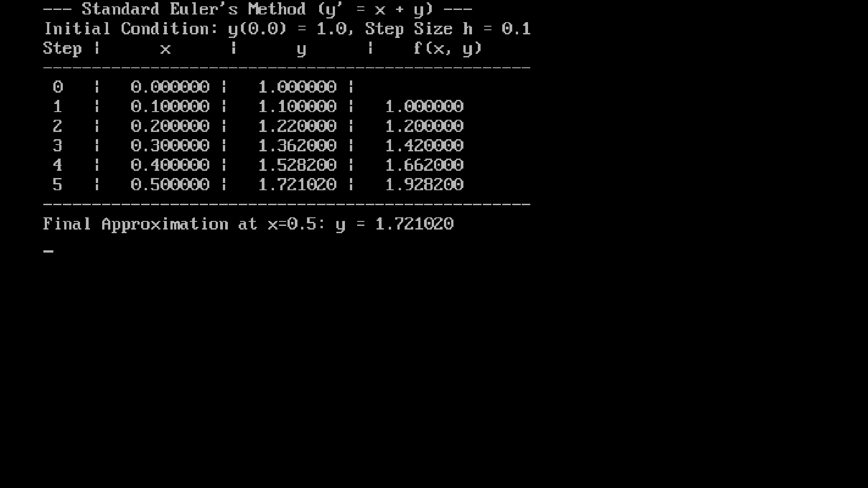
Conclusion: The program was executed successfully.
Q.2) Modified Euler’s Method in C Programming
Aim: To solve the differential equation $y^{'}=x+y$using the Modified Euler’s Method and compute the approximate values of $y$for each step.
Formula:
$$y_{n+1}=y_{n}+\frac{h}{2}[f(x_{n},y_{n})+f(x_{n+1},y_{p})]$$
$$x_{n+1}=x_{n}+h$$
Programming Formula:
k1 = f(x, y);
y_predictor = y + H * k1;

k2 = f(x_next, y_predictor);

y = y + (H / 2.0) * (k1 + k2);
x = x_next;

Program:
#include <stdio.h>
#include <math.h>
#include <conio.h>
double f(double x, double y) {
return x + y;
}
void modified_eulers_method_solve() {
const double X_INITIAL = 0.0;
const double Y_INITIAL = 1.0;
const double H = 0.1;
const int N_STEPS = 5;
double x = X_INITIAL;
double y = Y_INITIAL;
double x_next;
double y_predictor;
double k1, k2;
int i;
clrscr();
printf("--- Modified Euler's Method (y' = x + y) ---\n");
printf("Initial Condition: y(%.1f) = %.1f, Step Size h = %.1f\n", X_INITIAL, Y_INITIAL, H);
printf("Step | x | y | Predictor y | Avg. Slope\n");
printf("-------------------------------------------------------------\n");
printf(" 0 | %10.6f | %10.6f |\n", x, y);
for (i = 1; i <= N_STEPS; i++) {
k1 = f(x, y);
x_next = x + H;
y_predictor = y + H * k1;
k2 = f(x_next, y_predictor);
y = y + (H / 2.0) * (k1 + k2);
x = x_next;
printf(" %d | %10.6f | %10.6f | %10.6f | %10.6f\n",
i, x, y, y_predictor, (k1 + k2) / 2.0);
}
printf("-------------------------------------------------------------\n");
printf("Final Approximation at x=%.1f: y = %.6f\n", x, y);
}
int main() {
modified_eulers_method_solve();
getch();
return 0;
}

Output:
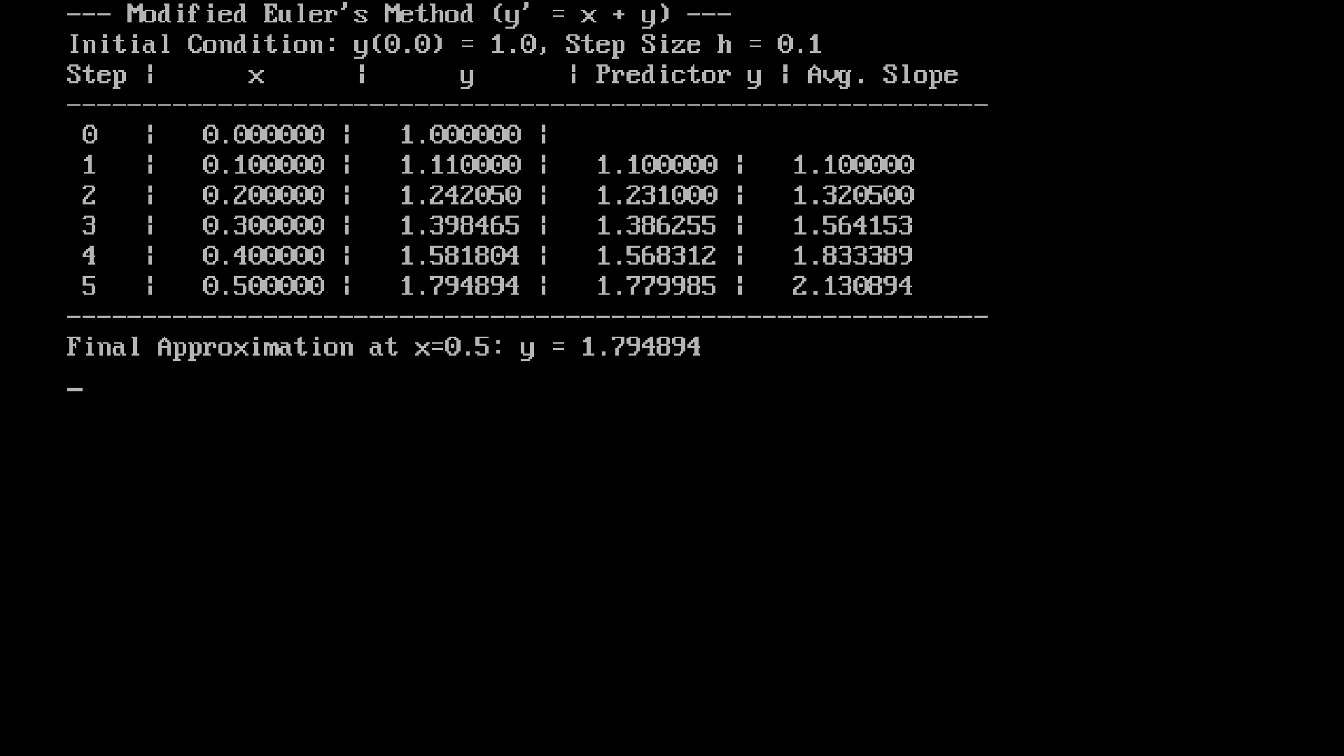
Conclusion: The program was executed successfully.

Q. 3) Taylor Series Method
Aim:To solve the differential equation $y^{'}=x+y$using the Taylor Series Method with given initial conditions.
Formula:
$$y_{i+1}=y_{i}+h y_{i}^{'}+\frac{h^{2}}{2} y_{i}^{''} \\ y_{i}^{'}=f(x_{i},y_{i})=x_{i}+y_{i} \\ y_{i}^{''}=f^{'}(x_{i},y_{i})=1+x_{i}+y_{i}$$
Programming Formula:
y_prime = f(x, y);
y_double_prime = f_prime(x, y);
y = y + h * y_prime + (h * h / 2) * y_double_prime;

Program:
#include <stdio.h>
#include <math.h>
#include <conio.h>
double f(double x, double y) {
return x + y;
}
double f_prime(double x, double y) {
return 1.0 + x + y;
}
void taylor_series_solve() {
const double X_INITIAL = 0.0;
const double Y_INITIAL = 1.0;
const double H = 0.1;
const int N_STEPS = 5;
double x = X_INITIAL;
double y = Y_INITIAL;
double y_prime;
double y_double_prime;
int i;
clrscr();
printf("--- Taylor Series Method (y' = x + y) ---\n");
printf("Initial Condition: y(%.1f) = %.1f, Step Size h = %.1f\n", X_INITIAL, Y_INITIAL, H);
printf("Step | x | y | y' (f) | y'' (f') \n");
printf("----------------------------------------------------------------\n");
printf(" 0 | %10.6f | %10.6f | \n", x, y);
for (i = 1; i <= N_STEPS; i++) {
y_prime = f(x, y);
y_double_prime = f_prime(x, y);
y = y + H * y_prime + (H * H / 2.0) * y_double_prime;
x = x + H;
printf(" %d | %10.6f | %10.6f | %10.6f | %10.6f\n", i, x, y, y_prime, y_double_prime);
}
printf("----------------------------------------------------------------\n");
printf("Final Approximation at x=%.1f: y = %.6f\n", x, y);
}
int main() {
taylor_series_solve();
getch();
return 0;
}

Output:
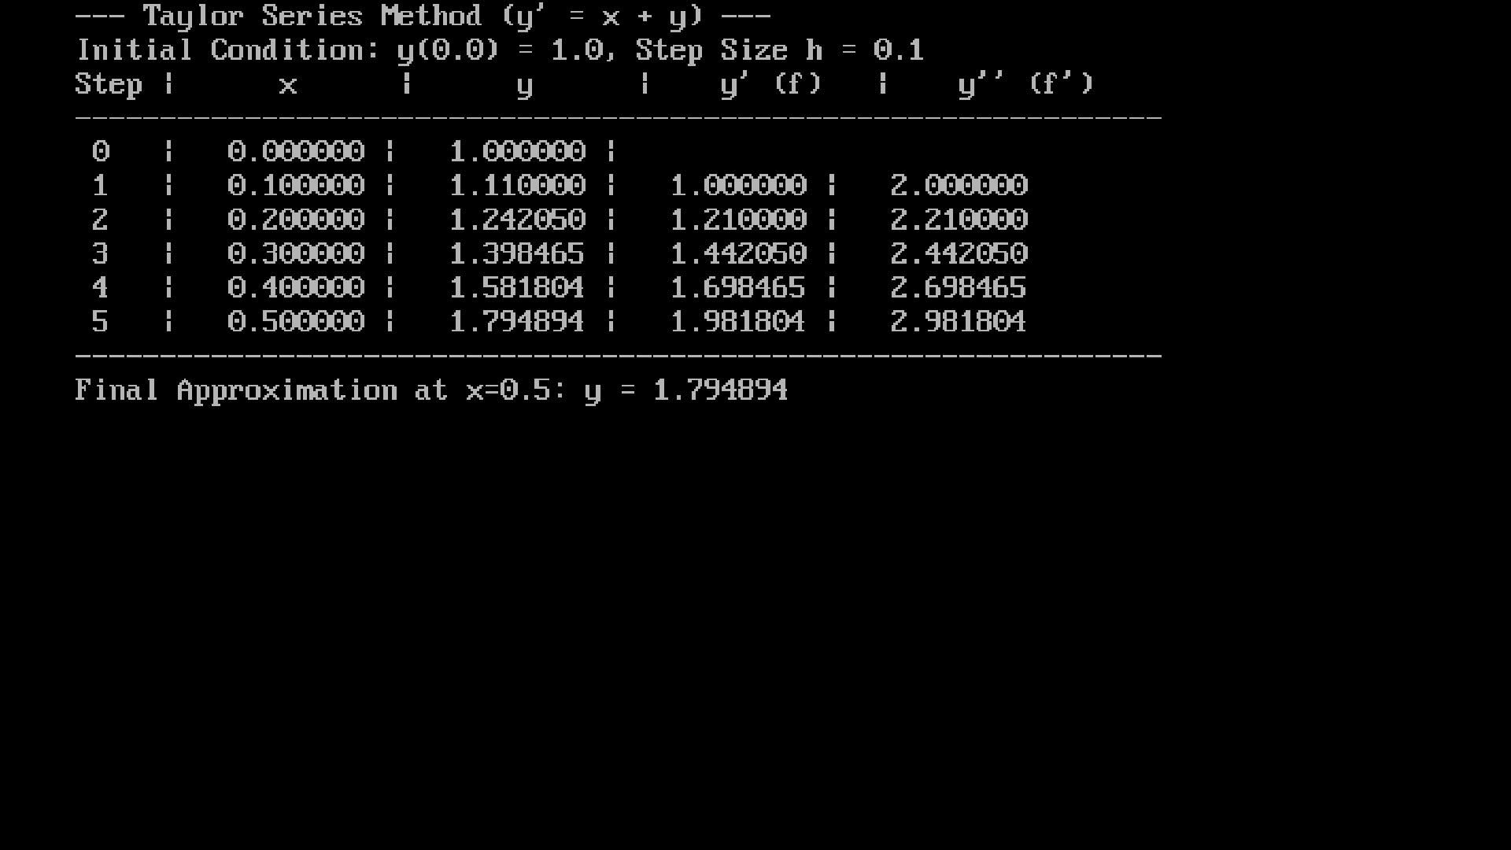
Conclusion: The program was executed successfully.

Transportation problem

Q.1) Transportation Problem using the Least Cost Method.
Aim:
To write a C program to find the initial feasible solution of a Transportation Problem using the Least Cost Method, and to compute the minimum transportation cost.
Formula:
1. Least Cost Selection Rule
Choose the cell with:
$$\text{Minimum Cost}=min⁡(c_{ij})$$
Allocation Rule
$$x_{ij}=min⁡({\text{Supply}}_{i}, {\text{Demand}}_{j})$$
Update Supply & Demand
$${\text{Supply}}_{i}={\text{Supply}}_{i}-x_{ij} \\ {\text{Demand}}_{j}={\text{Demand}}_{j}-x_{ij}$$
Total Transportation Cost
$\text{Total Cost}=∑(x_{ij}×c_{ij})$
Programming Formula:
min_cost = temp_cost[i][j];
alloc = (supply_left[min_i] < demand_left[min_j]) ? supply_left[min_i] : demand_left[min_j];
supply_left[min_i] -= alloc;
demand_left[min_j] -= alloc;
total_cost += alloc * cost[min_i][min_j];
Program:
#include <stdio.h>
#include <conio.h>
int main() {
int cost[3][4] = {
{ 4, 7, 6, 3 },
{ 8, 5, 9, 2 },
{ 1, 4, 3, 8 }
};
int supply[3] = { 40, 35, 45 };
int demand[4] = { 30, 25, 50, 15 };
int allocation[3][4];
int i, j;
int min_cost, min_i, min_j, alloc;
long total_cost = 0;
int items_to_alloc = 0;
int supply_left[3];
int demand_left[4];
int temp_cost[3][4];
clrscr();
printf("=======TRANSPORTATION PROBLEM========\n\n");
printf("Cost Matrix:\n");
for (i = 0; i < 3; i++) {
for (j = 0; j < 4; j++) {
printf("%4d", cost[i][j]);
}
printf(" | Supply: %d\n", supply[i]);
}
printf("\nDemand:");
for (j = 0; j < 4; j++) {
printf("%4d", demand[j]);
}
printf("\n\n");
for (i = 0; i < 3; i++) {
supply_left[i] = supply[i];
items_to_alloc += supply[i];
for (j = 0; j < 4; j++) {
allocation[i][j] = 0;
temp_cost[i][j] = cost[i][j];
}
}
for (j = 0; j < 4; j++) {
demand_left[j] = demand[j];
}
while (items_to_alloc > 0) {
min_cost = 9999;
min_i = -1;
min_j = -1;
for (i = 0; i < 3; i++) {
for (j = 0; j < 4; j++) {
if (temp_cost[i][j] < min_cost) {
min_cost = temp_cost[i][j];
min_i = i;
min_j = j;
}
}
}
if (supply_left[min_i] < demand_left[min_j]) {
alloc = supply_left[min_i];
} else {
alloc = demand_left[min_j];
}
allocation[min_i][min_j] = alloc;
total_cost += (long)alloc * cost[min_i][min_j];
items_to_alloc -= alloc;
supply_left[min_i] -= alloc;
demand_left[min_j] -= alloc;
if (supply_left[min_i] == 0) {
for (j = 0; j < 4; j++) {
temp_cost[min_i][j] = 9999;
}
}
if (demand_left[min_j] == 0) {
for (i = 0; i < 3; i++) {
temp_cost[i][min_j] = 9999;
}
}
}
printf("=======LEAST COST METHOD SOLUTION=======\n\n");
printf("Allocation Matrix:\n");
for (i = 0; i < 3; i++) {
for (j = 0; j < 4; j++) {
if (allocation[i][j] > 0) {
printf("%4d", allocation[i][j]);
} else {
printf("%4s", "-");
}
}
printf("\n");
}
printf("\nTotal Transportation Cost: %ld", total_cost);
getch();
return 0;
}

Output:
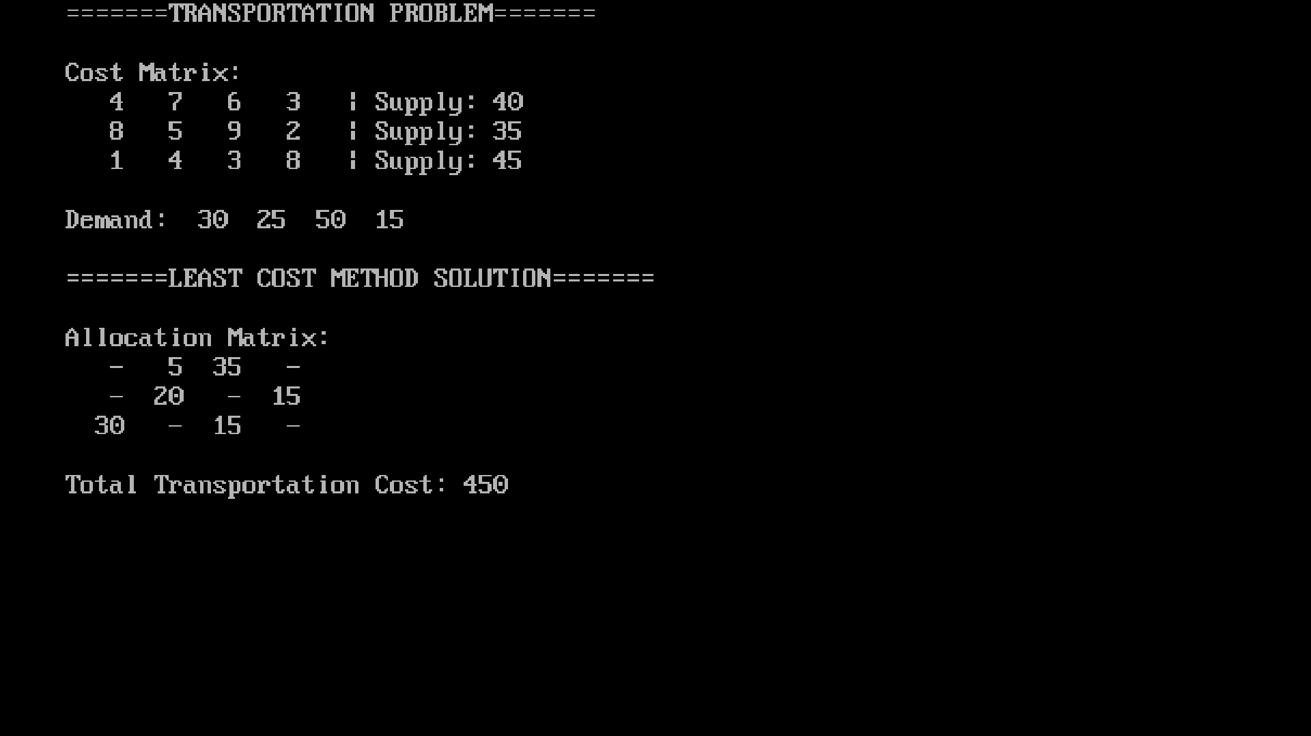
Conclusion: The program was executed successfully.

