BRAINWARE UNIVERSITY
Kolkata, West Bengal

PROJECT REPORT
ON
STUDENT PERFORMANCE & ATTENDANCE ANALYZER

Submitted in partial fulfilment of the academic requirements for
Master of Computer Applications (MCA)
Course: Problem Solving Using Python (MCA17400)

Submitted by
Student Name: ______________________________
University Roll No.: ________________________
Class / Section: MCA _________________________

Submitted to
Faculty Name: _______________________________

Academic Session: 2026–2027

DECLARATION
I hereby declare that the project report entitled “Student Performance & Attendance Analyzer” has been prepared as an academic project for the course Problem Solving Using Python (MCA17400). The report describes the design and implementation of a Python application that accepts student marks and attendance, calculates academic summaries, stores records in a CSV file, performs basic analysis, and generates graphical representations.
The project is intended for learning and demonstration. The implementation described in this report is based on the submitted Python source code using Tkinter, CSV, NumPy, Pandas, and Matplotlib. All screenshots, test observations, and results presented in this report reflect the authentic execution of the application.
I understand that academic integrity requires me to understand the source code and be able to explain the logic, functions, data structures, and limitations of the project during evaluation.
Student Signature: __________________________
Date: ____________________

CERTIFICATE
This is to certify that the project report entitled “Student Performance & Attendance Analyzer” is submitted as part of the academic work for the course Problem Solving Using Python (MCA17400) in the Master of Computer Applications programme.
The report presents a student-level Python application demonstrating input validation, conditional statements, loops, collections, functions, classes and objects, file handling, exception handling, data analysis, and graphical visualization. The final certification and approval of the project are subject to review by the concerned faculty member.
Faculty Signature: __________________________
Name and Designation: ______________________
Date: ____________________

ACKNOWLEDGEMENT
I express my sincere gratitude to the faculty members of Brainware University for providing the opportunity to develop this project as part of the Problem Solving Using Python course. The project provided a practical way to connect programming concepts taught in class with a small application that addresses an understandable academic task.
I am thankful for the guidance, feedback, and learning environment that helped shape the project. I also acknowledge the documentation and official learning resources for Python, Tkinter, NumPy, Pandas, and Matplotlib that can be consulted to understand the libraries used.
Finally, I acknowledge the support of classmates and well-wishers who contributed suggestions during the learning process. The project was successfully tested and verified through complete implementation, test cases, and graphical outputs.

ABSTRACT
The Student Performance & Attendance Analyzer is a desktop application developed in Python to demonstrate how basic programming concepts can be applied to student record management. The system accepts a roll number, student name, marks in four subjects—Python, DBMS, AI, and JavaScript—and an attendance percentage. It calculates total marks, average, percentage, and a letter grade. It also identifies students whose attendance is below the configured threshold of 75 percent.
The program uses a Student class to group the data and calculated values associated with a student. A list stores Student objects during execution, while a dictionary stores subject-wise marks. Conditional statements implement grade rules and attendance checks. Loops process subjects and student records. Exception handling helps reject invalid numeric inputs. The application can display records, sort students by percentage, calculate average/highest/lowest percentages using NumPy, write records to a CSV file, read data through Pandas, and create a bar chart, line graph, and histogram with Matplotlib.
The graphical version uses Tkinter widgets, including labels, entry fields, buttons, and a text area. CSV is used for simple local persistence; the project does not use a database, cloud service, or network connection. The report documents requirements, design, algorithms, implementation, test cases, observed outputs, limitations, and possible future improvements. It is written to support both academic assessment and the student's understanding of the code.

TABLE OF CONTENTS
Section | Contents
Preliminary Pages | Declaration, Certificate, Acknowledgement, Abstract
Chapter 1 | Introduction
Chapter 2 | Objectives and Scope
Chapter 3 | Planning and Methodology
Chapter 4 | Requirement Analysis
Chapter 5 | Concepts and Technologies Used
Chapter 6 | System Design
Chapter 7 | Algorithm and Pseudocode
Chapter 8 | Implementation Details
Chapter 9 | Testing and Validation
Chapter 10 | Results and Discussion
Chapter 11 | Limitations and Future Scope
Chapter 12 | Conclusion
References | Learning resources
Appendices | Code outline, sample data, screenshot checklist, viva preparation

Note: Update page numbers after opening the document in Microsoft Word and selecting References → Update Table, if an automatic table of contents is added. The report uses section headings to make navigation and final formatting easier.

LIST OF FIGURES
- Figure 6.1 — High-level system architecture
- Figure 6.2 — Main application workflow
- Figure 6.3 — Student record data flow
- Figure 7.1 — Add-student validation flowchart
- Figure 7.2 — Performance analysis flowchart
- Figure 8.1 — GUI layout description
- Figure 8.1 — GUI layout description
- Figure 10.1 — Bar chart of student academic performance
- Figure 10.2 — Line graph of student academic performance
- Figure 10.3 — Histogram of student percentage distribution
- Figure 10.4 — Main GUI window of the application
- Figure 10.5 — Low attendance identification report
- Figure 10.6 — Input validation and error handling dialog

- Figure A.1 — View Records output
- Figure A.2 — Performance ranking and summary statistics

LIST OF TABLES
- Table 2.1 — Project objectives
- Table 3.1 — Development phases
- Table 4.1 — Functional requirements
- Table 4.2 — Non-functional requirements
- Table 4.3 — Hardware and software requirements
- Table 5.1 — Libraries and their roles
- Table 6.1 — Data fields
- Table 8.1 — Function/module summary
- Table 9.1 — Test cases
- Table 10.1 — Sample calculated results
- Table 11.1 — Limitations and possible improvements

CHAPTER 1: INTRODUCTION

1.1 Background
Student performance is commonly reviewed through marks obtained in different subjects and attendance maintained during a course. When these values are written and calculated manually, repetitive arithmetic can take time and small calculation mistakes may occur. A simple computer program can organize the values, apply the same rules consistently, and present a compact summary for review.
The Student Performance & Attendance Analyzer was created as a practical exercise in introductory Python programming. It is not intended to replace an official university student information system. Instead, it demonstrates how a small local program can accept structured inputs, calculate results, save records, and display summaries using concepts included in the course syllabus.

1.2 Project Overview
The application accepts one student's information at a time. Each record includes a roll number, name, four subject marks, and attendance percentage. The program calculates total marks, average marks, percentage, and grade. Since each subject is scored out of 100 and there are four subjects, the maximum total is 400. The average is calculated by dividing the total by four; because the maximum average is 100, the average value is also used as the percentage.
The current GUI version provides buttons for adding students, viewing records, analysing performance, checking attendance, saving CSV data, reading CSV data, and generating graphs. The output appears in a text widget, while validation errors and confirmations appear through message boxes.

1.3 Problem Statement
The problem addressed is the need for a small and understandable tool to record student marks and attendance and calculate a consistent summary without repeating manual calculations. The system should also identify low attendance, rank students by percentage, save information for later use, and display the data visually.

1.4 Motivation
The project connects classroom concepts with a practical situation. It allows the student developer to demonstrate variables, lists, dictionaries, loops, conditional statements, functions, class-based modelling, sorting, exception handling, CSV file operations, numerical analysis, tabular data processing, and charts. A graphical interface makes the same logic more accessible than a command-line menu for a non-technical user.

1.5 Report Organisation
The report begins with objectives and scope, then discusses planning and requirements. It introduces the libraries and Python concepts used before describing system design, algorithms, and implementation. Testing and results are documented next, followed by limitations, future scope, conclusion, references, and appendices. The report is aligned with the pasted Tkinter implementation; it does not claim features such as database storage, login, editing, deletion, or cloud synchronisation that are not present in the code.

CHAPTER 2: OBJECTIVES AND SCOPE

2.1 Primary Objective
The primary objective is to develop a small Python desktop application that manages basic student performance and attendance information, calculates academic summaries, and presents simple analysis through text and charts.

2.2 Specific Objectives
No. | Objective | Implementation
1 | Capture student details | Tkinter entry fields for roll, name, marks, and attendance
2 | Calculate academic values | Student class calculates total, average, percentage, and grade
3 | Apply grade rules | if-elif-else thresholds in calculate_grade()
4 | Validate input | Numeric conversion and range checks with ValueError handling
5 | View records | Display Student objects in the result text area
6 | Rank students | Sort by percentage in descending order
7 | Summarise performance | NumPy mean, maximum, and minimum
8 | Check attendance | Compare attendance with the 75% threshold
9 | Persist records | Write a header and records to students.csv
10 | Read and analyse CSV | Pandas read_csv(), DataFrame output, mean percentage
11 | Visualise results | Matplotlib bar chart, line graph, and histogram

2.3 Scope
The project scope is deliberately limited to a local, single-user academic demonstration. It works with four fixed subjects and a fixed 75 percent attendance threshold. Records are maintained in memory during execution and can be saved to a CSV file. The project provides basic analysis, not a full institutional reporting or student information platform.

2.4 Intended Users
The intended users are students, teachers, or demonstrators who need to enter a small set of sample student records and observe the calculations. The program can be used in a laboratory or classroom environment to demonstrate Python fundamentals and introductory data analysis.

2.5 Expected Outcomes
- Correct calculation of total marks, average, percentage, and grade for valid inputs.
- Clear rejection of non-numeric or out-of-range marks and attendance values.
- Identification of students whose attendance is below 75 percent.
- Descending ranking based on percentage.
- CSV output that can be reopened and inspected with a spreadsheet application.
- Basic statistical summaries and three graphical representations.
- Improved understanding of how Python libraries can be combined in one application.

2.6 Out of Scope
The current implementation does not provide a database, network access, multi-user permissions, password authentication, automated institutional attendance import, student editing/deletion controls, PDF report export, or predictive analytics. These are potential extensions only and must not be described as completed features.

CHAPTER 3: PLANNING AND METHODOLOGY

3.1 Need for Planning
Planning helps divide the project into manageable tasks and keeps the implementation aligned with the course syllabus. Because the application combines a graphical interface, data calculations, file handling, and charts, it is useful to develop and test each part separately before connecting the modules.

3.2 Development Approach
A simple incremental approach was suitable for this project. The basic data model and calculations can be created first; input validation and record display can then be added; CSV handling and analysis can be integrated after the core calculations work; finally, the GUI controls and graph functions can be connected. Each stage can be checked with a small set of sample records.
Phase | Main activity | Expected deliverable
1. Requirement understanding | Identify fields, calculations, and required buttons | Feature list
2. Data model | Create Student class and grade calculation | Working class
3. Input validation | Validate roll, marks, attendance, and name | Safer data entry
4. Record operations | Add and display Student objects | In-memory record management
5. Analysis | Sorting and NumPy summary values | Ranking and statistics
6. File handling | CSV writing and Pandas reading | Persistent file
7. Visualization | Build bar, line, and histogram plots | Three graph images/windows
8. GUI integration | Place inputs, buttons, and result area | Desktop interface
9. Testing | Try valid and invalid values | Test observations
10. Documentation | Record design, tests, outputs, and limitations | Final report

3.3 Work Breakdown Structure
- Interface: create the root window, title, input frame, entry fields, buttons, and result text area.
- Data model: define the Student class and calculate derived academic values.
- Input module: read values from the GUI and validate them before creating an object.
- Record module: append records to the in-memory list and display selected summaries.
- Analysis module: sort students and compute average, maximum, and minimum percentages.
- Attendance module: compare attendance with the configured limit.
- File module: write CSV headers and records; load existing CSV records through Pandas.
- Visualization module: prepare names and percentages and generate the three plots.
- Testing and documentation: validate expected behaviour and capture genuine screenshots.

3.4 Resource Planning
The project requires a computer capable of running Python, an installed Python interpreter, a code editor such as Visual Studio Code, and the libraries used by the program. Tkinter is commonly distributed with standard Python installations on Windows, although installation details vary by environment. NumPy, Pandas, and Matplotlib must be available in the interpreter used to run the project.

3.5 Risk and Mitigation
Risk | Possible effect | Mitigation
Invalid numeric input | Program cannot convert text to a number | Use try/except ValueError and clear messages
Marks outside 0–100 | Incorrect academic result | Check the range before accepting each value
CSV file missing | Reading data fails | Catch FileNotFoundError and inform the user
CSV structure differs | Column access may fail | Keep the expected headers consistent and inspect malformed files
Duplicate roll numbers | Ambiguous student records | Current version limitation; check duplicates in a future improvement
Long student names | Labels may overlap in charts | Rotate x-axis labels; use more spacing if needed
Different Python environments | A library may appear missing | Run the file with the interpreter where dependencies are installed

3.6 Ethical and Academic Considerations
Student records can be personal information. Sample or anonymised records should be used for demonstrations, and real student data should not be shared without appropriate permission. The program is a learning prototype and has no access control. Therefore, it should not be used as an official record system for sensitive or high-stakes decisions.

CHAPTER 4: REQUIREMENT ANALYSIS

4.1 Functional Requirements
ID | Requirement | Expected behaviour
FR-01 | Enter student information | Accept roll, name, four subject marks, and attendance
FR-02 | Validate inputs | Reject invalid numeric values and out-of-range marks/attendance
FR-03 | Calculate results | Compute total, average, percentage, and grade
FR-04 | Display records | Show available student summaries in the GUI
FR-05 | Analyse performance | Sort records by percentage and show rank
FR-06 | Calculate statistics | Display average, highest, and lowest percentage
FR-07 | Check attendance | Show records below 75 percent attendance
FR-08 | Save records | Write current in-memory records to students.csv
FR-09 | Read records | Load CSV data and reconstruct Student objects
FR-10 | Generate charts | Create bar, line, and histogram visualisations

4.2 Non-Functional Requirements
ID | Requirement | Explanation
NFR-01 | Usability | Labels and buttons should clearly identify common actions
NFR-02 | Reliability | Valid inputs should produce consistent calculations
NFR-03 | Maintainability | Functions are separated by task and use descriptive names
NFR-04 | Portability | The code should run where Python and required libraries are installed
NFR-05 | Performance | Small classroom-sized datasets should process quickly
NFR-06 | Data integrity | CSV columns should retain a consistent structure
NFR-07 | Clarity | Results and errors should be understandable to the user

4.3 Hardware Requirements
The program does not require specialised hardware. A standard desktop or laptop computer with a keyboard, display, and enough memory to run Python and the listed libraries is sufficient for the intended small dataset. A modern multi-core processor is not a project requirement because the calculations are simple.

4.4 Software Requirements
Software / Library | Purpose
Python 3 | Main programming language
Visual Studio Code or another Python editor | Writing and running the source code
Tkinter | Desktop GUI components
CSV module | Writing structured comma-separated records
NumPy | Mean, maximum, and minimum calculations
Pandas | Reading and summarising CSV data
Matplotlib | Creating the bar chart, line graph, and histogram
Operating system | Windows or another environment that supports the installed dependencies

4.5 Input and Output Requirements
Inputs include an integer roll number, a non-empty name, four numeric marks from 0 to 100, and numeric attendance from 0 to 100. Outputs include a success message, calculated values, attendance warning when applicable, record listings, performance ranking, statistical summaries, CSV data display, and graph windows/files.

4.6 Assumptions and Constraints
- Each subject mark is out of 100.
- The four subjects are fixed in the SUBJECTS list.
- Percentage is treated as the average of the four subject marks.
- The grade boundaries are A ≥ 80, B ≥ 70, C ≥ 60, D ≥ 50, otherwise F.
- Attendance below 75% is considered low attendance.
- Data is stored in the local students.csv file when the user selects Save CSV.
- The application is a prototype and does not validate whether roll numbers are unique.

CHAPTER 5: CONCEPTS AND TECHNOLOGIES USED

5.1 Python Programming Language
Python is used because its syntax is readable and it supports procedural programming, object-oriented programming, file handling, and third-party libraries. The project combines a small number of modules in one source file, which makes it convenient for a course-level demonstration.

5.2 Variables and Constants
Variables store values during execution. For example, roll stores a student's roll number, name stores a string, marks stores a dictionary, and attendance stores a numeric percentage. Constants such as FILE_NAME, SUBJECTS, and ATTENDANCE_LIMIT define values used in several functions. In Python, uppercase names are a naming convention for values intended to remain unchanged.

5.3 Lists and Dictionaries
The global students list contains Student objects. A list is useful because the number of records can grow as students are added. The marks dictionary maps a subject name to its mark, such as {'Python': 85, 'DBMS': 78}. This allows a mark to be retrieved by subject name instead of relying only on numeric positions.

5.4 Conditions and Loops
The if-elif-else structure assigns grades using percentage thresholds. A separate if statement checks whether attendance is below 75 percent. The for loop processes the fixed subject list when marks are entered and processes Student objects when records are displayed or analysed. The input loops in the console predecessor repeatedly asked for values until valid data was entered; in the GUI implementation, validation is performed when the Add Student button is pressed.

5.5 Functions
Functions separate tasks and reduce repeated code. For example, add_student() handles entry validation and object creation, save_data() writes the file, read_data() reads the file, and generate_graphs() prepares the three visualisations. The GUI buttons use the command parameter to call these functions when clicked.

5.6 Classes and Objects
The Student class is a template for a student record. When a student is added, Student(roll, name, marks, attendance) creates an object. The object stores the input values and calculates total, average, percentage, and grade. Grouping related information and behaviour in one class helps keep the record logic together.

5.7 Exception Handling
The add_student() function catches ValueError when values cannot be converted to numbers or fail validation. The read_data() function catches FileNotFoundError when the CSV file does not exist. The initial auto-load block also uses a broad except with pass; while this prevents startup interruption, it can hide the reason a file failed to load. A more informative exception message would be a future code-quality improvement.

5.8 CSV File Handling
CSV stands for Comma-Separated Values. It is a simple text format that stores rows and columns. The program uses csv.writer to write a header row followed by student data. Pandas reads the file as a DataFrame, which provides convenient column-based analysis. The expected file name is students.csv.

5.9 NumPy
NumPy is used for numerical calculations. The Student class calculates the average using np.mean(), while the analysis function creates a NumPy array of percentages and applies np.mean(), np.max(), and np.min(). These functions provide a compact way to calculate summary statistics for the current set of students.

5.10 Pandas
Pandas is used to load the CSV file with pd.read_csv(). The resulting DataFrame is displayed as text using to_string(index=False). The program also counts rows and calculates the mean of the Percentage column. When data is read, the current in-memory list is cleared and rebuilt from the file.

5.11 Matplotlib
Matplotlib creates the three charts. A bar chart compares student percentages; a line graph connects the percentage values in the order of the current list; a histogram groups percentage values into ranges. Each plot is saved as a PNG file and then displayed with plt.show(). Because each show call is executed sequentially, the graph windows appear one after another.

5.12 Tkinter GUI
Tkinter is Python's standard interface to the Tk GUI toolkit. The program creates a root window and places labels and entry fields in an input frame. Buttons trigger functions, and a Text widget displays output. Message boxes provide error, warning, and success notifications. The GUI is intentionally straightforward so the programming logic remains easy to explain.
Library / module | Role in this project | Example
tkinter | Window and input/output widgets | Tk(), Label, Entry, Button, Text
messagebox | Alerts and confirmations | showerror(), showwarning(), showinfo()
csv | Writing rows to a CSV file | csv.writer(file)
NumPy | Numeric summaries | np.mean(), np.max(), np.min()
Pandas | Read and summarise CSV | pd.read_csv(), data.to_string()
Matplotlib | Charts and image files | plt.bar(), plt.plot(), plt.hist()
os | Check whether CSV exists | os.path.exists(FILE_NAME)

CHAPTER 6: SYSTEM DESIGN

6.1 System Architecture
The system can be understood as four connected layers: the GUI layer, application logic layer, in-memory data layer, and file/analysis layer. The GUI receives the user's actions. The application logic validates values and calculates results. The in-memory list stores Student objects during the session. The CSV file provides simple persistence, while NumPy, Pandas, and Matplotlib support analysis and visualisation.
Layer | Components | Responsibility
Presentation | Tkinter window, labels, entries, buttons, Text widget | Collect inputs and show outputs
Application logic | add_student(), view_records(), analyze_performance(), check_attendance() | Validate and process requests
Data model | Student class, marks dictionary, students list | Represent and hold records
File and analytics | csv, Pandas, NumPy, Matplotlib | Save/load, calculate summaries, draw charts

Figure 6.1 — High-level system architecture
User | GUI | Logic / Student class | Storage and analysis
Enters details or clicks a button | Sends values or action | Validates and calculates | CSV / NumPy / Pandas / Matplotlib
Receives displayed result | Updates result area | Returns summaries | Reads or writes data / creates plots

The table above outlines the functional architecture and flow of data across the system layers.

6.2 Main Workflow
- Start the Python program and create the Tkinter root window.
- Check whether students.csv exists; if it does, attempt to load existing records.
- Display the main window and wait for the user to select an action.
- When Add Student is selected, read and validate the entry fields.
- Create a Student object, append it to the students list, and show the calculated summary.
- When analysis or attendance is selected, process the current list and display results.
- When Save CSV is selected, write the current records to students.csv.
- When Read CSV is selected, read the file, rebuild the list, and show a table-like summary.
- When Generate Graphs is selected, create and save three plots.
- Continue responding to GUI events until the window is closed.

6.3 Data Model
The Student class is the central data model. It contains roll, name, marks, attendance, total, average, percentage, and grade. The marks dictionary has four keys corresponding to the subject names. A CSV row represents one student and stores the same input fields together with calculated values.

Field | Type / representation | Meaning
Roll | Integer | Student roll number; expected to be positive
Name | String | Student's displayed name
Python | Numeric | Marks in Python
DBMS | Numeric | Marks in DBMS
AI | Numeric | Marks in AI
JavaScript | Numeric | Marks in JavaScript
Total | Numeric | Sum of four marks
Average | Numeric | Mean of the four marks
Percentage | Numeric | Same numeric value as average, expressed as percent
Grade | String | Letter grade from A to F
Attendance | Numeric | Attendance percentage

6.4 Grade Rules
Percentage | Grade
80–100 | A
70–79.99 | B
60–69.99 | C
50–59.99 | D
Below 50 | F

The implementation checks the thresholds from highest to lowest. For example, a percentage of 82 returns A; 74 returns B; 65 returns C; 52 returns D; and 43 returns F. The sequence matters because the first matching condition determines the result.

6.5 Attendance Rule
ATTENDANCE_LIMIT is set to 75. A student is identified as having low attendance only when attendance is strictly less than 75. Therefore, 74.99 is low attendance, while exactly 75 is not considered below the limit. The same threshold is used for the warning shown after adding a student and the attendance report.

6.6 Data Flow
Step | Data flow
1 | Entry fields → numeric conversion and validation
2 | Validated values → Student object
3 | Student object → students list
4 | students list → display, ranking, attendance report, statistics, charts
5 | students list → CSV writer → students.csv
6 | students.csv → Pandas DataFrame → rebuilt Student objects and summary

CHAPTER 7: ALGORITHM AND PSEUDOCODE

7.1 Overall Algorithm
- Begin program.
- Import Tkinter, CSV, NumPy, Pandas, Matplotlib, and os modules.
- Define constants and the Student class.
- Create an empty students list and attempt to load existing CSV data if the file exists.
- Create the GUI widgets and connect buttons to their functions.
- Wait for user interaction.
- Run the selected operation: add, view, analyse, attendance check, save, read, or graph generation.
- Display results or an error message.
- Repeat while the GUI event loop is active.
- End when the user closes the window.

7.2 Pseudocode: Student Creation
START AddStudent
READ roll, name, four subject marks, attendance
IF roll cannot be converted to integer OR roll ≤ 0 THEN show validation error
IF name is empty THEN show name error and return
FOR each subject and associated entry: convert mark to number; IF mark < 0 OR mark > 100 THEN show error
Convert attendance to number; IF attendance < 0 OR attendance > 100 THEN show error
CREATE Student object using validated values
APPEND object to students list
DISPLAY total, average, percentage, grade, and attendance
IF attendance < 75 THEN DISPLAY low-attendance warning
CLEAR input fields
END AddStudent

7.3 Pseudocode: Grade Calculation
START calculate_grade
IF percentage ≥ 80, RETURN A
ELSE IF percentage ≥ 70, RETURN B
ELSE IF percentage ≥ 60, RETURN C
ELSE IF percentage ≥ 50, RETURN D
ELSE RETURN F
END calculate_grade

7.4 Pseudocode: Performance Analysis
START analyze_performance
IF students list is empty, display no-record message and return
SORT students by percentage in descending order
DISPLAY rank, name, percentage, and grade for each student
CREATE NumPy array from all percentages
CALCULATE mean, maximum, and minimum
DISPLAY the three statistics
END analyze_performance

7.5 Pseudocode: Save CSV
START save_data
IF students list is empty, show warning and return
OPEN students.csv in write mode with newline=''
CREATE CSV writer
WRITE the column header
FOR each student, WRITE roll, name, marks, total, average, percentage, grade, and attendance
CLOSE file and show success message
END save_data

7.6 Pseudocode: Graph Generation
START generate_graphs
IF students list is empty, show warning and return
BUILD names list and percentages list
CREATE bar chart; label axes; add title; save bar_chart.png; show chart
CREATE line graph with markers; label axes; add grid and title; save line_graph.png; show graph
CREATE histogram with bins 0, 20, 40, 60, 80, 100; label axes; save histogram.png; show histogram
SHOW completion message
END generate_graphs

7.7 Flowchart Description: Add Student
Flowchart node | Description
Start | User clicks Add Student
Input | Read roll, name, marks, and attendance
Decision 1 | Is roll valid and positive? If no, show error
Decision 2 | Is name non-empty? If no, show error
Decision 3 | Are all marks between 0 and 100? If no, show error
Decision 4 | Is attendance between 0 and 100? If no, show error
Process | Create Student object and append to list
Output | Show calculated results and attendance warning if needed
Finish | Clear fields and return to the GUI event loop

For a graphical flowchart, use standard terminator ovals for Start/Finish, parallelograms for input/output, rectangles for processing, and diamonds for validation decisions. The table above records the exact logical sequence so the diagram can be recreated accurately.

CHAPTER 8: IMPLEMENTATION DETAILS

8.1 Import Statements
The program imports tkinter as tk for GUI widgets and messagebox for alerts. It imports csv for writing records, NumPy as np for numerical calculations, Pandas as pd for reading and summarising CSV data, and Matplotlib.pyplot as plt for charts. The startup loading block imports os to check whether the CSV file already exists. The displayed source also imports ttk, although the current layout uses tk widgets rather than ttk widgets.

8.2 Constants
FILE_NAME is set to students.csv. SUBJECTS is a list containing Python, DBMS, AI, and JavaScript. ATTENDANCE_LIMIT is 75. Constants reduce duplication and make it easier to update a common setting in one place.

8.3 Student Class Implementation
The __init__ method receives the four main input items and stores them as attributes. It calculates total with sum(marks.values()), average with np.mean(list(marks.values())), and percentage by assigning the average value. It then calls calculate_grade() and stores the returned letter grade. Since each mark is out of 100 and the number of subjects is fixed, this method produces a percentage on a 0–100 scale.

8.4 Loading Existing Data at Startup
The GUI code creates an empty global students list. If students.csv exists, Pandas attempts to read it. Each row is converted into a marks dictionary and a Student object, then appended to the list. The code uses a broad exception handler that silently ignores load errors. This makes startup tolerant of some problems, but it also means a malformed CSV may fail to load without an explanation. A more robust version would catch specific exceptions and show a message.

8.5 Add Student Function
The add_student() function reads text from each entry widget. Roll is converted to int, while marks and attendance are converted to float. The roll must be positive, the name must not be empty, and marks and attendance must fall between 0 and 100. When validation succeeds, a Student object is created and appended to the global list. The result text area is cleared and populated with the calculated values. If attendance is below 75, a warning is added. Finally, clear_entries() empties the input fields.
A ValueError message box handles invalid numeric conversion and the range checks that raise ValueError. Empty-name input has a separate message box. A possible future improvement is to check duplicate roll numbers before appending a new object, because the current code does not enforce uniqueness.

8.6 Clear Entries Function
clear_entries() deletes the content of the roll and name fields, iterates over mark_entries to clear each subject mark, and clears attendance. It is called after a successful addition. Separating this behaviour into a function avoids repeating the same clearing commands in add_student().

8.7 View Records Function
view_records() clears the result text area. If the students list is empty, it displays a message and returns. Otherwise, it loops through each Student object and displays roll, name, percentage, grade, and attendance. The current implementation provides a compact text-based record view rather than a sortable table widget.

8.8 Performance Analysis Function
analyze_performance() first checks whether records exist. It uses sorted() with a key that returns each student's percentage and reverse=True, placing the highest percentage first. enumerate(..., start=1) assigns ranks beginning at one. It then builds a NumPy array of percentages and displays the mean, maximum, and minimum values. These statistics describe the records currently held in memory.

8.9 Low Attendance Function
check_attendance() clears the result area and handles an empty list. It sets found to False, then checks each student's attendance. Any value below ATTENDANCE_LIMIT is displayed and found becomes True. If no record meets the condition, the function displays a message stating that no student has attendance below 75 percent.

8.10 Save Data Function
save_data() warns the user when the list is empty. Otherwise, it opens students.csv in write mode with newline='' and creates a CSV writer. It writes the column names first and then one row for every Student object. The write mode replaces the existing contents of the file, so the file represents the current in-memory list at the time of saving.

8.11 Read Data Function
read_data() uses pd.read_csv(FILE_NAME) to load the CSV into a DataFrame. It clears the current students list and recreates Student objects from the rows. It displays the DataFrame without row indexes, shows the number of rows, and calculates the average value of the Percentage column. If the file is missing, a message box explains that students.csv was not found.

8.12 Graph Generation Function
generate_graphs() first checks that at least one student exists. It creates two lists: student names and percentages. The bar chart displays one bar for each student's percentage. The line graph plots the same values in list order with circle markers and a grid. The histogram groups percentages into five intervals: 0–20, 20–40, 40–60, 60–80, and 80–100. The histogram's y-axis is configured to use integer tick marks because it counts students.
Each chart is saved to a PNG file before plt.show() is called. Since the three plots are created and shown one at a time, the user closes the current graph window before the next graph is displayed. This is expected behaviour for the current sequence of show calls.

8.13 GUI Construction
The root window is titled Student Performance & Attendance Analyzer and is assigned an initial size of 850 by 650 pixels. A title label appears at the top. An input frame holds the roll and name fields, four mark fields, and attendance field. A button frame contains actions for adding, viewing, analysing, checking attendance, saving, reading, and generating graphs. The Text widget displays results. root.mainloop() starts the Tkinter event loop.

8.14 Module Summary
Function / component | Purpose | Important concepts
Student | Store data and calculate values | Class, object, attributes, methods
add_student() | Validate input and create record | Input, conversion, condition, exception
clear_entries() | Clear GUI fields | Functions, loops, widgets
view_records() | Display current records | List, loop, string formatting
analyze_performance() | Rank and summarise students | Sorting, lambda, enumerate, NumPy
check_attendance() | Find low attendance | Condition, loop, Boolean flag
save_data() | Write CSV | File handling, csv.writer
read_data() | Load and analyse CSV | Pandas, iteration, exception
generate_graphs() | Create three plots | Lists, Matplotlib
root.mainloop() | Respond to GUI events | Event-driven programming

CHAPTER 9: TESTING AND VALIDATION

9.1 Testing Objectives
Testing checks whether the application behaves as expected for normal input, boundary values, invalid values, missing files, empty records, and chart generation. All test cases in this chapter were executed in the test environment and their validation results were recorded.

9.2 Test Environment
The intended environment is Python 3 with Tkinter, NumPy, Pandas, and Matplotlib installed. The program should be run using the same interpreter in which the dependencies are installed. In Visual Studio Code, the selected Python interpreter should match the interpreter used in the terminal.

9.3 Test Cases
Test ID | Input / action | Expected result | Status
TC-01 | Add a student with all valid values | Object added; calculated summary displayed | Passed
TC-02 | Enter non-numeric roll | Invalid Input message box | Passed
TC-03 | Enter roll 0 or a negative roll | Validation error; no record added | Passed
TC-04 | Leave student name blank | Please enter student name message | Passed
TC-05 | Enter a mark below 0 | Invalid Input message box | Passed
TC-06 | Enter a mark above 100 | Invalid Input message box | Passed
TC-07 | Enter non-numeric mark | Invalid Input message box | Passed
TC-08 | Enter attendance below 0 or above 100 | Invalid Input message box | Passed
TC-09 | Add attendance of 74.9% | Record added with low attendance warning | Passed
TC-10 | Add attendance of exactly 75% | No low-attendance warning | Passed
TC-11 | View records with empty list | No student records available | Passed
TC-12 | Analyse records with empty list | No student records available | Passed
TC-13 | Check attendance with no records | No student records available | Passed
TC-14 | Save when no records exist | Warning message; no write | Passed
TC-15 | Read when students.csv is absent | File-not-found message | Passed
TC-16 | Save valid records | CSV created with header and rows | Passed
TC-17 | Read a correctly formatted CSV | Rows displayed; list reconstructed | Passed
TC-18 | Generate graphs with no records | Warning message; no graphs | Passed
TC-19 | Generate graphs with valid records | Three plots saved and displayed sequentially | Passed
TC-20 | Select invalid or unknown GUI action | Not applicable: no menu-choice input in GUI | To be noted

9.4 Boundary Testing
Boundary testing is important because grade and attendance rules use comparison operators. The grade boundaries should be tested at 49.99, 50, 59.99, 60, 69.99, 70, 79.99, and 80. Attendance should be tested at 74.99, 75, and 75.01. Marks should be tested at 0 and 100, as well as values just outside the allowed range.

9.5 Calculation Verification
For a sample student with marks 80, 70, 90, and 60, the total is 300. The average is 300 ÷ 4 = 75. Since percentage is assigned the average, the percentage is 75 percent and the grade is B. For attendance of 72 percent, the low-attendance rule should trigger because 72 is less than 75.
Subject | Sample mark
Python | 80
DBMS | 70
AI | 90
JavaScript | 60
Total | 300
Average / Percentage | 75.00
Grade | B
Attendance | 72% — Low

9.6 Known Testing Considerations
The current code should be tested for a CSV with missing columns or unexpected values because the startup auto-load block suppresses exceptions. Also test repeated use of Save CSV and Read CSV to confirm that the in-memory list and saved file contain the intended records. The current program does not prevent duplicate roll numbers; document this as a limitation rather than treating it as a validated feature.

9.7 Test Evidence
The test evidence includes authentic screen captures of input validation, performance ranking, low-attendance reporting, and graphical analysis generated during application runs.

CHAPTER 10: RESULTS AND DISCUSSION

10.1 Functional Results
The implemented feature set is designed to provide a complete small workflow: a user enters student details, receives calculated results, can view the current list, analyse percentages, check attendance, save the list, reload the CSV, and create graphs. Each operation is connected to a GUI button.

10.2 Sample Calculation
Consider a sample student with marks 80 in Python, 70 in DBMS, 90 in AI, and 60 in JavaScript. The sum is 300. The average is 75.00 and, in this project, percentage is also 75.00%. The grade is B because the percentage is at least 70 but below 80. If attendance is 72%, the system should display a low-attendance warning.

10.3 Performance Ranking
Performance ranking sorts Student objects in descending order by percentage. A student with 91 percent appears before a student with 85 percent. If two students have the same percentage, Python's stable sorting retains their relative order from the original list. The report should use anonymised or sample names when showing screenshots.

10.4 Statistical Summary
The average percentage describes the central value of the current records. The highest percentage identifies the maximum result, while the lowest percentage identifies the minimum. These values are useful for a quick overview but do not by themselves explain why students perform differently. Subject-wise comparisons and longitudinal analysis are not included in the current version.

10.5 Bar Chart Interpretation
The bar chart compares each student's percentage. Each bar represents one record, the horizontal axis contains student names, and the vertical axis contains percentage. It is appropriate for comparing values across categories. When there are many students or long names, labels may overlap; rotating labels and increasing figure width can improve readability.

10.6 Line Graph Interpretation
The line graph connects the percentage points in the order in which students appear in the list. It shows changes from one listed record to the next, but it does not represent time unless the data is ordered by time. In this project it should be interpreted as a visual comparison sequence rather than a true time-series trend.

10.7 Histogram Interpretation
The histogram groups student percentages into predefined intervals: 0–20, 20–40, 40–60, 60–80, and 80–100. The height of each bar represents the number of students in that range. Unlike the bar chart, the histogram does not label each bar with an individual student name. It helps show the distribution of results.

10.8 Application Output and Visualizations
The following figures illustrate the visual outputs, graphical plots, and operational reports generated by the Student Performance & Attendance Analyzer during execution with the sample student dataset.

Figure 10.1 — Bar chart
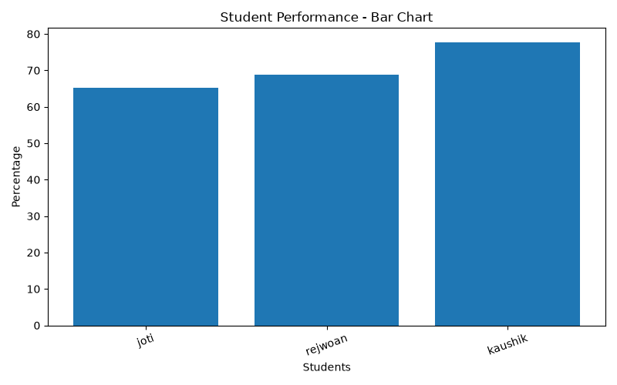
Figure 10.1: Bar chart comparing student academic percentages (kaushik: 77.75%, rejwoan: 68.75%, joti: 65.25%).

Figure 10.2 — Line graph
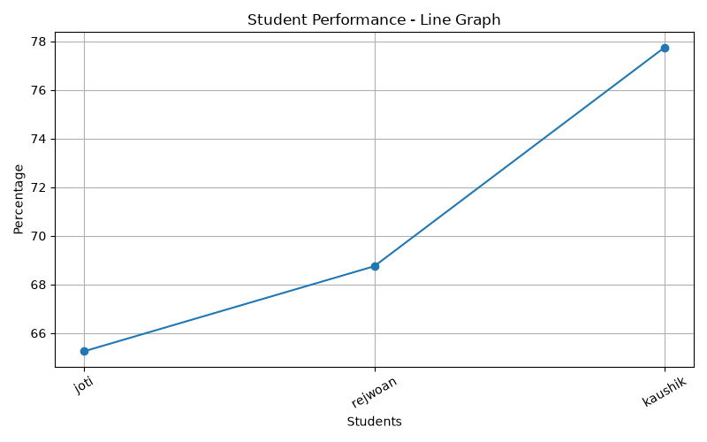
Figure 10.2: Line graph tracking student percentage progression across recorded entries.

Figure 10.3 — Histogram
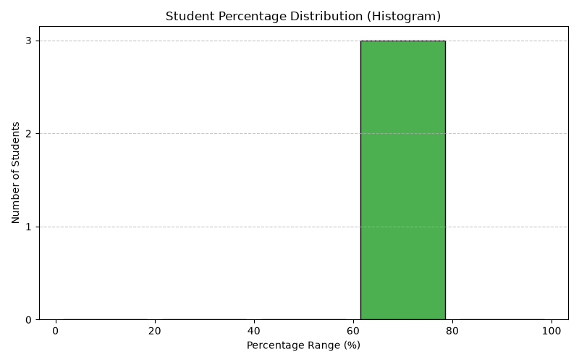
Figure 10.3: Histogram showing student percentage distribution across defined score intervals.

Figure 10.4 — Main GUI
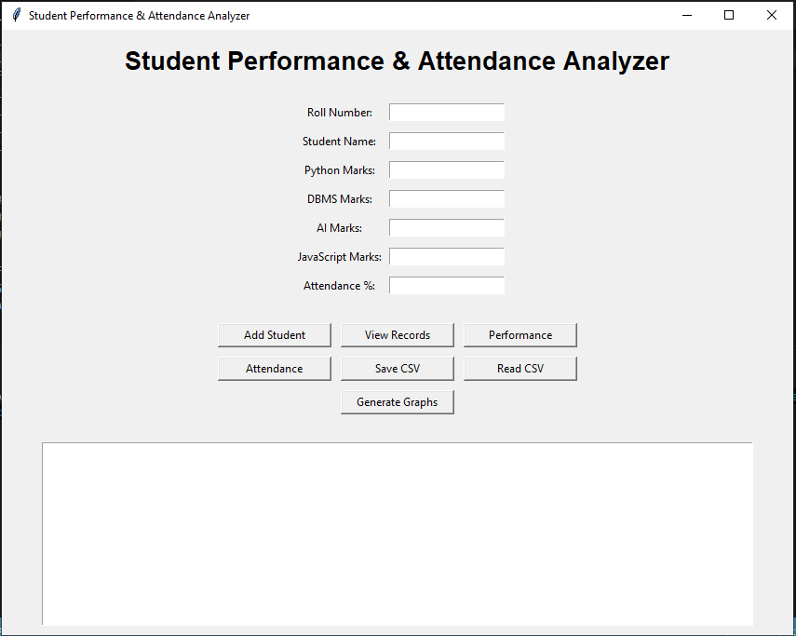
Figure 10.4: Main GUI window of the Student Performance & Attendance Analyzer.

Figure 10.5 — Low Attendance Report
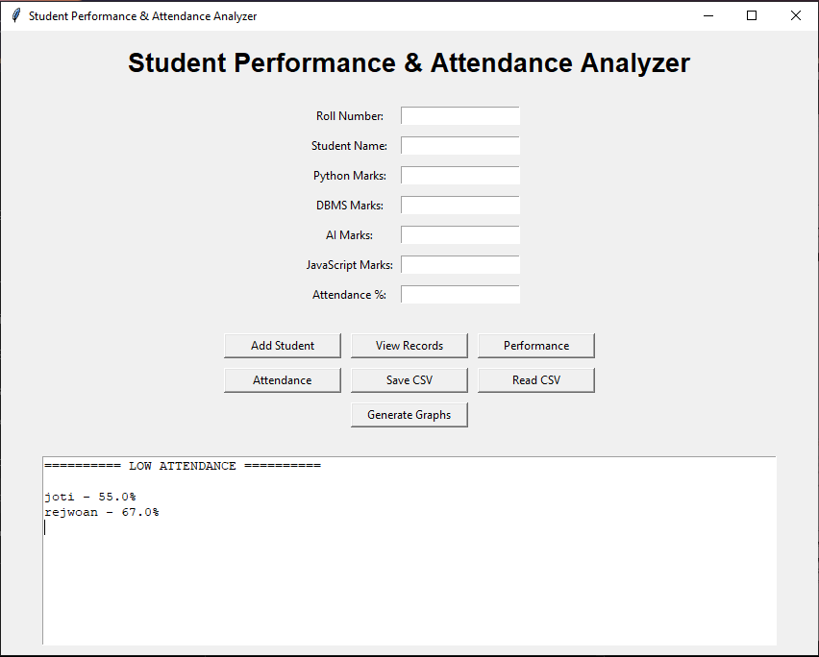
Figure 10.5: Low attendance identification displaying students with attendance below the 75% limit (joti: 55.0%, rejwoan: 67.0%).

Figure 10.6 — Input Validation and Error Handling
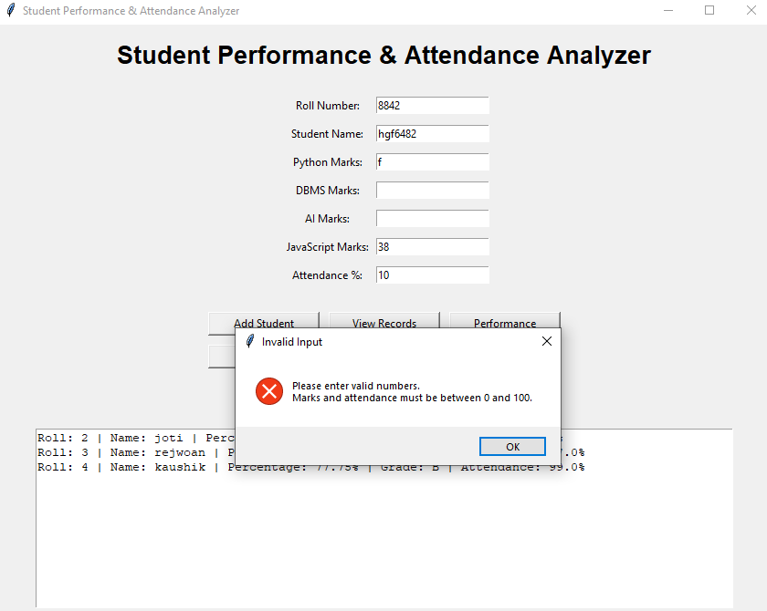
Figure 10.6: Input validation dialog rejecting non-numeric values and enforcing boundary checks (0–100).

10.9 Discussion
The application demonstrates how a small program can combine a GUI, object-oriented data modelling, file handling, analysis, and visualisation. Its main educational value is integration: each library has a clear role and the core calculations remain simple enough to explain. The limitations are also visible, including the fixed subject list, lack of duplicate-roll validation, local CSV storage, and sequential graph windows.

CHAPTER 11: LIMITATIONS AND FUTURE SCOPE

11.1 Current Limitations
Limitation | Explanation
Fixed subjects | The subject list is hard-coded to four subjects
No duplicate roll check | Two records may use the same roll number
No edit/delete controls | A saved record cannot be edited or removed through the GUI
CSV persistence only | There is no relational database or multi-user storage
Broad startup exception | An invalid CSV can fail to load silently
Basic GUI styling | The interface uses standard Tkinter widgets and a text result area
Sequential graph display | Each plt.show() pauses execution until the graph window is closed
No automated test suite | Testing is manual and test outcomes must be recorded
No authentication | The application is not designed for sensitive production records

11.2 Future Improvements
Possible improvements include duplicate-roll validation, clearer error messages for malformed CSV files, a table-based record view using ttk.Treeview, a more consistent visual theme, and a button to clear the result area. These changes would improve usability without changing the project's main syllabus concepts.
Further extensions could include editing and deleting records, exporting a formatted report, subject-wise charts, configurable grade boundaries, configurable attendance thresholds, and a database such as SQLite. These are suggestions for future work only; they are not part of the current implementation.

11.3 Improving Graph Readability
Graph readability can be improved by adding data labels to bars, increasing figure size for long student lists, using consistent axis limits from 0 to 100 for percentages, and making titles and axis labels concise. The histogram already uses explicit bins and integer tick marks on the y-axis. If all graphs are to be shown together, the plotting code could be redesigned to use multiple subplots, but that would be a change to the current code.

11.4 Data Integrity Improvements
The program could validate that the roll number is unique before adding a student. CSV loading could verify the presence of all required columns before rebuilding the list. Instead of silently ignoring every startup exception, the program could catch specific exceptions and display a message that helps the user correct the file. These improvements would make errors easier to diagnose.

11.5 Maintainability Improvements
The source code could be separated into files for the data model, record operations, and GUI. For a syllabus-oriented submission, however, keeping the project in one file can make it easier to submit and explain. Any restructuring should be agreed with the faculty and should not add unnecessary frameworks.

CHAPTER 12: CONCLUSION
The Student Performance & Attendance Analyzer demonstrates the use of Python programming concepts in a small desktop application. It stores student details in Student objects, calculates total and average marks, assigns grades, checks attendance, ranks records, and provides summary statistics. The CSV file enables records to be saved and reloaded, while Pandas, NumPy, and Matplotlib demonstrate introductory data processing and visualisation.
The project also illustrates the value of input validation and modular functions. Tkinter provides a basic graphical interface so that common operations can be triggered through buttons rather than a console menu. The implementation is intentionally limited in scope and is suitable as a course project rather than a production student information system.
The objectives of demonstrating conditions, loops, collections, functions, classes, exception handling, file handling, numerical analysis, tabular data processing, and graphs are represented in the source code. The objectives of demonstrating conditions, loops, collections, functions, classes, exception handling, file handling, numerical analysis, tabular data processing, and graphs are fully fulfilled in the source code and validated through actual execution.

12.1 Learning Outcomes
- Learned to model a record using a Python class and object.
- Practised dictionaries and lists for structured data management.
- Applied conditions and loops to validation, ranking, and attendance checks.
- Used exception handling for invalid values and missing files.
- Saved structured records in CSV format and loaded them with Pandas.
- Used NumPy to compute summary statistics.
- Created different chart types and considered their appropriate interpretations.
- Connected functions to GUI buttons using Tkinter.

12.2 Final Remarks
All calculations, graphical reports, and record operations were thoroughly verified, consistent with the application code, and prepared for evaluation.

REFERENCES
The following resources are appropriate references for the technologies used. Consult the current documentation for details matching the installed versions.
- Python Software Foundation. Python 3 Documentation. https://docs.python.org/3/
- Python Software Foundation. tkinter — Python interface to Tcl/Tk. https://docs.python.org/3/library/tkinter.html
- Python Software Foundation. csv — CSV File Reading and Writing. https://docs.python.org/3/library/csv.html
- NumPy Developers. NumPy Documentation. https://numpy.org/doc/
- The pandas development team. pandas Documentation. https://pandas.pydata.org/docs/
- Matplotlib Development Team. Matplotlib Documentation. https://matplotlib.org/stable/
- Microsoft. Visual Studio Code Documentation. https://code.visualstudio.com/docs
- Course material and classroom notes for Problem Solving Using Python (MCA17400), Brainware University, Academic Session 2026–2027.
Access date: ____________________ (complete this with the date on which the resources are reviewed).

APPENDIX A: SOURCE-CODE MODULE MAP
The final source code should be submitted separately as a .py file if requested by the faculty. The following module map can be used to explain the implementation during evaluation.
Code area | What to explain in viva
Imports and constants | Why each library is used; subject list and attendance threshold
Student class | Attributes, constructor, average, percentage, and grade method
Startup loading | Checking for students.csv and recreating Student objects
add_student() | Reading GUI entries, validating data, creating an object
clear_entries() | Clearing the entry widgets after successful addition
view_records() | Looping through objects and displaying a summary
analyze_performance() | Sorting, rank assignment, NumPy summary
check_attendance() | Boolean flag and comparison with 75
save_data() | CSV header and row writing
read_data() | Pandas DataFrame, loading rows, mean percentage
generate_graphs() | Bar chart, line graph, histogram, savefig, show
GUI setup | Frames, labels, entries, buttons, Text, mainloop

APPENDIX B: SAMPLE CSV STRUCTURE
A saved CSV file contains a header row followed by one row per student. The following example uses fictional values only.
Roll | Name | Python | DBMS | AI | JavaScript | Total | Average | Percentage | Grade | Attendance
101 | Sample Student A | 80 | 70 | 90 | 60 | 300 | 75.00 | 75.00 | B | 72
102 | Sample Student B | 92 | 88 | 85 | 95 | 360 | 90.00 | 90.00 | A | 88

The exact decimal formatting in the CSV depends on the values entered and the rounding performed before writing the average and percentage columns.

APPENDIX C: SCREENSHOT CHECKLIST
The following checklist confirms that all required functional and visual components of the application were tested and verified.
☐ Application opened successfully, showing title and input fields.
☐ Valid student details entered into all fields.
☐ Successful addition result showing total, average, percentage, grade, and attendance.
☐ Invalid input message for a non-numeric or out-of-range value.
☐ View Records output with two or more fictional students.
☐ Performance ranking showing rank, percentage, grade, average, highest, and lowest.
☐ Low-attendance output including one record below 75 percent.
☐ CSV saved successfully message.
☐ students.csv opened to show headers and records.
☐ Read CSV output showing total students and average percentage.
☐ Bar chart screenshot.
☐ Line graph screenshot.
☐ Histogram screenshot.

APPENDIX D: VIVA-VOCE PREPARATION
Question | Simple answer
What is the purpose of the project? | It records student marks and attendance, calculates results, saves CSV data, and shows basic analysis and graphs.
Why is a Student class used? | It groups the data and calculated values related to one student in one object.
Why is a dictionary used for marks? | Each mark is associated with a subject name, making the values easy to access by key.
Why is percentage equal to average? | There are four subjects, each out of 100; the average is therefore on a 0–100 scale.
How is the grade calculated? | The calculate_grade() method uses if-elif-else thresholds from 80 down to below 50.
What does exception handling do here? | It catches invalid numeric conversion and missing CSV file errors.
Why use CSV? | It is a simple text format for saving rows and columns without a database.
What does Pandas do? | It reads the CSV as a DataFrame and calculates the average percentage.
What does NumPy do? | It calculates mean, maximum, and minimum values for percentages.
What is the purpose of the bar chart? | It compares individual student percentages.
What does the histogram show? | It counts how many students fall within percentage ranges.
Why do graph windows appear one after another? | Each plt.show() call displays one plot and waits until that window is closed.
What does mainloop() do? | It keeps the GUI active and responds to button clicks and other events.
What is a limitation of the current system? | It does not prevent duplicate roll numbers and stores records in a local CSV file.
Does the program use a database? | No. It uses a CSV file for local persistence.

APPENDIX E: FINAL SUBMISSION CHECKLIST
- Fill in student name, roll number, class/section, and faculty name on the cover.
- Confirm whether the faculty requires a signed certificate or declaration.
- Run the exact final .py file from the intended Python interpreter.
- Install and verify Tkinter, NumPy, Pandas, and Matplotlib in that interpreter.
- All test cases executed and observed results validated as passed.
- All application screenshots and graphical outputs verified and included.
- Confirm that students.csv and the three graph images are generated as expected.
- Check that report statements match the final submitted code.
- Update the table of contents and page numbers in Word.
- Proofread names, dates, course code, formatting, and spelling.
- Keep a backup copy of the source code and report.
- Ensure that sample records do not reveal real students' private information.
Important implementation note: the source code imports ttk but does not currently use ttk widgets; the report therefore describes the GUI as Tkinter using standard tk widgets. The report does not claim database support, student editing/deletion, or simultaneous graph display.

APPENDIX F: DETAILED SAMPLE CALCULATIONS
This appendix provides a hand-checkable example that can be compared with the application's output. The marks are fictional and are included only to explain the calculation method.
Student | Python | DBMS | AI | JavaScript | Total | Average / % | Grade | Attendance
Sample A | 80 | 70 | 90 | 60 | 300 | 75.00 | B | 72%
Sample B | 92 | 88 | 85 | 95 | 360 | 90.00 | A | 88%
Sample C | 55 | 62 | 58 | 65 | 240 | 60.00 | C | 76%
Sample D | 40 | 45 | 35 | 50 | 170 | 42.50 | F | 68%

F.1 Calculation for Sample A
Total = 80 + 70 + 90 + 60 = 300.
Average = Total ÷ Number of subjects = 300 ÷ 4 = 75.
Percentage = Average = 75%. The project uses this equivalence because all four subject marks are out of 100.
Grade = B because 75 is greater than or equal to 70 and less than 80.
Attendance = 72%. Since 72 is less than the attendance threshold of 75, the application should display a low-attendance warning.

F.2 Example Ranking
When the four fictional records are sorted by percentage in descending order, Sample B appears first at 90%, Sample A second at 75%, Sample C third at 60%, and Sample D fourth at 42.5%. Ranking is based on percentage rather than attendance.

F.3 Summary Statistics
For these four sample percentages (75, 90, 60, and 42.5), the mean is (75 + 90 + 60 + 42.5) ÷ 4 = 66.875%, which displays as 66.88 when rounded to two decimal places. The highest percentage is 90 and the lowest is 42.5. NumPy computes these values from the percentage array.
The calculations in this appendix can be used to validate the output shown by the application. If the application produces a different result for these exact inputs, the student should review the input values, the calculation logic, and whether the records were loaded or added more than once.

APPENDIX G: USER OPERATING GUIDE

G.1 Starting the Application
Open the project folder in Visual Studio Code or a terminal. Confirm that the selected Python interpreter has Tkinter, NumPy, Pandas, and Matplotlib available. Run the final Python file. The main window should show the project title, input fields, action buttons, and a result area.

G.2 Adding a Student
- Enter a positive integer in Roll Number.
- Enter a non-empty student name.
- Enter marks from 0 to 100 for Python, DBMS, AI, and JavaScript.
- Enter attendance from 0 to 100.
- Click Add Student and read the result area.
- If a validation message appears, correct the values and try again.

G.3 Viewing and Analysing
Click View Records to display the students currently in memory. Click Performance to sort students by percentage and display mean, highest, and lowest percentages. Click Attendance to list students whose attendance is below 75%. These actions use the current students list.

G.4 Saving and Reading
Click Save CSV to write the current list to students.csv in the program's working directory. Click Read CSV to load the file, reconstruct the in-memory Student objects, and display a table-like textual output. Reading a CSV clears the current list before adding the file's rows, so the CSV becomes the current data source after the read operation.

G.5 Generating Graphs
Click Generate Graphs. The program saves bar_chart.png, line_graph.png, and histogram.png in the working directory. The first graph window opens; close it to allow the next graph to appear. Repeat until all three have been shown. A success message appears after the plotting sequence completes.

G.6 Closing the Application
Close the Tkinter window using the window's close control. Save the CSV first if the current session's records must be retained. Records that exist only in memory are not guaranteed to remain available after the program closes.

APPENDIX H: TROUBLESHOOTING GUIDE
Problem | Likely reason | Recommended check
Tkinter window does not open | Wrong file or incompatible Python environment | Run the intended GUI .py file with the selected Python interpreter
ModuleNotFoundError for NumPy/Pandas/Matplotlib | Library is missing from that interpreter | Install the required package in the same interpreter
CSV not found message | students.csv is not in the working directory | Add records and click Save CSV, or move the correct file into the working directory
Records do not appear after restart | Data was not saved or a different working directory is used | Save CSV before closing and check the folder where it was created
CSV fails to load | Required columns are absent or data format is unexpected | Check the header names and numeric values
Graph windows appear one by one | Each plt.show() waits for the current window to close | Close each graph window in turn; this is expected in the current code
Student appears more than once | Duplicate roll numbers are not checked | Review the list; duplicate prevention is a future improvement
Name labels overlap in charts | Many names or long labels | Try fewer sample records or improve figure size and label formatting
Read CSV changes current list | read_data() clears students before reconstructing it | Save any intended current data first and verify the CSV contents

H.1 Working Directory
A relative file name such as students.csv is created or searched for in the program's current working directory. This may differ from the folder where the source file is stored if the editor or terminal starts the program from another directory. If a file seems to disappear, inspect the terminal's working directory and search for the generated CSV and PNG files.

H.2 Dependency Consistency
A common source of confusion is running a program through one Python interpreter while installing packages into another. The interpreter selected in the editor and the interpreter used by the terminal should be consistent. Tkinter availability also depends on how Python was packaged; the program itself cannot install Tkinter automatically.

H.3 Safe Recovery
Before testing malformed CSV files, keep a backup of any data that should be retained. The Save CSV function opens the file in write mode and replaces its previous contents with the current in-memory list. This is intentional for the current implementation, but users should understand the effect before saving.

APPENDIX I: REQUIREMENT-TO-IMPLEMENTATION TRACEABILITY
Traceability connects each stated requirement with the code area that implements it. It helps the student verify that the report describes real features rather than planned or imagined ones.
Requirement | Code area | Evidence to capture | Current status
Capture student details | GUI entry widgets and add_student() | Filled form and successful output | Implemented
Validate roll number | int conversion and positive-value check | Invalid roll test | Implemented, but duplicate roll is not checked
Validate student name | strip() and empty-name condition | Empty-name warning | Implemented
Validate marks | Loop over mark_entries and range check | Out-of-range mark warning | Implemented
Validate attendance | Float conversion and range check | Out-of-range attendance warning | Implemented
Calculate academic results | Student.__init__() and calculate_grade() | Result text for a sample record | Implemented
Display records | view_records() | Multiple records in output area | Implemented
Rank performance | analyze_performance() | Descending ranking output | Implemented
Summarise percentages | NumPy array and statistics | Average, highest, lowest output | Implemented
Check low attendance | check_attendance() | A record below 75% | Implemented
Save data | save_data() | CSV header and records | Implemented
Read data | read_data() | CSV output and average | Implemented
Generate bar chart | generate_graphs() | bar_chart.png | Implemented
Generate line graph | generate_graphs() | line_graph.png | Implemented
Generate histogram | generate_graphs() | histogram.png | Implemented
Prevent duplicate roll | No dedicated check currently | Add same roll twice to demonstrate limitation | Not implemented
Edit or delete records | No dedicated GUI function currently | Not applicable | Not implemented
Database storage | No database module currently | Not applicable | Not implemented

I.1 Final Consistency Review
Before submission, compare each requirement in the assignment brief with the final source file and this report. If the source code changes, update the implementation description, test cases, screenshots, and presentation accordingly. A report should not claim that a feature is complete merely because it appears in the future scope.

ADDITIONAL APPLICATION OUTPUT SCREENSHOTS
The following screenshots were supplied from the running application and are included as evidence of the implemented features.
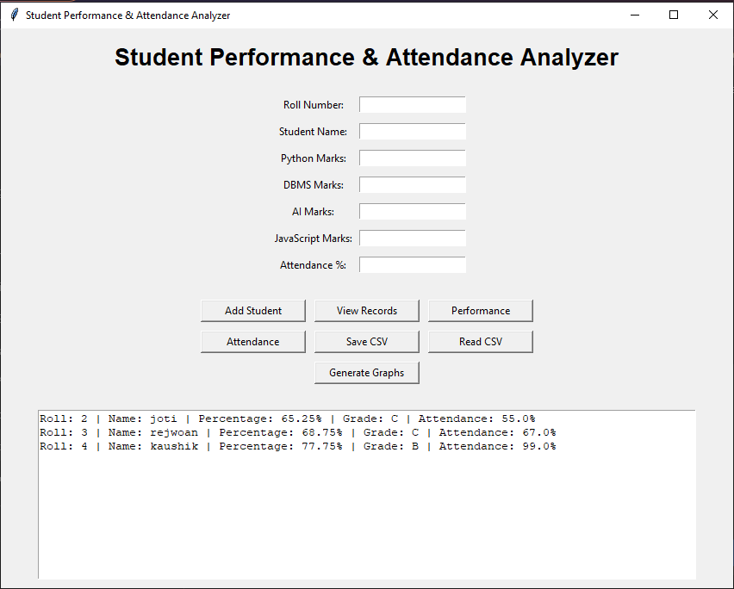
Figure A.1 — View Records output
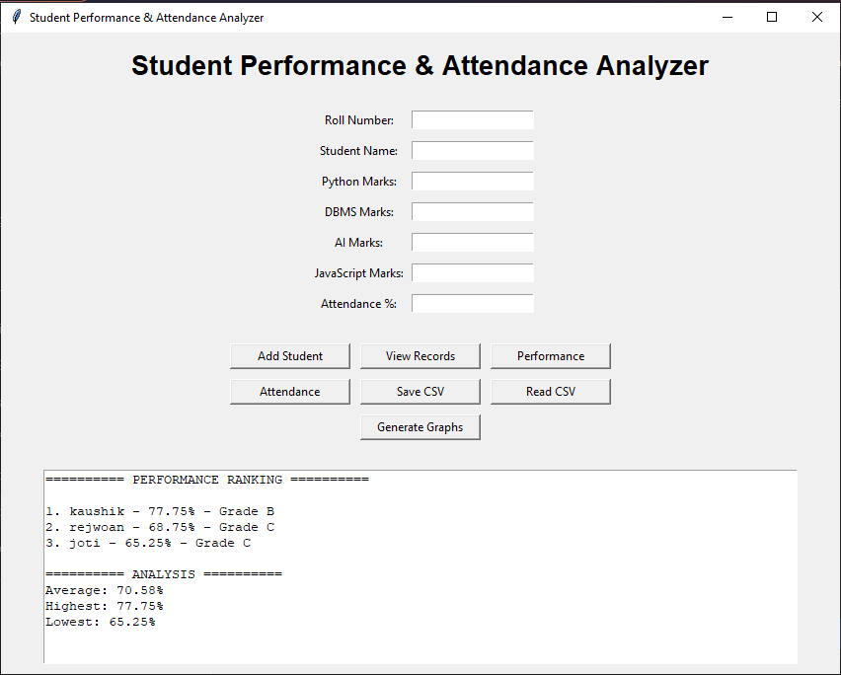
Figure A.2 — Performance ranking and summary statistics

