**Table of Content**

[Introduction to the Report 3](#_Toc251345845)

[Part 1: Networking Principles, Protocols, and Devices 3](#_Toc269283266)

[Networking Protocols 3](#_Toc1095807433)

[Comparative Analysis Table 4](#_Toc415769759)

[Networking Devices 4](#_Toc2078035822)

[Detailed Description 5](#_Toc1021509193)

[Benefits and Restrictions of Networked Solutions 5](#_Toc1520732633)

[Effect of Organization Topology 5](#_Toc1750479884)

[Correspondence and Data Transfer Capacity Prerequisites 5](#_Toc1936930135)

[Proficiency in Systems administration Frameworks 5](#_Toc280174072)

[Part 2: Benefits and Restrictions of Networked Solutions 5](#_Toc1601473880)

[Advantages of Networked Systems 6](#_Toc1558953309)

[Limitations and Challenges 6](#_Toc2027770963)

[Effect of Organization Topology 6](#_Toc181097251)

[Correspondence and Transfer Speed Necessities 6](#_Toc717169758)

[Efficiency of Networking Systems 6](#_Toc1793895742)

[Organized Arrangements in Various Settings 7](#_Toc1482815561)

[Part 3: Operating Principles of Networking Devices 7](#_Toc133410292)

[Routers 7](#_Toc253850176)

[Switches 7](#_Toc1557385090)

[Hubs 8](#_Toc1440517994)

[Bridges 8](#_Toc55288880)

[Network Execution and Effectiveness 8](#_Toc1527270656)

[Part 4: Server Types and Networking Software 8](#_Toc2113366448)

[Organizing Programming 8](#_Toc2117853803)

[Working Standards of Systems Administration Gadgets 9](#_Toc227417996)

[Activity 2 9](#_Toc1840850759)

[9](#_Toc381804184)

[Step-by-Step Plan for Making a Local Area Network 9](#_Toc301783252)

[Step 1: Network Requirement Analysis 9](#_Toc1862225797)

[Step 2: Hardware Selection 10](#_Toc1002298801)

[Step 3: Network Segmentation 10](#_Toc774221339)

[Stage 4: Access Control 10](#_Toc734627400)

[Stage 5: Physical Setup 10](#_Toc999225197)

[Stage 6: Organization Setup 10](#_Toc655766439)

[Stage 7: Testing and Investigating 10](#_Toc580463869)

[Switch Configuration 11](#_Toc1985521609)

[Associating Model PCs: 11](#_Toc913291730)

[Support for 255 PCs and Extendability: 11](#_Toc1628481001)

[FastEthernet Ports on the Ground Floor: 11](#_Toc201102792)

[Setting Access Mode for Ports: 11](#_Toc1942848413)

[VLAN and Access Configuration 11](#_Toc964424656)

[Involving VLANs for Traffic The board: 11](#_Toc2026109483)

[Making an Administration VLAN: 12](#_Toc173890302)

[Commands for Network Configuration 12](#_Toc1996545794)

[Arranging Terminal Settings for VLANs and Ports: 12](#_Toc1513175383)

[Getting to the Ground Floor: 12](#_Toc1437314307)

[Configure Commands in the Zip Organizer: 12](#_Toc2045496293)

[Trunk Configuration 13](#_Toc1737975275)

[Designing Trunk Ports: 13](#_Toc77880431)

[Network Testing and Security Commands: 13](#_Toc1118862794)

[Command in the Zip Envelope: 13](#_Toc1360165626)

[Router Configuration 13](#_Toc340253867)

[Drawing an obvious conclusion with the Switch: 14](#_Toc2045274355)

[Commands for Switch Connection point Arrangement: 14](#_Toc155346956)

[Commands in the Zip Folder: 14](#_Toc1723658387)

[Testing and Verification 14](#_Toc2119595926)

[Exhaustive Testing Agenda: 14](#_Toc1589991846)

[Proof in the Zip Envelope: 14](#_Toc1853936101)

[Security Prerequisites and Quality of Services for Accessories: 15](#_Toc1263815184)

[Maintenance Schedule to Support the Network: 15](#_Toc181045011)

[Supporting Devices Development and Communication Devices: 15](#_Toc1986655725)

[Significance of Upgrades and Security Requirements: 16](#_Toc647026519)

[Conclusion 16](#_Toc1865000072)

[Combination of Key Discoveries 16](#_Toc384898492)

[Significance of Understanding Networking Standards 16](#_Toc768210280)

[The Powerful Idea of Network Principles 16](#_Toc638490196)

[Suggestions for Network Design and the Executives 16](#_Toc128940113)

[Final Reflections 17](#_Toc285479368)

# **Table of Figures**

**Figure1..........................................................................................................................................4**

**Figure2..........................................................................................................................................8**

**Figure3........................................................................................................................................10**

**Figure4........................................................................................................................................11**

**Figure5........................................................................................................................................14**

**Figure6........................................................................................................................................15**

**Figure7........................................................................................................................................19**

# **Introduction to the Report**

In the modern, speedy-evolving technology landscape, understanding the requirements and protocols of communication systems is more important than ever. This report's ambition is to interrupt the complicated world of networking and provide a comprehensive analysis of the policies that govern the go-with-the-flow of facts throughout specific virtual mediums. By demystifying the elaborate relationship between exclusive networking structures and devices, we are hoping to arm readers with a deeper know-how of their particular roles and functionalities.

Our primary goal is to contribute to the educational development of the sphere whilst additionally imparting practical implications for specialists and lovers alike. As the sector turns into increasingly dependent on virtual connectivity, the capacity to layout, control, and improve network systems is a precious talent. This report is organized to first introduce readers to the fundamental networking standards, observed through an in-depth contrast of usual structures, networking conventions, and gadgets. Subsequent sections will discover the advantages and obstacles of networked arrangements, the impact of networking topology, and the productivity of structured networking frameworks. We will then study the useful requirements of networking principles and devices, as well as specific server types and networking software, culminating in complete information on the challenge.

By the cease of this file, readers can anticipate to have a strong grasp of the subsequent principles:

* Fundamental networking standards and protocols
* Typical structures, networking conventions, and gadgets
* Advantages and barriers of networked arrangements
* Impact of networking topology on system performance
* Productivity of structures networking frameworks
* Functional standards of networking concepts and devices
* Server type

## **Part 1: Networking Principles, Protocols, and Devices**

Definition and Significance: Networking principles standards structure the groundwork of information correspondence in PC organizations. They incorporate the standards and techniques that administer how information is communicated and gotten across networks.

Key Concept: This incorporates grasping the OSI (Open Frameworks Interconnection) model, the TCP/IP model, and how these systems work with correspondence and information trade in organizations.

## 

## **Networking Protocols**

Outline: Protocols are sets of rules that direct the way in which information is communicated over an organization. They guarantee that gadgets can impart no matter what their fundamental design.

* TCP/IP (Transmission Control Convention/Web Convention): This is the primary convention suite for web and local network information transmission. TCP guarantees solid conveyance of information bundles, while IP handles the tending to and steering.
* UDP (Client Datagram Convention): UDP is utilized for applications that require quick, effective correspondence without the requirement for blunder checking and adjustment.
* HTTP and HTTPS: These conventions are utilized for communicating web information. HTTPS is the safe adaptation of HTTP, giving scrambled correspondence.
* FTP (Record Move Convention): FTP is utilized for the exchange of documents over an organization.

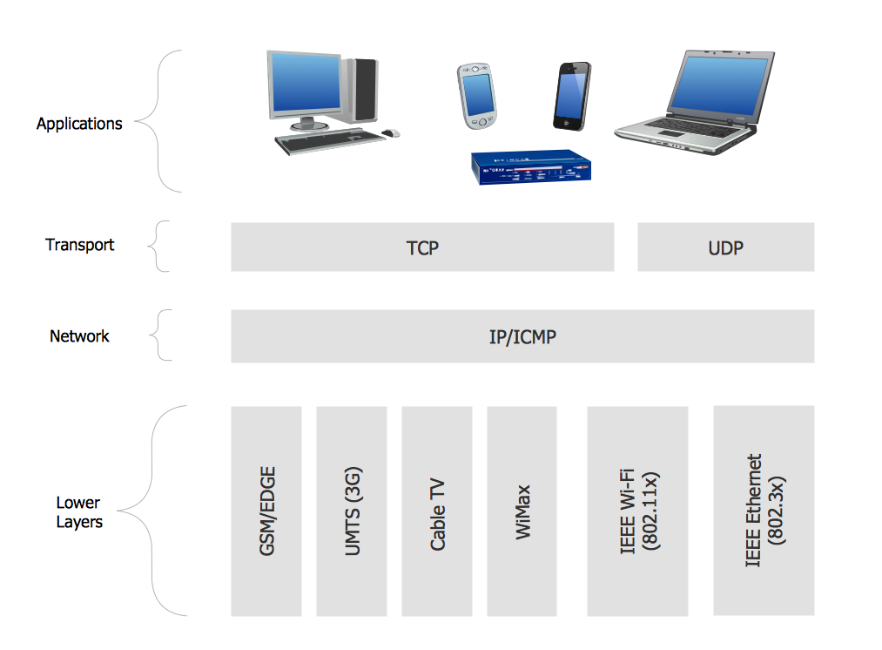

**Figure1**

## **Comparative Analysis Table**

**Reliability, Speed, Security, and Use Cases:**

A table comparing TCP/IP, UDP, HTTP/HTTPS, FTP, etc., based on these factors.

|  |  |  |  |  |
| --- | --- | --- | --- | --- |
| Protocol | Reliability | Speed | Security | Use Cases |
| TCP/IP | High | Moderate | Moderate (can be enhanced with TLS/SSL) | Web browsing, email, file transfer |
| UDP | Low | High | Low (no inherent encryption) | Streaming media, online gaming |
| HTTP | Moderate | Moderate | Low (no encryption) | Web browsing, data transfer |
| HTTPS | Moderate | Moderate | High (encrypted communication) | Secure web browsing, transactions |
| FTP | Moderate | Moderate to High | Low (can be secured with FTPS or SFTP) | File transfer, website maintenance |

### **Networking Devices**

* Routers: Devices that route data between different networks, operating at the network layer.
* Switches: Operate at the data link layer, directing data within a single network.
* Hubs: Basic networking devices that broadcast data to all connected devices.
* Bridges: Connect two network segments, filtering traffic based on MAC addresses.

### 

### **Detailed Description**

* TCP/IP Suite: In-depth exploration of how TCP/IP facilitates internet communication, including IP addressing, subnetting, and the role of DNS (Domain Name System).
* UDP Characteristics: Discuss where and why UDP is preferred over TCP, such as in streaming media or online gaming.
* HTTP and HTTPS Protocols: Explaining how these protocols work in web browsers and servers, the role of SSL/TLS in HTTPS, and their importance in web security.
* FTP in real life: How FTP works, its utilization cases, and correlation with fresher conventions like SFTP (Secure Record Move Convention).

### 

### **Benefits and Restrictions of Networked Solutions**

* Benefits: Sharing assets, bringing together information from the board, and working with correspondence.
* Constraints: Security weaknesses, reliance on network accessibility, and versatility challenges.

### 

### **Effect of Organization Topology**

* Kinds of Topologies: Star, transport, ring, cross-section, and hybrid topologies and their suggestions on network execution and dependability.
* Picking the Right Topology: Elements impacting the decision of organization geography, like size, versatility, and spending plan.

### 

### **Correspondence and Data Transfer Capacity Prerequisites**

* Transfer speed Significance: What transmission capacity means for network execution, particularly in information-weighty applications.
* Improving Transfer speed: Methods for enhancing data transmission utilization, for example, traffic moulding and Nature of Administration (QoS).

### 

### **Proficiency in Systems administration Frameworks**

* Estimating Organization Proficiency: Measurements for surveying network execution, similar to throughput, idleness, and parcel misfortune.
* Improving Proficiency: Procedures to further develop network effectiveness, including network configuration best practices, equipment updates, and programming arrangements.

## 

## **Part 2: Benefits and Restrictions of Networked Solutions**

Networked solutions allude to the utilization of interconnected registering gadgets and frameworks to share assets and data.

**Importance: They are essential in the present digital scene, empowering effective correspondence, information trade, and asset the board across different areas.**

### 

### **Advantages of Networked Systems**

* Asset Sharing: Networks empower various clients and gadgets to share assets like printers, documents, and web associations, prompting cost-effectiveness and accommodation.
* Further developed Correspondence: The capacity to share data rapidly and successfully, whether it's through messages, texting, or cooperative programming, is a critical advantage of organized arrangements.
* Adaptability: Networks can be increased or down to meet the changing necessities of an association, giving adaptability in assets to the executives and framework extension.

### 

### **Limitations and Challenges**

* Security Concerns: The interconnected idea of Networks conveys them helpless against security threats like hacking, infections, and information breaks.
* Maintenance and Management: Networks require standard upkeep and talented faculty for the executives, which can be resource-intensive.
* Reliance on Network Accessibility: A weighty dependence on the network implies that blackouts can essentially disturb tasks.

### 

### **Effect of Organization Topology**

* Network Geography: The physical and legitimate plan of a network; it is spread on a mission to incorporate how gadgets and associations.
* Types and Suggestions: Talking about star, ring, transport, mesh, and hybrid topologies and how each influences network execution, dependability, and adaptability.

### 

### **Correspondence and Transfer Speed Necessities**

* Transfer speed: The volume of data per unit of time that a transmission medium (like a web association) can deal with.
* Deciding Transmission Capacity Needs: Variables influencing transfer speed necessities incorporate the sort and measure of information sent, the number of clients, and the applications utilized.
* Adjusting Transmission Capacity: Methodologies for overseeing transfer speed incorporate traffic prioritization, information pressure, and utilizing storing servers.

### 

### **Efficiency of Networking Systems**

* Estimating Effectiveness: Productivity can be calculated as far as throughput, inactivity, blunder rates, and asset use.
* Further developing Network: Proficiency: Procedures, for example, proficient network configuration, picking the correct topology, and utilizing progressed organizing gear can improve productivity.
* Quality of Service (QoS): QoS components can be utilized to focus on significant traffic, guaranteeing that basic applications have vital assets.

### 

### **Organized Arrangements in Various Settings**

* Professional workplaces: In business settings, arranged networks work with activities like client relationships with the executives, inventory management, and working from home.
* Educational Institutions: Schools and colleges use networks for e-learning stages, understudy data frameworks, and exploration cooperation.
* Medical services Area: Networks are critical in medical services for patient records, executives, telemedicine, and associating different symptomatic hardware.

## 

## **Part 3: Operating Principles of Networking Devices**

The powerful working of a network intensely depends on its fundamental parts - the networking devices. These gadgets, including routers, switches, hubs, and bridges, take part in crucial bits of sending, receiving, and carrying information across a network. It is vital for anyone involved in network design, implementation, or other business to understand how these devices work. In this section, we study what these devices are doing and how they contribute to the efficiency of a network in general ways that are productive for everyone concerned.

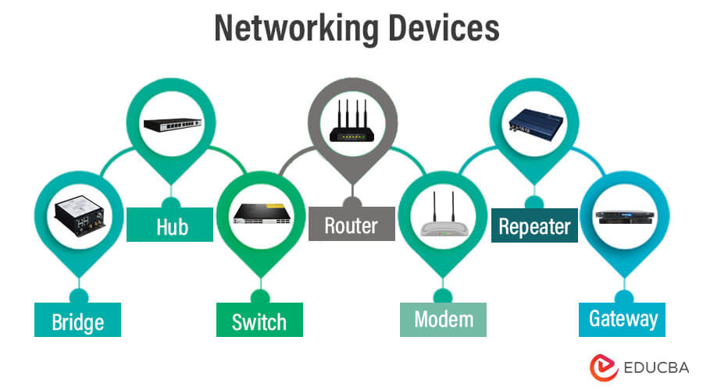

**Figure2**

### 

### **Routers**

* Benefits: Routers are at the core of any network, managing packages of information amondifferent locations which are networked together. Within the framework of the OSI model these operate at the network layer, and use IP addresses to decide upon transmission paths.
* Directing Tables and Conventions: Routers keep up with steering tables that store courses to various network objections. They use running conventions like OSPF (Open Most Limited Way First) and BGP (Line Passage Convention) to learn and refresh these courses.
* Job in Organization Security: Routers likewise assume a critical part in network security by carrying out firewalls and organization strategies to control the traffic stream.

### **Switches**

* Usefulness: Working at the information connect layer, switches are basic in overseeing the information stream inside a network. Dissimilar to centres, which broadcast information to every associated gadget, changes wisely forward information to the planned beneficiary.
* Sorts of Switches: There are two essential kinds of switches - oversaw and unmanaged. Overseen switches offer more control, permitting network chairmen to design, make due, and screen network access, while unmanaged switches are less complicated, with attachment and play gadgets.
* VLANs and Organization Division: Switches empower the formation of Virtual Neighborhood (VLANs), permitting network division and further developing traffic for the executives, which improves security and execution.

### 

### **Hubs**

* Fundamental Usefulness: Hubs points are the most straightforward networking protocol devices that interface different devices in a network. Working at the actual layer, Hubs broadcast approaching information bundles to every associated gadget.
* Restrictions: Because of their tendency to broadcast to all ports, centers are less proficient and secure as compared with switches. They are usually utilized in more modest or less perplexing organization arrangements.

### 

### **Bridges**

* Reason and Usefulness: Bridges are utilized to interface two separate network sections, working at the information connect layer. They channel network traffic, sending or impeding information bundles in light of MAC addresses.
* Use in Network Expansion: Bridges are precious in broadening a network or interfacing various pieces of a network that utilise comparative conventions but are fragmented for productivity.

### **Network Execution and Effectiveness**

* Traffic The executives: These gadgets assume an essential part in overseeing network traffic, guaranteeing effective information transmission, and diminishing blockage.
* Load Adjusting and Failover: Progressed organizing gadgets, particularly routers and switches, can be designed for load adjusting to appropriate network traffic equitably across assets and failover to offer nonstop support if there should be an occurrence of gadget or way disappointment.
* Nature of Administration (QoS): Many networking devices support QoS, which focuses on specific sorts of traffic (like VoIP or streaming) to guarantee ideal execution for basic applications.

## 

## **Part 4: Server Types and Networking Software**

Servers are strong PCs that give information, assets, and services to different PCs (clients) in a network. Networking software, then again, incorporates the scope of projects and applications that empower and oversee network interchanges.

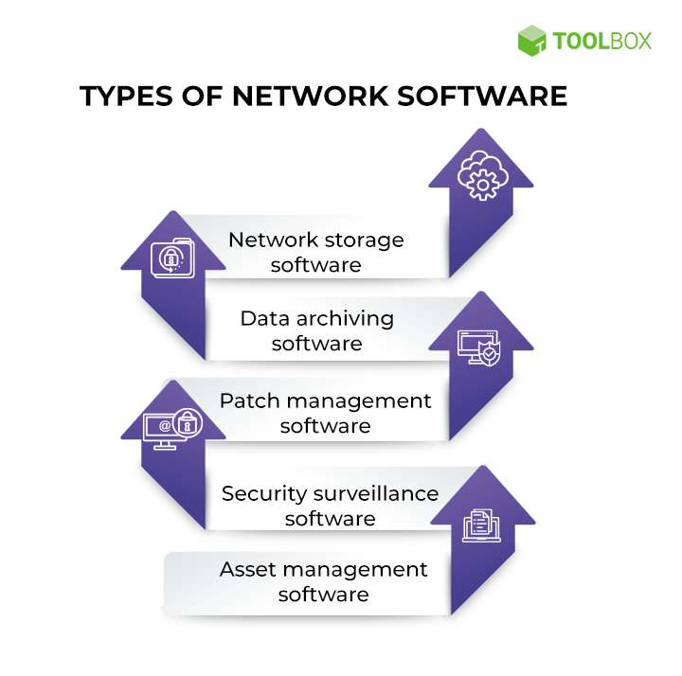

**Figure3**

### 

### **Organizing Programming**

* Network Working Frameworks (NOS): These are particular working frameworks intended for overseeing network assets. They work with information correspondence, client validation, and asset sharing.
* Network Management Software: This product helps check and oversee network assets. It incorporates apparatuses for traffic investigation, execution checking, and issue finding.
* Network Security Programming: Fundamental for safeguarding network information, this incorporates firewalls, hostile-to-infection projects, and interruption discovery frameworks.
* Correspondence and Cooperation Devices: Programming like email servers, VoIP frameworks, and coordinated effort stages are urgent for successful correspondence inside an organization.

### 

### **Working Standards of Systems Administration Gadgets**

#### 

#### **Routers and Switches**

Examining how routers direct traffic among organizations and how switches interface gadgets inside an organization. Investigating highlights like directing conventions and VLAN support.

Firewalls and Security Machines: Understanding the job of firewalls in network security and how security apparatuses can safeguard against different digital dangers.

#### 

#### **Server and Organization Programming Practically speaking.**

Contextual analyses: Genuine instances of how various sorts of servers and networking software programming are executed in different businesses.

Picking the Right Mix: Elements to consider while choosing servers and networking software, including business size, financial plan, security necessities, and execution prerequisites.

#### 

#### **Future Patterns**

Emerging Technologies: Investigating advancements in server equipment, like energy-effective plans, and in networking software, similar to artificial intelligence-driven network-the-board apparatuses.

Cloud and Edge Figuring: Examining the shift towards cloud-based administrations and the developing significance of Edge registering in-network plans.

# **Activity 2**

## 

**Figure4**

## **Step-by-Step Plan for Making a Local Area Network**

### 

### **Step 1: Network Requirement Analysis**

In the initial phase of setting up a Local Area Network (LAN), it's essential to understand what the network will be used for and who will be using it. We need to figure out how many people will be connecting to the network on each floor, what kind of devices they will be using (like computers and printers), and what they'll be doing on the network. This information helps us design a network that can handle the workload efficiently.

### 

### **Step 2: Hardware Selection**

Choose appropriate networking hardware:

* Switches: Deploy switches that can handle the calculated traffic and offer scalability for future expansion.
* Computers and Printers: Ensure these devices are compatible with the intended network usage and performance requirements.

### 

### **Step 3: Network Segmentation**

To coordinate our network successfully and improve security, we'll utilize a method called network division. Consider separating the organization into various segments. Along these lines, we can keep understudy PCs separate from staff and authoritative devices. It helps in dealing with the organization better and adds an additional layer of safety.

### 

### **Stage 4: Access Control**

Presently, we should discuss who gains access to what in the organization. We'll set up rules and strategies that control who can utilize explicit assets. For example, we'll conclude that understudies ought to just access specific pieces of the organization except if there's an extraordinary motivation to get to more. This step is significant for keeping up with security and ensuring everyone has access to what they need.

### 

### **Stage 5: Physical Setup**

With the arranging done, now is the ideal time to genuinely set up everything. We'll find appropriate spots for our switches on each floor, guaranteeing they're secure and all-around ventilated to prevent overheating. We'll likewise ensure all devices, like PCs and printers, are associated with the right switches, utilizing organized cabling situations to keep things flawless and proficient.

### 

### **Stage 6: Organization Setup**

Presently, we're getting into the nitty-gritty of arranging our organization. We'll set up each change to comprehend which devices have a place in what part of the organization. For instance, we'll let the Switch know that this port interfaces with understudy devices and that the port is associated with personnel devices. We'll likewise apply any significant limitations or authorizations as per our entrance control arrangements. For easy understanding, here are the points:

Assign out VLANs on each Switch. Apply fundamental limitations for specific client bunches in arrangement with the laid-out network approaches.

Design access ports for every device, guaranteeing appropriate VLAN arrangement.

### 

### **Stage 7: Testing and Investigating**

Before we call it an incredible well done, we want to ensure everything is filling in as it should. We'll run tests to check assuming our organization has appropriate access controls and in the event that our entrance controls are taking care of their business. Considering we experience any issues, we'll utilize analytic orders to find and fix the problems. It's like making sure all the pieces of a puzzle fit together perfectly.

## 

## **Switch Configuration**

In this phase, we will set up the switches such that our organization works without a hitch.

### 

### **Associating Model PCs:**

To begin with, we connect a prototype or model PC for both staff and understudies to the Switch. This assists us with guaranteeing that our design turns out accurately for various kinds of clients. Consider it a trial to ensure everything is set up appropriately.

### 

### **Support for 255 PCs and Extendability:**

Our organization is intended to help up to 255 PCs, which is a decent number for most situations. Furthermore, assuming that we need to add more PCs later on, we can, without much of a stretch, stretch out the organization to accommodate them. This gives us adaptability and space to develop without a total update.

### 

### **FastEthernet Ports on the Ground Floor:**

For the ground floor, where a great deal of the activity occurs, we utilize what's classified as "FastEthernet" ports on the Switch. These ports are intended to deal with information rapidly, ensuring things run as expected for both staff and understudies. It resembles having a fast track on an interstate for the devices on the ground floor.

### 

### **Setting Access Mode for Ports:**

Presently, when we associate PCs and printers with the Switch, we really want to ensure they can converse with the organization accurately. To do this, we set the entrance mode for these ports appropriately. It resembles giving each port exceptional manual guidance on the most proficient method to act. For instance, a port associated with a PC will have unexpected settings in comparison to a port associated with a printer. Along these lines, everything functions as it ought to, and gadgets can impart with no disarray.

## 

## **VLAN and Access Configuration**

In this section, we'll investigate how we oversee network traffic and set up an exceptional method for controlling and communicating with our switches.

### **download**

**Figure5**

### **Involving VLANs for Traffic The board:**

We will utilize something called VLANs, which represent Virtual LANs, to deal with the traffic in our organization. Envision VLANs as independent paths on a busy highway. Every path is for a particular sort of traffic, similar to understudy information, personnel information, or even administration information. Along these lines, we can keep everything coordinated and guarantee that one kind of traffic doesn't get stirred up with another. It resembles having devoted paths for vehicles, trucks, and bikes out and about.

### 

### **Making an Administration VLAN:**

Presently, here's a flawless thing. We will make a unique path, or VLAN, only for dealing with our switches. We call this the Administration VLAN. It resembles having a confidential street that only we, as organization executives, can utilize. This is really helpful on the grounds that it permits us to access and control the switches remotely using orders like Telnet. It resembles having a mystery passage to arrive at our changes from any place when we want to make changes or really take a look at their status.

By utilizing VLANs and making an Administration VLAN, we ensure our organization's traffic streams without a hitch, and we have a solid and helpful method for dealing with our switches. Everything really revolves around keeping things coordinated and open when we really want them.

## 

## **Commands for Network Configuration**

In this section, we'll go through the particular orders expected to set up our organization, including arranging VLANs and guaranteeing the ground floor ports fill in as they ought to. Additionally, we'll address the orders connected with designing our Administration VLAN.

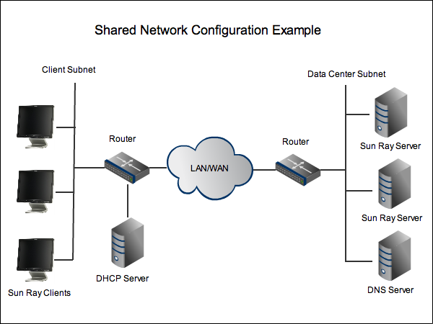

**Figure6**

### 

### **Arranging Terminal Settings for VLANs and Ports:**

To ensure our organization works without a hitch, we utilize explicit orders. These orders are like bit-by-bit directions for our switches. We let them know how to deal with various sorts of traffic in multiple VLANs. For instance, we use orders to make VLANs and relegate ports to these VLANs. It's like doling out unambiguous paths on a street to various kinds of vehicles. By doing this, we keep our organization coordinated and productive.

### 

### **Getting to the Ground Floor:**

Since a ton of significant stuff occurs on the ground floor, we really want to guarantee that the ports there are set up accurately. We use orders to ensure these ports interface with the right VLAN and have the proper access rules. It resembles giving each port on the ground floor a key to the right path on our network highway. This guarantees that information streams flawlessly to and from gadgets on that floor.

### 

### **Configure Commands in the Zip Organizer:**

You'll find this large number of commands perfectly coordinated in the zip envelope we've given. It resembles having a playbook for setting up our organization. You can adhere to the directions inside to arrange VLANs, set admittance rules, and ensure everything is perfect. It's our approach to ensuring that the organization runs like clockwork.

With these commands and the directions in the zip organizer, we can certainly design our organization to address our issues, guaranteeing that everything is accurately set up and all set. Everything, without a doubt, revolves around ensuring that our organization works effectively and safely.

## 

## **Trunk Configuration**

In this section, we'll investigate how we configure trunk ports and set up fundamental commands for network testing and security.

### 

### **Designing Trunk Ports:**

Trunk ports are like interstates for our organization. They're designed to permit explicit VLANs to go through with practically no gridlocks. We use commands to set up these trunk ports, ensuring they comprehend which VLANs they need to deal with. It resembles doling out specific paths on a roadway for various sorts of traffic - every path (VLAN) has its own motivation, and the storage compartment ports guarantee they stream without a hitch.

### 

### **Network Testing and Security Commands:**

Presently, we should discuss guaranteeing our organization works accurately and safely. We've remembered a few fundamental commands for the zip folder we gave. These commands assist us with testing the organization's well-being and security. For instance, we utilize the PING command to check in the event that devices can communicate with one another. It resembles conveying a message to check whether somebody is there to reply. Telnet and SSH orders correspond to secret handshakes that permit us to get to our organization remotely for board purposes while keeping it secure.

### 

### **Command in the Zip Envelope:**

You'll find this multitude of significant commands perfectly coordinated in the zip folder. It resembles having a tool kit with every one of the vital devices to keep our organization in top shape. You can refer to these commands at whatever point you really want to arrange trunk ports or perform network tests and security checks. It's our approach to guaranteeing that our organization moves along as planned as well as stays protected from any likely issues.

By designing trunk ports accurately and involving these commands for testing and security, we guarantee that our organization works proficiently and safely, very much like an all-around kept-up transportation framework.

## 

## **Router Configuration**

In this section, we'll dive into the setup of the Switch, which assumes a vital part in associating every one of our switches and overseeing traffic to and from the web.

### 

### **Drawing an obvious conclusion with the Switch:**

Consider the Switch the traffic cop of our organization. The focal centre connects every one of our switches and guarantees that information can move starting with one Switch and then onto the next, very much like directing traffic at a busy convergence. It's liable for ensuring that when a PC on one story needs to get to something on another floor or arrive at the web, it knows the best way to take it. Fundamentally, the Switch is our organization's pilot.

### 

### **Commands for Switch Connection point Arrangement:**

To set up our Switch accurately, we've remembered explicit commands for the zip folder we gave. These commands assist us with arranging the Switch's connection points. Points of interaction resemble the section and leave focus for information on the Switch. By utilizing these commands, we can advise the Switch how to flawlessly speak with our switches and the rest of the world, guaranteeing that information streams. It resembles giving the Switch a nitty gritty guide, so it knows precisely where to send information.

### 

### **Commands in the Zip Folder:**

You'll find this large number of fundamental commands perfectly coordinated in the zip envelope. Like having a bunch of directions guide our Switch's activities. You can refer to these commands at whatever point you really want to set up or change the Switch's points of interaction. It's our approach to guaranteeing that our organization's traffic streams without a hitch and arrives at its objective with no re-routes.

By designing the Switch and utilizing these commands, we guarantee that our organization works effectively, very much like an all-around overseen transportation framework, with the Switch as the dependable traffic cop, ensuring everything goes without a hitch.

## 

## **Testing and Verification**

In this part, we'll talk about how we guarantee that our organization is working accurately and safely by leading different tests and checks.

### 

### **Exhaustive Testing Agenda:**

To ensure that our organization is moving along as expected, we've arranged a nitty gritty agenda. This agenda incorporates tests like PING, broadened PING, Telnet, SSH, and IP course checks. These tests assist us with analyzing various parts of our organization's usefulness. For example, PING tests permit us to check on the off chance that devices can converse with one another, broadened PING assists us with digging further into network associations, and Telnet and SSH tests guarantee we can safely get to and deal with our organization from a distance, and IP course checks make sure that information follows the correct way. It resembles running a progression of tests on a vehicle to guarantee it's in excellent working condition.

### 

### **Proof in the Zip Envelope:**

We've gone above and beyond to give proof to every one of these tests. You'll find the consequences of these tests flawlessly coordinated in the zip folder we've connected. This proof resembles a report card for our organization, showing that it has finished every one of the expected assessments with no problem at all. It's our approach to showing that our organization isn't recently designed but is completely useful and secure.

By directing these tests and giving proof in the zip organizer, we can certainly say that our organization isn't just set up but completely tried, guaranteeing that it works productively and safely, like having an organization thoroughly reviewed and ensured to work immaculately.

## 

## **Security Prerequisites and Quality of Services for Accessories:**

With regard to choosing accessories for our organization, we need to pay special attention to security and quality. Security is fundamental since we need to ensure our organization is protected from any unapproved access or cyber threats. This implies picking extras that have underlying security highlights, similar to firewalls and encryption, to safeguard our information and devices.

Quality of services is likewise vital. We need accessories that can deal with our organization's requests without pumping the brakes. Examples include peripherals that optimize data timing and focus on critical traffic such as video conferencing or large basic file transfer operations. In short, companies want remote applications that require work to run uninterrupted and productive.

## 

## **Maintenance Schedule to Support the Network:**

## We really need a proper testing and cleaning program to keep the organization in tip-top shape These maintenance programs are reminiscent of ordinary car tune-ups. Our organizational gear will be checked and polished in clear time. This includes finding and downloading software updates, making sure security patches are applied and everything is working as it should.

## Despite this, support also includes managing the performance of our organization. No matter what bottlenecks or blips we overlook, we can quickly address them to eliminate any major problems. A well-planned maintenance program ensures the smooth and safe operation of our company for many years to come.

## **networking-network_maintenance_checklist-h_half_column_mobile**

**Figure7**

## **Supporting Devices Development and Communication Devices:**

As our organization develops, we want it to be adequately adaptable to help new devices. This implies picking accessories that can scale with our requirements. For instance, we ought to pick routers and switches that have additional ports or the capacity to grow handily. Along these lines, when we add more PCs or specialized devices, our organization can deal with them easily.

Specialized devices, similar to telephones or video conferencing hardware, ought to likewise consistently coordinate with our organization. They should be viable and simple to set up. The right accessories guarantee that as we grow and present new devices, our organization stays proficient and able.

## 

## **Significance of Upgrades and Security Requirements:**

Updates resemble giving our organization a boost. As innovation develops, we really want to consider upgrading our accessories to stay aware of the most recent advancements. This upgrades execution as well as reinforces security. More up-to-date accessories frequently accompany further developed security that safeguard us from steadily advancing cyber threats.

Security necessities are of the most extreme significance. In the present digital world, online protection is a top concern. We can't stand to disregard it. Updating our accessories to satisfy the most recent security guidelines is an unquestionable requirement to shield our organization and sensitive information. It resembles sustaining the walls of our advanced post to keep intruders out.

## 

## **Conclusion**

### 

### **Combination of Key Discoveries**

The investigation of networking standards, protocols, and devices, as well as the top-to-bottom examination of organized arrangements, server types, and networking software, on the whole structures a thorough comprehension of the current network framework. From the central systems network rules that guide information correspondence to the complex operations of different networking devices and the essential sending of servers and programming, this report takes care of a wide range of subjects fundamental for the field of organization plan and the board.

### 

### **Significance of Understanding Networking Standards**

The meaning of dominating networking principle standards couldn't possibly be more significant in the advanced times. Whether it's for guaranteeing a proficient information stream, improving security, or upgrading asset use, a careful comprehension of these standards is fundamental. This information isn't just central to the plan and execution of strong networking principles but is also vital for investigating and keeping up with existing organizations.

### 

### **The Powerful Idea of Network Principles**

Networking, as a field, is dynamic and continually developing. The quick progressions in innovation request nonstop learning and variation. The shift towards distributed computing, the rising significance of online protection, and the approach of innovations like 5G and IoT (Web of Things) are reshaping the landscape of networking. Experts in this field should keep up to date with these progressions to plan arrangements that are compelling today as well as versatile and versatile for what's in store.

### 

### **Suggestions for Network Design and the Executives**

The bits of knowledge acquired from this report are important for anybody engaged with the network plan and the board. Grasping the transaction between various systems administration gadgets, the benefits and limits of different networking devices, and the proper use of various server types and systems networking structures are the reasons for settling on informed choices in this field. Proficient and secure network infrastructure is critical for the progress of practically all advanced associations, and this, seen straightforwardly, adds to accomplishing these goals.

### 

### **Final Reflections**

All in all, the domain of networking is perplexing and complex, enveloping a great many ideas, devices, and advances. As this field keeps on advancing, so too should the information and abilities of the people who work inside it. This report fills in as a primary aid, offering a definite outline and basic examination that will help yearning and current IT experts in their quest for greatness in-network plans and the executives. The future of networking is splendid and loaded with potential, and it depends on the experts in this field to saddle this potential and steer the digital world towards more prominent network, proficiency, and security.

# **References**

<https://www.ibm.com/topics/networking#:~:text=Networks%20follow%20protocols%2C%20which%20define,other%20devices%20to%20recognize%20it.>

<https://desklib.com/document/benefits-and-constraints-of-different-ne/>

<https://www.logicmonitor.com/blog/the-impact-of-network-topology>

<https://blog.netwrix.com/2019/01/08/network-devices-explained/>

<https://www.indeed.com/career-advice/career-development/types-of-servers>

<https://executiveeducation.wharton.upenn.edu/thought-leadership/wharton-at-work/2022/08/leveraging-social-networks-for-execution/>

<https://www.linkedin.com/advice/3/how-can-core-network-testing-verification-methods#:~:text=Core%20network%20testing%20and%20verification%20is%20the%20process%20of%20checking,core%20network%20components%20and%20interfaces.>

<https://worldwideservices.net/network-maintenance-guide-upkeep/>