NovaShyld Cybersecurity Analyst Internship – Task 1 Report Title: Cybersecurity Fundamentals & Awareness Report
Intern Name: Arooj Fatima
Task: 1 of 5
Date: 28/07/2026
GitHub Repository: https://github.com/arooj2075/NovaShyld_Task_1
Mentor: mentornovashyldtech@gmail.com

Table of Contents
1. Executive Summary 2
2. Scope of Assessment 2
3. Methodology 2
4. Findings 4
5. Severity Rating 5
6. Evidence (Screenshots) 5
7. Recommendations 8
8. Conclusion 8
9. GitHub Repository Link 8
10. References 8

1. Executive Summary
Task 1 focuses on building cybersecurity awareness through the study of core principles, real-world breach analysis, and identification of common attack vectors. This report summarizes the findings and presents them using a standard VAPT reporting structure.

2. Scope of Assessment
The scope of Task 1 includes:
CIA Triad
Threat modeling basics
MITRE ATT&CK overview
Real-world breach case study
Attack vector identification
Awareness documentation

3. Methodology

3.1 Study Core Security Principles
This phase focused on understanding foundational cybersecurity concepts that support secure system design and awareness.
CIA Triad
Confidentiality: Ensuring information is accessible only to authorized users. This protects sensitive data from unauthorized access or disclosure.
Integrity: Ensuring data remains accurate, consistent, and unaltered. This prevents unauthorized modification or corruption of information.
Availability: Ensuring systems, applications, and data remain accessible when required. This includes preventing downtime caused by attacks or system failures.
Threat Modeling Threat modeling involves identifying potential threats, vulnerabilities, and attack paths before they occur. It helps analysts understand how attackers think, what assets are valuable, and where weaknesses exist.
Attacker Mindset Understanding attacker behavior is essential. Attackers typically aim to gain initial access, escalate privileges, move laterally, and extract data. Studying real-world breaches helps anticipate similar attack patterns and improve defensive strategies.
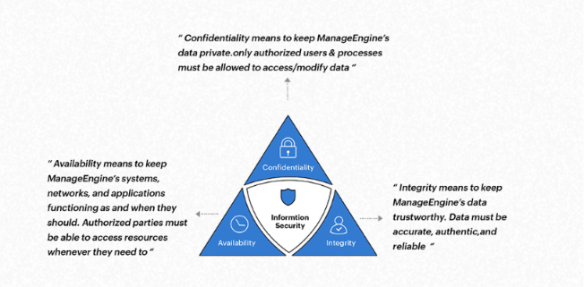
3.2 Case Study Analysis – Uber 2022 Breach
A real-world breach was analyzed to understand attacker behavior and weaknesses exploited.
What Happened: An attacker gained access to Uber’s internal systems using a stolen contractor password. The attacker used MFA fatigue (push bombing) to overwhelm the victim with login approval requests. When the victim hesitated, the attacker impersonated Uber IT on WhatsApp, convincing the contractor to approve the login.
Root Cause:
Stolen credentials (contractor password leaked via malware and sold on the dark web)
Weak MFA awareness
Social engineering via WhatsApp
Hardcoded administrator password found inside a PowerShell script
Poor internal access control on shared drives
Impact: The attacker accessed:
Uber’s Slack workspace
Internal dashboards
Cloud environments (AWS, GCP)
Sensitive internal scripts and administrative tools
Prevention:
Strong MFA policies (number matching, phishing-resistant MFA)
Employee awareness training
Removal of hardcoded credentials
Improved access control and segmentation
Regular security audits of internal scripts and shared drives
3.3 Attack Vector Identification
The following attack vectors were identified based on the Uber 2022 breach:
Phishing / Social Engineering: The attacker impersonated Uber IT on WhatsApp to trick the contractor into approving MFA.
Weak Credentials: The attacker used a stolen contractor password obtained from malware and sold on the dark web.
MFA Fatigue (Push Bombing): The attacker repeatedly triggered MFA requests until the victim approved one.
Misconfigurations / Hardcoded Passwords: A PowerShell script contained a hardcoded administrator password, allowing privilege escalation.
Poor Access Control: Sensitive scripts were stored on shared network drives accessible after initial access.
These vectors demonstrate how attackers exploit human error, weak authentication, and poor internal security practices.
3.4 Awareness Documentation
The findings from Task 1 were documented using a VAPT-style reporting format. This includes:
- Executive Summary
- Scope
- Methodology
- Findings
- Severity Ratings
- Evidence (Screenshots)
- Recommendations
- Conclusion
This structured documentation ensures that cybersecurity risks are clearly communicated and supports organizational awareness. It also demonstrates how real-world breaches can be analyzed and documented using professional reporting standards.

4. Findings
Finding 1: Weak Credentials
Weak or stolen passwords allow attackers to gain initial access without needing technical exploitation. In the Uber breach, the contractor’s password was harvested by malware and sold on the dark web, enabling unauthorized entry.
Finding 2: Phishing & Social Engineering
Attackers often manipulate human behavior. In this case, the attacker impersonated Uber IT on WhatsApp, convincing the contractor to approve an MFA request. This demonstrates how social engineering bypasses technical controls.
Finding 3: Misconfigurations
A PowerShell script stored on a shared drive contained a hardcoded administrator password. This misconfiguration allowed the attacker to escalate privileges and access sensitive systems.
Finding 4: Lack of Awareness
The contractor approved an MFA request due to confusion and pressure. This highlights the importance of employee awareness training to recognize suspicious authentication attempts.

5. Severity Rating

Finding | Severity | CVSS Score | Impact
Weak Passwords | High | 7.5 | High risk of compromise
Phishing | Medium | 5.4 | User-targeted attack
Misconfiguration | High | 7.8 | System exposure
Lack of Awareness | Critical | 9.0 | Leads to multiple attack vectors

6. Evidence (Screenshots)
Insert your screenshots here:
CIA Triad notes

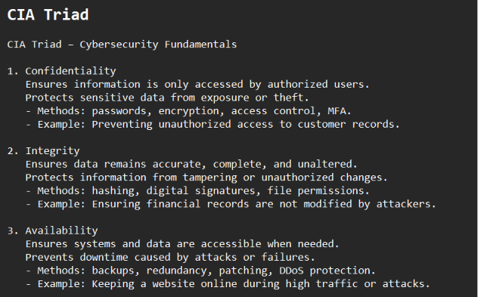

Mitre Attack Notes
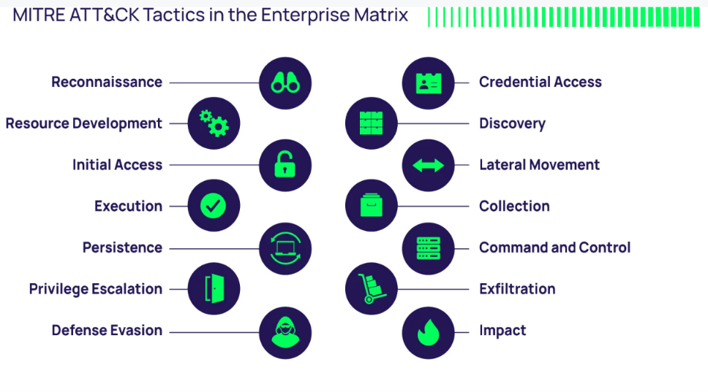
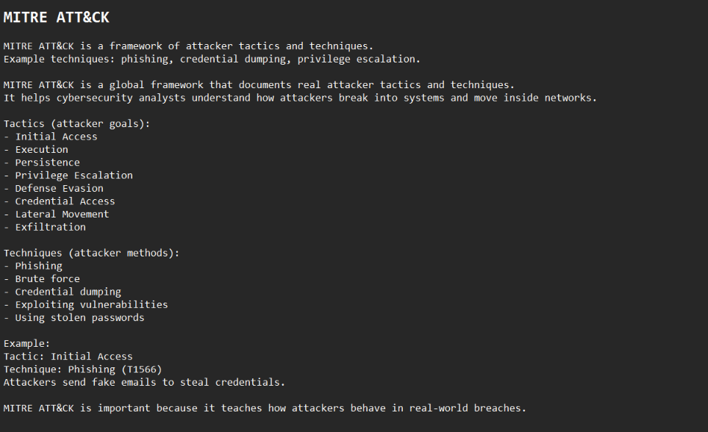

Case study article screenshot
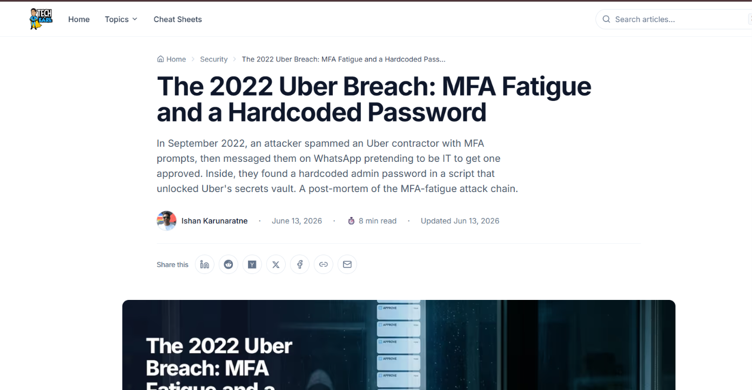

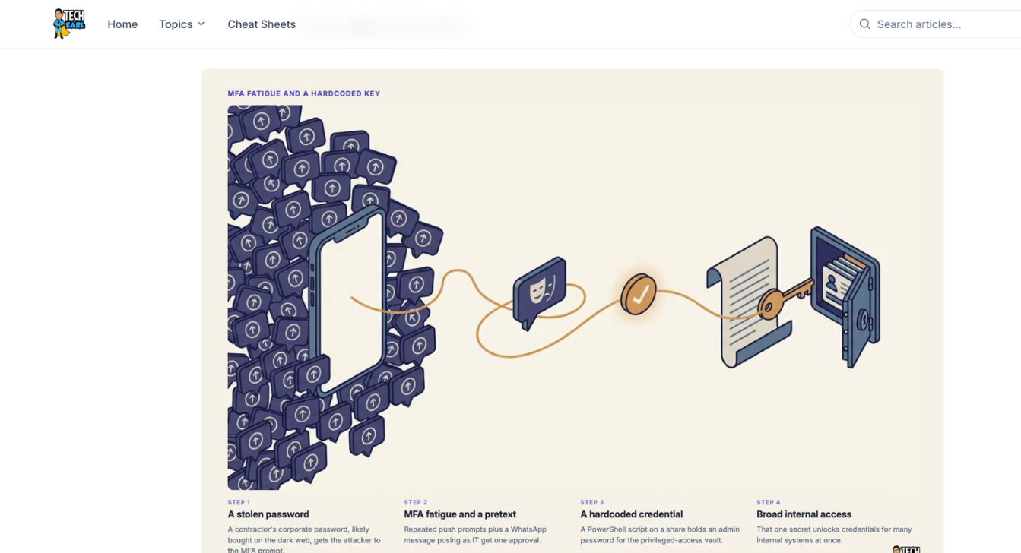

Attack vector notes
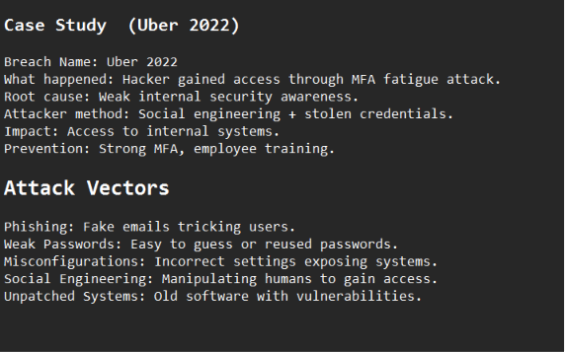

7. Recommendations
- Enforce strong password policies
- Conduct regular awareness training
- Implement MFA
- Patch misconfigurations
- Improve monitoring

8. Conclusion
Task 1 provided foundational cybersecurity awareness by exploring core principles, attacker behavior, and real-world breach analysis. The Uber 2022 case study demonstrated how simple weaknesses — such as stolen credentials, MFA fatigue, and misconfigurations — can lead to major security incidents. Understanding these attack vectors and documenting them using a VAPT-style structure strengthens organizational readiness and highlights the importance of continuous security awareness.

9. GitHub Repository Link
https://github.com/arooj2075/NovaShyld_Task_1?utm_source=copilot.com

10. References
CIA Triad- https://www.manageengine.com/academy/cia-triad.html
Uber 2022 Breach Article – techearl.com
MITRE ATTACK Framework – attack.mitre.org, https://delinea.com/blog/what-is-the-mitre-attack-framework
Cybersecurity Awareness Concepts – cisa.gov
MFA Fatigue Attack Explanation – various public cybersecurity blogs

