Intern Name: Arooj Fatima
Task: 2 of 5
Date: 30/07/2026
GitHub Repository: https://github.com/arooj2075/NovaShyld_Task_2
Mentor: mentornovashyldtech@gmail.com

Table of Contents
2.1 Objective 2
2.2 Tools & Environment 2
2.3 Methodology 2
2.4 Findings 3
2.5 Evidence 3

2.1 Objective
The objective of Task 2 is to install and configure Damn Vulnerable Web Application (DVWA) on Kali Linux and verify that the application is fully operational.

This Environment will be used for demonstrating and analysing common web application vulnerabilities in subsequent tasks.

2.2 Tools & Environment
Operating System: Kali Linux
Web Server: Apache2
Database Server: MariaDB
Application: DVWA
Browser: Firefox
User: Arooj

2.3 Methodology
A structured approach was followed to ensure DVWA was installed correctly and prepared for vulnerability testing.
2.3.1 Environment Preparation
- Apache2 service was started.
- MariaDB service was started.
- DVWA files were placed under /var/www/html/dvwa.
2.3.2 Database Configuration
- DVWA database was created in MariaDB.
- A dedicated DVWA user was created with appropriate privileges.
- The DVWA configuration file (config.inc.php) was updated to match database credentials.
2.3.3 Application Setup
- DVWA was accessed via browser at http://127.0.0.1/dvwa.
- The setup page was executed to initialise DVWA tables.
- The login page was verified using default credentials (admin / password).
- The dashboard loaded successfully.
2.3.4 Security Configuration
- DVWA security level was set to Low to enable testing of basic vulnerabilities.
- Vulnerability modules such as SQL Injection were accessed to confirm functionality.

2.4 Findings
Finding 1: DVWA Application Accessible
Status: Passed Description: The DVWA login page loaded successfully, confirming correct installation.
Finding 2: Authentication Functional
Status: Passed Description: Default credentials allowed successful login, confirming authentication functionality.
Finding 3: Security Level Configurable
Status: Passed Description: Security level was successfully set to Low for testing.
Finding 4: Vulnerability Modules Accessible
Status: Passed Description: Modules such as SQL Injection loaded without errors, confirming DVWA is ready for exploitation tasks.

2.5 Evidence

Figure 2.1: Kali Linux Installed Successfully
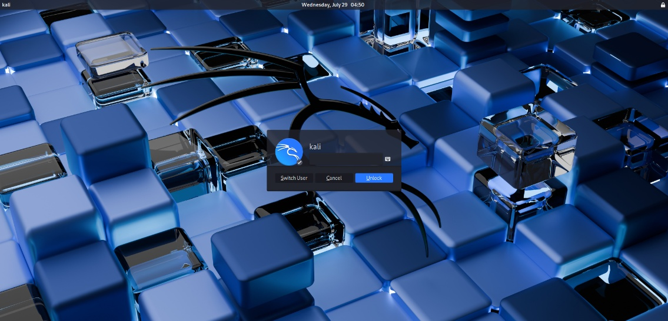
Figure 1 Kali successfully installed

Figure 2.2: DVWA Login Page displayed successfully

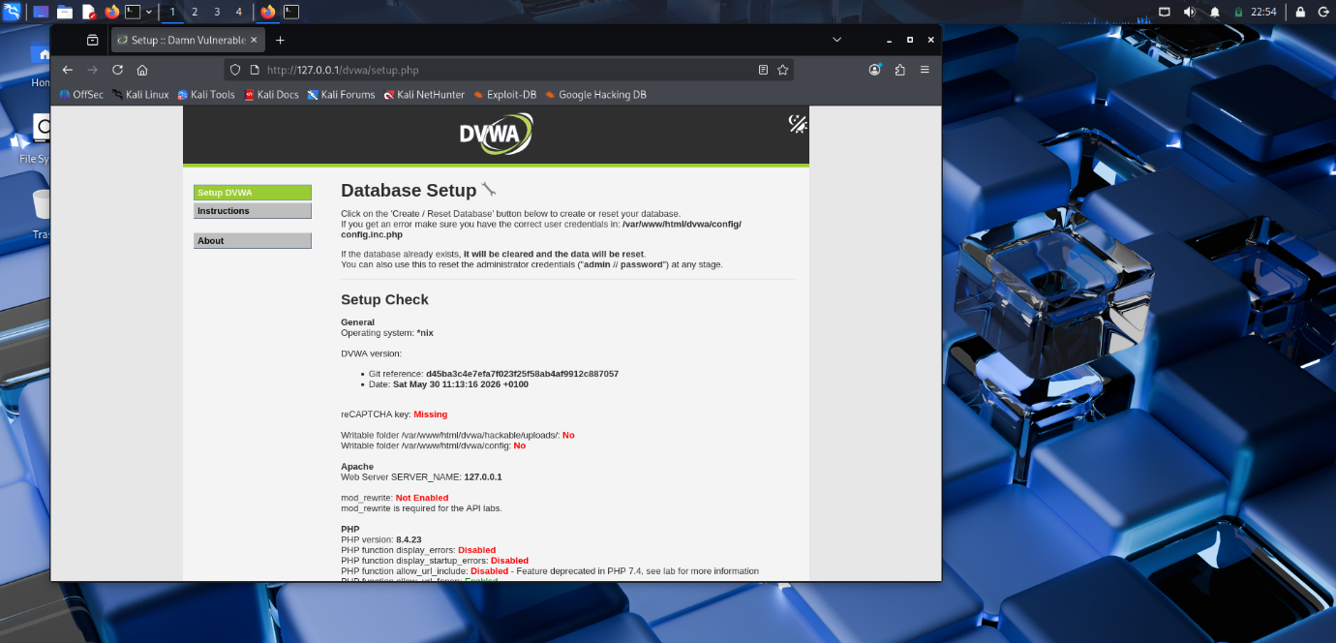
Figure 2 DVWA Setup Page

Figure 2.3: DVWA Dashboard after successful login
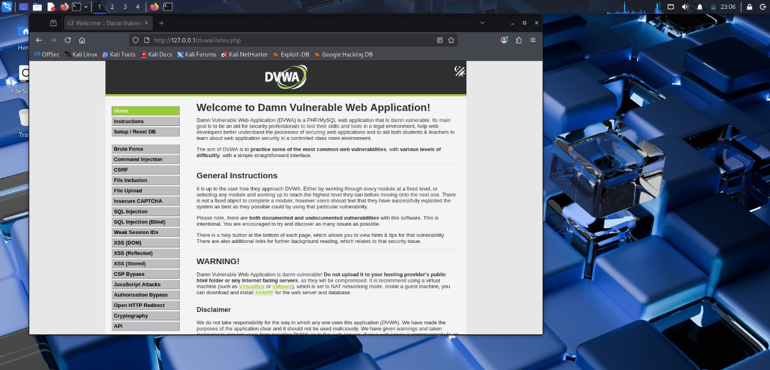
Figure 3 Logged In Successfully

Figure 2.4: DVWA Security Level set to Low

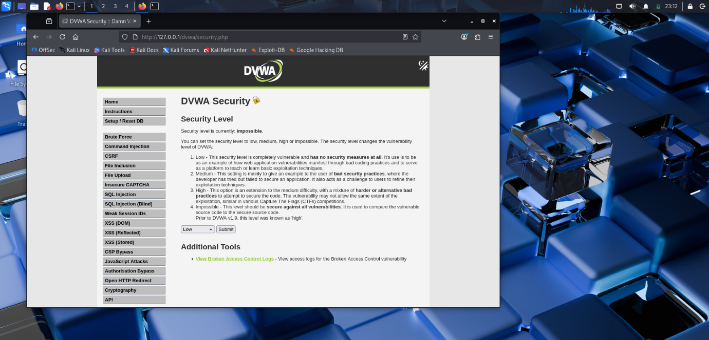
Figure 4 DVWA Security Level set to Low

Figure 2.5: DVWA SQL Injection module loaded successfully

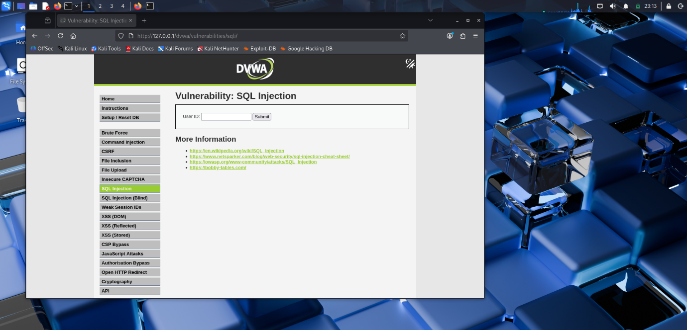
Figure 5 DVWA SQL Injection module loaded successfully

2.6 Conclusion
DVWA was successfully installed and configured on Kali Linux. The application is fully operational, and all modules are accessible. The security level has been set to Low, enabling controlled vulnerability testing in subsequent VAPT tasks. This environment is now ready for exploitation and analysis in Task 3.

