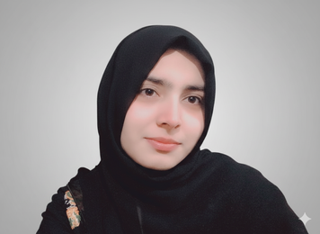 | ADAN ALTAF  Frontend Developer | Python Developer (Basic) | Graphic Designer
 | Address: | Gojra, Pakistan
 | Phone: | +923318689416
 | Email: | adanrajpoot416@gmail.com
SUMMARY
Motivated and creative Frontend Developer and Graphic Designer with hands-on experience in web design, basic Python development, and digital content creation. Skilled in blending design and technology to build engaging, user-friendly web interfaces and visuals. Certified in Graphic Design (DigiSkills Pakistan) and proficient in using modern design and development tools to deliver professional results.
CERTIFICATIONS
Graphic Design Course — DigiSkills Pakistan | 2023 - Present
Completed a certified online training focused on the fundamentals of graphic design, branding, and visual communication. Gained practical experience in logo design, poster creation, social media graphics, color theory, typography, and layout design using tools like Canva and Adobe Photoshop (basic). Developed creative problem-solving and design thinking skills to produce professional digital content.
EXPERIENCE
Freelance Graphic Designer | Self-Employed |  | 2022 - 2025  2023 - 2025
 | Designed logos, posters, and presentations for online clients. | 2022 - 2025  2023 - 2025
 | Delivered visually engaging designs aligned with client branding. | 2022 - 2025  2023 - 2025
 | Used Canva and PowerPoint for professional presentation layouts. | 2022 - 2025  2023 - 2025
Frontend Developer (Trainee) | Personal Projects |  | 2022 - 2025  2023 - 2025
 | Created responsive web pages with clean and modern layouts. | 2022 - 2025  2023 - 2025
 | Practiced basic JavaScript and Python for web interactivity. | 2022 - 2025  2023 - 2025
 | Used VS Code for project development and version control. | 2022 - 2025  2023 - 2025
EDUCATION
Bachelor of Science in Computer Science (BSCS) | 2022 - Present
University of Agriculture Faisalabad, Pakistan
F.Sc. Pre-Engineering 2020 - 2022 Punjab College Gojra, Pakistan
Matric (Science) 2018 - 2020 Ateeq Public High School Gojra, Pakistan
ADDITIONAL INFORMATION
Technical Skills: Frontend Development: HTML5, CSS3, JavaScript (Basics), Responsive Web
Design, Programming: Python (Basic level), Design Tools: Canva, Adobe Photoshop (Basic), MS PowerPoint, Software & Productivity Tools: VS Code, MS Word, MS Excel, Other Skills: UI Layouts, Branding, Logo Design, Presentation Design, Data Handling
Languages: English — Intermediate, Urdu — Fluent
Certifications: Graphic Design Course — DigiSkills Pakistan( Certified in logo design, branding, and visual content creation.)
Soft Skills: Creative Thinking, Team Collaboration, Communication Skills, Time Management, Problem Solving

