Task 1 Temperature Status (if-else)

Task 2 Mobile Data Package (if-else)

Task 3 Hospital Appointment (nested if-else)

Task 4 Online Food Order (nested if-else)
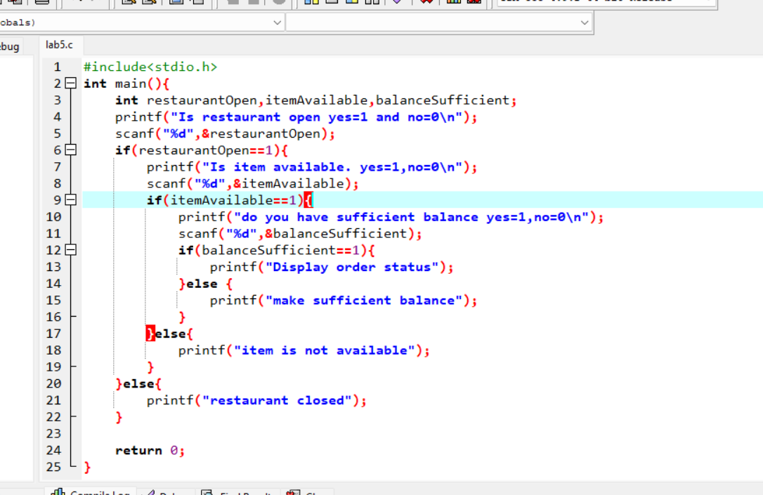

Task 5 ATM and Transaction Selection (Nested switch):

