WEEKLY PERFORMANCE REPORT
Weekly commercial pulse: reconcile plans before ranking interventions
Enterprise sales and units; targeted Stores decisions
PERIOD | 5–11 Oct 2026, Monday–Sunday
COMPARED WITH | Weekday-aligned 6–12 Oct 2025, Monday–Sunday
SCOPE | Enterprise merchandise across disjoint Stores, Croma.com, TataNeu and Quick Commerce sales channels; separate subsequent-week check; Stores-only economics.
MEASURE | Sales NMV (₹ crore) and units; Stores markdown / markdown-table gross sales and Stores merchandise profit / matching cost-available NLC net sales.
PREPARED FOR | CEO Office, category and pricing leaders, Stores zone managers
DATA AS OF | 19 Oct 2026 [R11, R13]

THE BOTTOM LINE
Enterprise NMV fell ₹4.59 Cr (10.81%) to ₹37.87 Cr as units fell 2,809 (14.23%); Stores accounted for ₹3.89 Cr of the decline. Hold blanket markdown, permit only capped, controlled Stores tests, and do not rank performance against unverified AOP.
▪ Stores lost 2,148 units and ₹3.89 Cr, or 84.75% of the net enterprise NMV decline: investigate stock, traffic and conversion ahead of indiscriminate price cuts.
▪ The separate 12–18 Oct 2026 week fell 14.94% YoY in NMV against 13–19 Oct 2025, worse than the headline week's 10.81% decline: check current demand before treating the first week as a run rate.
▪ Delhi NCR, RON and Hyderabad explain 87.40% of the net Stores decline: direct their zone managers to diagnose stock, prices and offer execution first.
▪ Stores markdown intensity fell 3.11 percentage points while cost-covered merchandise margin rose 2.58 points: protect matched-SKU profit floors; neither movement proves a causal price effect.
▪ Do not use AOP attainment for pricing decisions until Finance reconciles conflicting Stores and zone targets.

DECISIONS AND ASKS
▪ Hold untargeted Stores iPhones/Macbook markdown and authorise Delhi NCR, RON and Hyderabad diagnostics for 26 Oct–1 Nov; preserve funded offers and SKU price floors.
▪ Authorise Macbook and Hyderabad iPhone tests only if verified eligible turnover and funded price gap fit the cap and positive SKU floor; pre-register comparable matched-store demand and positive net-contribution criteria. Historical illustrative caps: ~₹0.27 lakh and ~₹0.56 lakh. Otherwise do not launch.
▪ Direct Finance and Sales Data Engineering to quarantine plan-led decisions and reconcile independent daily channel and zone AOP in value and units by 1 Nov; no plan-driven markdown until signed off.

CONTENTS
1. Decision first: separate verified performance from the AOP gap
2. Channel bridge: check volume versus ASP and plan comparability
3. Category bridge: verify scope before calling a growth driver
4. Stores margin and markdown: reconcile NLC coverage first
5. Stores-zone execution: YoY sales and units, not invalid plan attainment
6. Next-week targeted tests and stop rules
Appendix. Evidence, calculations and method

1. Decision first: separate verified performance from the AOP gap
Enterprise NMV fell ₹4.59 Cr and 2,809 units; Stores account for 84.7% of the sales loss. Base next week's decisions on observed demand, not disputed AOP.

5–11 OCT 2026 VS 6–12 OCT 2025: OBSERVED SALES
₹37.87 Cr  ENTERPRISE NMV  −10.8% YoY  LY ₹42.46 Cr | 16,934  ENTERPRISE UNITS  −14.2% YoY  LY 19,743 | ₹26.27 Cr  STORES NMV  −₹3.89 Cr  11,083 units vs 13,231 LY | ₹11.60 Cr  ONLINE NMV  LY ₹12.30 Cr  5,851 units vs 6,512 LY

Stores lost ₹3.89 Cr and 2,148 units, driving 84.7% of the enterprise NMV shortfall; Online fell from ₹12.30 Cr to ₹11.60 Cr. The larger unit fall warrants a stock, conversion and offer-execution check before any blanket markdown. Implied ASP reflects product and channel mix as well as selling price; it cannot establish a price-driven cause.
STORES ECONOMICS: DIFFERENT, STORES-ONLY POPULATIONS
10.8%  COST-COVERED MERCHANDISE MARGIN  LY 8.3%  Merchandise profit ÷ matching NLC net sales | 9.4%  MARKDOWN RATE  LY 12.6%  Markdown ÷ markdown-table gross sales

On cost-available Stores rows, merchandise margin was 10.8% versus 8.3%; Stores markdown was 9.4% versus 12.6% of its own gross-sales base. Those separate populations do not prove that a markdown change lifted margin or depressed demand; neither measure covers Online.
AOP unavailable for decision-making
Do not publish enterprise, channel or zone plan attainment. Stores-zone targets exceed the printed Stores plan by ₹129.02 Cr and 56,198.7 target units; a revised zone control still differs from that printed plan by ₹0.78 Cr and 2,798.02 units. Croma.com/TataNeu targets are allocated or duplicated, while an independent disjoint Stores/Online/Quick Commerce control cannot be proved. This is a plan-evidence discrepancy, not a sales gap.

CEO decision and owner
 | Action | Owner | Expected impact | Confidence
P1 | Quarantine disputed AOP from pricing decisions; reconcile original daily Stores-zone and disjoint Online/Quick Commerce targets before releasing attainment.  Finance planning across Stores, Croma.com, TataNeu and Quick Commerce · KPI: Signed daily source-to-control crosswalk and zero residual in target units and ₹ Cr · Freeze 26 Oct; discrepancy log 28 Oct; status 1 Nov.  Guardrail: No plan-driven markdown until both value and unit controls, date coverage, category scope and disjoint channel mapping are signed off; rely on actual-only comparisons meanwhile.  Evidence: R3, R4, R11, R12, R13, D72, D150 | Finance Controller / Planning Data Governance Lead with Sales Data Engineering | Business impact not sized: the printed Stores-zone plan exceeds the Stores plan by ₹129.02 Cr; the revised control differs by ₹0.78 Cr. These are source discrepancies, not recoverable sales. | High

Evidence for this section: R3, R4, R6, R7, R11, R12, R13, D21, D62, D64, D72, D73, D150, D151, D209, D210, D211, D212, D213, D214, D215, D216, D217

2. Channel bridge: check volume versus ASP and plan comparability
Stores explain ₹3.89 Cr of the ₹4.59 Cr enterprise decline; fewer units across channels, not an identified price cut, are the stronger observed signal.

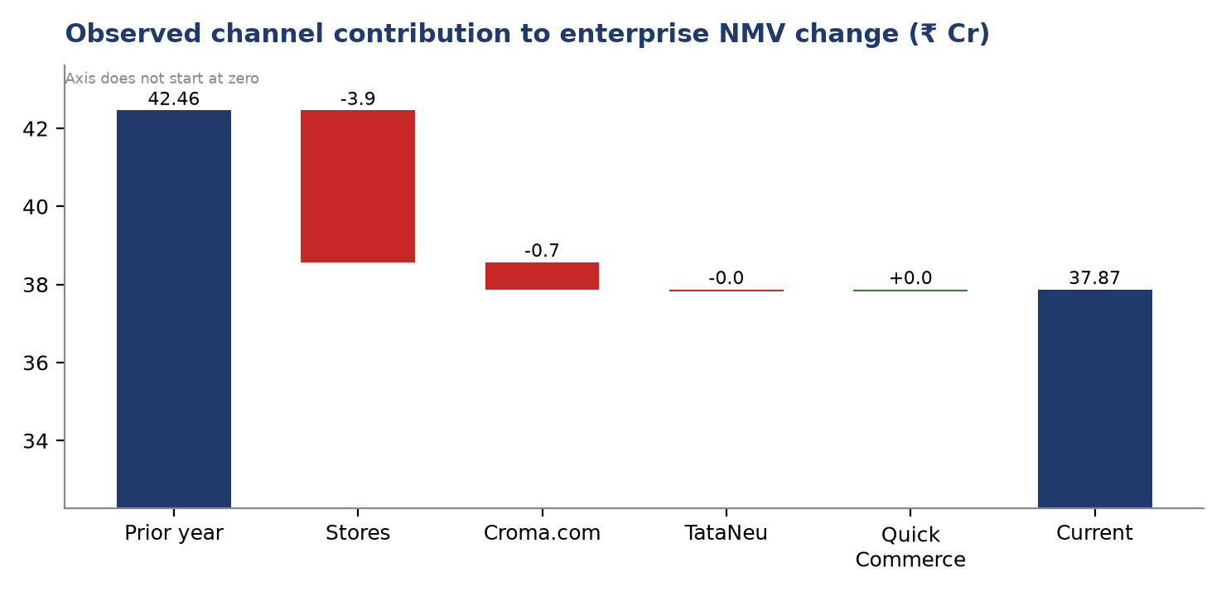
Values rounded to two decimal places.
Source T12: derived (contribution on R3 {"key": "channel", "cur": "cy_nmv", "base": "ly_nmv"})
Actuals only: channel volume and implied ASP
Channel | CY NMV (₹ Cr) | YoY (₹ Cr) | NMV YoY | CY units | Units YoY | Implied CY ASP (₹) | Implied LY ASP (₹)
Stores | 26.27 | -3.89 | -12.9% | 11,083 | -16.2% | ₹23,703 | ₹22,795
Croma.com | 8.89 | -0.70 | -7.3% | 3,898 | -11.8% | ₹22,807 | ₹21,702
TataNeu | 2.23 | -0.04 | -1.8% | 984 | -6.4% | ₹22,663 | ₹21,598
Quick Commerce | 0.48 | 0.04 | +9.1% | 969 | -7.0% | ₹4,954 | ₹4,223
Source T5: derived (from R3; nmv_change_cr = cy_nmv-ly_nmv; nmv_growth_pct = 100*(cy_nmv/ly_nmv-1); unit_growth_pct = 100*(cy_qty/ly_qty-1); asp_cy_rs = cy_nmv*10000000/cy_qty; asp_ly_rs = ly_nmv*10000000/ly_qty)
Stores lost ₹3.89 Cr; Croma.com lost ₹0.70 Cr. Quick Commerce gained just ₹0.04 Cr despite lower units, offset by TataNeu's ₹0.04 Cr decline; it is not a growth engine to fund a separate price push. The volume/mix/ASP accounting effects are −₹6.04 Cr, −₹0.16 Cr and +₹1.61 Cr, respectively. ASP includes mix and does not establish a causal price effect.
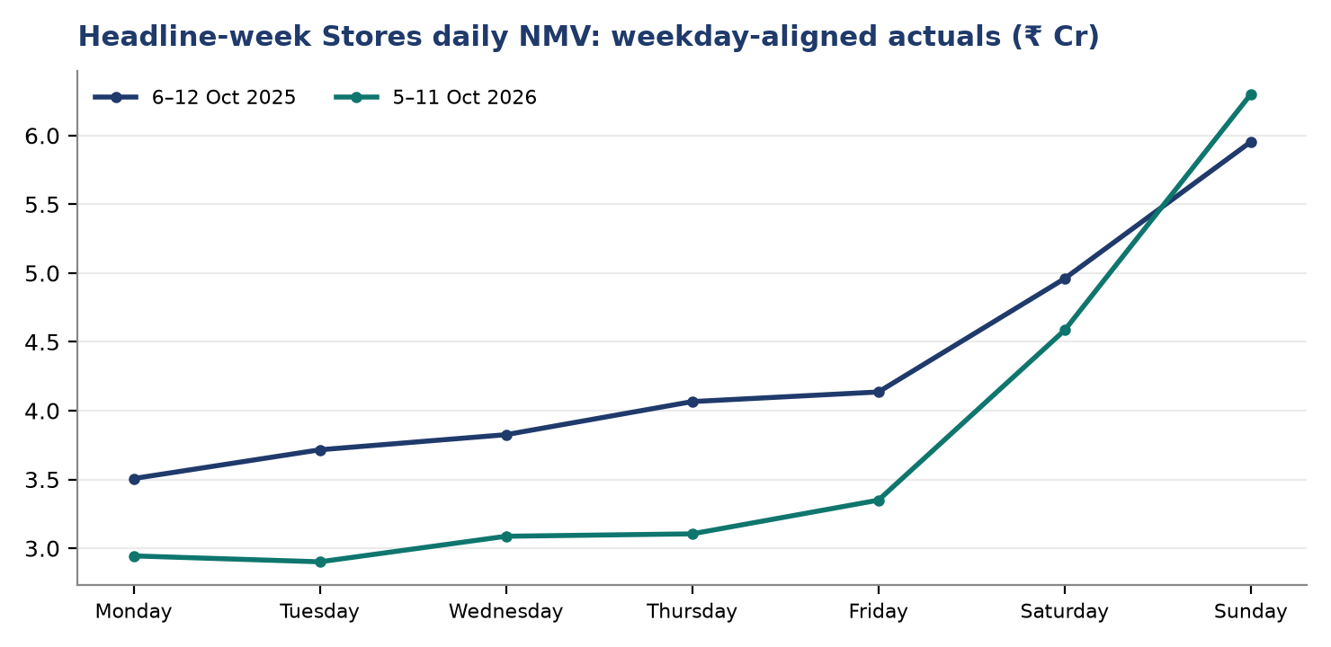
NMV chart values rounded to two decimal places; Sunday growth is calculated from unrounded daily sales.
Source T13: derived (from R10; cy_nmv_cr = cy_nmv/10000000; ly_nmv_cr = ly_nmv/10000000; nmv_yoy_pct = 100*(cy_nmv/ly_nmv-1); cy_markdown_pct = 100*cy_markdown/cy_gross_sales; ly_markdown_pct = 100*ly_markdown/ly_gross_sales; where cy_gross_sales > 0)
Sunday Stores NMV grew 5.8% and units 3.8%, against a Monday–Saturday NMV decline of 17.5%. Sunday's markdown/gross rate was 11.7%, 3.0 pp above the earlier days' weighted 8.7%; this association is not evidence that heavier markdown caused the rise.
Separate recency check, not the headline week
In 12–18 Oct 2026 against 13–19 Oct 2025, enterprise NMV was ₹48.17 Cr vs ₹56.63 Cr (−14.9% YoY), worsening 4.1 pp from the headline week's YoY growth. Stores fell 17.9% YoY and accounted for 85.5% of that separate week's shortfall. Monitor Stores units and conversion before changing offers for 26 Oct–1 Nov; the two weeks have different prior-year bases.

Recency by channel: actuals only, 12–18 Oct versus 13–19 Oct
Channel | CY (₹ Cr) | LY (₹ Cr) | NMV YoY
Stores | 33.27 | 40.50 | -17.9%
Croma.com | 11.45 | 12.44 | -8.0%
Quick Commerce | 0.56 | 0.69 | -18.8%
TataNeu | 2.89 | 3.00 | -3.7%
Source T16: derived (contribution on R11 {"key": "channel", "cur": "cy_nmv", "base": "ly_nmv"})
Evidence for this section: R3, R10, R11, T5, T7, T12, T13, T16, D21, D23, D24, D25, D80, D88, D91, D92, D103, D104, D120, D121, D122, D136, D140

3. Category bridge: verify scope before calling a growth driver
iPhones and Macbook each lost ₹1.08 Cr, but the category sales levels miss channel totals by ₹0.01 Cr in each year; rank their losses without claiming an exact enterprise category bridge.

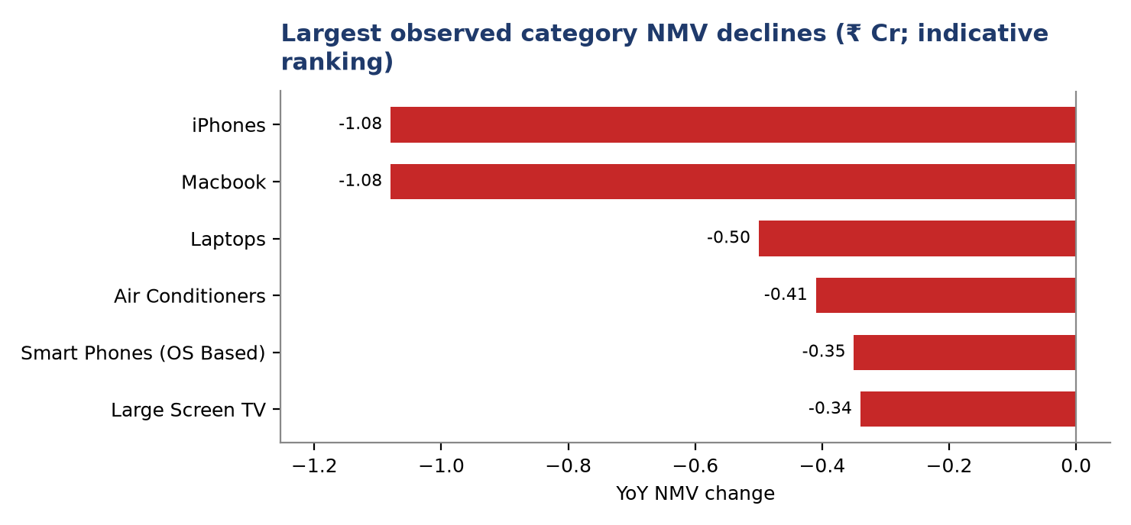
Published category change ranking, not a fully reconciled enterprise level bridge.
Source T17: derived (from T6)
Categories to diagnose: units and implied ASP
Category | CY NMV (₹ Cr) | LY NMV (₹ Cr) | Change (₹ Cr) | CY units | LY units | Unit change | CY implied ASP (₹) | LY implied ASP (₹)
iPhones | 6.66 | 7.74 | -1.08 | 749 | 891 | -142 | ₹88,919 | ₹86,869
Macbook | 4.17 | 5.25 | -1.08 | 336 | 448 | -112 | ₹124,107 | ₹117,188
Laptops | 4.71 | 5.21 | -0.50 | 941 | 1,070 | -129 | ₹50,053 | ₹48,692
Air Conditioners | 2.45 | 2.86 | -0.41 | 707 | 844 | -137 | ₹34,653 | ₹33,886
Smart Phones (OS Based) | 4.61 | 4.96 | -0.35 | 1,308 | 1,460 | -152 | ₹35,245 | ₹33,973
Large Screen TV | 5.44 | 5.78 | -0.34 | 955 | 1,063 | -108 | ₹56,963 | ₹54,374
Only the largest observed category declines; not an exhaustive bridge and no category AOP. ASP is NMV divided by units.
Source T17: derived (from T6)
iPhones and Macbook together lost ₹2.16 Cr and 254 units, an indicative 47.1% of the channel-level NMV decline. iPhones fell from 891 to 749 units; Macbook from 448 to 336. Check sellable stock, SKU mix and funded competitor offers before testing any price change; aggregate implied ASP does not establish elasticity. Confidence: medium for attribution, high for the printed category unit counts.
Category scope does not tie at published precision
Category NMV sums to ₹37.86 Cr versus channel ₹37.87 Cr currently, and ₹42.45 Cr versus ₹42.46 Cr last year: an unassigned ₹0.01 Cr residual in each year. Units do tie at 16,934 and 19,743. Raw transaction-to-category mapping is absent; rounding is possible, not proven. Do not force a level waterfall or use the partial channel/category or brand lists to fill this gap. Category AOP is unavailable.

Evidence for this section: R1, R2, R3, R9, R10, T6, T17, D1, D2, D3, D4, D96, D97, D149, D157, D158

4. Stores margin and markdown: reconcile NLC coverage first
Stores markdown fell 3.1 pp while cost-covered MM rose 2.6 pp; both movements reconcile within their own Stores populations, not to a causal price story.

Stores cost-covered economics: same NLC rows only
CY NLC net ₹ Cr | LY NLC net ₹ Cr | CY profit ₹ Cr | LY profit ₹ Cr | CY MM% | LY MM% | CY rows | LY rows
₹24.8 Cr | ₹27.4 Cr | ₹2.69 Cr | ₹2.27 Cr | 10.8% | 8.3% | 7,361 | 8,541
Source T19: derived (from R6; cy_nlc_cr = cy_nlc_net_sales/10000000; ly_nlc_cr = ly_nlc_net_sales/10000000; cy_profit_cr = cy_merch_profit/10000000; ly_profit_cr = ly_merch_profit/10000000; cy_mm_pct = 100*cy_merch_profit/cy_nlc_net_sales; ly_mm_pct = 100*ly_merch_profit/ly_nlc_net_sales; where cy_nlc_net_sales > 100000000)
Stores markdown: markdown-table gross denominator only
CY gross ₹ Cr | LY gross ₹ Cr | CY markdown ₹ Cr | LY markdown ₹ Cr | CY markdown % | LY markdown %
₹31.0 Cr | ₹35.6 Cr | ₹2.93 Cr | ₹4.47 Cr | 9.4% | 12.6%
Source T20: derived (from R7; cy_md_pct = 100*cy_markdown/cy_gross_sales; ly_md_pct = 100*ly_markdown/ly_gross_sales; where cy_gross_sales > 30)
Excluding the reported total, the NLC categories add to ₹24.8 Cr/₹27.4 Cr net sales, ₹2.69 Cr/₹2.27 Cr merchandise profit and 7,361/8,541 eligible rows; category-to-total residual is zero on each measure in both years. Profit rose ₹0.43 Cr. Markdown categories also tie to their gross and markdown totals in both years; markdown fell ₹1.54 Cr.
Coverage is not interchangeable
Cost-covered NLC net sales are ₹1.44 Cr/₹2.75 Cr below all-sales Stores NMV in current/prior periods: different populations, not missing profit. Use profit divided by matched NLC net sales, never all-sales NMV; markdown divided by its own gross. Neither ratio covers Online.

Cost-covered MM bridge: largest category contributions, pp
Category | LY MM% | CY MM% | Within pp | Mix pp | Total pp
Macbook | 8.2% | 15.2% | +0.8 pp | +0.0 pp | +0.8 pp
iPhones | 2.7% | 4.6% | +0.4 pp | +0.1 pp | +0.5 pp
Smart Phones (OS Based) | 7.2% | 11.2% | +0.4 pp | +0.0 pp | +0.5 pp
Laptops | 7.1% | 10.4% | +0.5 pp | -0.0 pp | +0.4 pp
Gaming Laptops | 6.8% | 10.7% | +0.2 pp | +0.0 pp | +0.2 pp
Largest contributions shown; full bridge ties to cost-covered Stores MM.
Source T9: derived (rate_mix on T2 {"key": "sop_category", "cur_num": "cy_merch_profit", "cur_den": "cy_nlc_net_sales", "base_num": "ly_merch_profit", "base_den": "ly_nlc_net_sales"})
Markdown bridge: largest category contributions, pp
Category | LY markdown % | CY markdown % | Within pp | Mix pp | Total pp
Macbook | 7.2% | 0.8% | -0.7 pp | +0.1 pp | -0.7 pp
iPhones | 9.9% | 7.3% | -0.5 pp | +0.0 pp | -0.5 pp
Large Screen TV | 13.6% | 10.9% | -0.4 pp | -0.0 pp | -0.4 pp
Smart Phones (OS Based) | 12.4% | 9.6% | -0.3 pp | -0.0 pp | -0.3 pp
Laptops | 12.3% | 9.7% | -0.3 pp | +0.0 pp | -0.3 pp
Gross-weighted markdown; largest contributions, not the full bridge.
Source T10: derived (rate_mix on T3 {"key": "sop_category", "cur_num": "cy_markdown", "cur_den": "cy_gross_sales", "base_num": "ly_markdown", "base_den": "ly_gross_sales"})
Within-category rates account for +2.6 pp of the +2.6 pp NLC MM change; mix contributes around −0.02 pp. On the separate gross base, within-category markdown contributes −3.2 pp and mix +0.1 pp to the −3.1 pp change. Sunday markdown ran +3.0 pp above the gross-weighted Monday–Saturday rate. These accounting associations do not prove markdown drove demand or profit.
Evidence for this section: R3, R6, R7, R10, T2, T3, T9, T10, T19, T20, D9, D10, D11, D12, D13, D14, D15, D16, D17, D18, D46, D47, D48, D55, D56, D57, D98, D100, D140, D153, D154, D155, D156, D174, D175

5. Stores-zone execution: YoY sales and units, not invalid plan attainment
Delhi NCR, RON and Hyderabad account for 87.4% of the net Stores NMV decline; direct their ZMs to diagnose units before considering discounts.

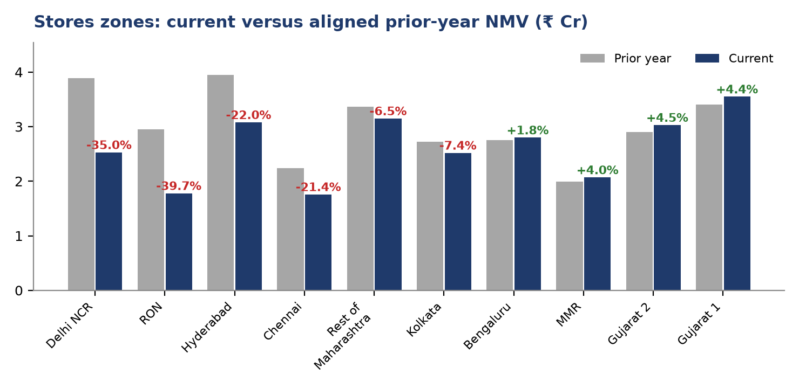
Amounts shown to two decimal places; small changes such as Bengaluru's ₹0.05 Cr remain visible.
Source T4: derived (from R4; nmv_change_cr = cy_nmv-ly_nmv; nmv_growth_pct = 100*(cy_nmv/ly_nmv-1); qty_growth_pct = 100*(cy_qty/ly_qty-1))
All Stores zones and accountable managers: observed YoY only
Zone | ZM | CY NMV (₹ Cr) | LY NMV (₹ Cr) | Δ NMV (₹ Cr) | NMV YoY | CY units | LY units | Units YoY
Delhi NCR | Sandeep Arora | ₹2.53 Cr | ₹3.89 Cr | -1.36 | -35.0% | 1,028 | 1,606 | -36.0%
RON | Vikram Singh | ₹1.78 Cr | ₹2.95 Cr | -1.17 | -39.7% | 764 | 1,366 | -44.1%
Hyderabad | Srinivas Reddy | ₹3.08 Cr | ₹3.95 Cr | -0.87 | -22.0% | 1,309 | 1,647 | -20.5%
Chennai | Meena Iyer | ₹1.76 Cr | ₹2.24 Cr | -0.48 | -21.4% | 782 | 1,038 | -24.7%
Rest of Maharashtra | Anita Kulkarni | ₹3.15 Cr | ₹3.37 Cr | -0.22 | -6.5% | 1,341 | 1,554 | -13.7%
Kolkata | Debashis Roy | ₹2.52 Cr | ₹2.72 Cr | -0.20 | -7.4% | 1,069 | 1,129 | -5.3%
Bengaluru | Harish Kumar | ₹2.80 Cr | ₹2.75 Cr | 0.05 | +1.8% | 1,164 | 1,186 | -1.9%
MMR | Rohit Menon | ₹2.07 Cr | ₹1.99 Cr | 0.08 | +4.0% | 929 | 882 | +5.3%
Gujarat 2 | Kiran Patel | ₹3.03 Cr | ₹2.90 Cr | 0.13 | +4.5% | 1,199 | 1,272 | -5.7%
Gujarat 1 | Nirav Shah | ₹3.55 Cr | ₹3.40 Cr | 0.15 | +4.4% | 1,498 | 1,551 | -3.4%
Source T4: derived (from R4; nmv_change_cr = cy_nmv-ly_nmv; nmv_growth_pct = 100*(cy_nmv/ly_nmv-1); qty_growth_pct = 100*(cy_qty/ly_qty-1))
Zone sums tie exactly to Stores CY and LY NMV and units. Sandeep Arora’s Delhi NCR fell ₹1.36 Cr, Vikram Singh’s RON ₹1.17 Cr and Srinivas Reddy’s Hyderabad ₹0.87 Cr: together 87.4% of the ₹3.89 Cr net Stores decline. Four growing zones added ₹0.41 Cr, partly offsetting the losses; they are not proof of a broad recovery.
Local diagnostic examples: top-current-sales zone–category pairs only
Zone | Category | CY NMV (₹ Cr) | LY NMV (₹ Cr) | CY units | LY units
Gujarat 1 | iPhones | ₹0.75 Cr | ₹0.60 Cr | 84 | 67
Rest of Maharashtra | iPhones | ₹0.68 Cr | ₹0.64 Cr | 79 | 71
Hyderabad | iPhones | ₹0.67 Cr | ₹0.77 Cr | 73 | 88
Gujarat 2 | iPhones | ₹0.57 Cr | ₹0.47 Cr | 65 | 56
Hyderabad | Large Screen TV | ₹0.53 Cr | ₹0.62 Cr | 95 | 114
Source R5: For Stores only, excluding Miscellaneous and Charges, for the period 2026-10-05 to 2026-10-11 versus 2025-10-06 to 2025-10-12, return the top 20 zone …
Check different local conditions, not a standard discount
In the partial sales list, Gujarat 1 iPhones rose ₹0.15 Cr while Hyderabad iPhones fell ₹0.10 Cr and 15 units. Hyderabad TV markdown/gross in the separate partial markdown list was 10.9% versus 13.9%; its cost-covered NLC rows have a different base. Check stock, CPI, funded offers and conversion locally before changing price.

Evidence for this section: R3, R4, R5, R8, T4, T8, D5, D6, D7, D8, D34, D36, D42, D168, D169, D170, D172, D173

6. Next-week targeted tests and stop rules
Hold broad Stores markdown. Release reversible Macbook or Hyderabad iPhone pilots only when verified SKU economics and the approved cap can fund the actual competitive correction; otherwise do not launch.

Stores Macbook markdown on gross fell from 7.2% to 0.8% while separate cost-covered margin rose from 8.2% to 15.2%; enterprise Macbook units fell 25.0%. These aggregates do not establish price elasticity.
Pilot caps are historical-base budgets, not forecast uplift or profit. Before either test, Pricing and Finance must verify eligible in-stock same-SKU turnover, competitor net-price gap, bank/brand funding and required incremental retailer markdown. Launch only if the approved cap funds that correction and SKU selling prices clear a positive contribution floor.
Pre-register success and stop rules
Before approval, set a minimum comparable matched-store observation period and sample, a demand criterion, and a positive net-contribution success threshold. Track units/conversion AND incremental cost-covered merchandise profit after retailer markdown and booked funding versus simultaneous controls. Compare both arms daily; stop/revert for inferior matched profit, cap or SKU-floor breach, stock-out, invalid costs/funding or lost comparability. Otherwise do not launch.

Owner decisions for the next week
 | Action | Owner | Expected impact | Confidence
P1 | Hold untargeted Stores iPhones/Macbook markdown; retain funded offers and Gujarat iPhone execution; permit only signed matched tests.  Stores iPhones and Macbook; Gujarat held, not causal controls · KPI: Same-SKU units, conversion, offer execution and matched cost-covered merchandise profit · Freeze 26 Oct; inspect daily; decide by 2 Nov.  Guardrail: Maintain funded customer offers and verified SKU contribution floors; no blanket price cuts.  Evidence: R7, R8, D179, D180, D193 | Head of Stores Pricing with category heads and Gujarat ZMs | Observed category gross ₹9.12 Cr and markdown ₹0.45 Cr; untargeted extra retailer markdown cap ₹0 Cr. | High
P1 | Audit in-stock same-SKU rival prices, offers and POS compliance in Delhi NCR, RON and Hyderabad; identify RON's leading SKUs before requesting markdown.  Delhi NCR, RON and Hyderabad Stores; category leads are partial · KPI: Daily stock, competitor net-price gap, funded offer and POS compliance by zone · Begin 26 Oct; report gaps 28 Oct; decision 29 Oct.  Guardrail: No incremental markdown before SKU, stock, competitor and funding checks; escalate supply or execution failures.  Evidence: R4, R5, R8, D181, D182, D193, D194 | ZMs Sandeep Arora, Vikram Singh and Srinivas Reddy with Stores Pricing Lead | Whole-zone NMV ₹7.39 Cr, down ₹3.40 Cr and 1,518 units: diagnostic exposure, not recoverable sales. Extra diagnostic markdown cap ₹0 Cr. | High
P1 | Quarantine disputed AOP; reconcile daily Stores-zone, Online and Quick Commerce value and unit targets before plan-led pricing.  All Stores zones and Online/Quick Commerce · KPI: Signed reconciled source-plan and actual-scope crosswalk in value and units · Freeze 26 Oct; sign off or flag unresolved by 1 Nov.  Guardrail: No plan-based price changes without signed disjoint daily value and unit control totals.  Evidence: R3, R4, R12, R13 | Finance Controller / Planning Data Governance Lead with Sales Data Engineering | Business prize not sized; source-plan conflicts are not lost sales. | High
P2 | Test a reversible funded competitive Macbook price in eligible Stores against simultaneous unchanged-price matched-SKU stores only after the common release gate passes.  Eligible Stores Macbook SKUs, not Online · KPI: Matched-store units/conversion and incremental cost-covered profit net of retailer markdown/funding · Pre-register before launch; monitor daily; decide 2 Nov.  Guardrail: Require cap-funded gap and positive SKU contribution; stop on poorer matched profit, cap/floor breach, stock or funding failure.  Evidence: R2, R6, R7, D161, D184, D218 | Macbook Category Head and Stores Pricing Lead with Finance approval | Historical illustrative additional retailer markdown maximum ~₹0.27 lakh; eligible turnover and funded gap not verified. | Medium
P2 | Test a reversible funded Hyderabad Stores iPhone correction against simultaneous unchanged-price Hyderabad matched-SKU stores only after the common release gate passes.  Hyderabad iPhones; Gujarat held, not cross-zone controls · KPI: Matched Hyderabad units/conversion and incremental cost-covered profit net of retailer markdown/funding · Pre-register before launch; monitor daily; decide 2 Nov.  Guardrail: Require cap-funded gap and positive SKU contribution; stop on poorer matched profit, cap/floor breach, stock or funding failure.  Evidence: R4, R5, R8, D168, D187, D219 | Hyderabad ZM Srinivas Reddy with iPhones Category Head, Stores Pricing Lead and Finance approval | Historical illustrative additional retailer markdown maximum ~₹0.56 lakh from observed partial pair; eligible turnover and funded gap not verified. | Medium

Transaction cutoff
Latest transaction coverage ends 19 Oct 2026; next-week test outcomes are not yet observed.

Evidence for this section: R2, R3, R4, R5, R6, R7, R8, R11, R12, R13, D161, D162, D163, D164, D165, D168, D179, D180, D181, D182, D184, D187, D193, D194, D218, D219

Appendix: evidence, calculations and method
NUMBER AUDIT
135 of 135 figures in the text were matched to a data result or a recorded calculation. All figures in the narrative trace to the evidence below.
Independent review: pass. Publish: the prior major issues are resolved—the pilot release gate tests verified stock, funded net-price gap, budget feasibility and a positive SKU floor, and pre-registration requires comparable matched-store demand and positive incremental net-contribution success criteria. The AOP bottom line is a single decision sentence, caveats are no longer duplicated at the end, the charts display two decimals, and independent checks of enterprise, channel, category, Stores economics, zone and both action caps align with evidence; audit passes 135/135.

Evidence register
ID | What it answers | Rows | Used
R1 | For 2026-10-05 to 2026-10-11 versus 2025-10-06 to 2025-10-12, excluding Miscellaneous and Charges, return by mutually exclusive channel (Stores, Croma.com, TataNeu, Quick Commerce) | 52 | context
R2 | For enterprise across the mutually exclusive Stores, Croma.com, TataNeu and Quick Commerce, excluding Miscellaneous and Charges, for 2026-10-05 to 2026-10-11 versus 2025-10-06 to 2 | 16 | yes
R3 | For 2026-10-05 to 2026-10-11 versus 2025-10-06 to 2025-10-12, return enterprise sales split into mutually exclusive channels: Stores, Croma.com, TataNeu, and Quick Commerce, exclud | 4 | yes
R4 | For Stores only, excluding Miscellaneous and Charges, provide all zones for 2026-10-05 to 2026-10-11 versus 2025-10-06 to 2025-10-12, ordered by cy_nmv descending. Return columns: | 10 | yes
R5 | For Stores only, excluding Miscellaneous and Charges, for the period 2026-10-05 to 2026-10-11 versus 2025-10-06 to 2025-10-12, return the top 20 zone x SOP category pairs ranked by | 20 | yes
R6 | For Stores only, with Miscellaneous and Charges excluded, compare 2026-10-05 to 2026-10-11 versus 2025-10-06 to 2025-10-12. On NLC rows where net landing cost is available, return | 16 | yes
R7 | For Stores only, excluding Miscellaneous and Charges merchandise groups, return SOP category rows plus a Stores-total row for 2026-10-05 to 2026-10-11 versus 2025-10-06 to 2025-10- | 17 | yes
R8 | For Stores only, excluding Miscellaneous and Charges, for 2026-10-05 to 2026-10-11 versus 2025-10-06 to 2025-10-12, return the top 20 zone x SOP-category pairs ranked by cy_markdow | 20 | yes
R9 | For Stores only, excluding Miscellaneous and Charges merchandise groups, compare 2026-10-05 to 2026-10-11 versus 2025-10-06 to 2025-10-12. Return the top 20 SOP category x brand pa | 20 | context
R10 | For the aligned weekdays Monday to Sunday, compare 2026-10-05 to 2026-10-11 with 2025-10-06 to 2025-10-12. Exclude Miscellaneous and Charges. Group by weekday and mutually exclusiv | 28 | context
R11 | For a separately labeled RECENCY CHECK, compare the latest complete Monday–Sunday week 2026-10-12 to 2026-10-18 against weekday-aligned 2025-10-13 to 2025-10-19 (not the headline w | 4 | yes
R12 | For Stores AOP, 2026-10-05 to 2026-10-11 inclusive, return one row per distinct source zone plus an independently stored Stores channel AOP control or source-defined control aggreg | 11 | yes
R13 | For the complete weeks 2026-10-05 to 2026-10-11 and 2026-10-12 to 2026-10-18, return PLAN PROVENANCE ONLY for independently recorded daily-phased AOP VALUE and AOP QUANTITY by orig | 6 | yes
T1 | Cost-available Stores category rows only, excluding reported Stores-total | 0 | context
T2 | NLC category components exclude reported total by numeric denominator | 15 | context
T3 | Stores markdown category excluding reported total, rate on category gross | 16 | context
T4 | Zone actual YoY only, exclude all unverified plan columns | 10 | yes
T5 | Headline four channel observed NMV, quantity, inferred ASP only | 4 | yes
T6 | Partial enterprise category ranking, NOT a full bridge due 0.01cr per-period mismatch | 16 | context
T7 | Headline 4-channel unit volume versus channel mix versus channel ASP exact bridge | 4 | context
T8 | Stores zone exact change contribution | 10 | context
T9 | Cost-covered Stores MM percent exact within-category vs category mix | 15 | yes
T10 | Stores category markdown rate vs category mix exact bridge, gross denominator | 16 | yes
T11 | R12 zone AOP values excluding separately stored control; diagnostic only not comparable to R3 | 10 | context
T12 | Reconciled four-channel year-on-year NMV contribution: actuals only | 4 | yes
T13 | Seven weekday Stores actual NMV and markdown, ₹ crore; 364-day aligned; not Online | 7 | yes
T14 | Partial top-20 Stores brand-category markdown list, illustrative not full brand contribution | 8 | context
T15 | Stores daily gross and markdown from complete Monday-Sunday sales, excluding Online nulls; amounts in raw rupees | 7 | context
T16 | Recency 12-18 Oct versus 13-19 Oct prior year actual NMV change by four channels; AOP columns deliberately excluded | 4 | yes
T17 | Largest observed category NMV declines, indicative ranking only; R2 published category totals short channel level by ₹0.01 Cr each year | 6 | yes
T18 | Stores NLC category MM current and LY, cost-available only, top five sales, crore | 5 | context
T19 | Stores cost-available NLC total only, rupees converted to crore; same-row MM | 1 | yes
T20 | Stores markdown total on gross from markdown population only | 1 | yes

Calculations cited in this report
ID | Measure | Formula | Result | Inputs
D1 | R2 vs R3 CY NMV category residual crores | channels-categories | 0.01 | channels = 37.87 (R3.cy_nmv SUM); categories = 37.86 (R2.cy_nmv SUM)
D2 | R2 vs R3 LY NMV category residual crores | channels-categories | 0.01 | channels = 42.46 (R3.ly_nmv SUM); categories = 42.45 (R2.ly_nmv SUM)
D3 | R2 vs R3 CY units residual | channels-categories | 0 | channels = 1.693e+04 (R3.cy_qty SUM); categories = 1.693e+04 (R2.cy_qty SUM)
D4 | R2 vs R3 LY units residual | channels-categories | 0 | channels = 1.974e+04 (R3.ly_qty SUM); categories = 1.974e+04 (R2.ly_qty SUM)
D5 | R4 vs Stores CY NMV residual | zones-store | 0 | zones = 26.27 (R4.cy_nmv SUM); store = 26.27 (R3.cy_nmv where Stores)
D6 | R4 vs Stores LY NMV residual | zones-store | 0 | zones = 30.16 (R4.ly_nmv SUM); store = 30.16 (R3.ly_nmv where Stores)
D7 | R4 vs Stores CY quantity residual | zones-store | 0 | zones = 1.108e+04 (R4.cy_qty SUM); store = 1.108e+04 (R3.cy_qty where Stores)
D8 | R4 vs Stores LY quantity residual | zones-store | 0 | zones = 1.323e+04 (R4.ly_qty SUM); store = 1.323e+04 (R3.ly_qty where Stores)
D9 | R6 CY category net sales less Stores-total | cat-total | 0 | cat = 2.483e+08 (T2.cy_nlc_net_sales SUM); total = 2.483e+08 (R6.cy_nlc_net_sales where Stores-total)
D10 | R6 LY category net sales less Stores-total | cat-total | 0 | cat = 2.741e+08 (T2.ly_nlc_net_sales SUM); total = 2.741e+08 (R6.ly_nlc_net_sales where Stores-total)
D11 | R6 CY category profit less Stores-total | cat-total | 0 | cat = 2.693e+07 (T2.cy_merch_profit SUM); total = 2.693e+07 (R6.cy_merch_profit where Stores-total)
D12 | R6 LY category profit less Stores-total | cat-total | 0 | cat = 2.265e+07 (T2.ly_merch_profit SUM); total = 2.265e+07 (R6.ly_merch_profit where Stores-total)
D13 | R6 CY category rows less Stores-total | cat-total | 0 | cat = 7,361 (T2.cy_nlc_rows SUM); total = 7,361 (R6.cy_nlc_rows where Stores-total)
D14 | R6 LY category rows less Stores-total | cat-total | 0 | cat = 8,541 (T2.ly_nlc_rows SUM); total = 8,541 (R6.ly_nlc_rows where Stores-total)
D15 | R7 CY category gross less Stores-total | cat-total | 0 | cat = 31 (T3.cy_gross_sales SUM); total = 31 (R7.cy_gross_sales where Stores-total)
D16 | R7 LY category gross less Stores-total | cat-total | 0 | cat = 35.59 (T3.ly_gross_sales SUM); total = 35.59 (R7.ly_gross_sales where Stores-total)
D17 | R7 CY category markdown less Stores-total | cat-total | 0 | cat = 2.928 (T3.cy_markdown SUM); total = 2.928 (R7.cy_markdown where Stores-total)
D18 | R7 LY category markdown less Stores-total | cat-total | 0 | cat = 4.467 (T3.ly_markdown SUM); total = 4.467 (R7.ly_markdown where Stores-total)
D21 | Headline 4-channel unit volume versus channel mix versus cha | price_volume_mix(R3).total_change | -4.59 | rows analysed = 4 (R3)
D22 | Headline 4-channel unit volume versus channel mix versus cha | price_volume_mix(R3).total_change_pct | -10.81 | rows analysed = 4 (R3)
D23 | Headline 4-channel unit volume versus channel mix versus cha | price_volume_mix(R3).volume_effect_total | -6.041 | rows analysed = 4 (R3)
D24 | Headline 4-channel unit volume versus channel mix versus cha | price_volume_mix(R3).mix_effect_total | -0.1614 | rows analysed = 4 (R3)
D25 | Headline 4-channel unit volume versus channel mix versus cha | price_volume_mix(R3).price_effect_total | 1.613 | rows analysed = 4 (R3)
D34 | Stores zone exact change contribution: total change | contribution(R4).total_change | -3.89 | rows analysed = 10 (R4)
D36 | Stores zone exact change contribution: gross increase | contribution(R4).gross_increase | 0.41 | rows analysed = 10 (R4)
D42 | Stores zone exact change contribution: top3 net share of cha | contribution(R4).top3_net_share_of_change_pct | 87.4 | rows analysed = 10 (R4)
D46 | Cost-covered Stores MM percent exact within-category vs cate | rate_mix(T2).rate_change | 2.581 | rows analysed = 15 (T2)
D47 | Cost-covered Stores MM percent exact within-category vs cate | rate_mix(T2).rate_effect_total | 2.599 | rows analysed = 15 (T2)
D48 | Cost-covered Stores MM percent exact within-category vs cate | rate_mix(T2).mix_effect_total | -0.0175 | rows analysed = 15 (T2)
D55 | Stores category markdown rate vs category mix exact bridge, | rate_mix(T3).rate_change | -3.107 | rows analysed = 16 (T3)
D56 | Stores category markdown rate vs category mix exact bridge, | rate_mix(T3).rate_effect_total | -3.171 | rows analysed = 16 (T3)
D57 | Stores category markdown rate vs category mix exact bridge, | rate_mix(T3).mix_effect_total | 0.0641 | rows analysed = 16 (T3)
D62 | Headline units change | cy-ly | -2,809 | cy = 1.693e+04 (R3.cy_qty SUM); ly = 1.974e+04 (R3.ly_qty SUM)
D63 | Headline unit YoY percent | (cy/ly-1)*100 | -14.23 | cy = 1.693e+04 (R3.cy_qty SUM); ly = 1.974e+04 (R3.ly_qty SUM)
D64 | Stores share of enterprise NMV shortfall | 100*(ly-cy)/(total_ly-total_cy) | 84.75 | cy = 26.27 (R3.cy_nmv where Stores); ly = 30.16 (R3.ly_nmv where Stores); total_ly = 42.46 (R3.ly_nmv SUM); total_cy = 37.87 (R3.cy_nmv SUM)
D72 | R4 inflated zone sum less R3 Stores plan NMV | bad-old | 129 | bad = 161.3 (R4.cy_aop_nmv SUM); old = 32.25 (R3.cy_aop_nmv where Stores)
D73 | R4 inflated target qty less R3 Stores target qty | bad-old | 5.62e+04 | bad = 7.025e+04 (R4.cy_aop_qty SUM); old = 1.405e+04 (R3.cy_aop_qty where Stores)
D80 | Reconciled four-channel year-on-year NMV contribution: actua | contribution(R3).gross_increase | 0.04 | rows analysed = 4 (R3)
D88 | Recent week enterprise NMV YoY percent, separate window | 100*(cur/base-1) | -14.94 | cur = 48.17 (R11.cy_nmv SUM); base = 56.63 (R11.ly_nmv SUM)
D90 | Recent week enterprise units YoY percent | 100*(cur/base-1) | -14.58 | cur = 2.22e+04 (R11.cy_qty SUM); base = 2.599e+04 (R11.ly_qty SUM)
D91 | Recent week enterprise YoY growth change vs headline pp | recent-headline | -4.129 | recent = -14.94 (D88 (Recent week enterprise NMV YoY percent, separate window)); headline = -10.81 (D22 (Headline 4-channel unit volume versus channel mix versu
D92 | Recent week Stores YoY percent | 100*(cur/base-1) | -17.85 | cur = 33.27 (R11.cy_nmv where Stores); base = 40.5 (R11.ly_nmv where Stores)
D96 | R2 iPhones and Macbook combined change crore | (a+ b)-(c+d) | -2.16 | a = 6.66 (R2.cy_nmv where iPhones); b = 4.17 (R2.cy_nmv where Macbook); c = 7.74 (R2.ly_nmv where iPhones); d = 5.25 (R2.ly_nmv where Macbook)
D97 | R2 iPhones+Macbook share of enterprise NMV fall indicative n | 100*(ly1+ly2-cur1-cur2)/(total_ly-total_cy) | 47.06 | ly1 = 7.74 (R2.ly_nmv where iPhones); ly2 = 5.25 (R2.ly_nmv where Macbook); cur1 = 6.66 (R2.cy_nmv where iPhones); cur2 = 4.17 (R2.cy_nmv where Macbook); total_
D98 | Cost-covered Stores merchandising profit YoY change crore | (cy-ly)/10000000 | 0.4274 | cy = 2.693e+07 (R6.cy_merch_profit where Stores-total); ly = 2.265e+07 (R6.ly_merch_profit where Stores-total)
D100 | Stores markdown crore change from gross-sales table | cy-ly | -1.539 | cy = 2.928 (R7.cy_markdown where Stores-total); ly = 4.467 (R7.ly_markdown where Stores-total)
D103 | Sunday Stores NMV YoY percent exact raw daily | 100*(cy/ly-1) | 5.813 | cy = 6.3e+07 (R10.cy_nmv row 24); ly = 5.954e+07 (R10.ly_nmv row 24)
D104 | Sunday Stores unit YoY percent | 100*(cy/ly-1) | 3.812 | cy = 2,696 (R10.cy_qty row 24); ly = 2,597 (R10.ly_qty row 24)
D120 | Exact first six days Stores YoY NMV percent excluding Sunday | 100*((a-c)/(b-d)-1) | -17.5 | a = 2.627e+08 (T15.cy_nmv SUM); b = 3.016e+08 (T15.ly_nmv SUM); c = 6.3e+07 (T15.cy_nmv where Sunday); d = 5.954e+07 (T15.ly_nmv where Sunday)
D121 | Sunday Stores markdown gross-based rate raw | 100*a/b | 11.7 | a = 8.7e+06 (T15.cy_markdown where Sunday); b = 7.434e+07 (T15.cy_gross_sales where Sunday)
D122 | Mon-Sat Stores markdown gross-based rate raw | 100*(a-c)/(b-d) | 8.732 | a = 2.928e+07 (T15.cy_markdown SUM); b = 3.1e+08 (T15.cy_gross_sales SUM); c = 8.7e+06 (T15.cy_markdown where Sunday); d = 7.434e+07 (T15.cy_gross_sales where S
D135 | Recency 12-18 Oct versus 13-19 Oct prior year actual NMV cha | contribution(R11).segments_down | 4 | rows analysed = 4 (R11)
D136 | Recency 12-18 Oct versus 13-19 Oct prior year actual NMV cha | contribution(R11).top1_share_of_gross_pct | 85.46 | rows analysed = 4 (R11)
D140 | Sunday Stores markdown premium against Monday-Saturday weigh | 100*(sun_md/sun_gross-(week_md-sun_md)/(week_gross-sun_gross)) | 2.971 | sun_md = 8.7e+06 (T15.cy_markdown where Sunday); sun_gross = 7.434e+07 (T15.cy_gross_sales where Sunday); week_md = 2.928e+07 (T15.cy_markdown SUM); week_gross
D149 | R2 iPhones plus Macbook current units versus prior year delt | a+b-c-d | -254 | a = 749 (R2.cy_qty where iPhones); b = 336 (R2.cy_qty where Macbook); c = 891 (R2.ly_qty where iPhones); d = 448 (R2.ly_qty where Macbook)
D150 | R12 source control versus R3 Stores plan value discrepancy I | source-previous | -0.7818 | source = 31.47 (R12.cy_aop_nmv where Stores Control Aggregate); previous = 32.25 (R3.cy_aop_nmv where Stores)
D151 | R12 source control versus R3 Stores plan quantity discrepanc | source-previous | -2,798 | source = 1.125e+04 (R12.cy_aop_qty where Stores Control Aggregate); previous = 1.405e+04 (R3.cy_aop_qty where Stores)
D153 | R6 CY covered NLC net sales less R3 Stores actual NMV, disti | covered/10000000-sales | -1.439 | covered = 2.483e+08 (R6.cy_nlc_net_sales where Stores-total); sales = 26.27 (R3.cy_nmv where Stores)
D154 | R6 LY covered NLC net sales less R3 Stores actual NMV, disti | covered/10000000-sales | -2.745 | covered = 2.741e+08 (R6.ly_nlc_net_sales where Stores-total); sales = 30.16 (R3.ly_nmv where Stores)
D155 | R6 CY cost-covered Stores merchandise profit INR crore, corr | profit/10000000 | 2.693 | profit = 2.693e+07 (R6.cy_merch_profit where Stores-total)
D156 | R6 LY cost-covered Stores merchandise profit INR crore, corr | profit/10000000 | 2.265 | profit = 2.265e+07 (R6.ly_merch_profit where Stores-total)
D157 | R1 partial channel category rows missing current units vs co | complete-partial | 546 | complete = 1.693e+04 (R3.cy_qty SUM); partial = 1.639e+04 (R1.cy_qty SUM)
D158 | R1 partial channel category rows missing prior year units vs | complete-partial | 651 | complete = 1.974e+04 (R3.ly_qty SUM); partial = 1.909e+04 (R1.ly_qty SUM)
D161 | R2 Macbook year-on-year quantity percent | 100*(current/base-1) | -25 | current = 336 (R2.cy_qty where Macbook); base = 448 (R2.ly_qty where Macbook)
D162 | R7 Macbook markdown rate CY on category gross | 100*md/gross | 0.7985 | md = 0.02699 (R7.cy_markdown where Macbook); gross = 3.38 (R7.cy_gross_sales where Macbook)
D163 | R7 Macbook markdown rate LY on category gross | 100*md/gross | 7.196 | md = 0.2923 (R7.ly_markdown where Macbook); gross = 4.061 (R7.ly_gross_sales where Macbook)
D164 | R6 Macbook cost covered margin CY same rows | 100*profit/sales | 15.22 | profit = 4.361e+06 (R6.cy_merch_profit where Macbook); sales = 2.865e+07 (R6.cy_nlc_net_sales where Macbook)
D165 | R6 Macbook cost covered margin LY same rows | 100*profit/sales | 8.152 | profit = 2.518e+06 (R6.ly_merch_profit where Macbook); sales = 3.088e+07 (R6.ly_nlc_net_sales where Macbook)
D168 | Hyderabad partial top-store iPhone NMV change crore | cy-ly | -0.1029 | cy = 0.6684 (R5.cy_nmv row 2); ly = 0.7713 (R5.ly_nmv row 2)
D169 | Gujarat 1 partial top-store iPhone NMV change crore | cy-ly | 0.15 | cy = 0.7481 (R5.cy_nmv row 0); ly = 0.5981 (R5.ly_nmv row 0)
D170 | Hyderabad iPhones top list quantity change | cy-ly | -15 | cy = 73 (R5.cy_qty row 2); ly = 88 (R5.ly_qty row 2)
D172 | Hyderabad Large Screen TV top-20 markdown rate CY on gross | 100*markdown/gross | 10.93 | markdown = 0.06835 (R8.cy_markdown row 0); gross = 0.6255 (R8.cy_gross_sales row 0)
D173 | Hyderabad Large Screen TV top-20 markdown rate LY on gross | 100*markdown/gross | 13.87 | markdown = 0.1008 (R8.ly_markdown row 0); gross = 0.7269 (R8.ly_gross_sales row 0)
D174 | R6 sum 15 categories current net sales crore (exclude total) | (both-total)/10000000 | 24.83 | both = 4.966e+08 (R6.cy_nlc_net_sales SUM); total = 2.483e+08 (R6.cy_nlc_net_sales where Stores-total)
D175 | R6 sum 15 categories prior year net sales crore (exclude tot | (both-total)/10000000 | 27.41 | both = 5.483e+08 (R6.ly_nlc_net_sales SUM); total = 2.741e+08 (R6.ly_nlc_net_sales where Stores-total)
D179 | HOLD Stores iPhones and Macbook observed markdown-table CY g | iphone+mac | 9.121 | iphone = 5.741 (R7.cy_gross_sales where iPhones); mac = 3.38 (R7.cy_gross_sales where Macbook)
D180 | HOLD Stores iPhones and Macbook observed markdown-table CY m | iphone+mac | 0.4456 | iphone = 0.4186 (R7.cy_markdown where iPhones); mac = 0.02699 (R7.cy_markdown where Macbook)
D181 | DIAGNOSTIC Delhi NCR + RON + Hyderabad Stores CY observed NM | ncr+ron+hyd | 7.39 | ncr = 2.53 (R4.cy_nmv where Delhi NCR); ron = 1.78 (R4.cy_nmv where RON); hyd = 3.08 (R4.cy_nmv where Hyderabad)
D182 | DIAGNOSTIC Delhi NCR + RON + Hyderabad Stores observed YoY N | (ncr+ron+hyd)-(ncr_ly+ron_ly+hyd_ly) | -3.4 | ncr = 2.53 (R4.cy_nmv where Delhi NCR); ron = 1.78 (R4.cy_nmv where RON); hyd = 3.08 (R4.cy_nmv where Hyderabad); ncr_ly = 3.89 (R4.ly_nmv where Delhi NCR); ron
D184 | TEST Macbook additional retailer markdown spend cap equal 10 | markdown*share/100 | 0.0027 | markdown = 0.02699 (R7.cy_markdown where Macbook); share = 10 (assumption)
D187 | TEST Hyderabad iPhones additional discretionary markdown spe | markdown*share/100 | 0.0056 | markdown = 0.05554 (R8.cy_markdown row 7); share = 10 (assumption)
D193 | Hold iPhones plus Macbook Stores category markdown budget ca | zero | 0 | zero = 0 (assumption)
D194 | DIAGNOSTIC three target zones observed 5–11 Oct Stores lost | (ncr+ron+hyd)-(ncr_ly+ron_ly+hyd_ly) | -1,518 | ncr = 1,028 (R4.cy_qty where Delhi NCR); ron = 764 (R4.cy_qty where RON); hyd = 1,309 (R4.cy_qty where Hyderabad); ncr_ly = 1,606 (R4.ly_qty where Delhi NCR); r
D209 | Headline Online actual CY crore | ec+tn+qc | 11.6 | ec = 8.89 (R3.cy_nmv where Croma.com); tn = 2.23 (R3.cy_nmv where TataNeu); qc = 0.48 (R3.cy_nmv where Quick Commerce)
D210 | Headline Online actual LY crore | ec+tn+qc | 12.3 | ec = 9.59 (R3.ly_nmv where Croma.com); tn = 2.27 (R3.ly_nmv where TataNeu); qc = 0.44 (R3.ly_nmv where Quick Commerce)
D211 | Headline Online CY units | ec+tn+qc | 5,851 | ec = 3,898 (R3.cy_qty where Croma.com); tn = 984 (R3.cy_qty where TataNeu); qc = 969 (R3.cy_qty where Quick Commerce)
D212 | Headline Online LY units | ec+tn+qc | 6,512 | ec = 4,419 (R3.ly_qty where Croma.com); tn = 1,051 (R3.ly_qty where TataNeu); qc = 1,042 (R3.ly_qty where Quick Commerce)
D213 | Stores cost-covered CY margin pct | p/s*100 | 10.84 | p = 2.693e+07 (R6.cy_merch_profit where Stores-total); s = 2.483e+08 (R6.cy_nlc_net_sales where Stores-total)
D214 | Stores cost-covered LY margin pct | p/s*100 | 8.263 | p = 2.265e+07 (R6.ly_merch_profit where Stores-total); s = 2.741e+08 (R6.ly_nlc_net_sales where Stores-total)
D215 | Stores markdown CY percentage gross | m/g*100 | 9.444 | m = 2.928 (R7.cy_markdown where Stores-total); g = 31 (R7.cy_gross_sales where Stores-total)
D216 | Stores markdown LY percentage gross | m/g*100 | 12.55 | m = 4.467 (R7.ly_markdown where Stores-total); g = 35.59 (R7.ly_gross_sales where Stores-total)
D217 | Stores headline unit change | cy-ly | -2,148 | cy = 1.108e+04 (R3.cy_qty where Stores); ly = 1.323e+04 (R3.ly_qty where Stores)
D218 | Macbook additional markdown cap in INR lakh | cap*100 | 0.2699 | cap = 0.002699 (D184 (TEST Macbook additional retailer markdown spend cap equal 10% observed Stores Macbook markdown, INR crore))
D219 | Hyderabad iPhones additional markdown cap in INR lakh | cap*100 | 0.5554 | cap = 0.005554 (D187 (TEST Hyderabad iPhones additional discretionary markdown spend cap equal 10% observed pair markdown))

164 further working calculations are recorded in the case ledger but not cited in the report.

Queries behind the figures
R2 — For enterprise across the mutually exclusive Stores, Croma.com, TataNeu and Quick Commerce, excluding Miscellaneous and
SQL omitted from this sample.
R3 — For 2026-10-05 to 2026-10-11 versus 2025-10-06 to 2025-10-12, return enterprise sales split into mutually exclusive chan
SQL omitted from this sample.
R4 — For Stores only, excluding Miscellaneous and Charges, provide all zones for 2026-10-05 to 2026-10-11 versus 2025-10-06 t
SQL omitted from this sample.
R5 — For Stores only, excluding Miscellaneous and Charges, for the period 2026-10-05 to 2026-10-11 versus 2025-10-06 to 2025-
SQL omitted from this sample.
R6 — For Stores only, with Miscellaneous and Charges excluded, compare 2026-10-05 to 2026-10-11 versus 2025-10-06 to 2025-10-
SQL omitted from this sample.
R7 — For Stores only, excluding Miscellaneous and Charges merchandise groups, return SOP category rows plus a Stores-total ro
SQL omitted from this sample.
R8 — For Stores only, excluding Miscellaneous and Charges, for 2026-10-05 to 2026-10-11 versus 2025-10-06 to 2025-10-12, retu
SQL omitted from this sample.
R11 — For a separately labeled RECENCY CHECK, compare the latest complete Monday–Sunday week 2026-10-12 to 2026-10-18 against
SQL omitted from this sample.
R12 — For Stores AOP, 2026-10-05 to 2026-10-11 inclusive, return one row per distinct source zone plus an independently stored
SQL omitted from this sample.
R13 — For the complete weeks 2026-10-05 to 2026-10-11 and 2026-10-12 to 2026-10-18, return PLAN PROVENANCE ONLY for independen
SQL omitted from this sample.
Generated 22 Oct 2026 05:10 UTC by the Croma profit planning report studio.

