LUGGAGE FOLLOWER

Enrollment. No. - 12104676, 12502922, 12102923

Name of Student- Hriday Goyal, Chetan Arora, Nikhil Arora

Name of supervisor(s) - Mrs. Neetu Singh (Internal)

Ms. Monika (External)



Submitted in partial fulfillment of the Degree of Bachelor of Technology

DEPARTMENT OF ELECTRONICS AND COMMUNICATION, JAYPEE INSTITUTE OF INFORMATION TECHNOLOGY, NOIDA

ACKNOWLEDGEMENT

I thank GOD almighty for guiding me throughout the semester. I would like to thank all those who have contributed to the completion of my project and helped me with valuable suggestions for improvement.

I am extremely grateful to Mrs. Neetu Singh, Assistant Professor, Division of Electronics and Communication, for providing me with best facilities and atmosphere for the creative work guidance and encouragement. I would like to thank my external coordinator, Ms. Monika, Assistant Professor,Division of Electronics and Communication, or all help and support extend to me.

Above all I would like to thank my parents without whose blessings, I would not have been able to accomplish my goal.

Signature of the student …………………………

Name of Student ………………………....

Date …………………………

CERTIFICATE

This is to certify that the work titled “Luggage Follower” submitted by Hriday Goyal, Chetan Arora and Nikhil Arora in partial fulfillment for the award of degree of B. Tech of Jaypee Institute of Information Technology, Noida has been carried out under my supervision. This work has not been submitted partially or wholly to any other University or Institute for the award of this or any other degree or diploma.

Signature of Supervisor ……………………..

Name of Supervisor ……………………..

Designation ……………………..

Date ……………………..

SUMMARY

Luggage follower is a project which generally deals with the following of the luggage. As in the today’s world, the humans are living very fast life and suffer many diseases which enables some of them not to carry the luggage and to deal with the situation, this device is very effective.This generally enables the user to carry a transmitter in his pocket containing ultrasonic sensors in it.

This ultrasonic sensor will also be available in the receiver which will enable to catch the electromagnetic wave thrown by the transmitter to catch by the receiver.

The receiver contains six ultrasonic sensors around our luggage which will cover the entire region of the luggage and help us to follow in each and every direction followed by the user.

TABLE OF CONTENTS

Chapter No. Topics

Certificate from the Supervisor

Acknowledgement

Summary

List of Figures

Chapter-1 Introduction

Chapter-2 Components / Background Material

Chapter-3 Working and Applications

Chapter 4 Conclusion

References

List of figures

Fig 1.1 Ultrasonic Sensors

Fig 1.2 Motors and Wheels

Fig 1.3 PCB

Fig 1.4 IC 7805

Fig 1.5 Arduino Uno

Fig 1.6 Transmitter

Fig 1.7 IC Pin diagram

Fig 1.8 Receiver with 6 ultrasonic sensors

Fig 1.9 Receiver with 2 ultrasonic sensors shown in the mid evaluation.

Fig 1.10 Receivers circuit diagram.

CHAPTER 1 (INTRODUCTION)

The Electronic Luggage Follower (ELF) - The purpose of the project was to create a robot that was capable of assisting travelers with their luggage as they go through an airport. The robot was capable of following a single target and avoiding obstacles using sensors. This project was very similar to our idea for device, in that it had the same basic functionality of carrying around a load for a specific user and following said user around. Since obstacle avoidance is also an important function of Knight Gear, this report gave the group some light on the knowhow of achieving this. ELF on the other hand was small and carried a smaller load that what device is planned on carrying. The final goal is to make the robot follow you.

Year back, I was suffering from back pain and one day I was travelling to Delhi and I was unable to lift the luggage because of my back pain. That day I decided to make a device which could really help us in lifting the luggage or carrying the luggage which could release my stress and also of others which are suffering with the same problem.

But due to my busy schedule and minor 1, I was not able to give time to this project. But finally I decided that I will make this project in our major 2.So I researched on this topic and after many weeks I found the solution.

We started working on the project step by step .we faced many problems while doing this.

when we completed our human following part ,we placed an sensor which can blow up the alarm if some other person try to steal our luggage from our back.

We are still working on the project to make it perfect of any user to use it smoothly.

Chapter 2(Components / Background Material)

Components:

The hardware components are:

Ultrasonic Sensors

Power System

Chassis

PCB

IC 7805

Arduino Uno

Motor driving IC (L293D)

Wheels and Motor

Battery

Transmitter

Receiver

IR Sensor

Ultrasonic Sensors

Sound is a natural phenomenon which helps us to recognize our environment without physical contact over widely varying distances. Ultrasonic sensors use sound to accurately detect objects and measure distances. These sensors provide outstanding background suppression to reliably detect objects, regardless of the object’s appearance. The output used – switching, analog or both – is determined based on your application requirements.

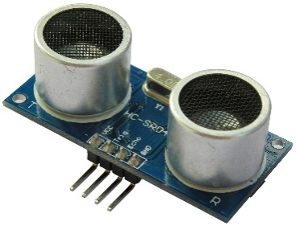

Fig 1.1 Ultrasonic Sensors

Power System

The device needed a good power supply that can put out a reasonable amount of current for the DC motors as well as run a microcontroller and sensors. There are many different types of batteries that were needed to be considered for a power source of the robot.

The crucial factors that were considered for the batteries include: long duration, high performance, fair cost, size and environmental friendliness. Another important consideration for the battery was its recharge ability. It is not supposed to take too much time to recharge. Also, in order to operate the device for a longer time, the power management systems was also considered. Moreover, using a photocell charger for the batteries turned out to be a good way to extend the battery life. Therefore, a high powered battery charger was used to perform this requirement.

Chassis

The Device needed a good power supply that can put out a reasonable amount of current for the DC motors as well as run a microcontroller and sensors. There are many different types of batteries that were needed to be considered for a power source of the robot.

The crucial factors that were considered for the batteries include: long duration, high performance, fair cost, size and environmental friendliness. Another important consideration for the battery was its recharge ability. It is not supposed to take too much time to recharge. Also, in order to operate the device for a longer time, the power management systems was also considered. Moreover, using a photocell charger for the batteries turned out to be a good way to extend the battery life. Therefore, a solar powered battery charger was used to perform this requirement.

Wheels and Motor

When deciding on what type of locomotion for device we looked at continuous tracks, six-wheel, and four-wheel. Continuous track also known as caterpillar tracks, or tank treads, are a track had of either steel, rubber, or a combination of steel and rubber, rotated by a series of sprockets. The continuous tracks turned out to be a better option than tires through rough terrain and can glide over small obstacles and small gaps in the ground, and are less likely to get stuck in mud. However they lack in speed and maneuverability compared to tires and they are harder to maintain, as the loss of a single segment of track immobilizes the entire vehicle. Additionally, the tracks has the potential to slip off their sprockets and jam, which in worst case scenario, the track would need to be broken before the jam can be fixed.

Due to the difficulty in maintenance and lower maneuverability and top speed compared to wheels, we decided not to work with continuous tracks and instead focus on a wheel vehicle. From here the decision came down to either using four-wheel locomotion or six-wheel locomotion. In the end our group decided to have four-wheel robotic locomotion of the device, because it can handle relatively rough terrain and move at high speeds. While a six-wheel drive could do the similar to a four-wheel drive or marginally better than four wheels, it was more economically reasonable to just go with the four-wheels and four motors. A suspension system was required to allow all four wheels to maintain ground contact when the robot encounters the uneven terrain. Also, a deformable tire of soft rubber to the wheel shall be applied to create a primitive suspension.

Two main wheels were powered by dc motors which are independently controlled for steering. The dc motors of the device had enough torque and power to handle the heavy weight of the payload. Also it must be reversible to assist the steering system of the robot.

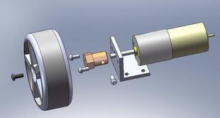

Fig 1.2 Motors and Wheels

PCB

A printed circuit board (PCB) mechanically supports and electrically connects [electronic components](http://en.wikipedia.org/wiki/Electronic_component) using [conductive](http://en.wikipedia.org/wiki/Electrical_conductor) tracks, pads and other features [etched](http://en.wikipedia.org/wiki/Industrial_etching) from copper sheets [laminated](http://en.wikipedia.org/wiki/Laminated) onto a non-conductive [substrate](http://en.wikipedia.org/wiki/Substrate_(electronics)). PCBs can be single sided (one copper layer), double sided (two copper layers) or multi-layer (outer and inner layers). Multi-layer PCBs allow for much higher component density. Conductors on different layers are connected with plated-through holes called [vias](http://en.wikipedia.org/wiki/Via_(electronics)" \o "Via (electronics)). Advanced PCBs may contain components - capacitors, resistors or active devices - embedded in the substrate.

Printed circuit boards are used in all but the simplest electronic products. Alternatives to PCBs include [wire wrap](http://en.wikipedia.org/wiki/Wire_wrap) and [point-to-point construction](http://en.wikipedia.org/wiki/Point-to-point_construction). PCBs require the additional design effort to lay out the circuit, but manufacturing and assembly can be automated. Manufacturing circuits with PCBs is cheaper and faster than with other wiring methods as components are mounted and wired with one single part. Furthermore, operator wiring errors are eliminated.

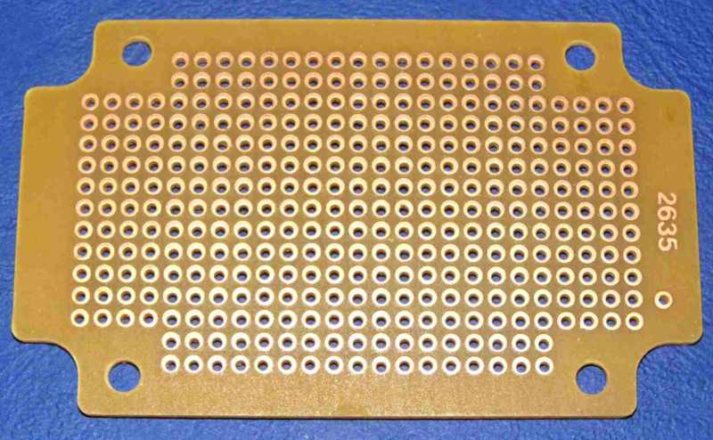

Fig 1.3 PCB

IC 7805

7805 is a voltage regulator integrated circuit. It is a member of 78xx series of fixed linear voltage regulator ICs. The voltage source in a circuit may have fluctuations and would not give the fixed voltage output. The voltage regulator IC maintains the output voltage at a constant value. The xx in 78xx indicates the fixed output voltage it is designed to provide. 7805 provides +5V regulated power supply. Capacitors of suitable values can be connected at input and output pins depending upon the respective voltage levels.

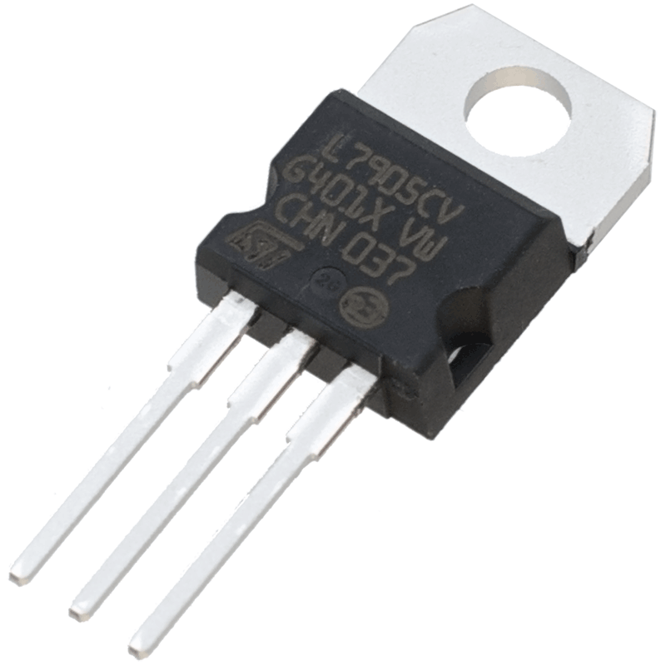

Fig 1.4 IC 7805

Arduino Uno

The Arduino Uno is a microcontroller board based on the ATmega328. It has 14 digital input/output pins (of which 6 can be used as PWM outputs), 6 analog inputs, a 16 MHz ceramic resonator, a USB connection, a power jack, an ICSP header, and a reset button. It contains everything needed to support the microcontroller; simply connect it to a computer with a USB cable or power it with an AC-to-DC adapter or battery to get started.

The Uno differs from all preceding boards in that it does not use the FTDI USB-to-serial driver chip. Instead, it features the Atmega16U2 (Atmega8U2 up to version R2) programmed as a USB-to-serial converter.

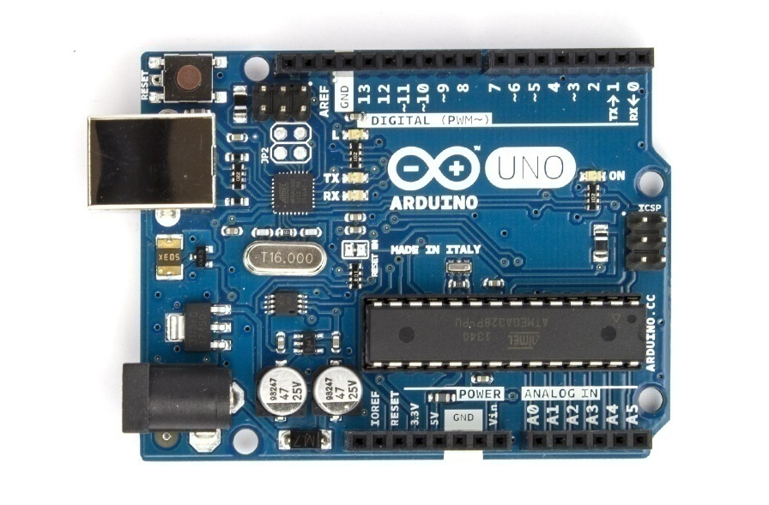

Fig 1.5 Arduino Uno

Transmitter

In [electronics](http://en.wikipedia.org/wiki/Electronics) and [telecommunications](http://en.wikipedia.org/wiki/Telecommunications) a transmitter or radio transmitter is an [electronic device](http://en.wikipedia.org/wiki/Electronic_device) which, with the aid of an antenna, produces [radio waves](http://en.wikipedia.org/wiki/Radio_wave). The transmitter itself generates a [radio frequency](http://en.wikipedia.org/wiki/Radio_frequency) [alternating current](http://en.wikipedia.org/wiki/Alternating_current), which is applied to the antenna. When excited by this alternating current, the antenna radiates [radio waves](http://en.wikipedia.org/wiki/Radio_wave). In addition to their use in [broadcasting](http://en.wikipedia.org/wiki/Broadcasting), transmitters are necessary component parts of many electronic devices that communicate by [radio](http://en.wikipedia.org/wiki/Radio_communication), such as phones, wireless, [Bluetooth](http://en.wikipedia.org/wiki/Bluetooth) enabled devices, [garage door openers](http://en.wikipedia.org/wiki/Garage_door_opener), [two-way radios](http://en.wikipedia.org/wiki/Two-way_radio) in aircraft, ships, and spacecraft, [radar](http://en.wikipedia.org/wiki/Radar) sets, and navigational beacons. The term transmitter is usually limited to equipment that generates radio waves for [communication](http://en.wikipedia.org/wiki/Communication_engineering) purposes; or [radiolocation](http://en.wikipedia.org/wiki/Radiolocation), such as [radar](http://en.wikipedia.org/wiki/Radar) and navigational transmitters. Generators of radio waves for heating or industrial purposes, such as [microwave ovens](http://en.wikipedia.org/wiki/Microwave_oven) or [diathermy](http://en.wikipedia.org/wiki/Diathermy) equipment, are not usually called transmitters even though they often have similar circuits.

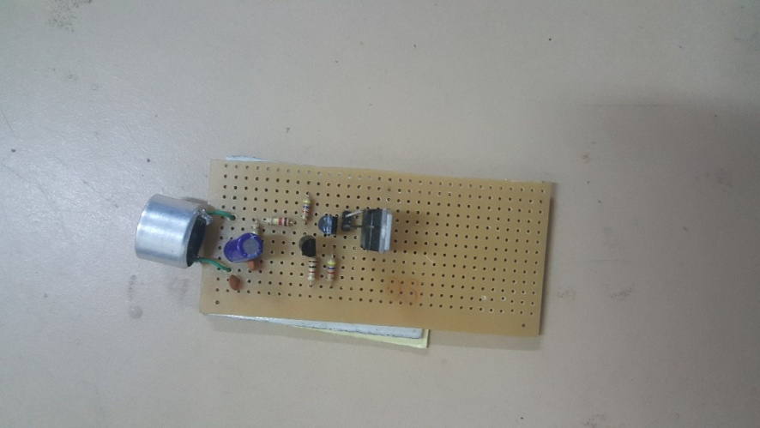

Fig 1.6 Transmitter

Motor Driving IC (L293D)

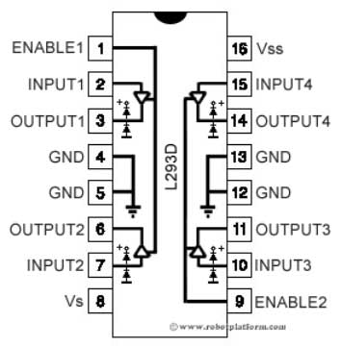

Fig 1.7 IC Pin Diagram

L293D IC generally comes as a standard 16-pin DIP (dual-in line package). This motor driver IC can simultaneously control two small motors in either direction; forward and reverse with just 4 microcontroller pins (if you do not use enable pins). Some of the features (and drawbacks) of this IC are:

Output current capability is limited to 600mA per channel with peak output current limited to 1.2A (non-repetitive). This means you cannot drive bigger motors with this IC. However, most small motors used in hobby robotics should work. If you are unsure whether the IC can handle a particular motor, connect the IC to its circuit and run the motor with your finger on the IC. If it gets really hot, then beware... Also note the words "non-repetitive"; if the current output repeatedly reaches 1.2A, it might destroy the drive transistors.

Supply voltage can be as large as 36 Volts. This means you do not have to worry much about voltage regulation.

Receiver

In [radio communications](http://en.wikipedia.org/wiki/Radio_communications), a radio receiver is an electronic device that receives [radio waves](http://en.wikipedia.org/wiki/Radio_wave) and converts the information carried by them to a usable form. It is used with an [antenna](http://en.wikipedia.org/wiki/Antenna_(radio)). The antenna intercepts radio waves ([electromagnetic waves](http://en.wikipedia.org/wiki/Electromagnetic_wave)) and converts them to tiny [alternating currents](http://en.wikipedia.org/wiki/Alternating_current) which are applied to the receiver, and the receiver extracts the desired information. The receiver uses [electronic filters](http://en.wikipedia.org/wiki/Electronic_filter) to separate the desired [radio frequency](http://en.wikipedia.org/wiki/Radio_frequency) signal from all the other signals picked up by the antenna, an [electronic amplifier](http://en.wikipedia.org/wiki/Electronic_amplifier) to increase the power of the signal for further processing, and finally recovers the desired information through [demodulation](http://en.wikipedia.org/wiki/Demodulation).

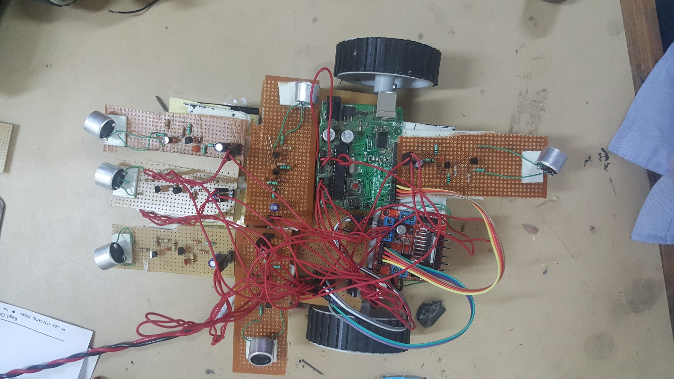

Fig 1.8 Receiver with 6 Ultrasonic sensors

IR Sensor

An Infrared (IR) sensor is used to detect obstacles in front of the robot or to differentiate between colors depending on the configuration of the sensor. The Picture is a very simple black box model of the IR Sensor. The sensor emits IR light and gives a signal when it detects the reflected light. An IR sensor consists of an emitter, detector and associated circuitry. The circuit required to make an IR sensor consists of two parts; the emitter circuit and the receiver circuit. The emitter is simply an IR LED (Light Emitting Diode) and the detector is simply an IR photodiode which is sensitive to IR light of the same wavelength as that emitted by the IR LED. When IR light falls on the photodiode, its resistance and correspondingly, its output voltage, change in proportion to the magnitude of the IR light received.

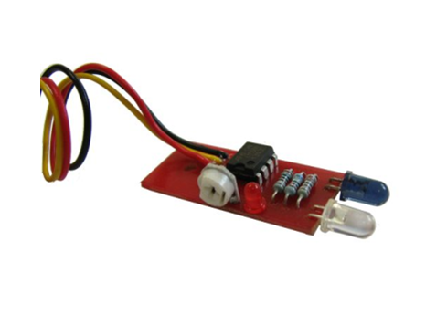

IR Sensor

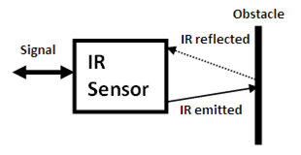

Circuit Diagram of IR sensor

|  |  |
| --- | --- |
| . | C:\Users\Hriday\Desktop\ULTRASONIC-TRANSMITTER (1).png  Fig 1.10 Receivers circuit diagram  Stages of the project  Stage 1  C:\Users\Hriday\Desktop\IMG-20150505-WA0000.jpg  Stage 2  C:\Users\Hriday\Desktop\20150504_183209.jpg  Stage 3  C:\Users\ayushi\Downloads\20150507_173308.jpg |

Chapter 3(Working and Applications)

Algorithm:

The purpose of this robot is to follow its user.The local method will use a closed system for localization, formed of only the robot itself, the user, and a signaling beacon. Normally the user will carry a signaling beacon (ultrasonic, infrared, radio, etc), which the robot will "see" and follow. Easy to say, doing it is of course much harder, as we need a smooth robot movement, so a lot of error compensation and fuzzy logic must be involved. Recently I made some excellent progress using ultrasounds as a transmission method, to create a simple beacon detector. The user needs to carry this tiny, low power ultrasonic beacon which the robot should be able to "hear" and use the signal to navigate to the target, and follow it.

There are several ways of implementing the working mechanism:

a) Using a single ultrasonic receiver, placed in front of the robot: the rover will need to rotate until it detects a maximum level of signal. Then it should move forward until the detected signal reaches a given threshold (so it will not hit the user, but stop right before him/her). It doesn't really work well, as the software gets overcomplicated and the results are not as good as expected.

b) Similar to “a”, but use a servo motor to rotate the ultrasonic sensor instead of rotating the entire robot. When the maximum signal is detected, the robot should turn towards the source, and begin moving forward. It still doesn't solve many of the issues found with “a”.

c) Using two ultrasonic receivers, placed some space apart, in the frontal part of the rover. Now we can make differential measurements, so it's easy to know from which part is the signal coming from, as the corresponding sensor will have higher readings. The robot can now directly turn towards the beacon, and follow the forward direction.

d) Using more than two sensors, ideally 8, placed at 45 degrees in a radial disposition. This would pinpoint the source more accurately, and reduce the time needed to find the beacon. Still, to simplify, I plan to go for the differential measurements presented at “c”.

The ultrasonic sensors already return an output signal which is a function of the distance to the beacon / user. This can be used to measure the distance. If greater accuracy is required, we can involve infrared light in the process: - the beacon sends a set of 38KHz modulated Infrared pulses marking moment of time t0 - the beacon immediately sends out the ultrasonic pulses - the receiver which is a few meters from the beacon, receives the infrared pulses practically instantaneously and knows the time is t0 (using a TSOPXX38) - the receiver registers the incoming ultrasonic pulses at the time t1, where t1>t0. By using the speed of sound in air, we can detect the path and follow it.

The algorithm compares the readings from the two sensors and decides whether to turn left (if left sensor return higher readings), right or to move forward (if the output of the two sensors is similar).

I built a total of 6 ultrasonic receivers that are to be placed three in the front, one at the back and one on each side. The idea is to have the robot turn around facing the ultrasonic signal, and then to make it follow the source using the three frontal sensors. The differential readings will help us decide whether to adjust the direction for left or right.

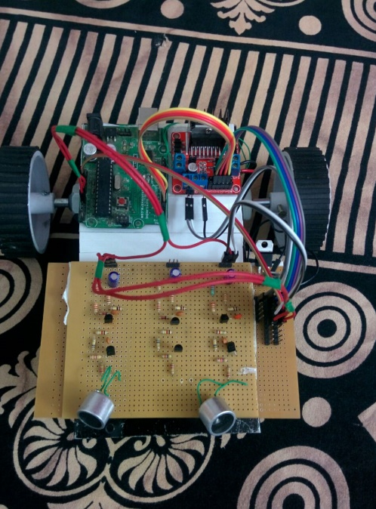

Fig 1.9 robot with 2 Ultrasonic sensors made in the mid evaluation.

APPLICATIONS

The Luggage Follower implements several applications that demonstrate the usefulness, viability and flexibility of the system.

Portable- One of the main advantages of the device is its small size and portability. It can be easily carried around without any difficulty. The prototype of the device is deigned in such a way that it gives more importance to the portability factor. All the devices are light in weight and can easily be fit into the user’s pocket.

Cost effective-The cost incurred for the construction of the device is quiet low. It was made from parts collected together from common devices. The device have not been made in large scale commercial purpose. Once that happens it’s almost certain that the device will cost much lower than the current price.

It generally enables the user to carry the without any difficulty or we can say that the luggage will follow the user and user need not to track it along with him rather the luggage will follow the user without any obstacle in it and it also includes buzzer system in it which will be activated due to threat.

It is also used in the movement of a blind person through wheelchair. A wheelchair bound person requires the freedom of upper limb body movement to move around. Any attachment to the wheelchair in the form of luggage will enable the blind person to move freely.Another major application of this project is it can even be used in cradle for the small babies.

ENHANCEMENTS

Future Enhancements:

1. Another Important feature is theft detection, which can be added which will increase the security of the luggage.

2. It can be can be implemented in different items eg: trolley, small bags, briefcase etc.

3. It can be connected to baby cradle but if u want to connect it, then it will be in front of the person.

4. It can be implemented in industrial machines like for shifting the small heavy machines which cannot be lifted easily and which has wheels attached in it.

Chapter 4(CONCLUSION)

The key here is the device that enables the luggage to follow the human with the help of a transmitter and also to deal with the obstacles with the help of ultrasonic sensors in the simplest way possible.

Clearly, this has the potential of becoming the ultimate device for following the luggage and make the user's life easy and comfortable. If they can get rid of the ultrasonic sensors and it ever goes beyond the initial development phase, that is. But as it is now, it is the ultimate device which enables the luggage to follow its user.

REFERENCES

[1] [David Rurangirwa](https://www.google.co.in/search?biw=1280&bih=699&tbm=bks&q=inauthor:%22David+Rurangirwa%22&sa=X&ei=69NHVYmSNqKvmAXJmoHgAw&ved=0CCMQ9AgwAA), Mechanisms for Combining Infrared and Ultrasound Signals*,* Ann Arbor, MI, 2007, pp. 123-35.

[2] Sensors (2015, Mar 19). Ultrasonic sensors (1st edition) [Online].

<http://www.sick.com/group/EN/home/products/product_portfolio/distance_sensors/Pages/ultrasonic_sensors.aspx>

[3] Arduino. (2015, Feb 20). Arduino Uno (1st edition) [Online] <http://arduino.cc/en/Main/ArduinoBoardUno>

[4] Motors. (2015, Mar 25). Motors and Wheels(2st edition) [Online]

<http://robokits.co.in/robot-parts/wheels-pullies-belts>

[5] Ultrasonic range finder. (2015, April 3). Ultrasonic range finder (1st edition) [Online] <http://www.micro-examples.com/public/microex-navig/doc/090-ultrasonic-ranger.html>

[6]Ultrasonic. (2015, Feb 20). Ultrasonic (1st edition) [Online] <http://www.bannerengineering.com/en-US/products/8/Sensors/30/Ultrasonic-Sensors>