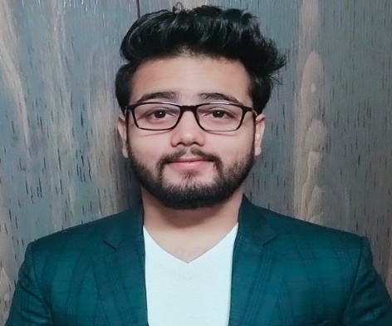

**EDUCATION**

Bachelors in Computer Science Engineering | Chandigarh University, Gharuan

*Session: 2019-2023 | Score: 7.90 CGPA*

Intermediate (RBSE) |Nirmal Happy School, Hindaun City(Rajasthan)

*Session: 2017-2018 | Percentage: 78.20%*

Matriculation (RBSE) | AVM Sr.sec. School, Hindaun City(Rajasthan)

*Session: 2015-2016 | Percentage: 89.17%*

**TRAINING & PROJECTS**

**REAL ESTATE PRICE PREDICTION**

* This project is about the price prediction which use AI & Machine Learning.
* It predict the price basis on users location and according to their budget.

**FREELANCING WEB PORTAL**

* This project is about freelancers where users can post or hire for jobs.
* This is very helpful for our ongoing generation.In this project we have use laravel,PHP,HTML,CSS.
* It is helpful for choosing user to apply for different position.

**ACADEMIC ACHIEVEMENTS**

* National Engineering Olympiad 2.0 (2019)
* Wipro TalentNext FutureSkills (2021)
* CodeKaze (2022)

**CERTIFICATIONS & AWARDS**

* Machine Learning Training Through Internshala
* Machine Learning Foundations: A Case Study Approach from Coursera
* HTML, CSS, and Javascript for Web Developers from Coursera
* Building Modern Python Applications on AWS from Coursera
* R- Programming from Coursera

**EXTRA CURRICULAR & CO-CURRICULAR ACHIEVEMENTS**

* District Level in Cricket
* CHESS

**SHIVAM ARORA**

Address: B-2, New Punjabi Colony ,Hindaun City,Karauli, Rajasthan(322230)

E-mail: [*shivamarora050620@gmail.com*](mailto:shivamarora050620@gmail.com)

Phone: +91 7733954538

LinkedIn: [www.linkedin.com/in/shivam-arora-arorag05](http://www.linkedin.com/in/shivam-arora-arorag05)

**PROFESSIONAL SUMMARY**

I'm a software developer & a Data Scientist who continually seeks out innovative solutions to everyday problems.I am reliable and dependable and often seek new responsibilities within a wide range of employment areas.

**TECHNICAL COMPETENCIES**

PYTHON **|** C++ **|** R **|** JAVA**|** MY SQL **|**

HTML **|** CSS **|** MACHINE LEARNING

**INTERPERSONAL SKILLS**

Team Leadership **|** Humour and Lightheartedness **|** Decision Making

**INTERESTS & HOBBIES**

Cooking **|** Travelling **|** Reading **|** Gardening **|** Fitness and Exercise

**LANGUAGES KNOWN**

English **|** Hindi **|** Punjabi

**PERSONAL DETAILS**

Mother’s Name:

Ritu Arora

Father’ Name: Subhash Arora

D.O.B.: 05/06/2000

Languages Known: Hindi, English