**Variance Gamma**

Rohit Arora Ying Wang

June 3, 2014

**Abstract:**

We examine Monte Carlo methods for simulation of Variance Gamma process. We implement algorithms for fitting Variance Gamma density, distribution and quantile functions. We use these to test the empirical evidence of non-normality in financial data. We develop algorithms for pricing European options and geometric Asian options where the underlying evolves as a Variance Gamma process using sequential Monte Carlo methods and benchmark our price against prices from Fourier transform techniques developed in papers based on Variance Gamma process. To reduce variance in our estimates we examine Control Variate, Importance sampling Bridge sampling techniques for Asian options. Finally we use pathwise estimation to develop Greeks for European options.

The paper is organized as follows. In section 1 we motivate the need for Variance Gamma process. In section 2 we briefly describe the notation and results used in the paper. In section 3 we present the algorithms developed and finally we present the results.

1. **Introduction**

Black-Scholes model for option pricing assumes that the underlying stock price process is log-normally distributed. However, implied stock price density suggests fat tail and skewed behavior. To counter this problem researchers have proposed Variance Gamma distribution as an underlying model for evolution of stock price process.

We developed functionality to fit a  density to data by optimizing log-likelihood. Since we do not have a closed form solution for the density we use the following result



Here  is a characteristic function. We then use root finding to develop the quantile function. We use these functions to fit real data and use the fitted density to construct the following graphs.

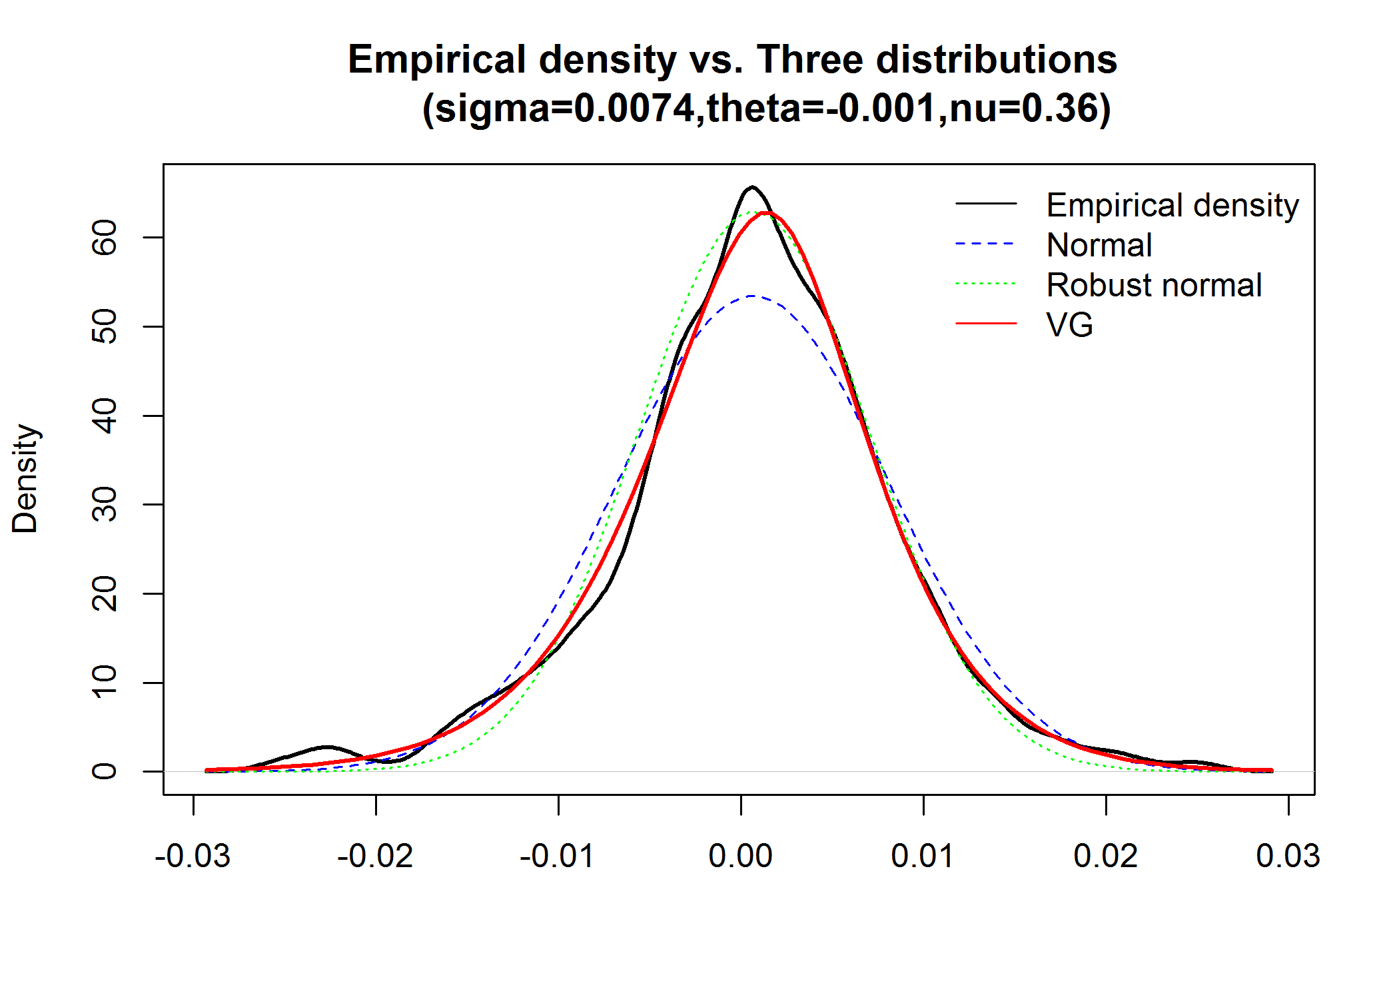

The adjacent figure shows a comparison of the various parametric densities against empirical density. We see that VG seems to fit the empirical density very well

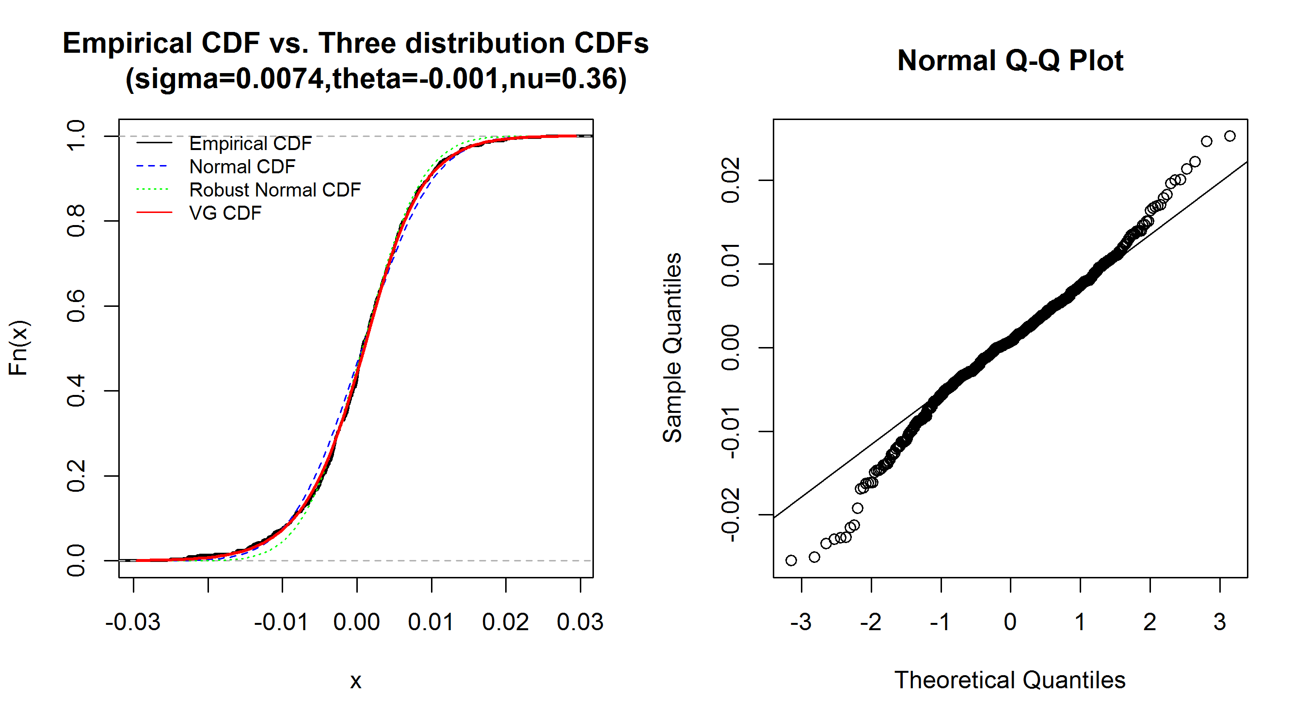

The adjacent figure shows a QQ plot. By examining the tails we can conclude non-normality. We can also see deviation from typical behavior from the overlayed distributions

Brownian motion moves in a uniform way over time and is unable to capture jumps in data. Hence it does not capture smile effects in volatility. On the other hand, Variance Gamma, as seen below is capable of producing jumps. Such a process can produce infinite number of jumps in any interval. It also exhibits a finite variation unlike Geometric Brownian motion.

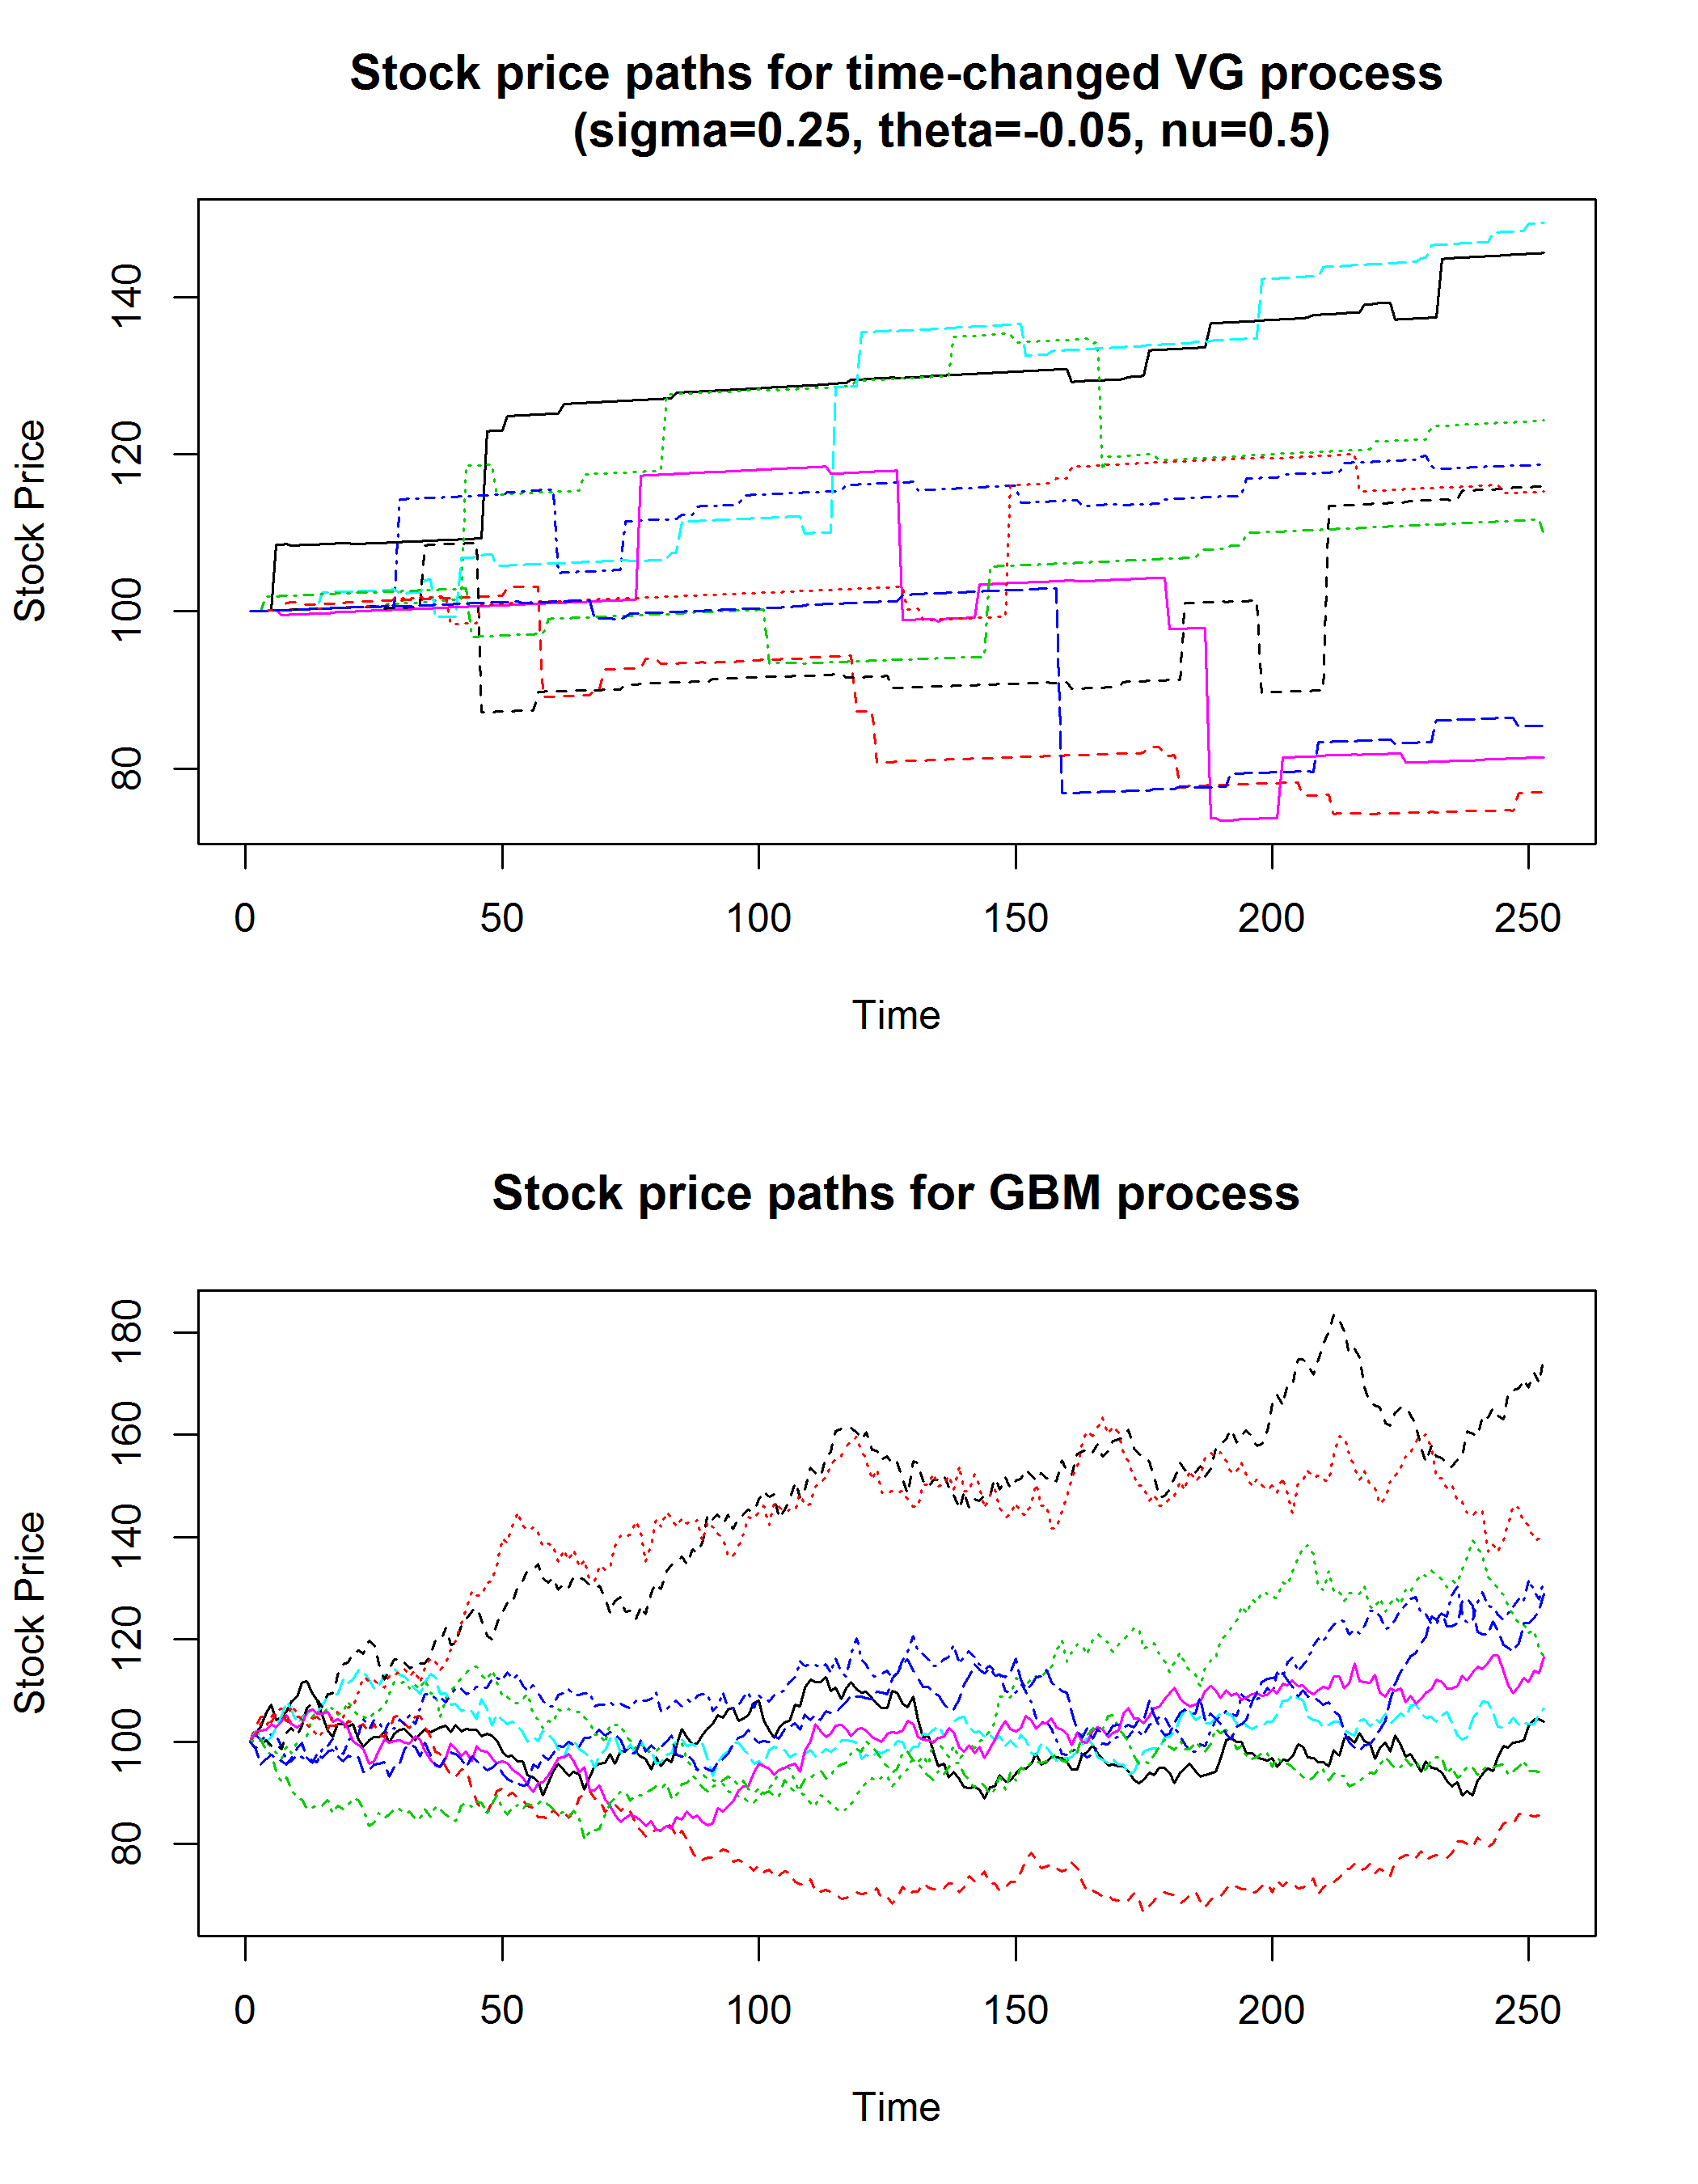

1. **Notation**

A random variable which is distributed with respect a Variance Gamma distribution has the following density



The above form shows that we can also obtain the density by conditioning a Normal density on Gamma density. We exploit this relationship to construct the density of a Variance Gamma random variable. Its characteristic function has the following form



The characteristic function severs an important role for pricing contracts using Fourier transform technique as suggested in [4]. We list the main result here



where is the characteristic function of the risk-neutral distribution. We use this technique to price European Calls and puts with Variance Gamma as the underlying. We further use results from [5] to price discretely monitored Geometric Asian options. These prices serve as a benchmark for all our pricing results from Monte-Carlo simulation.

1. **Methods**
   1. Simulation using time changed Brownian motion

Variance-Gamma is a class of Levy process and can be described using the following form.



We use the above formula to implement the following algorithm

* Generate  independently
* Return 
  1. Importance Sampling

Variance reduction is critical when pricing options that are deep out of money to reduce the standard error in estimation. We use the Radon-Nikodym derivative to change the probability measure to a new measure. Such a measure is presented in [2] and has the following form.



where and  are the independent process generated in the difference-of-gamma representation with new parameters.



* 1. Control Variate

Control Variate is an effective technique to reduce variance in an estimator based on variance of another variable whose expected value is known. It has the following general form.



We develop the Control Variate technique to price discreetly monitored geometric Asian option with fixed strike. Since Asian options are path-dependent, we use the price of the same option from the Black-Scholes framework where the analytical price is known as a Control Variate. Further we benchmark the results against the price from the Fourier transform technique.

* 1. Gamma Bridge Sampling with stratification

Similar to the case of Geometric Brownian Motion we stratify the terminal distribution of the Gamma random variable and use that to generate a Gamma bridge. We use the Time-Changed representation as suggested in [2] for the Gamma Bridge to generate the price path and subsequently the payoff. Then we use the optimal allocation algorithm to generate and estimate for the price of the Asian option.

The central idea is that path for a VG process is increasing. Then for any time  the conditional distribution of  . Details of the algorithm can be found in [2]

* 1. Pathwise estimation of Greeks

Suppose the price is given by

,

 the sensitivity is

.

Under certain conditions the expectation operator and the derivative operator can be interchanged. These conditions are satisfied for European options. Differentiating the payoff and using stock price derivatives suggested in [2] we get the following results





We benchmark the results from the pathwise method with results from crude Monte Carlo using finite difference method. We also use Fourier based estimates for Delta, Gamma and Rho for benchmarking results.

1. **Results**

As  increases the VG density becomes more peaked. As  increases the density becomes wider. As  increases the density becomes more skewed. As time increases the density becomes less peaked and we can see the density behaves more like Gaussian density. We can see this behavior in the following graphs.

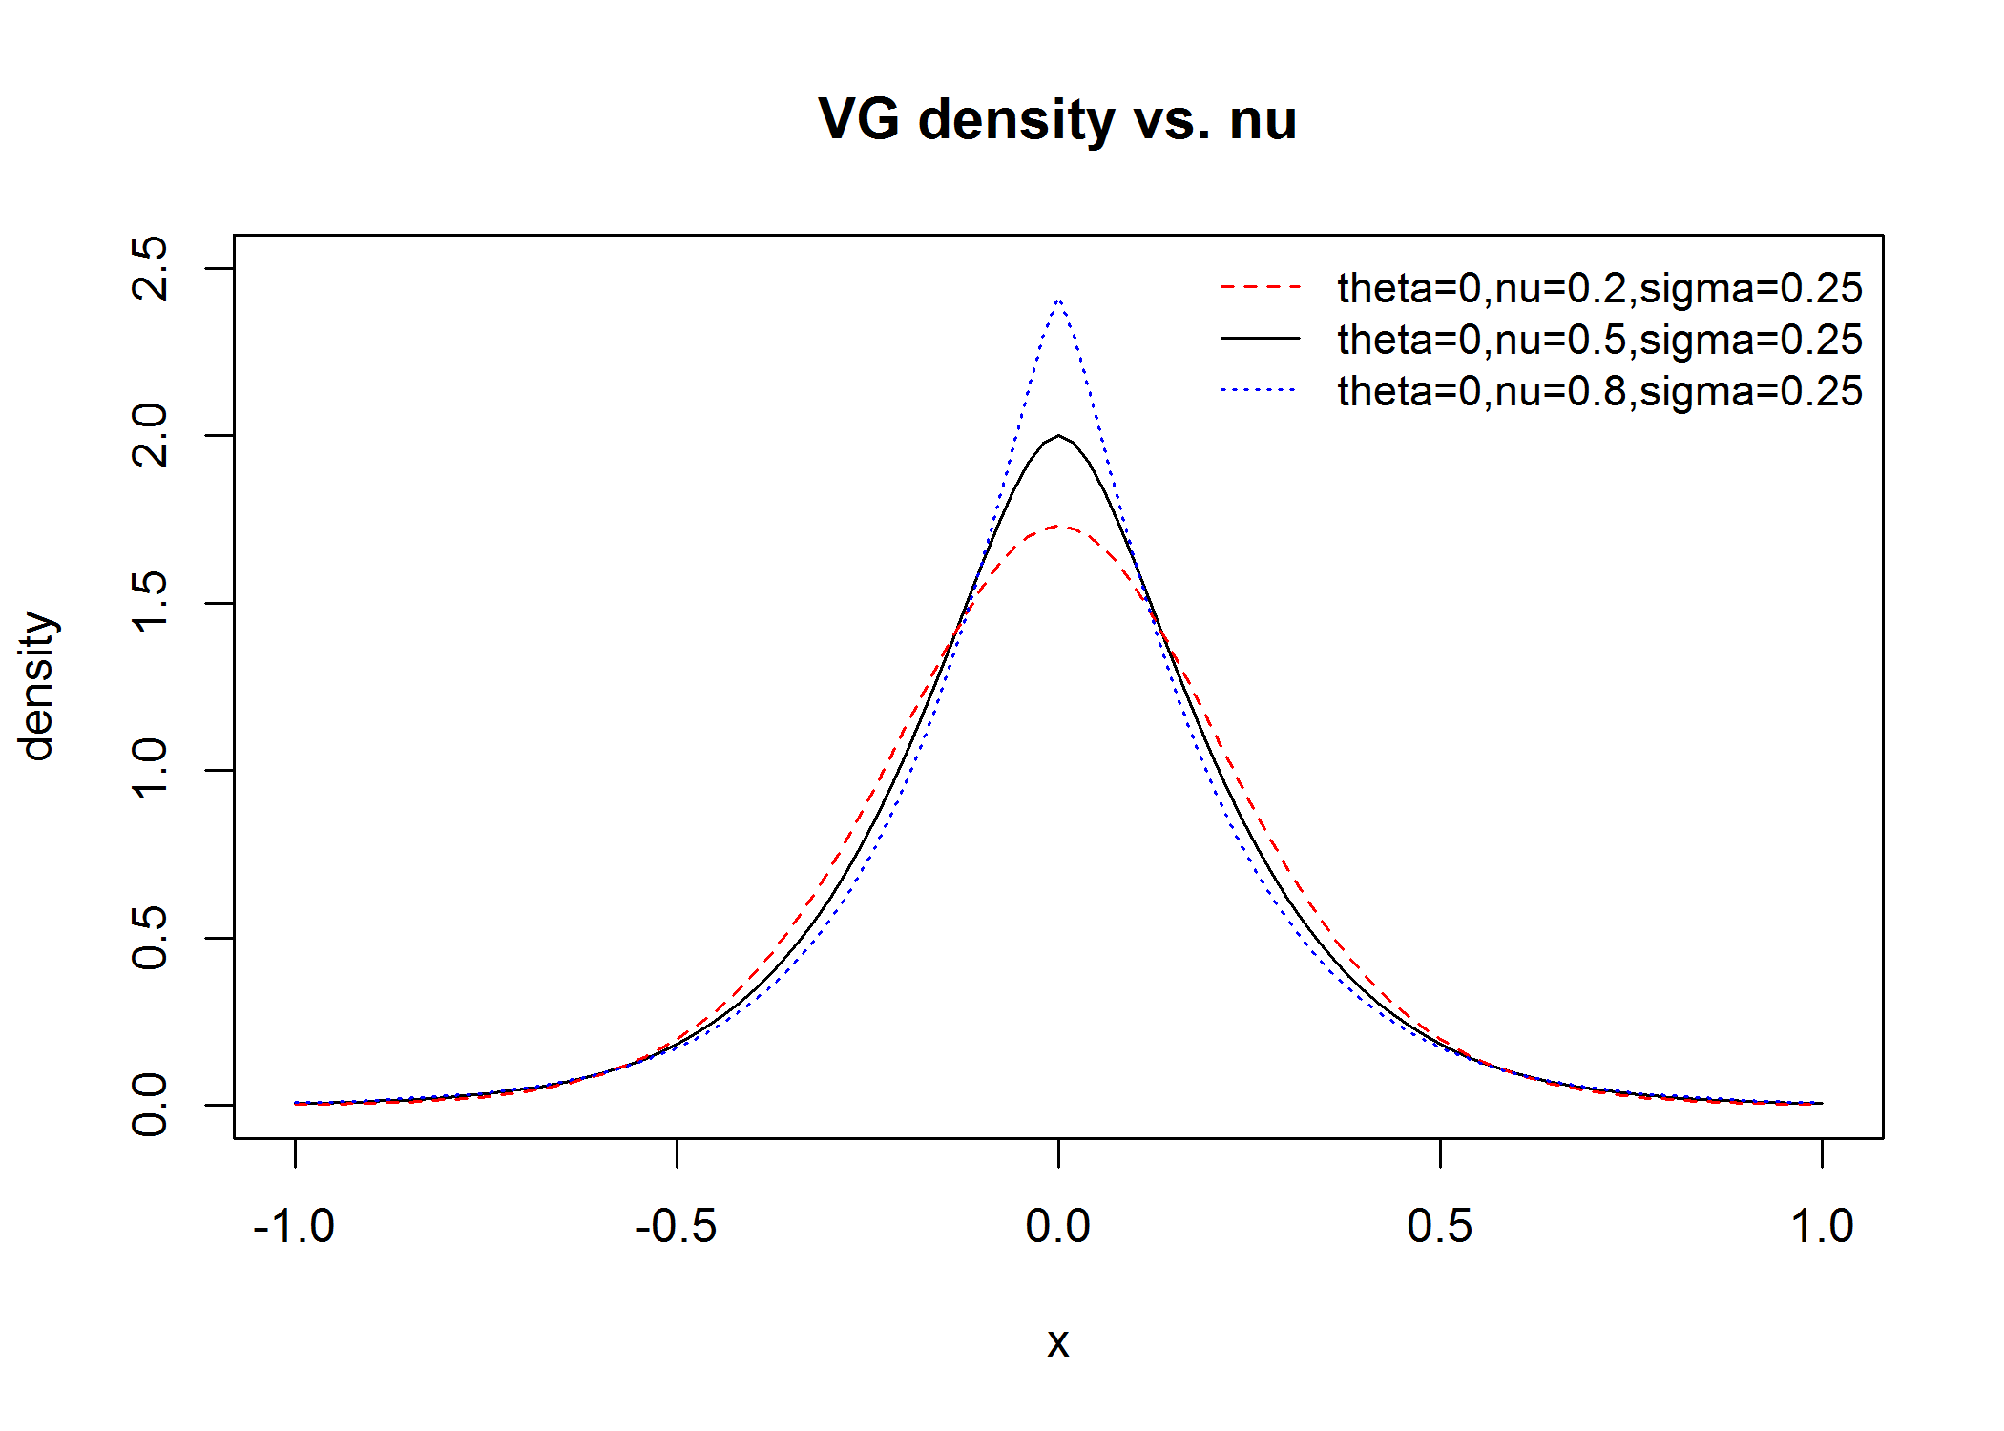 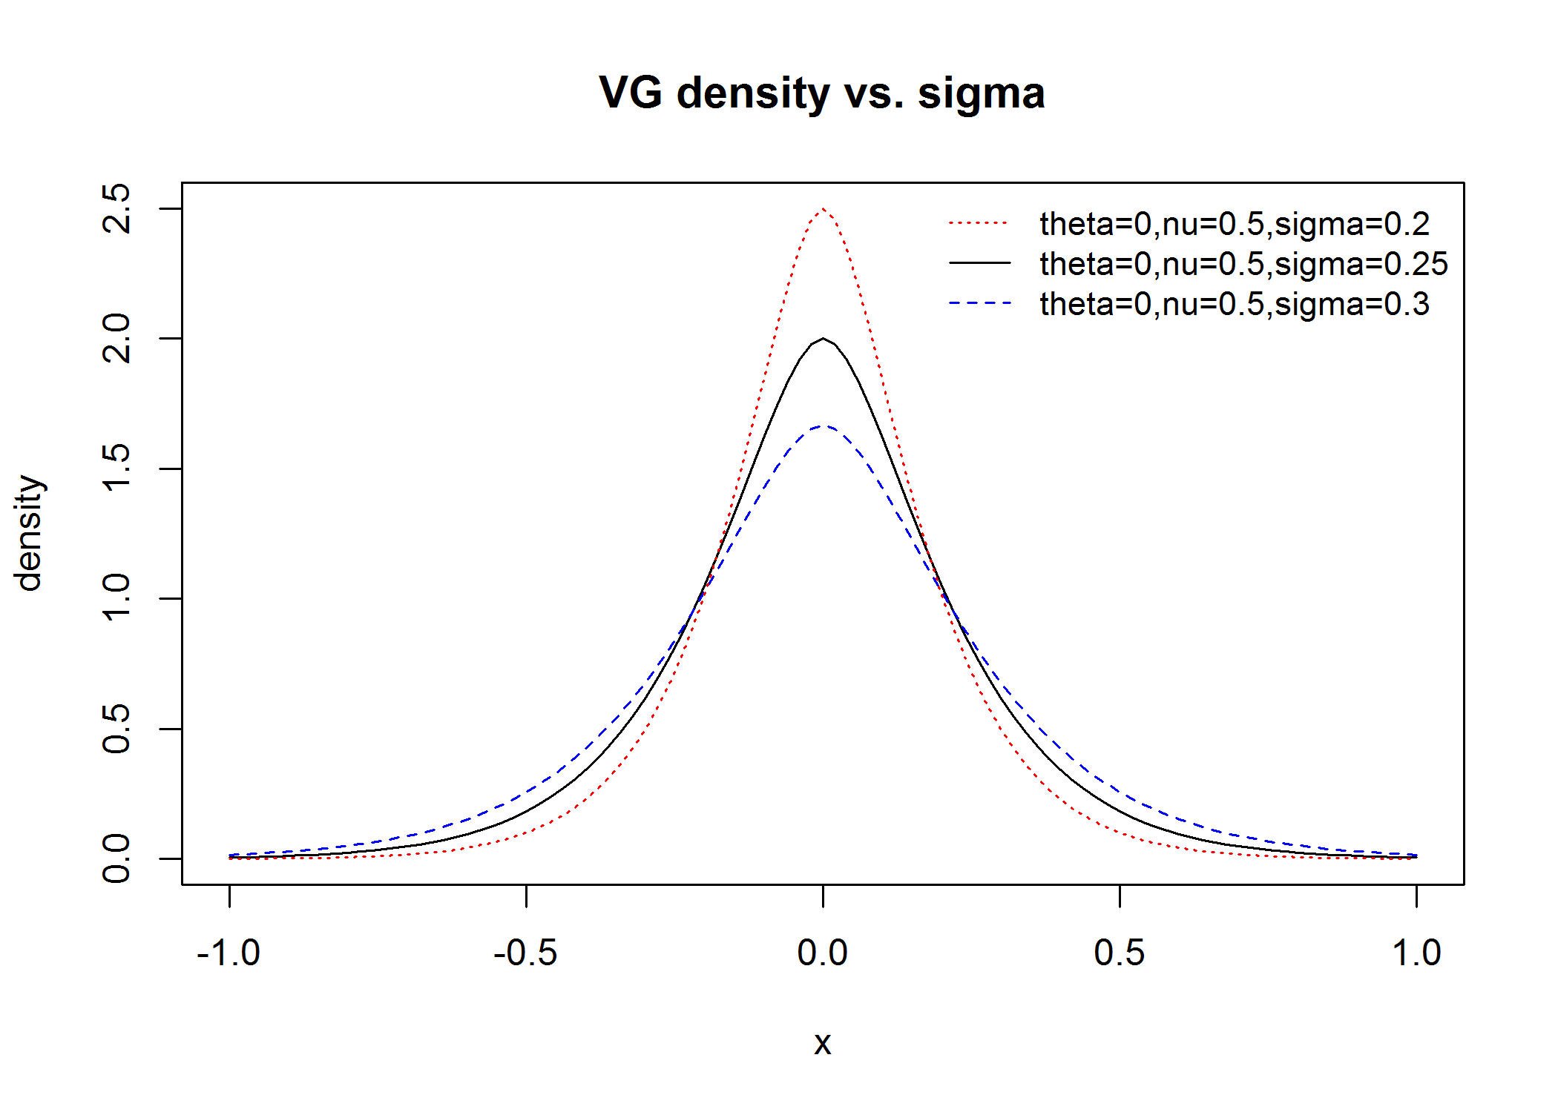

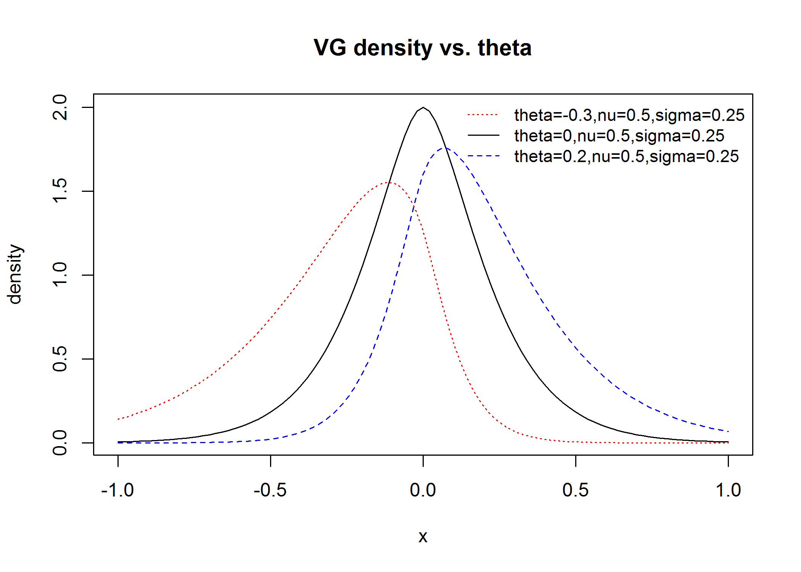 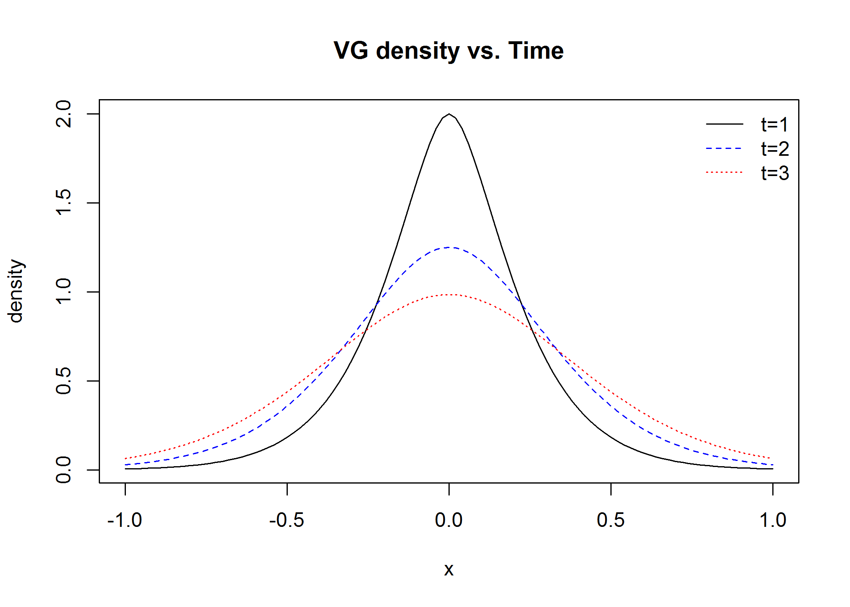

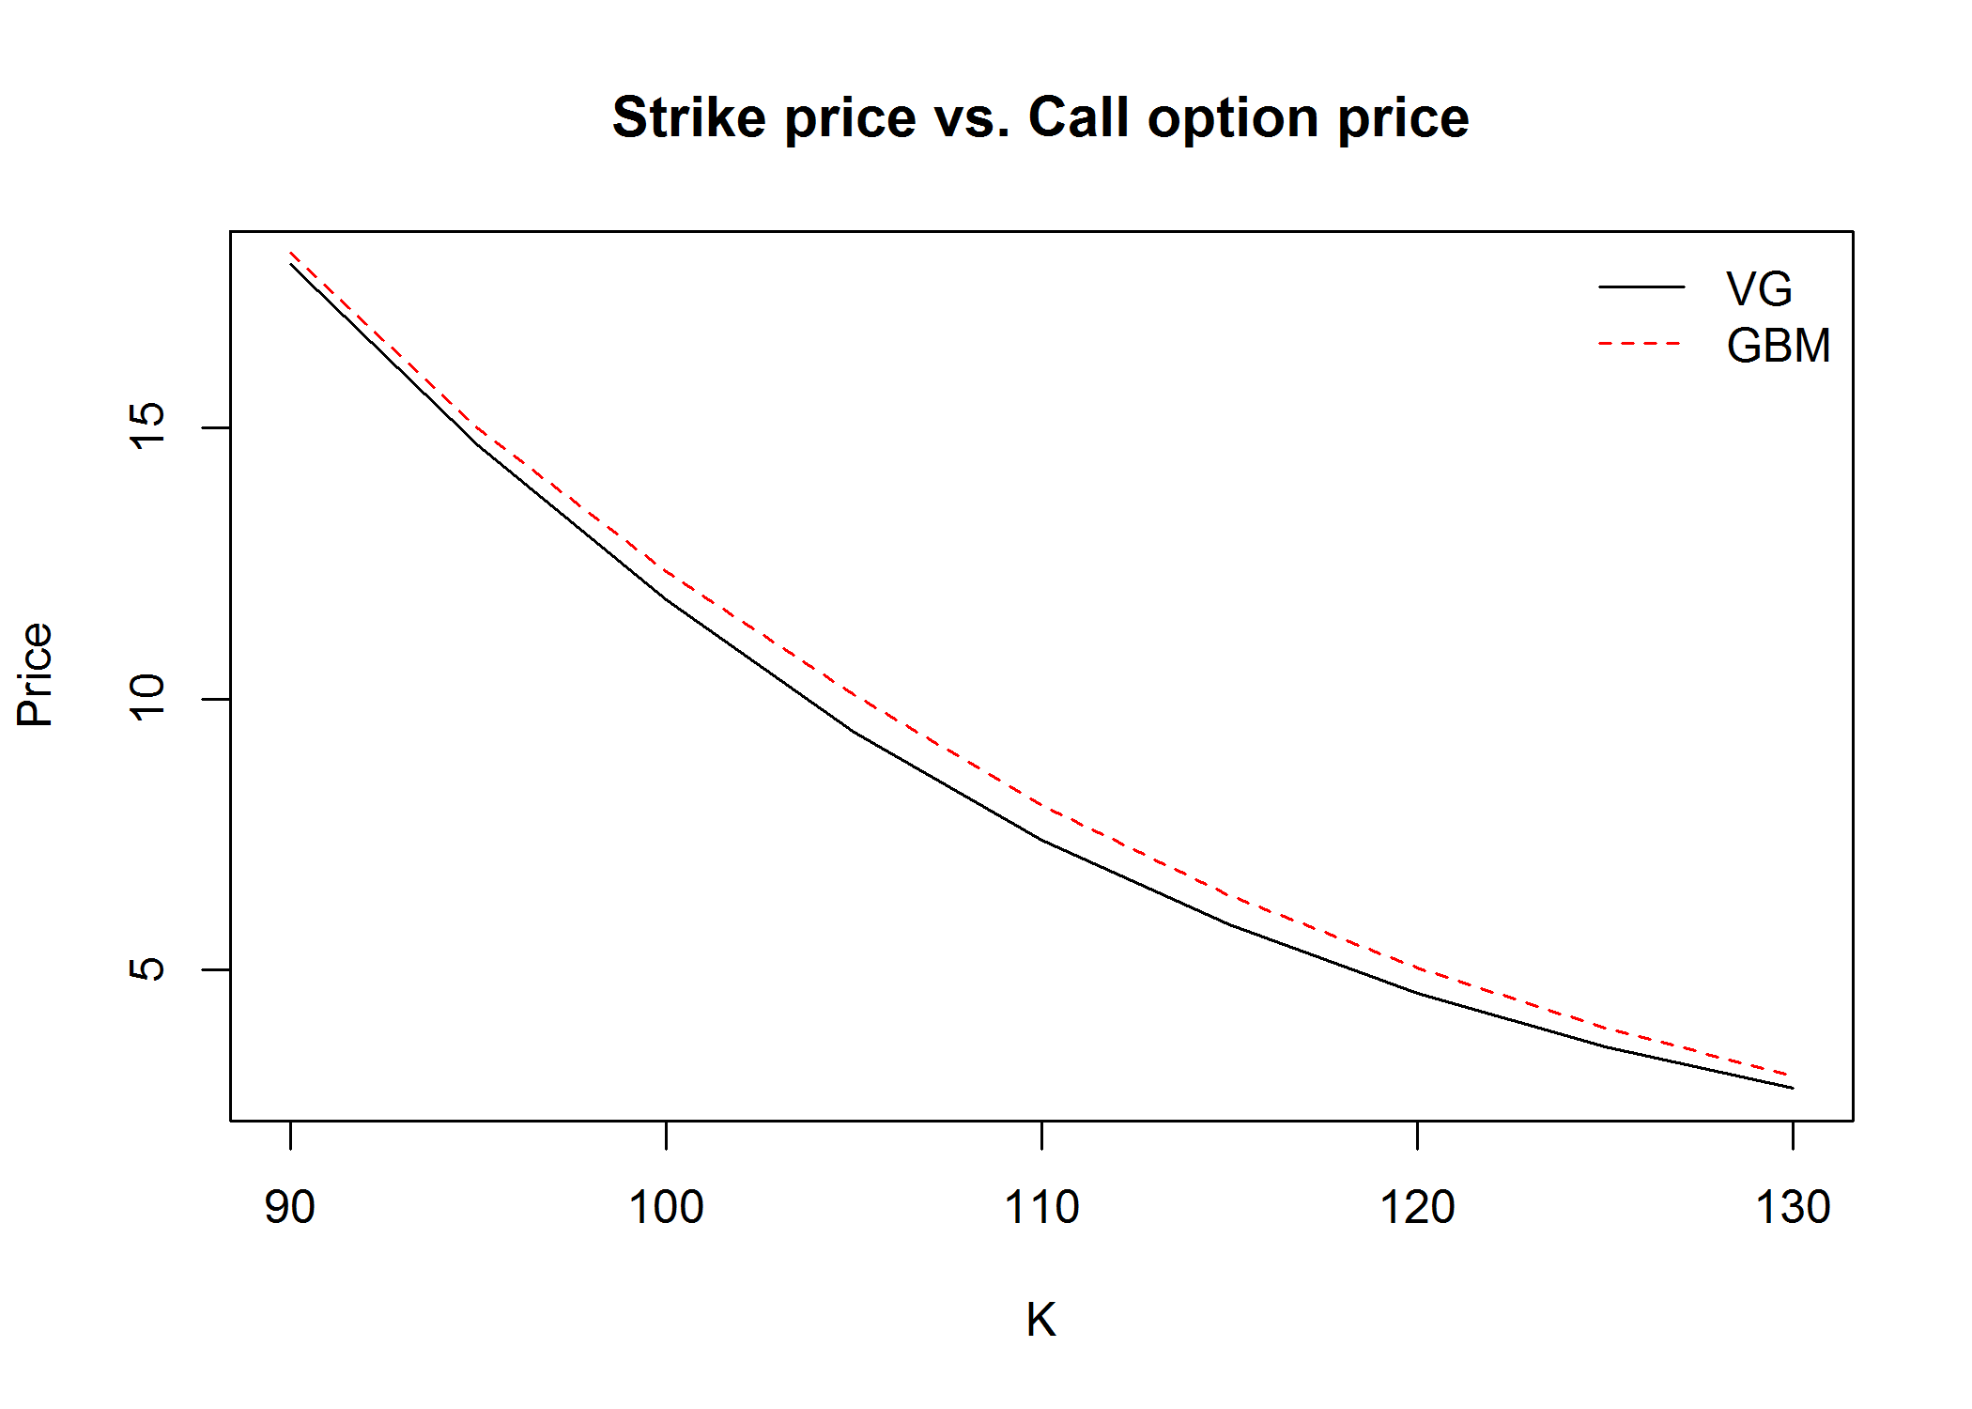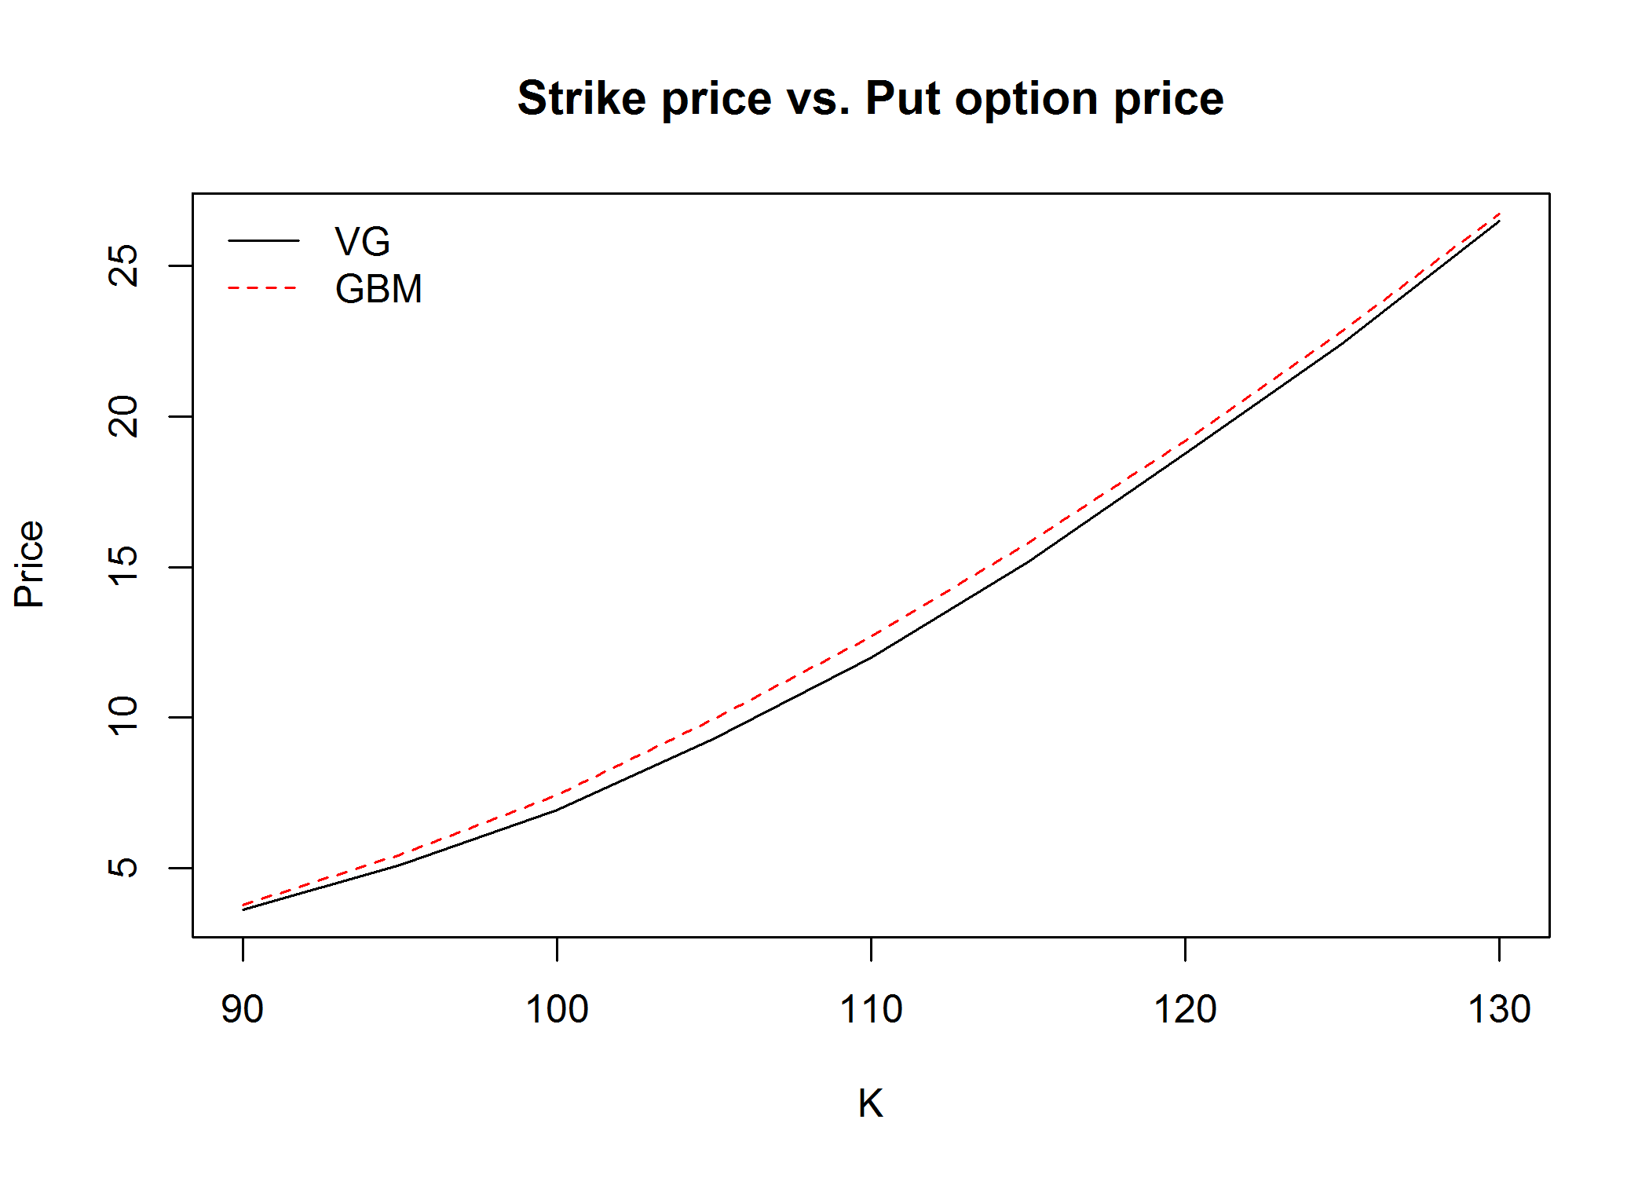

In the above graph we compare the Black-Scholes options prices against VG option price for European calls and puts. We notice that Black-Scholes over estimates the price.

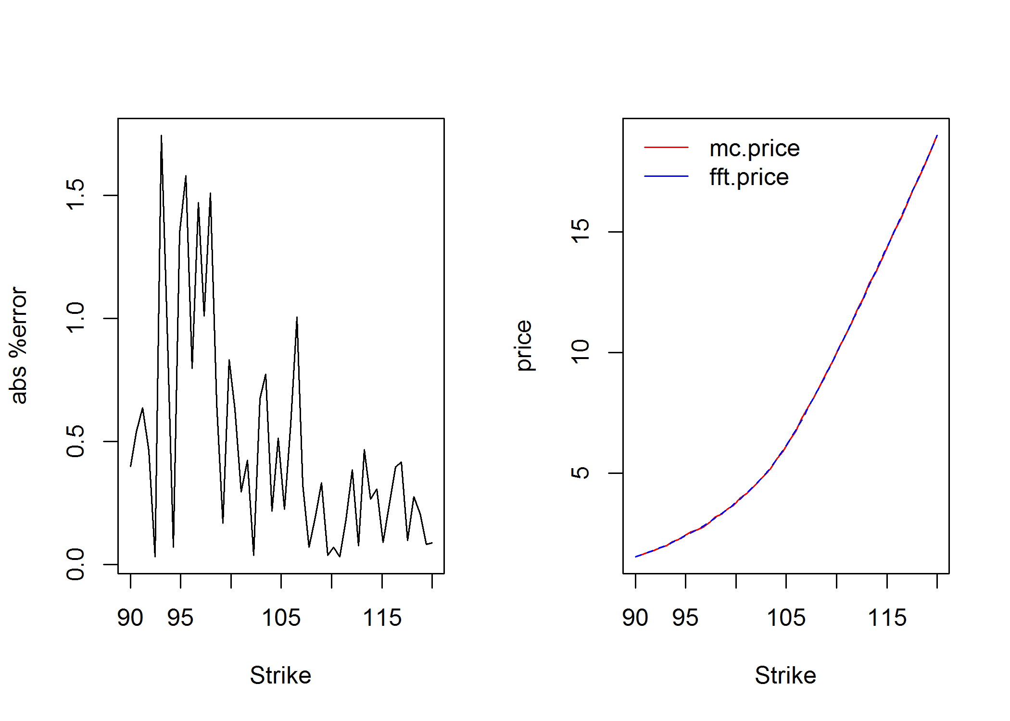

To the left we compare the price of our crude Monte Carlo estimate against Carr-Madan formula. We see that the % absolute error in our price estimate is small.

Below we show results of prices for European Calls, Puts and discretely monitored Geometric Asian option using crude Monte Carlo estimation. We benchmark the prices against Carr-Madan estimates for prices. We see that our price estimates are close.

|  |  |  |  |  |
| --- | --- | --- | --- | --- |
|  | **European Call** | | **European Put** | |
|  | **Estimated price** | **Standard error** | **Estimated price** | **Standard error** |
| VG Time Changed | 7.3624611 | 0.0502044 | 12.00348248 | 0.04563806 |
| VG Diff Gamma | 7.43042828 | 0.05110586 | 11.95911826 | 0.04570866 |
| VG FFT | 7.402404 | NA | 12.03764 | NA |
| GBM | 8.05231697 | 0.04896859 | 12.73824066 | 0.04516489 |
| GBM FFT | 8.026385 | NA | 12.66162 | NA |
|  | **Asian Call** | | **Asian Put** | |
|  | **Estimated price** | **Standard error** | **Estimated price** | **Standard error** |
| VG | 2.39295990 | 0.02190057 | 10.0600321 | 0.0318425 |
| VG FFT | 2.393005 | NA | 10.00268 | NA |
| GBM | 2.73848509 | 0.02005997 | 10.37265283 | 0.03154842 |
| GBM FFT | 2.76867 | NA | 10.38007 | NA |

**Variance Reduction**

**Importance Sampling**

Here we try to price the deep-out-of money European put with S0=100, and K=45. As new parameters for change of measure, we decrease original, increase originaland keep the  parameter constant. The parameters are as follows

|  |  |  |  |  |  |
| --- | --- | --- | --- | --- | --- |
|  |  |  |  |  |  |
| 0.25 | -0.05 | 0.5 | 0.35 | -0.1 | 0.5 |

Pricing results are as follows

|  |  |  |
| --- | --- | --- |
|  | **Estimated price** | **Standard error** |
| VG Diff Gamma | 0.025807280 | 0.001583751 |
| VG Importance Sampling | 0.0237484936 | 0.0005620372 |

As we can see in the table, there is variance reduction for the price, but not very significant. This is probably due to choice of parameters for the new probability measure. We are still working on how to make an efficient selection of new measure parameters.

**Control Variate**

Below are results for price of discretely monitored fixed strike Geometric option. We see significant variance reduction in our prices compared to crude Monte Carlo estimates.

|  |  |  |  |  |
| --- | --- | --- | --- | --- |
|  | **Asian Call** | | **Asian Put** | |
|  | **Estimated price** | **Standard error** | **Estimated price** | **Standard error** |
| VG | 2.395449 | 8.785859e-05 | 10.03663 | 0.0001258223 |

**Greeks**

In the graphs below we examine the behavior of changing VG parameters on Greeks. For Vega we examine a comparison between Black Scholes Vega and VG Vega. Except Gamma, increasing nu deceases the sensitivity. In case of varying Theta, Delta and Rho as moronically decreasing but Gamma and Vega peak at the origin and decrease on either sides. For sigma, we notice the dissimilarity between sensitivities of Black-Scholes and VG as sigma becomes larger. In case of Vega the effect is more pronounced in all ranges of sigma.

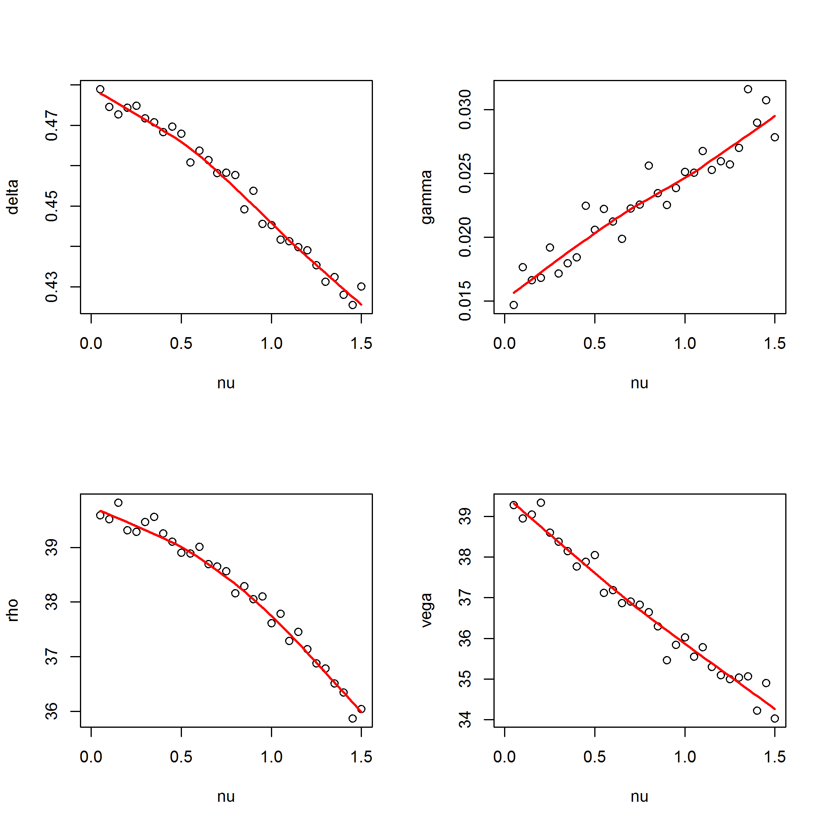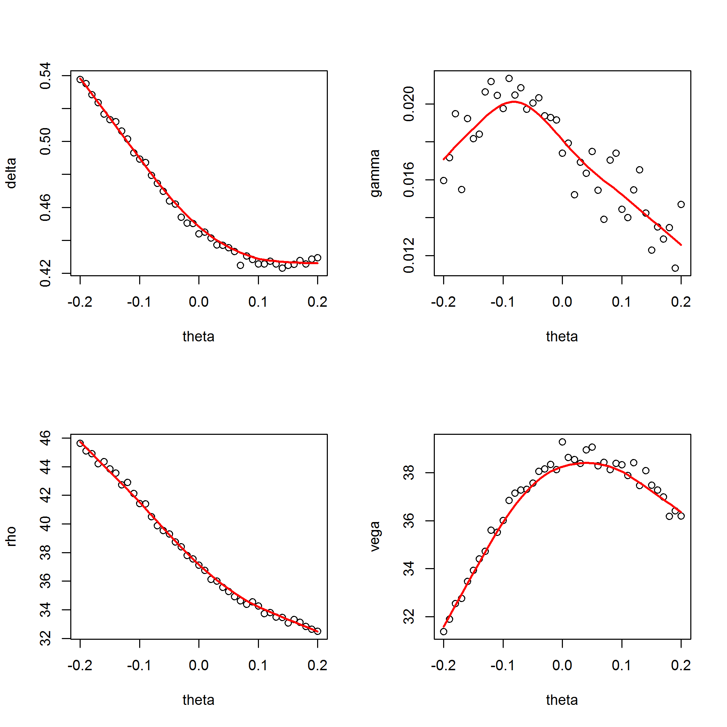

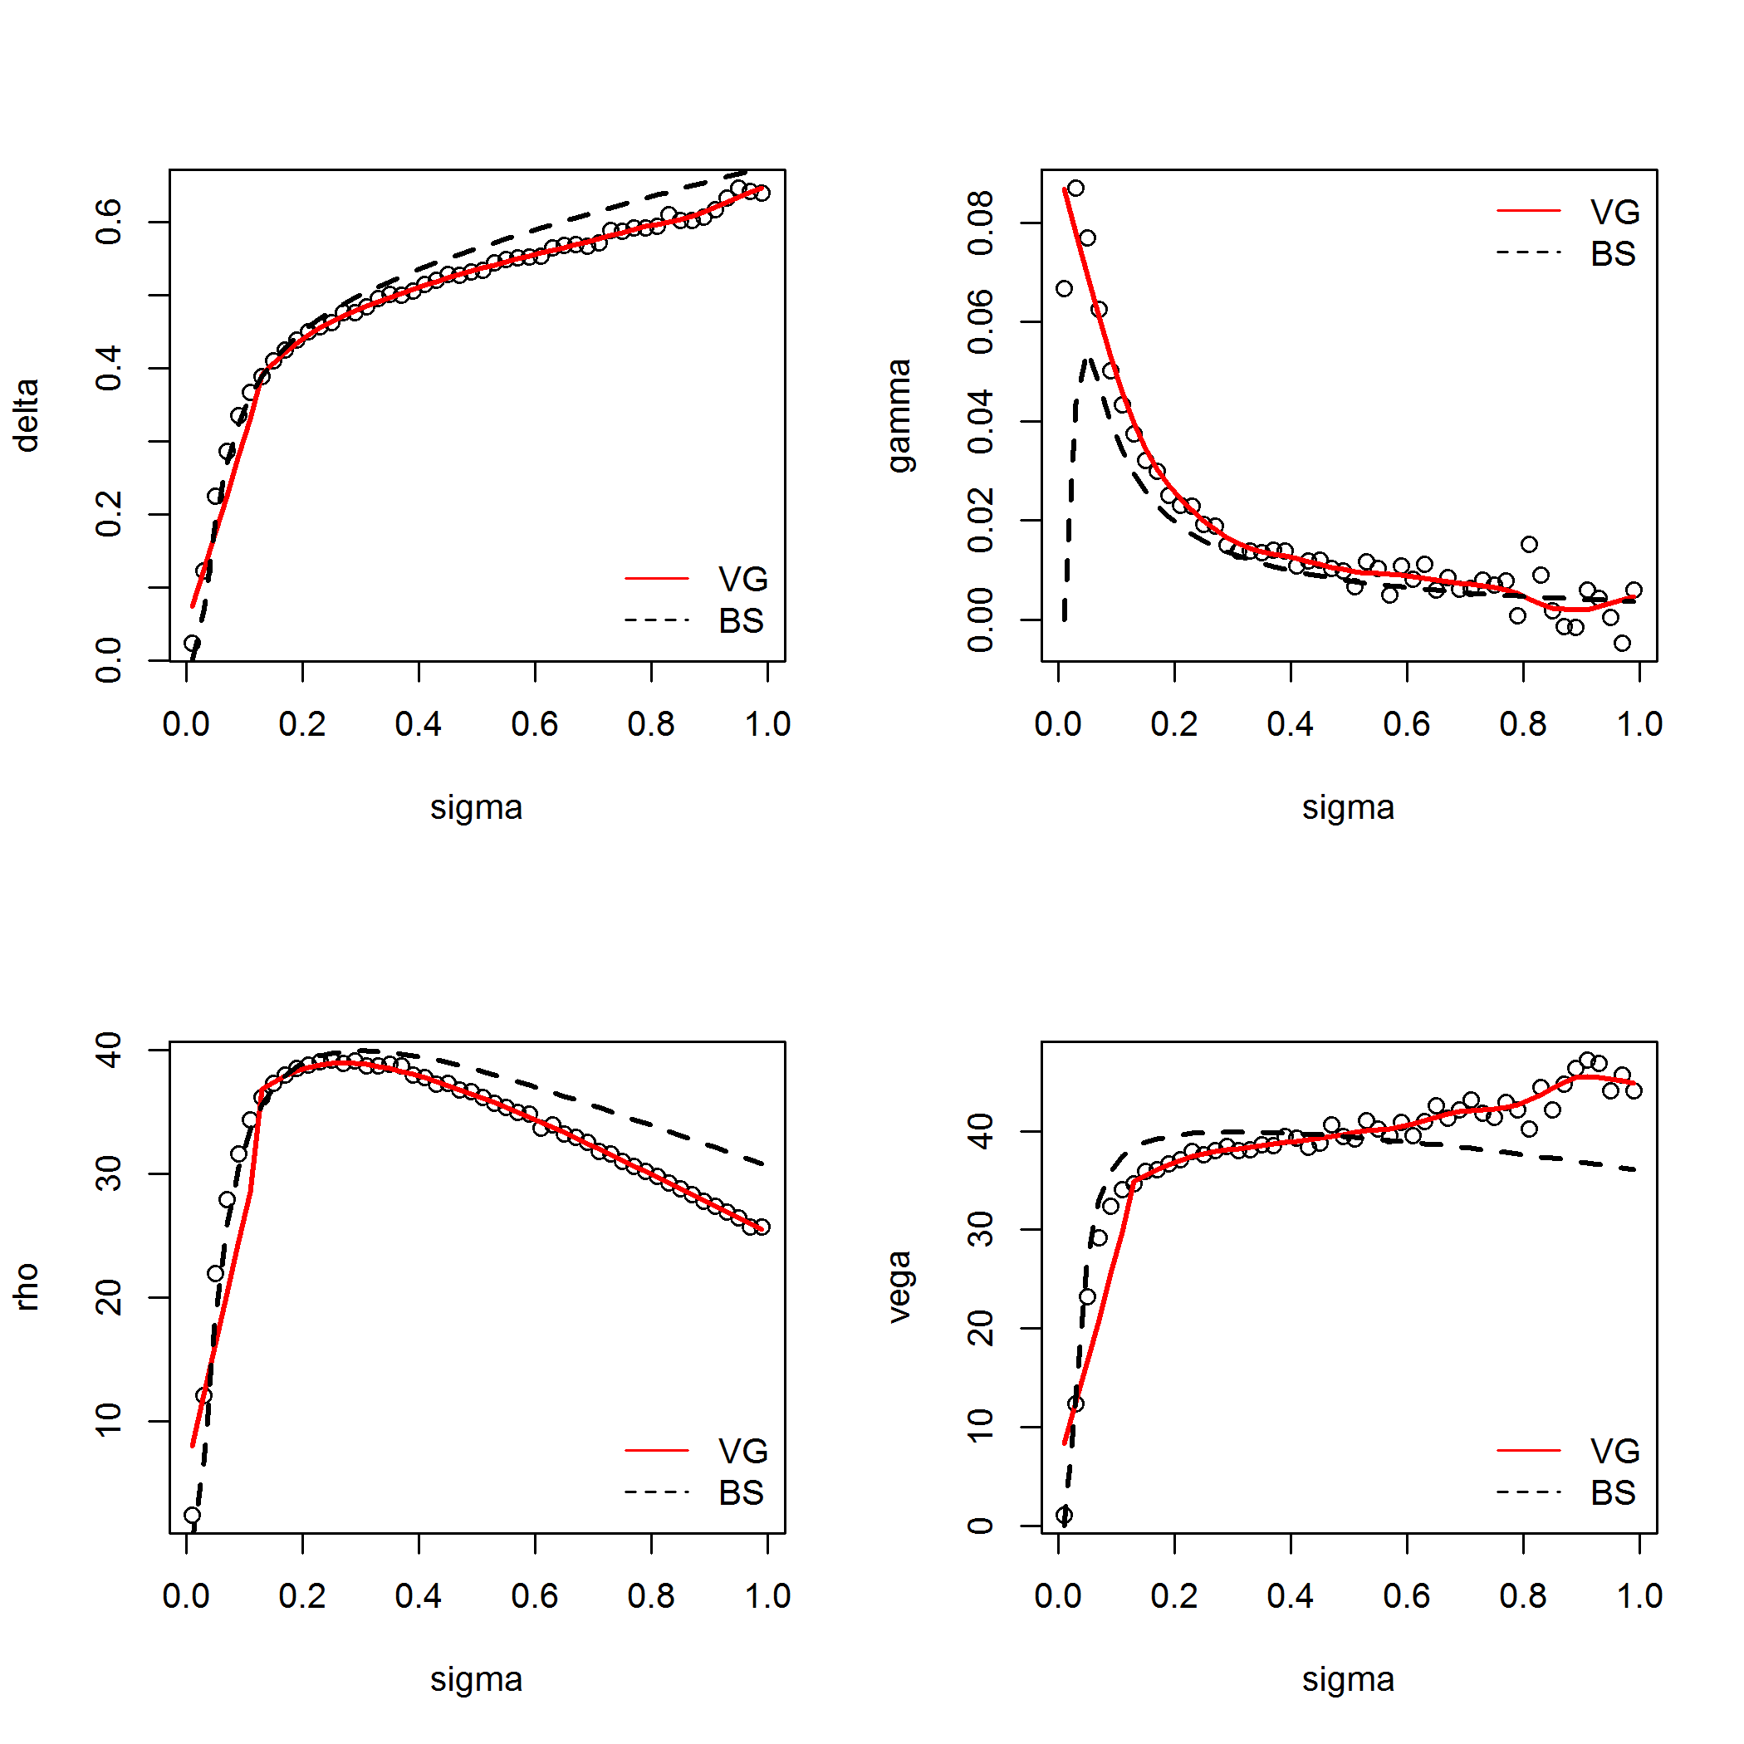

The following table shows the results for calculating Greeks using finite difference Monte Carlo, IPA and Fourier transform methods. We see that our IPA estimates are close to the Fourier estimates and finite difference estimates except for Gamma. In case of Gamma we see a high standard error and that is expected as we did not calculate an optimal step size for Gamma. Standard errors of finite difference method are higher than pathwise method. Therefore, pathwise derivative performs better than finite difference.

|  |  |  |
| --- | --- | --- |
|  | **European Call Greek Value** | **Standard Error** |
| **Delta diff** | 0.47934777 | 0.03566071 |
| **Delta pathwise** | 0.465494395 | 0.001945311 |
| **Delta Fourier** | 0.4653853 | NA |
| **Gamma diff** | 0.09000361 | 0.12400942 |
| **Gamma pathwise** | 0.018325135 | 0.001374918 |
| **Gamma Fourier** | 0.01978011 | NA |
| **Rho diff** | 39.6033748 | 0.3656007 |
| **Rho pathwise** | 38.9640694 | 0.1599638 |
| **Rho Fourier** | 39.13612 | NA |

# **References**

1. Madan, Dilip B.; Seneta, Eugene (1990). "The Variance Gamma (V.G.) Model for Share Market Returns". [Journal of Business](http://en.wikipedia.org/wiki/Journal_of_Business) 63 (4): 511–524
2. Fu, MichaelC. "Variance-Gamma and Monte Carlo." In Advances in Mathematical Finance, edited by MichaelC Fu, RobertA Jarrow, Ju-YiJ Yen and RobertJ Elliott, 21-34: Birkhäuser Boston, 2007.
3. Dilip Madan, Peter Carr, Eric Chang (1998). ["The Variance Gamma Process and Option Pricing"](http://www.math.nyu.edu/research/carrp/papers/pdf/VGEFRpub.pdf). European FinanceReview 2: 79–105
4. Carr, P., and Madan, D. (1999). "Option valuation using the fast Fourier transform", The Journal of Computational Finance 2(4), 61–73
5. Fusai G, Meucci, A. (2008), “Pricing Discretely Monitored Asian Options under Levy Processes”, Journal of Banking and Finance, 32(10), p.2076-2088