Avs to Jvs Conversion

# Prerequisite Softwares

Below is the prerequisite software which need to installed

* Microsoft SQL Server.
* Microsoft Office -Excel

# About

Conversion tool is designed to convert the AVS script file into JVS Format. Through this tool you can convert multiple AVS script files into JVS scripts in one go. AVS File extension should be “\***.mls”** and it will convert into **“*.java”** file.

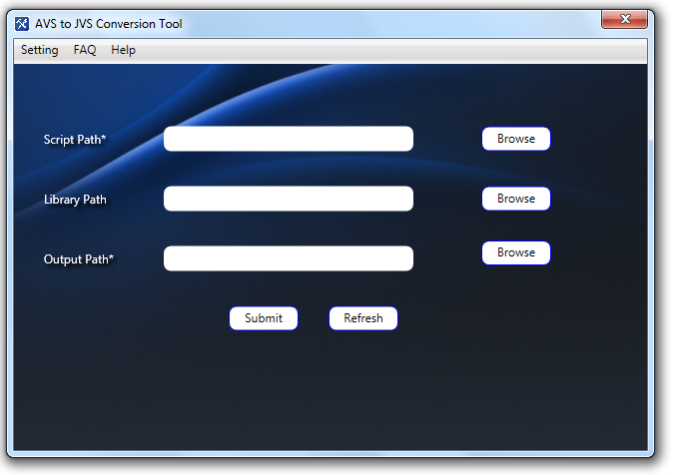

# Inputs

Following Input need to be provide by user.

**Script Path:** User have to provide the AVS Script folder location where All AVS (*.mls) files are placed.

**Library Path:** That is optional but mandate if they are getting called inside plugin.

**Output Path:** User have to provide the Output path location where data will be dump after conversion.

When you provide inputs and click on submit button it will show the progress till conversation not done. At last it will show count of number of files success or failure.

# Settings

User can able to change the setting of Conversation tool. Below things can user do through this setting page.

* User can change the database connection by provide server name and database name. server name will SQL Server instance and database name from which you want to connect.
* User can provide the excel file path and that excel will be used by tool for conversion or get the Enum values.
* User can provide the path log file where generated log will be dump incase exception occur while tool conversion.

**Format of Connection:**

**“**connection String="Data Source=” **Server Name**”; Initial Catalog=” **Database Name**”; Integrated Security=true;" provider Name="System. Data. SqlClient"**”**

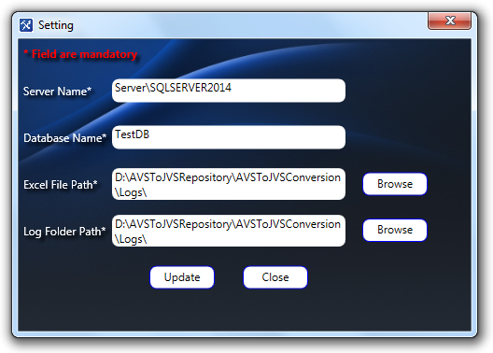

# Inputs

Following Input need to be provide by user.

**Server Name:** User have to provide the name of SQL server instance name.

**Database Name**: Name of the database where provided DB script has been executed.

**Excel Path:** Excel path will be that location where excel has been placed for application access.

**Log Path:** That location will be used to dump the log files with conversion status.

# FAQ

It will show what type of compilation error you will see in the converted JVS code and how you can rectify them manually.

# help

It will guide you following things

* How to operate conversation Tool?
* How to handle the setting page?
* What type of data will be accept as input and what will be the output?