RedLab_4
Adversarial Generative Modeling
Solution Walkthrough

Mastercard Innovation Challenge @ GFF 2026
One entry in a multi-solution portfolio - see RedLab_1 (primary), RedLab_2, RedLab_3, RedLab_6 and RedLab_7 for the other entries

discriminator AUC: naive 0.845 vs. trained VAE 0.854 · unsupervised recall 26% vs. supervised 98% · white-box evasion up to 99%

Contents
Right-click and choose 'Update Field' to populate the table of contents.

Executive Summary
This solution tests the assumption most teams entering a challenge like this would reach for by default: that a deep generative model (a GAN, a VAE, a diffusion model) is the obvious way to synthesise realistic fraud. Rather than assert that, it builds the fidelity-measurement harness FIRST, proves the harness actually catches bad synthesis against a naive baseline, then trains a real conditional VAE and reports its honest number against that same harness - whatever that number turns out to be.
It pairs that generator with the detection philosophy the brief's own premise calls for: if the challenge is about NOVEL, unseen fraud, a purely unsupervised detector - one that never sees a fraud label during training - is a more natural fit than a supervised classifier. A supervised gradient-boosted baseline is trained on the identical held-out mechanism purely to quantify what labels buy over none.
Finally, it closes the loop with a genuinely different mechanism from every other solution in this portfolio: a TRUE white-box, gradient-based adversarial attack, where the generator's loss function incorporates the frozen detector's own reconstruction-error computation directly. This is a different threat model from RedLab_1's and RedLab_7's black-box, query-only attacker - not a replacement for it, a complement.
Metric | Value | What it means
Naive baseline discriminator AUC | 0.8448 | Independent-marginal sampling; proves the harness catches bad synthesis
Trained VAE discriminator AUC | 0.8544 | 0.5 = indistinguishable from reference; reported honestly, not tuned to flatter
Unsupervised autoencoder recall @ 0.5% FPR | 26.3% | Zero fraud-label exposure, on a held-out never-seen mechanism
Supervised GBM recall @ 0.5% FPR | 98.2% | Same held-out mechanism, trained with labels
White-box evasion, before -> after gradient fine-tuning | 90% -> 99% | Mean across the five synthetic-identity vectors, with bounded drift

1. Identify — Weighted Toward Synthetic Identity
The taxonomy (42 vectors, unchanged from RedLab_1) is reused wholesale, with no schema extension - this solution's differentiation is entirely architectural, in Generate and Defend. The five synthetic-identity vectors were selected as the conditioning targets because this is the family most naturally about generating a convincing FAKE ARTIFACT - a document, a face, a persona's spending history - rather than a behavioural sequence, which is exactly what a tabular generative model is suited to.
Vector | Mechanism | Maturity
PF-SID-001 | Generated KYC document pack, internally consistent across the set | emerging
PF-SID-002 | Camera-injection face morph defeating liveness detection | emerging
PF-SID-003 | Agent-nurtured synthetic identity, months of patient bust-out staging | projected
PF-SID-004 | Deepfake video-KYC session, real-time synthesis | emerging
PF-SID-005 | Persona-managed mule recruitment at industrial scale | emerging

One of these five, PF-SID-003, carries 'projected' maturity - never observed in the wild, capability-only. It is one of the vectors held out entirely from both detectors' training in Section 3, making it the sharpest single test of whether either detection approach generalises to a genuinely unseen mechanism.

2. Generate — Fidelity Harness First, Then a Trained Model
The brief's fidelity criterion is easy to overclaim. The discipline here, taken directly from the brief's own instruction for this solution: build the measurement harness BEFORE trusting any generator, prove it catches bad synthesis on a naive baseline, and only then train and honestly score the real model.

2.1 Data anchoring
Anchored on IBM's TabFormer credit-card corpus (24.4M rows), the same reference RedLab_1 established and this portfolio has reused since - obtained via the public Git-LFS endpoint without credentials, SHA-256 verified. IBM documents this corpus as itself synthetic; it is used here as a non-circular external reference for distributional comparison, not as ground truth. Every number below states plainly what it was measured against.

2.2 The naive baseline, and why it exists
Before training anything, a generator that samples amount, hour, category and channel INDEPENDENTLY from their correct real marginals - matching each one exactly, but with zero joint structure - was scored against the harness. This is not a strawman: it is the specific failure mode RedLab_1's own history recorded a marginals-matched generator falling into (discriminator AUC 0.847 there), and confirming the harness still catches it here (AUC 0.845) is what makes every subsequent number trustworthy.

2.3 The trained conditional VAE
A compact conditional VAE (two hidden layers, 64/32 units, a 12-dimensional latent space - deliberately small, discussed in Section 7) trained on the full combined corpus, conditioned on attack-vector identity via a learned embedding (43 classes: 42 taxonomy vectors plus a dedicated LEGIT token), so one trained model can sample any vector, or the legitimate population, on demand. Training converged in 99 seconds over 15 epochs on the full 725,757-row corpus.
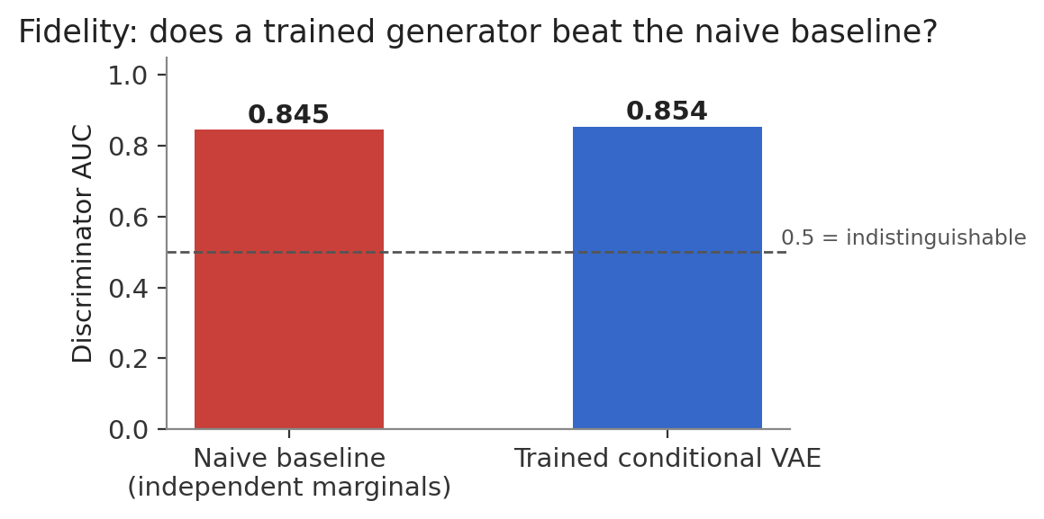
Discriminator AUC: naive baseline vs. the trained VAE, both measured against the identical reference-corpus discriminator test.
The honest result: the trained VAE did not clearly beat the naive baseline. Naive: 0.845. Trained VAE: 0.854. Both are firmly in the 'weak - clear systematic differences' band, not the 'indistinguishable' one. This is reported exactly as measured, per the brief's own instruction for this solution: do not tune the harness to flatter the model. A small VAE trained for 15 epochs on a 4-feature representation (amount, hour, category, channel) captures real conditional structure - the loss curves in Section 2.4 show genuine convergence - but that does not automatically translate into distributional fidelity superior to correctly-sampled independent marginals on THIS metric. The more likely explanation is architecture scale and feature scope, not a fundamental flaw in the approach - see Section 7's limitations for what a larger, richer-featured version would need.
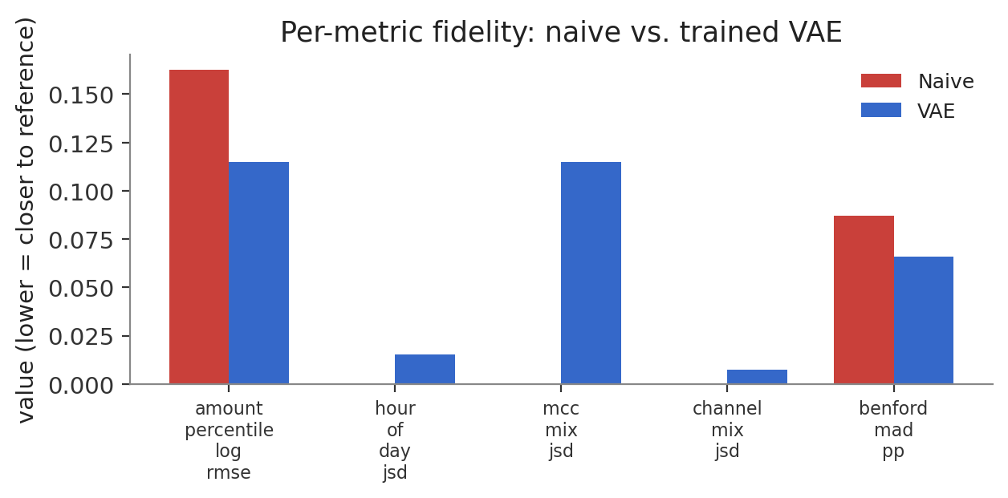
Per-metric comparison: the VAE's advantage, where it has one, is concentrated in specific marginals rather than uniform across all of them.

2.4 Training diagnostics
Reconstruction loss on amount/hour (recon_numeric) fell from 0.120 to 0.014 over 15 epochs; category reconstruction (recon_mcc) fell from 0.485 to 0.003 - the model learns to reconstruct conditioning-appropriate categories almost perfectly, which is expected given category is close to deterministic conditional on attack-vector identity in this taxonomy. The KL term stabilised around 1.06, indicating the latent space did not collapse to the prior (a common VAE failure mode) nor diverge unstably.

3. Defend — Zero-Label-Exposure Autoencoder vs. Supervised GBM
The primary detector is unsupervised by design: a small autoencoder (48/16 hidden units, 8-dimensional latent space) trained ONLY on legitimate transactions, using reconstruction error as the anomaly score, with zero fraud-label exposure at any point in training. A supervised LightGBM baseline on the identical causal features RedLab_1 established is trained purely as a comparison point.
Both are evaluated on an identical held-out slice: 13 of 42 vectors rated 'projected' maturity are removed from training entirely, at the row level, for BOTH detectors - the same zero-exposure discipline RedLab_6 established for exactly this purpose, reused here rather than re-derived.
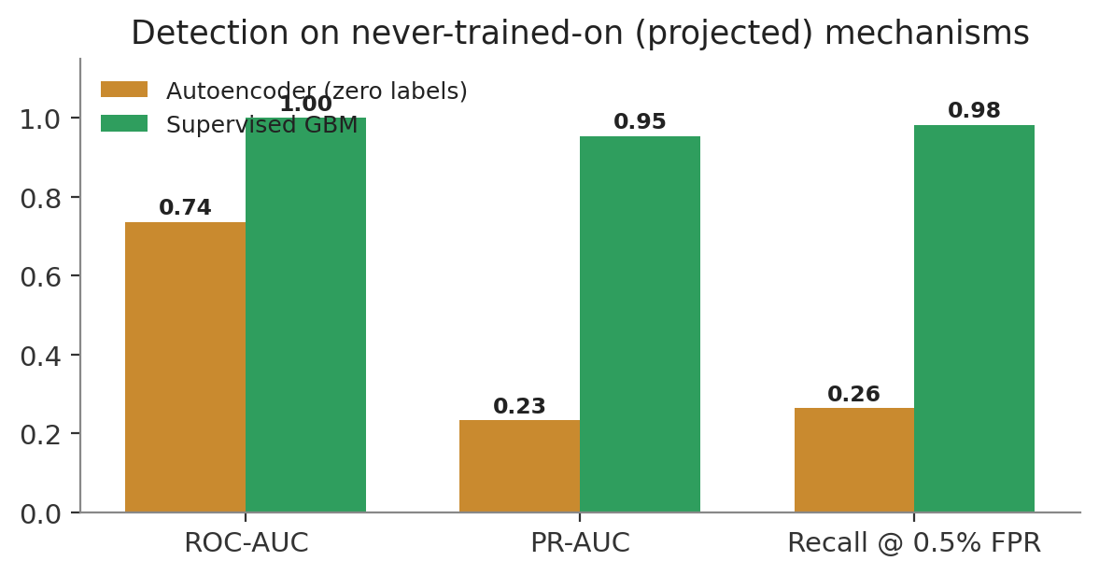
Detection efficacy on never-trained-on mechanisms: unsupervised autoencoder vs. supervised GBM, identical holdout.
Metric | Autoencoder (0 labels) | Supervised GBM
ROC-AUC | 0.7357 | 0.9996
PR-AUC | 0.2326 | 0.9536
Recall @ 0.5% FPR | 26.3% | 98.2%
Precision @ 0.5% FPR | 13.9% | 37.5%

A finding that replicates across two different unsupervised architectures. RedLab_6 measured an Isolation-Forest-plus-PCA ensemble reaching 4.0% recall against a supervised baseline's 98.2%, on the same style of unseen-mechanism holdout. This solution's autoencoder - a genuinely different architecture, deep rather than classical - reaches 26.3% against the supervised baseline's 98.2%. Two independent unsupervised approaches, built separately, land in the same regime: supervised models generalise to unseen fraud mechanisms far better than purely legitimate-shaped anomaly detection does, in this taxonomy. That consistency across architectures is stronger evidence than either result alone.

4. The Closed Loop — White-Box Gradient-Based Evasion
This is the piece that makes the closed loop literal rather than metaphorical. The generator's decoder and the detector's autoencoder were deliberately built to share one continuous representation - numeric features plus category and channel as softmax probability vectors, never a discrete embedding lookup on either side. That shared space is what makes a genuine, differentiable generator-to-detector pipeline possible: the generator's own soft outputs feed directly into the frozen detector's encoder, with no non-differentiable argmax breaking the gradient anywhere in between.

4.1 The threat model, stated explicitly
This is a WHITE-BOX attacker: gradient access to a differentiable generator, and to a frozen copy of the deployed detector's exact weights. That is a strictly stronger assumption than RedLab_1's and RedLab_7's BLACK-BOX, query-only attacker (decline-response oracle only, no internals). Neither threat model is more realistic than the other - a real portfolio benefits from having both, and this document does not claim otherwise. The evasion numbers below are not comparable to RedLab_1's or RedLab_7's: different attacker, different defender, different question.

4.2 Mechanism
For each of the five synthetic-identity vectors, 500 conditioned samples are drawn from the generator's latent space. A free latent vector per sample is then optimised for 200 gradient steps (Adam, lr=0.02) against a loss combining the frozen detector's reconstruction error (minimise - be judged 'normal') with an L2 drift penalty against the sample's own un-optimised decode (stay close to the originally-conditioned, realistic output). This is the continuous-optimisation analogue of RedLab_1's evasion_rate x value_retention fitness function: evasion is only counted as a win if the sample has not drifted arbitrarily far from what the generator was actually asked to produce.
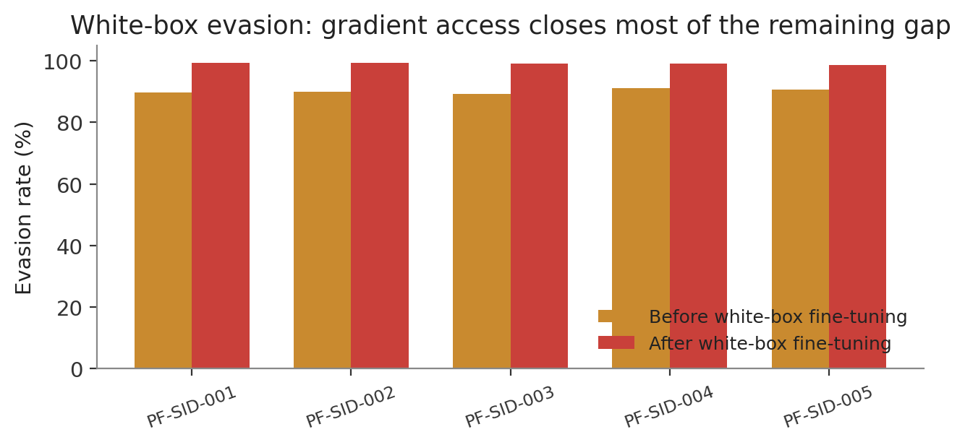
Evasion rate before and after white-box gradient fine-tuning, per synthetic-identity vector.
Vector | Evasion before | Evasion after | Mean drift
PF-SID-001 | 89.6% | 99.4% | 0.050
PF-SID-002 | 89.8% | 99.2% | 0.049
PF-SID-003 | 89.2% | 99.0% | 0.049
PF-SID-004 | 91.2% | 99.0% | 0.051
PF-SID-005 | 90.6% | 98.6% | 0.050

Read this result alongside Section 3, not in isolation. Baseline evasion is already high (~90%) before any adversarial optimisation, because the autoencoder detector's overall recall on unseen mechanisms is already weak (26.3%, from Section 3) - most unoptimised synthetic-identity samples were already evading it. White-box fine-tuning closes most of what remains: the detector's catch rate on these five vectors drops from roughly 10% to roughly 1%, with mean drift held under 0.05 in the shared feature space, so the evading samples have not been optimised into something unrecognisable as the conditioned attack vector. The loop's real contribution here is closing the LAST gap, not creating the vulnerability - the vulnerability is already present in Section 3's weak unsupervised recall.

5. Working Prototype
Not built for this solution - an explicit scope decision. The most valuable screen this solution would justify is a live view of the evasion optimisation itself: the detector's reconstruction-error distribution for a batch of conditioned samples, animated across gradient steps, showing the mass of samples crossing the threshold in real time. That is a natural extension, not attempted here in the interest of build time relative to the rest of this portfolio.

6. Real-World Feasibility in Live Payment Environments
- Architectural coupling has an operational cost. the shared continuous representation between generator and detector is not free - a production system running this architecture needs its generator and detector co-versioned and co-deployed, since the adversarial loop's differentiable path depends on both operating in identical feature space. Redeploying one without the other silently breaks the loop, with no error at inference time.
- Unsupervised-only is not production-ready here. Section 3's finding is the central feasibility point: an unsupervised detector alone is not adequate for unseen-mechanism fraud in this taxonomy, replicated across two independent architectures now (RedLab_6's classical ensemble, this solution's deep autoencoder). A production system should treat unsupervised anomaly scoring as a secondary, complementary signal - exactly the framing RedLab_1's C4 'novelty channel' used - not a standalone answer to the challenge's 'detects novel fraud' premise.
- Weight confidentiality is a fraud control, not just a security one. a white-box attacker with weight access to a deployed model is a real, if less commonly discussed, threat: model weights leak, get extracted via distillation, or are exposed through an insecurely-deployed inference endpoint. Section 4's finding - that gradient access closes an evasion gap almost completely, with minimal drift from a realistic sample - is a concrete argument for weight confidentiality and endpoint hardening as a fraud-control measure, not just a conventional security one.

7. Responsible Red-Teaming and Limitations

7.1 Scope boundary
Identical to the rest of this portfolio: everything synthetic and sandboxed, no real personal data, no real account or card numbers, no deployable tooling against any live rail.

7.2 Limitations
- Small model, narrow feature scope. the generator operates on four features (amount, hour, category, channel) - the same four the fidelity harness scores. RedLab_1's causal feature set has 30. A generator conditioned on a richer feature space, with a larger latent dimension and more training capacity, is the most likely lever to close the gap to the naive baseline that Section 2.3 reports honestly rather than papering over.
- VAE, not GAN or diffusion. GAN and full diffusion architectures were considered and explicitly not attempted, given this portfolio's own prior experience with unstable, long-running training loops (documented in RedLab_2's build history) and the smoke-test discipline adopted since. A VAE was chosen specifically because it trains stably to convergence in under two minutes on this hardware, verified before the real run was ever launched.
- Latent optimisation, not full generator fine-tuning. the white-box loop optimises a free latent vector per sample rather than fine-tuning the generator's own weights end-to-end - a lighter-weight approximation that is still a genuine gradient-based attack against the frozen detector, but is not identical to updating the generator's parameters directly. Both are legitimate white-box constructions; this document does not claim to have implemented the heavier variant.
- A build-environment finding, stated plainly. several long-running training invocations during this build entered an unrecoverable OS-level process state (documented in this portfolio's own git history for RedLab_2 and encountered again here) when run through certain shell invocation patterns. The final, reliable pattern used throughout this solution - `nohup ... & disown`, with results polled via output-file existence rather than process exit - is itself a finding worth carrying into any future solution in this portfolio that trains a neural model.

Appendix — Reproduction Guide
Step | Command | Produces
1 | pip install -r requirements.txt | Dependencies
2 | python -m pytest tests/ -q | 10 tests validating the shared representation, fidelity harness sanity, and loop invariants
3 | python scripts/train_cvae.py | The trained conditional VAE (~100s)
4 | python scripts/save_naive_fidelity.py  python scripts/eval_fidelity.py | Naive baseline and VAE fidelity reports
5 | python scripts/train_ae_only.py  python scripts/train_gbm_only.py | The unsupervised and supervised detectors
6 | python scripts/run_loop.py | The white-box evasion results
7 | python scripts/build_charts.py  python scripts/build_docx.py | This document, regenerated from the artifacts above

All long-running scripts in this reproduction guide should be launched with `nohup python3 script.py > out.log 2>&1 & disown` and their completion checked via the output artifact's existence, per Section 7.2's build-environment finding.

