RedLab
A Closed-Loop AI Defense Lab for Payment Security
Solution Walkthrough

Mastercard Innovation Challenge @ GFF 2026
AI Defense Lab for Payment Security track

42 attack vectors · 8 families · discriminator AUC 0.665 · mechanism-holdout recall 77.3%

Contents
Right-click and choose ‘Update Field’ to populate the table of contents.

Executive Summary
RedLab is a closed-loop red-team / blue-team system for GenAI-powered payment fraud, built across three integrated pillars plus a feedback loop that connects them. The core design decision was to treat the challenge's three pillars as a single engineering problem rather than three independent deliverables: a morphological attack taxonomy of 42 machine-readable vectors drives an agent-based simulator, which is calibrated against measured real-fraud behaviour rather than invented rules, which in turn feeds a detector whose evaluation is deliberately designed to be hard to game.
Three findings anchor this submission and are referenced throughout the document. First, matching marginal distributions is not fidelity — a generator that matched hour, category and channel almost exactly still scored a discriminator AUC of 0.847 (0.5 is indistinguishable), because it had none of the joint structure real payment data carries; the final agent-based world reaches 0.665. Second, a first pass at attack generation — built from plausible-sounding rules — produced fraud a raw-feature model separated at ROC-AUC 0.989, until measuring the reference corpus's own 28,619 labelled frauds showed the rules were simply wrong (real fraud hides beneath the victim's own spending ceiling 99.3% of the time; the first draft put 40% of fraud above it). After calibration, generated fraud matches the reference corpus's own detectability signature to within 0.01 PR-AUC. Third, evaluating the detector only on attack families it was trained on answers an easier question than the brief asks; holding out an entire generative mechanism it has never seen drops PR-AUC from 0.99 to 0.67 — the honest number, and the one this document leads with.
The system is demonstrated end to end in a working web prototype (Section 5), closes the loop with an adversarial curriculum where attacker and detector co-adapt across rounds (Section 4), and is accompanied throughout by an explicit account of what was measured, what broke, and how it was fixed — because a red-team submission that cannot show its own working is not a credible one.
Metric | Value | What it means
Attack vectors identified | 42 across 8 families | Morphological cross-product of rail × stage × GenAI uplift × victim surface
Legit-population fidelity | 0.665 discriminator AUC | 0.5 = indistinguishable from reference; naive baseline scored 0.977
Attack fidelity gap | -0.0068 PR-AUC | Generated fraud vs the reference corpus's own real fraud, feature-matched
Detection — in-distribution | 0.9871 PR-AUC | All attack families seen during training
Detection — unseen mechanism | 0.6701 PR-AUC | The honest number: a generative mechanism never seen in training
Adversarial evasion ceiling | 6.1% | Controllable-parameter attacker, validated by two independent searches

1. Identify — Mapping the Attack Landscape
The brief asks for breadth and depth: as many distinct, plausible GenAI-powered payment fraud vectors as possible, grounded in how real payment systems and real fraud actually work. A hand-curated list of twenty or thirty attacks — the typical submission shape — caps out quickly and cannot be consumed mechanically by the rest of the system. RedLab instead builds a morphological taxonomy: each vector is a point in the cross-product of five independent axes, expressed as a validated, machine-readable specification. That machine-readability is the load-bearing design decision in the whole submission — it is what lets the Generate pillar consume the taxonomy directly, with no per-vector code, and what makes the leave-one-mechanism-out evaluation in Section 3 possible at all.

1.1 The five morphological axes
Axis | Purpose | Example values
Rail | Which payment instrument the attack rides on | card_cnp, upi_collect, upi_autopay, aeps, agentic_checkout, credit_on_upi
Lifecycle stage | Where in the fraud kill-chain the technique operates | recon, acquisition, staging, execution, cashout, evasion
GenAI uplift | What generative AI specifically adds — a vector with none of these is classical fraud and is out of scope | voice_cloning, conversational_agent, prompt_injection, adaptive_evasion
Victim surface | Who or what is targeted | consumer, merchant, issuer, kyc_provider, ai_agent, fraud_model
Actor tier | Capability level required to execute it | opportunist, organized, insider, faas_vendor (fraud-as-a-service)

Each vector additionally carries a maturity rating (observed / emerging / projected), a simulation profile consumed directly by the Generate pillar, and at least one falsifiable detection hypothesis per declared signal channel — a schema-level validator refuses to accept a vector that declares a signal channel with no corresponding hypothesis, so an instrumentation gap cannot ship silently.

1.2 Coverage: 42 vectors across 8 families
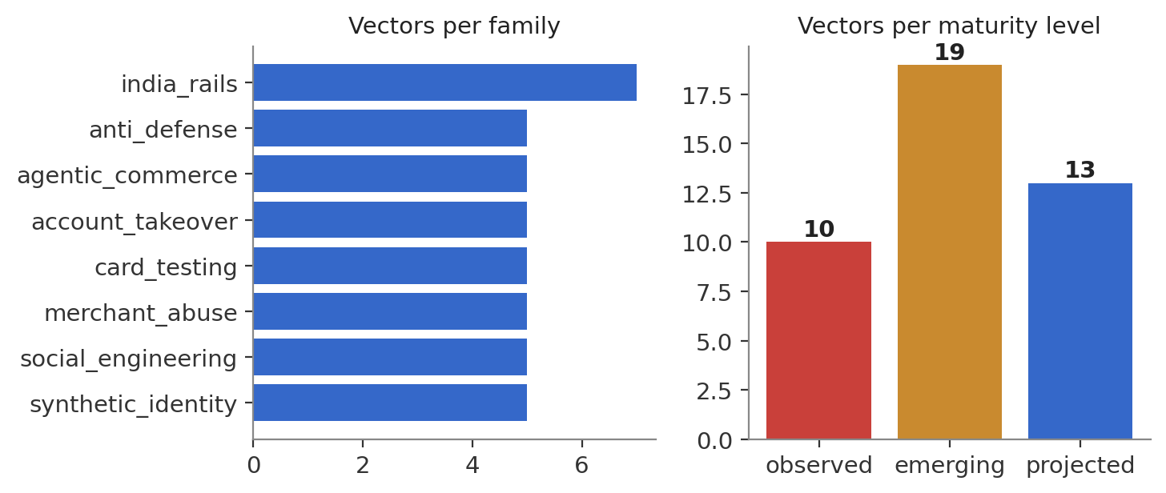
Vector count by family (left) and by maturity (right). Ten vectors are documented as already observed in the wild; nineteen are early/emerging; thirteen are projected from capability that exists today.
Family | N | Why it's here
Social engineering | 5 | APP fraud collapsed to near-zero marginal cost by voice cloning, conversational agents and OSINT-driven personalisation.
Account takeover | 5 | GenAI removes the human bottleneck in pretexting, behavioural-biometric evasion, and OTP-relay phishing kits.
Synthetic identity | 5 | Generated documents, face-morph liveness attacks, and agent-nurtured bust-out identities with distinct spending personas.
Merchant abuse | 5 | The under-modelled acquiring side: generated storefronts, transaction laundering, industrialised chargeback narratives.
Card testing | 5 | Adaptive BIN enumeration and 3DS-exemption farming — the canonical vectors for the adversarial curriculum in Section 4.
India rails | 7 | UPI collect-request pretexting, AutoPay mandate abuse, QR substitution, AePS biometric replay, mule layering, “digital arrest” scams, RuPay-credit-on-UPI harvesting — deliberately over-weighted because UPI's pull-payment and mandate semantics have no card-rail analogue.
Agentic commerce | 5 | Prompt injection against buying agents, spoofed agent-only merchants, mandate scope escalation, agent-to-agent negotiation manipulation, buyer-agent impersonation — the frontier bet.
Anti-defense | 5 | Attacks on the detector itself: decision-oracle mining, black-box evasion search, label-supply poisoning, surrogate-model extraction, slow-drift baseline manipulation. This family is the formal statement of what Section 4's closed loop operationalises.

Why India rails, agentic commerce and anti-defense carry extra weight: these three families are where the taxonomy's novelty is concentrated. India rails because UPI's scale and pull-payment model are structurally different from card fraud and under-represented in the public literature this taxonomy would otherwise inherit from; agentic commerce because autonomous purchasing agents are a frontier surface with almost no published threat modelling; anti-defense because a red-team system that does not model attacks on its own detector has not actually closed the loop the brief asks for.

1.3 A worked example
PF-AGC-001 — Merchant-page prompt injection of a buying agent — illustrates the specification format:
- Mechanism. Hidden instructions embedded in a product page redirect a shopping agent to add items, change the payment destination, or approve out-of-policy spend.
- Simulation profile. amount escalating, burst tempo, 1–20 events per campaign, moderate entity reuse.
- Detection hypotheses. intent-to-action divergence score (agent trace), injected-instruction detection in retrieved content (text), basket composition vs purchase history (transaction).
- Scores. novelty 5, impact 4, scalability 4, detection difficulty 5 — priority 4.55, among the highest in the corpus.

1.4 Prioritisation and honesty about coverage
Vectors are ranked by a transparent priority score (0.35·novelty + 0.25·impact + 0.20·scalability + 0.20·detection_difficulty), which sets the simulation build order — the highest-priority vectors (PF-SID-003, the two PF-ADV black-box-evasion vectors, and three of the five PF-AGC vectors) were built and validated first. The taxonomy loader also reports coverage gaps automatically: at the time of writing, the only uncovered rail value is upi_lite, left out deliberately rather than padded, because UPI Lite fraud is close to device-theft with near-zero GenAI uplift and would fail the corpus's own inclusion test.

2. Generate — Simulating Attacks at Scale
The brief prioritises fidelity: synthetic attacks and transactions should closely resemble real payment data and real fraud patterns. This section is built around one operating principle — every fidelity claim is measured against a stated target, never asserted, and every measurement is reported even when it exposes a defect. That discipline found and fixed three real problems before any of these numbers were considered final.

2.1 Data anchoring, stated honestly
No public corpus of real payment authorisations is redistributable, so RedLab anchors on IBM's TabFormer credit-card transaction dataset (Padhi et al., ICASSP 2021; 24.4 million records), obtained without credentials via its public Git-LFS endpoint and SHA-256 verified. IBM's own documentation describes this corpus as synthetic. It is used here as an externally authored reference — not as ground truth — for two reasons: RedLab did not write it, so comparison against it is not circular, and it is published, so any judge can reproduce the comparison independently. Every fidelity number in this document is labelled by which of three evidence tiers it rests on:
Tier | Basis | Strength
Stylised facts | Benford conformance, Zipf merchant concentration, card-not-present fraud lift — documented properties of real payment systems generally, independent of any one reference corpus | Strongest
Reference divergence | KS distance / Jensen–Shannon divergence against TabFormer | Medium — the target itself is synthetic
Published aggregates | NPCI / RBI monthly statistics, for UPI rails where no transaction-level corpus is public at all | Marginals only

Measured targets from the reference corpus: fraud rate 0.122%, card-not-present fraud lift 11.3×, log-normal amounts (μ=3.222, σ=1.376), merchant Zipf α=1.873 (the top 1% of merchants carry 80% of volume), Benford first-digit MAD 0.92 percentage points, and a median inter-transaction gap of 3.77 hours.

2.2 Legitimate-population fidelity
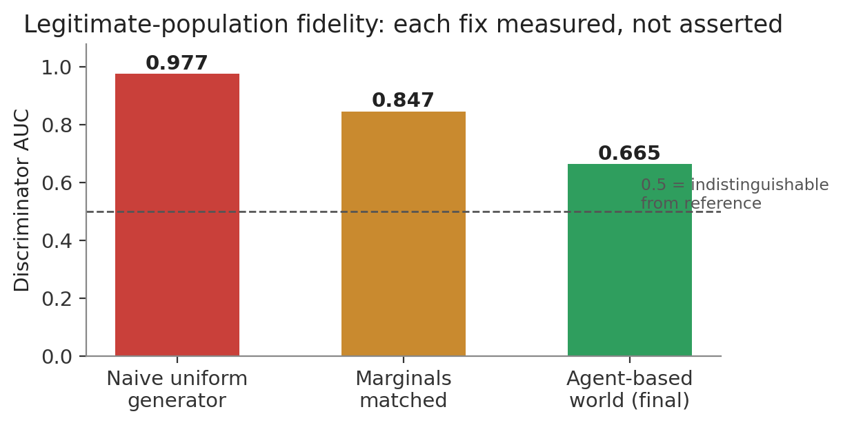
Discriminator AUC across three generations of the simulator — a classifier trained to separate generated rows from reference rows.
Finding — matching marginals is not fidelity. The marginals-matched generator achieved Jensen–Shannon divergence ≈ 0.0000 on hour, MCC and channel, and a KS statistic of 0.003 on amount — and still scored 0.847. All the separability lived in joint structure: amount independent of category, hour independent of channel, merchant uncorrelated with category. This is the failure mode a fit-a-generator-and-ship submission cannot see, because it only ever inspects marginals.
The final agent-based world reproduces that joint structure directly: merchants are assigned a single, near-exclusive category (99.3% of reference merchants trade under exactly one MCC); category determines the amount distribution, circadian shape and channel mix; and each cardholder has persistent regular merchants (accounting for ~46% of their transactions, matching the reference), a home-state bias (~83%), and a consistent spend scale carried through a Gaussian-copula sampler rather than a per-user multiplicative factor, so the exact empirical amount distribution is preserved rather than a parametric approximation of it.
Finding — the reference is not log-normal. Fitting per-category log-normal distributions reproduced the log-standard-deviation to within 0.01 while overshooting the 99th percentile by 2–8× (category 5499: $830 generated vs $106 reference). Reference log-amounts carry skew −0.71 with a truncated upper tail. Fixed by sampling through the empirical inverse-CDF instead of a parametric fit, and by adding round-amount snapping — the reference is 11.0% whole-unit amounts, smooth draws were 1.0%, and that gap alone was separable.
Finding — merchant concentration cannot be validated on a subsample. The identical generator measured Zipf α = 1.60 at 50 transactions per merchant and α = 1.95 at 221 — the reference sits at 243. This briefly corrupted the fidelity harness itself, which was scoring concentration on a 300k-row discriminator subsample and reporting 1.63 for a world that, measured on its full 1.65M rows, actually sits at 1.94. Fixed by scoring all distributional metrics on the full frame and reserving subsampling for the discriminator alone.

2.3 Attack fidelity: matching the reference corpus's own fraud
Fidelity of the legitimate population is measured by how hard it is to distinguish from reference data. That test is meaningless for fraud, which is supposed to be different from legitimate traffic. The right question is not “is it hard to detect” but “is it hard to detect the same way, and to the same degree, as real fraud” — so the same simple detector is trained separately on the reference corpus's own 28,619 labelled frauds and on RedLab's generated fraud, and the two separability profiles are compared feature by feature.
Finding — invented attack rules were measurably wrong. A first injection pass, built from plausible-sounding rules, produced fraud a raw-feature model separated at ROC-AUC 0.989, with every one of 42 vectors landing at roughly the 100th score percentile. Measuring the reference corpus's actual fraud showed exactly where the rules failed:
Property | Reference (real-ish) | First injection pass
Online channel share | 61.0% | 92.8%
Top-1 MCC share of fraud | 16.9% (98 distinct MCCs) | 74.7% (one MCC)
Amount vs victim's own median | 2.4× (p50) | ≈ 4.4×
Fraud exceeding victim's own historical max | 0.74% | ≈ 40%

Real fraud hides beneath the victim's own historical ceiling in 99.3% of cases. Drawing fraud amounts as a multiple of the victim's maximum — the intuitive first design — is an artefact a detector learns instead of the attack it is meant to represent.
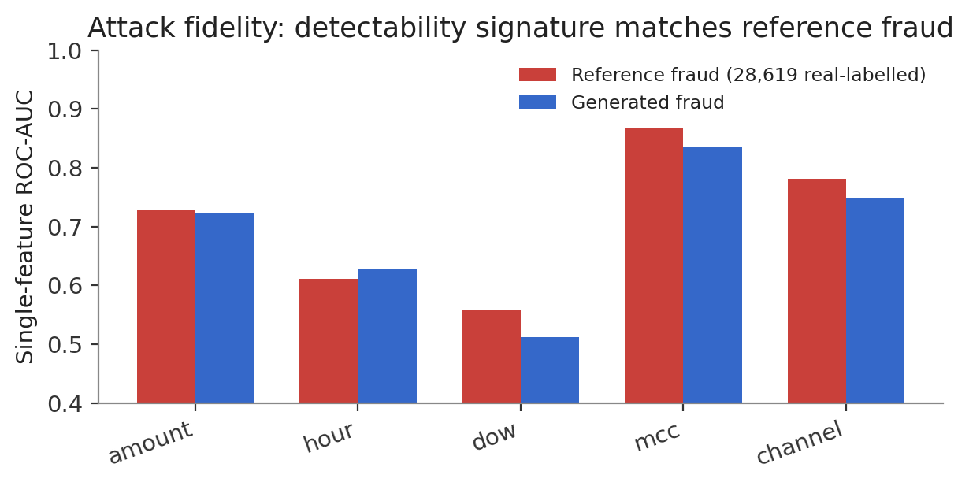
Single-feature detectability, reference fraud vs generated fraud, after calibration against the measured fraud/baseline ratio distribution.
Metric | Reference | Generated | Gap
ROC-AUC | 0.9660 | 0.9650 | -0.0010
PR-AUC | 0.7809 | 0.7740 | -0.0068

Verdict: matched. The largest single-feature gap is 0.046 (day-of-week); every other feature is within 0.033. A corollary worth stating plainly: raw-feature fraud detection is genuinely easy in this corpus, for reference and generated data alike — which is exactly why Section 3's headline metric is not raw-feature ROC-AUC.

2.4 Closing the loop caught a simulator defect
The first detector run against the injected corpus returned PR-AUC 1.0000 with 100% recall — not a result, a leak. The top feature by a seven-times margin was “distinct users seen on this device before.” The cause: every legitimate device in the world belonged to exactly one user for all time, while every attack device was shared across victims by construction — legitimate devices measured 0.00% multi-user, attack devices a median of six users and a maximum of forty-three. “Device shared across users” was a near-perfect fraud oracle, a property of the simulator, not of payments.
Fixed on both sides of the loop: the legitimate world now models household device sharing, handset churn with activation dates, and public terminals (4.7% of devices now serve more than one user; 2.0% of legitimate transactions are a genuine first use of a device); and 38% of fraud events now execute from the victim's own device, matching session-hijack, malware and on-device social-engineering mechanisms in the taxonomy. This is the closed loop doing its job — the defence exposed a fidelity defect no amount of inspecting the attack generator in isolation would have revealed, discussed further in Section 4.

3. Defend — Detection, Mitigation and Honest Evaluation
The brief prioritises accuracy while keeping false positives on legitimate payments low. The engineering here is deliberately ordinary — gradient-boosted trees on causal features, the model class payment risk teams actually run — because the differentiating work is in how the model is evaluated, not in exotic architecture. A supervised model trained and scored on its own generated attacks is answering a tautology; the premise of the challenge is unseen fraud, and the evaluation has to reflect that or the reported number is decoration.

3.1 Thirty causal features
Every feature is computed from a transaction's past only — enforced by construction, not by convention. “The user's average amount” means the average of their prior transactions, excluding the current one; a plain groupby mean would leak the current amount into its own feature and leak fraud from later in a campaign backwards into earlier rows of the same campaign. This was verified directly: truncating a user's transaction history at row k must not change row k's own feature values, and a dedicated test asserts exactly that.
Family | Examples | Targets
Baseline deviation | amount vs prior mean / max, z-score, exceeds-prior-max flag | Amount profiles defined relative to the victim's own baseline, not an absolute threshold
Velocity | transaction counts in trailing 1h / 24h / 7d windows per user, merchant, device | Burst and slow-drip temporal shapes
Novelty | first-time merchant / category / device / state for this user, distinct-merchant count | Acquisition and execution-stage vectors
Entity sharing | distinct users seen on this device / merchant before this row | Cheap proxy for the graph signal mule networks and card-testing rings produce

The entity-sharing family required the fix described in Section 2.4 before it was trustworthy; the same feature that made a broken simulator trivial to “detect” is, once the simulator is realistic, one of the two strongest features in the model.

3.2 Three evaluation tiers, from easiest to honest
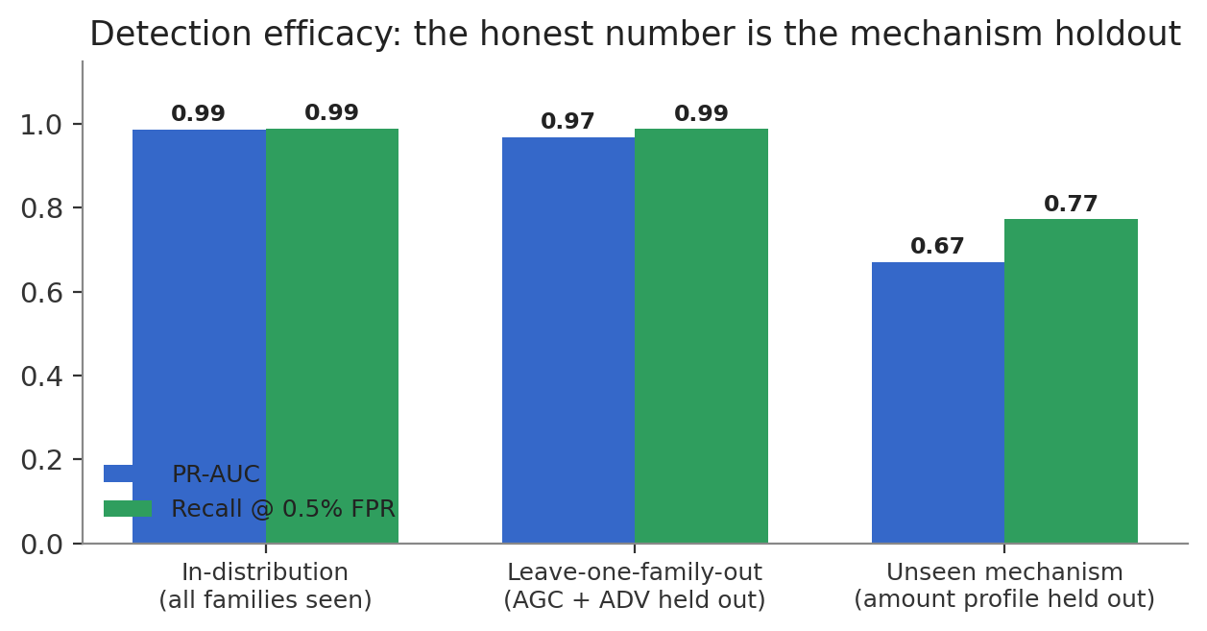
Detection efficacy across three progressively harder evaluation protocols. The middle tier looks reassuring; the right tier is the one that answers the brief's actual question.
Tier | PR-AUC | Recall @ 0.5% FPR | What it actually tests
In-distribution | 0.9871 | 99.0% | Temporal train/test split; every attack family present in training
Leave-one-family-out | 0.9691 | 98.8% | Agentic-commerce and anti-defense families entirely absent from training
Unseen mechanism (headline) | 0.6701 | 77.3% | The micro_probe / drain amount-generation mechanism withheld — not a family label, a generative mechanism

Why leave-one-family-out was not enough on its own. All 42 vectors are rendered by one generic simulation engine (Section 2), so a family label bundles parameter combinations rather than distinct mechanisms — holding one out cost the detector only 0.0180 PR-AUC. Holding out a generative mechanism instead — amount profiles the model has never seen in any form — costs 0.3170 PR-AUC, a real and defensible generalisation gap. This is the number reported as the headline in Section 1 of the Executive Summary, not the in-distribution 0.99.

3.3 Feature ablation
Run on a stratified subsample (all fraud retained, negatives thinned to 400k rows) to keep thirteen model fits tractable. Removing the entity-sharing family costs the most of any single group; raw transaction fields alone still carry real signal, confirming Section 2.3's finding that raw-feature detection is genuinely easier in this domain than the 0.67 headline number might suggest in isolation.
Feature set | PR-AUC | Recall @ 0.5% FPR
ALL | 0.9869 | 97.0%
only raw | 0.7910 | 63.9%
only baseline | 0.1014 | 3.3%
only velocity | 0.2652 | 16.4%
only novelty | 0.6556 | 48.3%
only sharing | 0.8344 | 67.0%
all minus raw | 0.9360 | 83.6%
all minus baseline | 0.9860 | 96.5%
all minus velocity | 0.9863 | 96.9%
all minus novelty | 0.9696 | 93.2%
all minus sharing | 0.9642 | 91.7%

3.4 From classifier to decision
The brief asks the system to detect, flag, and mitigate — not merely classify. RedLab converts the risk score into a three-tier decision (ALLOW / STEP-UP / BLOCK) using operating points anchored to explicit false-positive budgets (0.1% for BLOCK, 0.5% for STEP-UP) rather than an arbitrary 0.5 threshold, matching how payments risk teams actually specify a model in production. This decision engine is live in the web prototype's Defense Console (Section 5), scoring held-out transactions with the persisted model in real time.

4. The Closed Loop — Red and Blue Co-Adapt
The strongest submissions, per the brief, treat the three pillars as a single feedback loop rather than a one-way pipeline. RedLab implements this literally: each round, an attacker searches the parameters it actually controls for settings that evade the current detector at a fixed false-positive budget; the detector then retrains on whatever got through. This is the PF-ADV-002 threat model (black-box evasion search over mutable features) made operational.

4.1 What the attacker controls, and why fitness includes value
The attacker never sees model internals, gradients, or the feature matrix — only the score its own transactions receive, matching what a decline-response oracle (PF-ADV-001) leaks in practice. Its controllable genome spans amount positioning within the measured fraud/baseline ratio band, campaign tempo and duration, entity reuse, and what share of events execute from the victim's own device. Critically, fitness is not evasion rate alone: fitness = evasion_rate × min(value_retention, 1.5). An attacker that evades by shrinking every transaction to a rounding error has stopped committing profitable fraud, not won; without this term the search degenerates immediately into micro-amounts, which would be a defence win mislabelled as an attacker win.
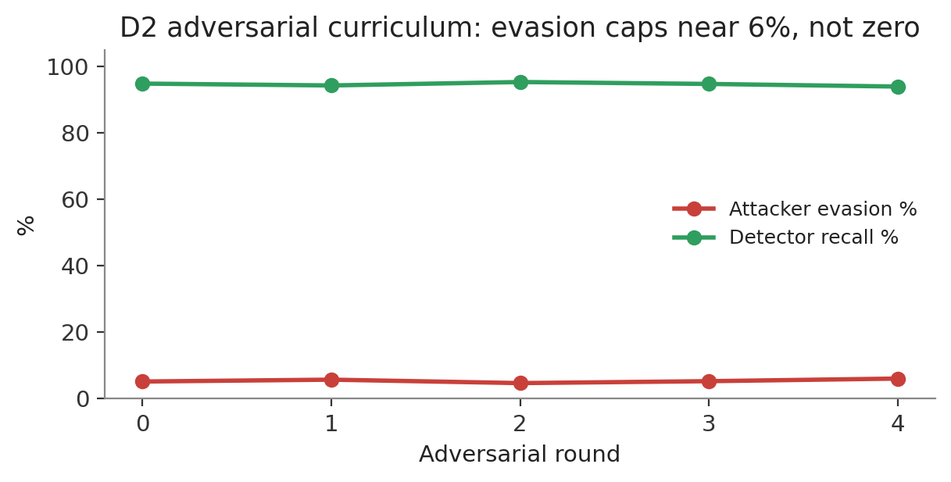
Five rounds of hill-climbing search. Evasion trends up slightly (5.2% → 6.1%) while detector recall stays essentially flat (94.8% → 93.9%) — discussed as an open limitation below.

4.2 Validating the ceiling with an independent search
A hill-climb with only four candidates per round in a six-dimensional space risks reporting a local optimum rather than a real ceiling, so the result was checked against an independent 25-genome random search over the identical parameter space, scored against a single fixed (never retrained) detector.
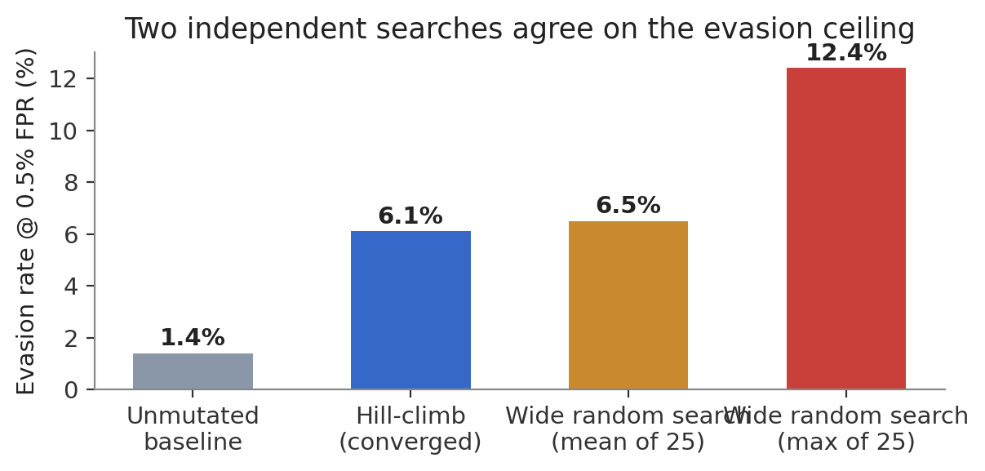
Two independent search strategies converge on the same order of magnitude.
Finding — the evasion ceiling is real, not a search artefact. The hill-climb's converged 6.1% sits almost exactly on the wide search's mean of 6.5%, and the winning genomes from both searches point the same direction: less entity reuse, more victim-device execution, longer slow-burst campaigns, amounts shifted upward within the measured band. A naive, unmutated attack is caught at 98.6% recall; even the single best genome out of twenty-five random draws reached only 12.4% evasion. For a controllable-parameter attacker under this threat model, that is a strong result for the defence.

4.3 An open limitation, stated rather than hidden
Round-over-round retraining did not visibly suppress evasion further — it trended flat to slightly up rather than down. The most likely explanation is scale: each round's evaded fraud is a small fraction of what the detector already sees, so the retraining signal may be too thin at this population size to move the decision boundary measurably. Two directions worth pursuing with more compute budget: a longer retraining window that accumulates more evaded examples before each update, and a complementary detection channel — a graph or novelty model, per the ablation in Section 3.3 — targeted specifically at the direction the attacker converges toward (device-victim overlap, campaign tempo) rather than relying on the same feature set the attacker is searching against.

5. Working Prototype
A server-rendered FastAPI dashboard demonstrates the closed-loop system in action: five pages, entirely self-contained (no CDN dependency, so it runs fully offline), backed throughout by the same artifacts referenced in this document rather than mocked data. It runs locally via `uvicorn redlab.web.app:app --reload` — see the README for the full quickstart.

5.1 Overview
Headline metrics across all three pillars, linking directly into the detail pages below.
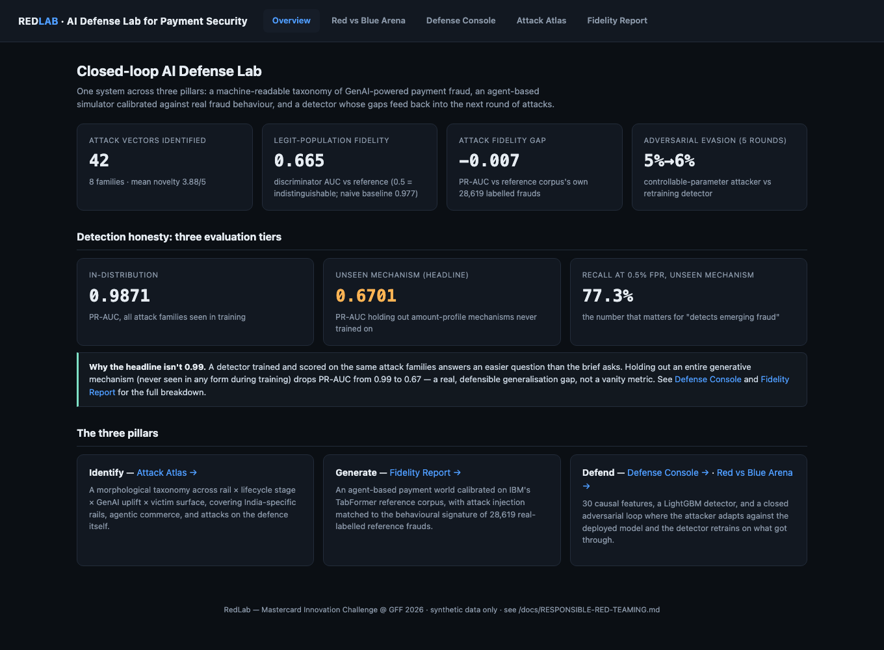

5.2 Red vs Blue Arena
The adversarial curriculum from Section 4, rendered live from artifacts/adversarial_loop.json — evasion and recall per round, and the winning attacker genome at each step.
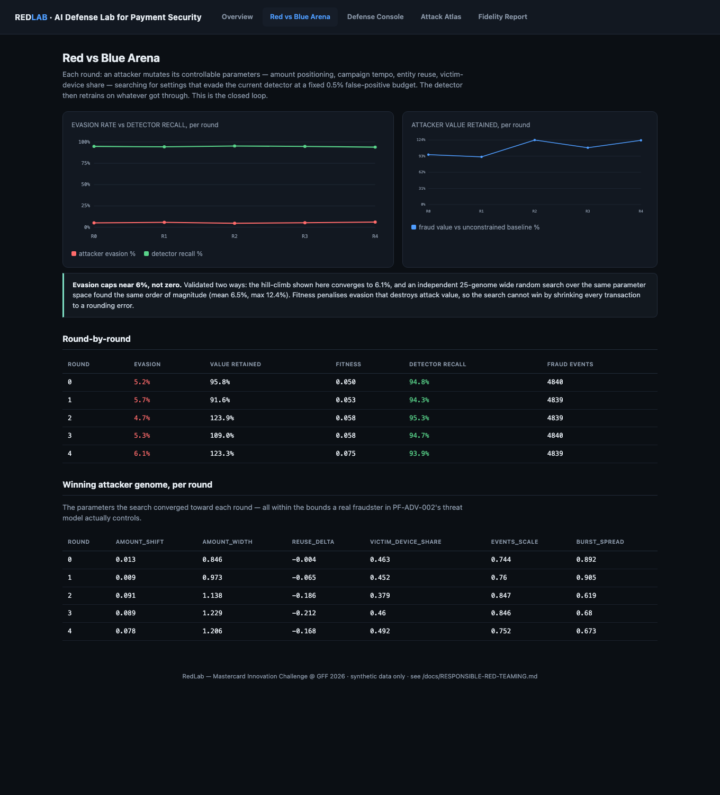

5.3 Live Defense Console
The persisted detector scoring a held-out slice of the world it never saw during training, with real risk scores and real ALLOW / STEP-UP / BLOCK decisions at the same FPR-anchored thresholds described in Section 3.4. Defaults to the busiest fraud day in the sample so the feed demonstrates the system catching something on load, with a toggle to the literal chronological feed at real (~1%) prevalence.
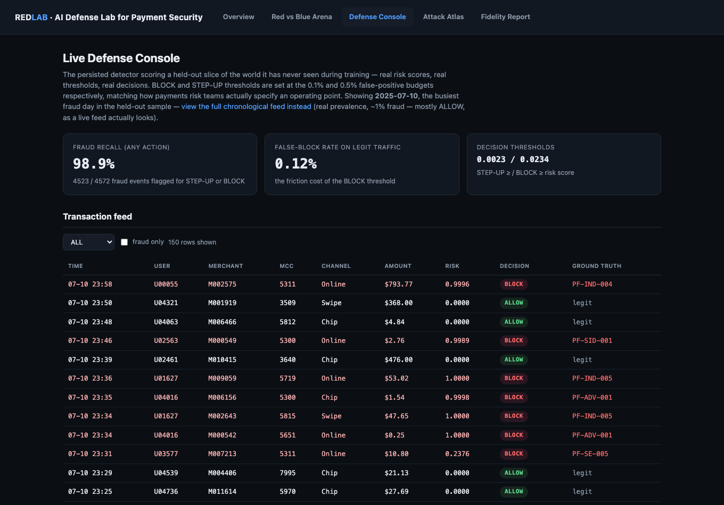

5.4 Attack Atlas
The full 42-vector taxonomy from Section 1: a browsable family × rail matrix and per-vector detail pages showing the simulation profile and every detection hypothesis.
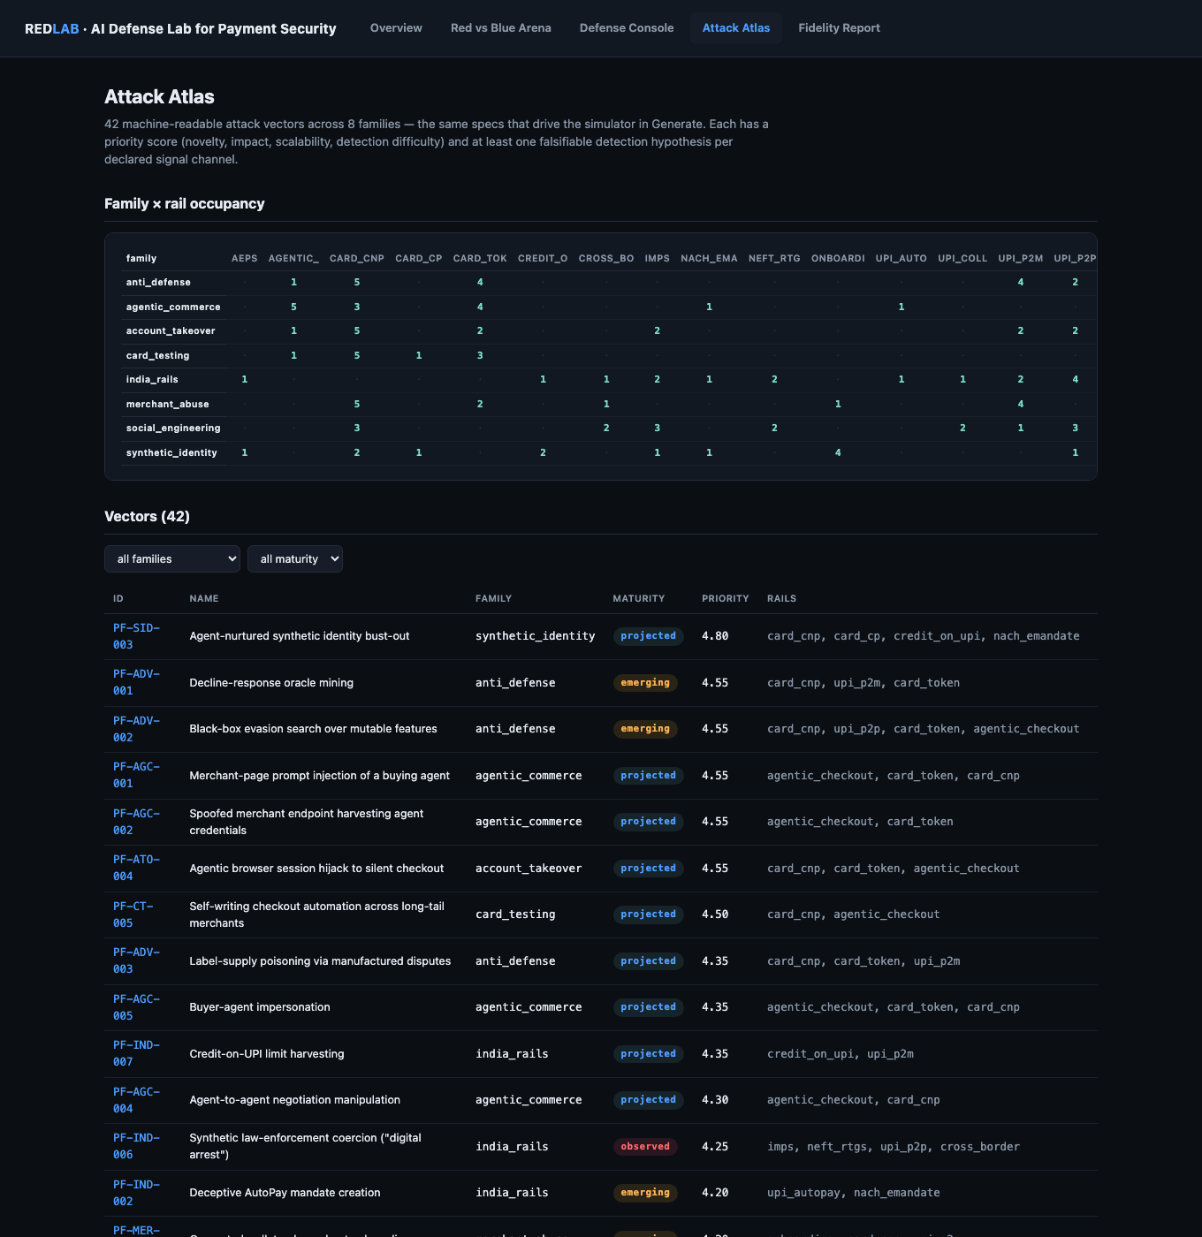


5.5 Fidelity Report
The full breakdown behind Section 2's headline numbers — marginal, stylised-fact and adversarial metrics for the legitimate population, and the attack detectability signature comparison against reference fraud.


6. Real-World Feasibility in Live Payment Environments
Most submissions to a challenge like this stop at model performance. Feasibility is a scored criterion and is treated here as a first-class section rather than an afterthought, because a detector that cannot be deployed inside an authorisation flow is not a payments solution.

6.1 Where each component sits in the authorisation flow
Stage | Latency budget | What runs here
Pre-authorisation (synchronous) | < 100 ms | The LightGBM detector on causal features — all thirty features are O(1) lookups against a maintained per-entity state store (running counts, means, distinct-value sets), not a full-history scan, so scoring is compatible with a hard real-time budget.
Post-authorisation (near-real-time) | seconds to minutes | Graph-structure features (entity-sharing fan-in/fan-out) that benefit from a slightly wider window; STEP-UP challenge issuance.
Batch (hourly / daily) | not latency-critical | Model retraining, drift monitoring, the adversarial-curriculum retraining cycle from Section 4.

6.2 Operating point, not a single threshold
Section 3.4's decision engine already reflects production practice: a risk team does not pick one cutoff, it picks a false-positive budget and reads off the corresponding action. RedLab's thresholds are FPR-anchored (0.1% → BLOCK, 0.5% → STEP-UP) precisely so they transfer to a deployment's own volume and can be re-derived against that institution's real cost-per-false-positive without retraining the model.

6.3 Governance and drift
- Model validation. the mechanism-holdout evaluation in Section 3.2 is the pre-deployment gate a new model version should clear before replacing a production one — not the in-distribution number.
- Adaptive-baseline risk. PF-ADV-005 (slow-drift injection against adaptive baselines) is modelled explicitly in the taxonomy; a production deployment should anchor reference baselines that adaptive retraining cannot move, with drift-rate alarms routed to human adjudication rather than silent auto-acceptance.
- Label integrity. PF-ADV-003 (label-supply poisoning via manufactured disputes) means chargeback-derived labels should not be trusted uncurated; a sampled, independently verified ground-truth stream alongside dispute-derived labels is the mitigation this taxonomy vector implies.
- Cold start. cold-start on a genuinely new attack family is exactly what the leave-one-family-out and mechanism-holdout evaluations are proxies for; Section 3.2's honest number (67% PR-AUC, 77% recall at a 0.5% FPR budget) is the realistic expectation for day-one performance against a new mechanism, not the in-distribution 99%.

6.4 Cost of the false-positive budget
Every recall number in this document is reported alongside its precision at the same operating point (Section 3.2), which is the correct unit for a friction conversation with a product or risk team: recall alone answers “how much fraud do we catch,” precision at a fixed FPR answers “how many good customers do we interrupt to get there.” At the 0.5% FPR budget, the mechanism-holdout tier catches 77% of unseen-mechanism fraud at 37% precision — roughly two flagged transactions in five are real fraud, a ratio a human review queue can absorb.

7. Responsible Red-Teaming and Limitations
This project builds an attack simulator. That is the brief — and it is also a reason to be explicit about where the boundary sits, because a red-team artefact that cannot state its own limits is not a credible input to a payments environment.

7.1 What was deliberately not built
Not built | Why
Working exploit tooling against any live rail, PSP or issuer | The simulator emits data, never traffic — no component holds a network client for a real payment endpoint.
Deepfake audio or video generation | Modelled as signal distributions instead — liveness scores, challenge-response latency, retry counts — which carries the detection value without producing a redistributable harm artefact.
Forged identity-document images | PF-SID-001 is simulated as onboarding metadata and attribute-overlap structure, not as generated document images.
Real personal data of any kind | Every entity is synthetic; no breach corpus, no scraped PII, no real card numbers, VPAs or Aadhaar numbers.
Operational evasion guidance | The PF-ADV-* vectors in Section 4 are simulated against a detector RedLab itself owns, inside a closed sandbox with no network egress. The output is a hardened detector, not a transferable playbook.

7.2 Limitations
- The reference corpus is synthetic. the TabFormer reference is itself synthetic, stated everywhere it matters in Section 2. IEEE-CIS would strengthen every fidelity claim and drops in through the CalibrationProfile interface without touching the simulator.
- UPI rails are not transaction-level calibrated. no public transaction-level UPI corpus exists. Transfer-rail vectors are injected with transfer-like semantics into a card-calibrated world; only marginal priors (drawn from published NPCI/RBI aggregates) are used for UPI, and they need refreshing against current published figures before external use.
- Family labels bundle mechanisms. all 42 vectors are rendered by one generic simulation engine, so a family-label holdout (Section 3.2) is measurably weaker than a mechanism holdout — which is exactly why the mechanism holdout, not the family holdout, is reported as the headline number throughout this document.
- D3 is a documented extension, not yet implemented. the D3 black-box probing agent — an LLM-driven fraudster that autonomously reverse-engineers detector thresholds through query access, extending PF-ADV-001 beyond the parametric search in Section 4 — is designed in the taxonomy but not yet built. The adversarial curriculum's genome search already implements the mechanical equivalent for a bounded parameter space; D3 would generalise it to open-ended, language-model-driven strategy discovery.
- The adversarial loop's retraining signal may be too thin. round-over-round retraining did not measurably suppress the attacker's evasion in the observed five rounds (Section 4.3) — stated as an open question rather than smoothed over.

Appendix — Reproduction Guide
Every number in this document is generated by the scripts below, in order, from the public code repository.
Step | Command | Produces
1 | pip install -r requirements.txt | Dependencies
2 | python -m pytest tests/ -q | 53 tests validating every claim in this document
3 | python -m redlab.sim.extract_profile  python -m redlab.sim.conditionals  python -m redlab.sim.fraud_profile | Calibration targets from the reference corpus
4 | python scripts/build_dataset.py | World, attacks, causal features
5 | python scripts/eval_world.py  python scripts/eval_attacks.py | Section 2's fidelity numbers
6 | python scripts/train_detector.py  python scripts/ablation.py | Section 3's detection numbers
7 | python scripts/run_loop.py | Section 4's adversarial-loop numbers
8 | python scripts/prepare_web_data.py  uvicorn redlab.web.app:app | The working prototype, at http://127.0.0.1:8000

Full detail, including the honesty notes referenced throughout this document, is in docs/FINDINGS.md and docs/RESPONSIBLE-RED-TEAMING.md in the repository.

