Racial Identity in a Changing World: The Impacts of Environmental Degradation on Linked Fate

*A. Rose Benton*

University of North Texas

Environmental degradation is an inherently marginalizing experience. A growing body of evidence shows that people of color are more likely to live in areas that experience environmental degradation, are less likely to receive help with remediation and natural disaster relief, and what help they do receive is often condemned rhetorically by politicians and media. Despite a large body of literature denoting the importance of political identity on climate politics, little research examines the causal arrow in the opposite direction. I argue that the experience of local environmental degradation can impact the salience of group positionality in the larger political environment. That environmental degradation and other factors related to climate change are disproportionately felt by the marginalized is not a secret. Just as feelings of alienation due to immigration status make it easier for an individual to feel that their fate is intertwined with that of others in their racial or ethnic group, so too should situations such as pollution, lack of access to clean water, and poorer health outcomes when these events impact groups along racial and ethnic lines. Through use of a novel measure of environmental degradation (proximity to EPA Superfund National Priority List sites), this study investigates degradation impacts on racialized group dynamics in the United States.

Keywords: *Environmental Degradation, Climate Politics, Racial and Ethnic Politics, Linked Fate*

It is imperative that political science reaches a more thorough understanding of the impact that humans have had on the global environment and the inevitable impacts that it will in turn have on political behavior (Roston 2010). Much literature has focused on the impact of demographic information such as race, gender and sexuality on belief in climate change, however little is known about the ways which experience with related phenomena like pollution and other types of environmental degradation might impact those same identities. This research seeks to bridge that gap.

While anthropogenic climate change and environmental degradation are existential threats to all humans and most geographic regions have been degraded in a variety of ways, marginalized groups are the most vulnerable due to issues of systemic inequality in political, economic, and social contexts(Joane Nagel 2012). Thus, an important question in understanding this issue is its impact on the political behavior of marginalized groups. I argue that when marginalized people experience the externalities of a changing climate, such as increasing pollution, land degradation, or natural disasters, the salience of their relative group positionality in the larger political environment should become more important to them through a stronger sense of racial linked fate. Perceptions of power disparities and systemic injustice surround environmentalist discourse in the broader political sphere, and so it logically follows that the degradation of local ecosystems may trigger the salience of racial identity. The following discussion will focus on a few groups of literature: first, I will detail the ways in which the effects of climate change and environmental degradation are dispersed socially and demographically; then I will discuss patterns of research in climate politics[1] and where this theorization fits in context; next I will illustrate the intertwined nature of identity and the environment; then we will move on to a discussion of group consciousness and linked fate as models of understanding racialized political behavior in the United States; before pulling these disparate literatures into a fleshed out theory of local environmental degradation and racial linked fate.

# Environmental Effects and Their Distribution

Environmental degradation is defined in varying ways, from very specific definitions such as that of Li and Reuveny (2006) which relies on the presence and level of 5 indicators (carbon dioxide emissions, nitrogen dioxide emissions, deforestation, land degradation, and organic pollution in water) to more general and expansive definitions which instead point to “a deterioration in environmental quality from ambient concentrations of pollutants and other activities and processes such as improper land use and natural disasters” (OECD n.d.). This paper will follow the later definition and discuss environmental degradation as a broad concept, understanding that this is a granular phenomena at best, which adapts and takes new forma in new contexts. Part of the reason for this is that climate change and environmental degradation are so intrinsically linked. Climate change can drive land degradation and land degradation makes the effects of climate change more impactful (Talukder et al. 2021). Is flooding more the fault of climate change for changing the sea level or the degraded land that is missing its natural protections from floods (such as plant cover, sand dunes, etc) because of human interference? The answer is both; however, for the purposes of doing science it is often easier to measure the direct impact of environmental degradation on humans.

The main consequences that the United States will see from a changing environment include both cyclical and permanent flooding of large portions of the country, drought and water scarcity, crop failure, and increased incidence and severity of natural disasters such as hurricanes and wildfires (Blankenship et al. 2020; EPA n.d.). Past the obvious risk of loss of life and property damage, these effects are likely to drive migration events, increase incidences of aggression, interpersonal violence and crime, and to lessen the ability of national and state governments to enforce rule of law (Anderson et al. 2000; McLeman 2018; Michael and Zumpe 1983; Piguet et al. 2011; Stock 2007; Tierney, Bevc, and Kuligowski 2006). These effects have the potential for significant impact to political behavior, however it is not the case that all people will experience the same type or level of impact. Those who live in marginal areas will be impacted much more than those who have the political clout to prevent pollution close to their homes and workplaces (this is often called NIMBYism, meaning Not In My Back Yard ism), the money to invest in mitigation measures, and better access to relief measures after effects have started to be felt (Hill 1965; Kramar et al. 2018; Muro, Victor, and Whiton. 2022; Joane Nagel 2012). It follows then that we should expect a range of outcomes when looking at how different groups respond to degradation.

There are two angles by which we can understand the distribution of human caused environmental changes: social and geopolitical. That is, structural inequality has made it so that those with the least political power are the most likely to bear the brunt of climate change and its externalities, while the geographic component of the issue indicates that certain regions and topographies will be more impacted more than others (Hill 1965; Muro, Victor, and Whiton. 2022; Joane Nagel 2012; O’Connell 2012; Tomaskovic-Devey and Roscigno 1997).

A growing body of evidence has shown that people of color are more likely to live in areas that experience adverse outcomes from environmental degradation such as drought and wildfire, are more likely to experience pollution due to proximity to industrial areas, are less likely to receive help from their leaders after natural disasters have occurred, and what help they do receive is often condemned rhetorically by politicians and media (Joane Nagel 2012; Nixon 2011; Soyapi and Kotzé 2016). This is not surprising, because the similar arguments can be made about other expressions of institutional violence, such as biased prison or immigration systems. Due to this pattern, if the political behavior of any group has been impacted by the environment it should be more obvious in groups who are marginalized. Climate change cannot be fully understood through the lens of the natural sciences because at a fundamental level its impacts are tied to overarching structural patterns of inequality and thus requires a wide body of interdisciplinary research to be described properly.

# Climate Politics and Political Science

The study of climate change politics in Political Science, especially in the American context, has been primarily focused on descriptive works which detail the influence of identity on belief in or concern for climate change, and on the individual, public opinion and electoral outcomes brought on by various environmental factors (Achen and Bartels 2016; Bechtel and Mannino 2021; Blankenship et al. 2020; Capstick and Pidgeon 2014; Egan and Mullin 2017; Fielding and Hornsey 2016; Harth 2021; Johnson, Brace, and Arceneaux 2005; Mackay et al. 2021). Natural disasters and high temperatures in particular have been linked to decreased government legitimacy, more critical appraisal of climate mitigation measures taken by executives, voter turnout, and vote choice (Blankenship et al. 2020; Carlin, Love, and Zechmeister 2013; Gasper and Reeves 2011; Gomez, Hansford, and Krause 2007; Healy and Malhotra 2009). At an individual level, these variables are known to heighten feelings of aggression and competition and to increase support for expensive policy measures, hinting at an increasing level of risk acceptance in respondents (Anderson et al. 2000; Hazlett and Mildenberger 2019).

The largest body of climate politics literature by far is that which describes the impact of demographic variables on belief in or concern for climate change; the two variables are highly correlated in American public opinion, so I will use the concepts interchangeably (Egan and Mullin 2017). As an issue which has been subject to heightened levels of politicization and polarization over recent decades, it is not surprising that political party and ideology are the strongest predictors of climate concern(Egan and Mullin 2017; McCright and Dunlap 2011). Closely following these are age, gender, and (more importantly for our purposes) race, and socioeconomic status. As I will discuss in the next section, the effects of climate change and environmental degradation are disproportionately felt by marginalized racial groups, women, and those of low socioeconomic status. This link between marginalization, climate concern, and climate vulnerability serves as the foundation of this theory of the environmental determinants of minority political behavior.

A tangential but possibly mitigating factor on the effect of the environment on political behavior is issue salience. While this is a highly polarized and highly politicized issue, it is also seen as a low salience one with respondents regularly ranking it as one of the least important issues on the public agenda, and it might even have decreased in recent years (Egan and Mullin 2017; Spisak et al. 2022). There is some hope for younger generations, however the general public mood in America is that climate change is something to fight over and have strong opinions about, not something to take action over (Egan and Mullin 2017; Tyson, Kennedy, and Funk 2021). This might indicate that even though certain groups are heavily impacted by environmental factors they prioritize other issues. Nonetheless I argue that climate impacts could be a spark that incentivizes a change in feelings of racial identity by making plain the relative inequality inherent in climate change. Although climate change is not one of Americans’ most salient issues, it may bring another issue into heightened relief: identity politics. What is largely missing from the literature is an in-depth analysis of the impacts of climate change and environmental degradation on group behavior.

# Group Consciousness and Linked Fate

In this section, I narrow the conversation from a discussion of the impact of environmental factors on broader political behavior to the more specific question of its impacts on racial identity formation and linked fate. As the above discussion shows, power politics and relative group positionality are the main obstacles in the way of a more equitable experience of climate change. A common way to overcome power disparities throughout the world is racial and ethnic mobilization, a mechanism by which groups of individuals with similar political interests coalesce in order to combine their electoral and social power (Fearon 2009; Leighley 2001; Vermeersch 2012). Nagel (1997, 23) argues that racial mobilization is a product of individuals partaking in a “continuous assessment of situation and audience, emphasizing or deemphasizing particular dimensions of ethnicity according to some measure of utility or feasibility”. As such, it is logical to investigate the ways in which climate impacts racial identity formation in particular.

One of the main frames of reference in which American politics understands race is through group consciousness and linked fate. These concepts build upon an understanding of race, not as an intrinsic, primordial facet of humanity, but rather as something socially constructed as a means of othering groups with various phenotypic attributes. Omi and Winant (2014) discuss the formation of racial identities through a historical framework, explaining how the importance of identity politics and a history of White political strategies which explicitly opposed the success of non-White groups has led to a consistent power struggle in American politics. Because race impacts the ways in which an individual experiences politics, it can also condition the attitudes and behaviors that they adopt within political society. Group consciousness is an understanding of one’s identity in the context of the relative group power disparities brought about by the racially hierarchical nature of American society (Omi and Winant. 2014). Linked fate, a concept originally used to describe the impact of chattel slavery on Black group consciousness, takes this one step further and articulates an assumption that whatever happens to one person within a group will impact the outcome of others and that what happens to the group will influence the fate of individuals (Dawson 1995). Dawson developed this concept through reference to his Black Utility Heuristic, which theorizes that their shared history has made race such an important factor for Black Americans that their individual political behavior is best understood when taking into account their relationship to the group. This is the basis of the study of race and ethnicity by scholars of American politics.

Two major developments in the theory of linked fate are relevant here. First, works such as Sanchez and Masuoka (2010) and Junn and Masuoka (2007) expand the idea of linked fate to other minority groups and describe the potential for malleability in linked fate. Not every Latino feels as if the political outcomes of Latinos as a group will affect them, the importance of their racial identity can condition the way in which that identity shapes their political attitudes and behavior. The theoretically relevant mechanism here is marginalization, because when groups who are excluded from society share experiences such as systemic poverty, xenophobic public opinion, the impacts of immigration on economic and social mobility, and possibly the disproportionate allocation of climate change effects, they are more likely to develop their group consciousness into a feeling of linked fate due to frequent reminders of relative group positionality (Sanchez and Masuoka 2010).

Second, further research made clear that the role of government policy can be influential in the formation of racial identity. Junn (2007) discusses the ways in which decisions by the federal government about which immigrants deemed acceptable and the ways in which those decisions have changed over time has influenced the changing racialized stereotypes for Asian Americans over time. Further, Silva et. al (2020) show that less institutionalized government policies, such as local police performance, can be racialized experiences that shape public opinion along group-based lines. I would argue that climate mitigation policies are experiences that trigger the salience of relative group positionality because they operate as threats to group security.

Security threats are a well known predictor of ethnic identity hardening in comparative politics because they allow for the politicization of group dynamics. By creating a group of insiders to which outside groups are held up as strange and other, they begin to construct an identity around this dynamic (Lake and Rothchild 1996). This identity is malleable and changes drastically over time as different factors raise the political salience of ethnic identity and groups adapt to meet new challenges (Barth 1969; Eller and Coughlan 1993; Weber 1978; Williams 2011 ) . Identity becomes instrumental as elites within the community start to wield ethnicity as a political tool with which to outbid each other, but can also be a symptom of modernization and interaction with a more diverse, densely populated city environment or some other change or shock to the standing context of identity politics (Bell 1975; Brass 1996; Williams 2011). The key here is that identity is context dependent and adaptive, indicating that major shocks like environmental change should precipitate some sort of change in the strength of political identity.

That environmental degradation and other factors related to climate change are disproportionately felt by the marginalized is not a secret. Just as feelings of alienation due to immigration status make it easier for an individual to feel that their fate is intertwined with that of others in their racial or ethnic group, so too should situations of disproportionate allocation of pollution and other types of environmental degradation when these events impact them along racial and ethnic lines.

*Hypothesis 1 (H1)*: The reported levels of linked fate for minority respondents will be impacted by their experience of degraded local environments.

In practical terms, I can see two plausible pathways for this relationship, which I will term the low visibility model and the high visibility model. Under the low visibility model the community in question does not recognize when the local environment has been degraded and as such their levels of linked fate are not impacted. However, some actor (such as the state government, an individual who does not broadcast their actions to the larger community, etc.) contacts the EPA and begins the decision process to name the contamination zone an EPA Superfund site. Once that process concludes the site will either be approved or denied. If the site is denied in the low visibility model, I expect no change in reported levels of linked fate. The people living near the site did not notice the instigating degradation event and a denied site does not receive the visibility boost that an approved one has, so they would continue to live their lives as usual. In the counterfactual in which the same site was approved by the EPA and thus received the accompanying signage, fences, and other visible indicators that some pollutant exists in the area, I expect linked fate would increase. Respondents who were previously unaware of the site would not necessarily see site approval as a relief from concerns brought to the government, because they were not aware that a problem existed in the first place. However, community members who are naive to the impact of environmental degradation in their local area who suddenly come upon an EPA Superfund site would likely be shocked and have cause to contemplate how and why the degradation happened in the first place. Thus, the only way for linked fate to go is up.

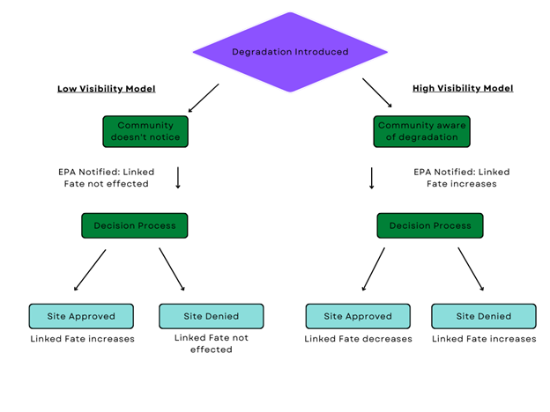

Under the high visibility model, I expect that an approved site will lower levels of linked fate for a similar reason. A community who has brought concerns about local environmental degradation to the federal government and then sees action from the EPA, in the form of site approval, has had their concerns addressed. Linked fate is in many ways an expression of the way a respondent sees the way they are treated by the government. If the government is responsive, linked fate should decrease. Finally, a denied Superfund site should increase linked fate. A community has expressed distress about environmental degradation and has been ignored, which would likely drive perceptions of adverse treatment by the government. The data currently available for this analysis include only approved sites, so this analysis will look only at (1) if change in proximity to approved sites over time impacts at all, and (2) which direction that change is in [2].

# Data and Operationalization

## Dependent Variable

The outcome of interest in this study, *linked fate*, is operationalized as a question from the 2016 and 2020 waves of the American National Elections Survey. The questions ask each racial group (Black, Hispanic, and Asian) “How much do you think that what happens generally to [racial group] people in this country will affect what happens in your life?” The ordinal factor is restructured so that it increases as the level of linked fate increases: “Not at all” (0), “Not very much” (1), “Some” (2), and “A lot” (3). The location for the 2,317 observations is coded as the geographic center point for their legislative district. This is the lowest geographic level available for the respondents.

## Independent Variables

The main predictor in this analysis is proximity to EPA Superfund National Priorities List Sites. This is a program established by the Comprehensive Environmental Response, Compensation, and Liability Act of 1980 (CERCLA), generally referred to as the EPA “Superfund” program/project. This is a novel predictor as of yet in political science as far as I can tell, but I would argue that it is more appropriate here than the commonly used measures (generally the levels of one or more specific pollutants in the air or water) because measures of any given pollutant are hardly a holistic measure of the entire local system. Knowing the levels of ozone in an area might be helpful in certain questions, but on their own their use in this study would not give us a good picture of the conditions that respondents live with due to long term challenges in the quality and reach of information about local pollutants(Ramirez et al. 2019) and the generally low level of issue salience associated with climate topics (Egan and Mullin 2017; Spisak et al. 2022).

By measuring proximity to a source of environmental degradation, we can more clearly connect the issue with a respondents daily life and, more importantly, Superfund sites are extremely visible as can be explained best through a narrative of the process each site (ideally) will go through. The life cycle of an EPA NPL listed site begins when a community realizes that there has been some event which has caused the area to be degraded, usually through pollution by some contaminant. The site is brought to the attention of the EPA and is given a preliminary assessment inspection, where an employee of the EPA surveys the site and determines if the report is viable for continued investigation. Then, a more detailed assessment leads to a review process during which a site is approved if it meets one or more of the following requirements:

● A score of 28.50 or higher on the Hazard Ranking System (HRS); a scoring instrument used by the EPA to quantify information collected during the various inspection phases.

● EPA determination that the site is a significant threat to public health

● EPA determination that remediation (an authority limited to NPL sites) will be more cost-effective than emergency removal (a more accessible tactic)

● Top Priority designation by a State or Territory government

● Recommendation by the Agency for Toxic Substances and Disease Registry (a sister agency also established by the CERCLA/Superfund legislation)

The key part of this process to its viability as a variable in this analysis is community recognition of the site. Since their recognition of the site is necessary for it to be noticed by the EPA, and due to the visibility of established sites (see Appendix 1), we can assume that most respondents would recognize that they live near or directly in a contaminated area.

|  |
| --- |
|  |

NPL proximity is measured in two ways. I utilize the lowest level of geocoding available for ANES respondents, legislative districts, to narrow down their location. I take the geographic center points of each district and calculate the distance to all NPL sites in the corresponding state [3]. The measure *proximity* is the mean distance for that respondent, which has been logged to account for skewness. Second, *In District* is a simple dichotomous variable indicating if there are any sites in that legislative district. Finally, I include a control for the average *HRS score* for all sites within the state in order to account for the impact that site severity might have on perceptions of pollution in the area.

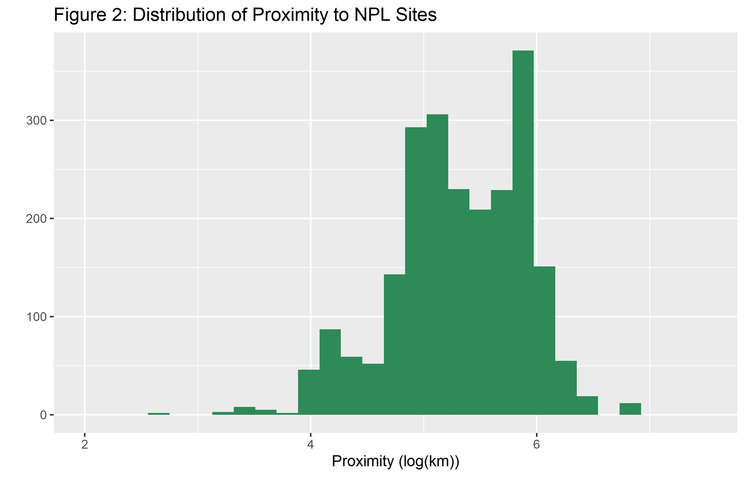

I also include additional respondent-level demographic predictors from the ANES which might influence survey sampling. *Age* is a 7 level-factor ranging from “18-24” to “65+”; *female* is a dichotomous measure of gender with male as the reference category; and *race* is a 3 level nominal factor with the levels “Asian American”, “Black or African American”, and “Hispanic or Latino”, which are the only groups that are targeted for this question. Finally, I include a control for which *census region* the respondent lives in, under the assumption that the context of racial identity varies across region meaning that states, say, in the South are not comparable to those in the West, Midwest, or Northeast, and a dichotomous measure of *time,* indicating which wave of the ANES the observation is from. Descriptive statistics for all of the variables in the model can be found in Appendix 3.

# Method

To evaluate the theoretical expectations outlined in the preceding section, I estimate a series of Bayesian hierarchical categorical logit models. In the context of the observed data in which respondents $i∈\{1,2,…,N\}$ are nested within congressional districts $j∈\{1,2,…,J\}$ which are in turn nested within states $s∈\{1,2,…,S\}$, the model can be expressed as a set of equations representing each level.

$$\begin{matrix} y_{ijs} & ∼Categorical\left(θ_{k}\right) \\ logit\left(θ_{k}\right) & =α_{js,k}+β_{1s,k}{Time}_{k}+β_{2,k}x_{2,k}+…+β_{l,k}x_{l,k} \end{matrix} \left(1\right)$$

Equation 1 represents the population-level effects, where the relative probability of the response $θ_{k}$ for each category $k∈\{1,…,K\}$ is a function of a global intercept $α$, a set of $L$ fixed coefficients $β_{l}$ which capture respondent-level demographic characteristics, a dichotomous indicator for survey wave that takes value of 0 for the 2016 ANES wave and 1 for the 2020 wave, and an interaction between time and average log proximity to an EPA Superfund site from the center point of a respondent’s congressional district, and a control for the average severity of those sites. The varying intercepts, denoted $α_{j,k}$ and $α_{s,k}$ capture congressional district and state specific deviations from the global average for the $k^{th}$ category respectively.

$$\begin{matrix}α_{j\left[s\right],k} & ∼MVN\left(γ_{10}+γ_{11}z_{11}+…+γ_{14}z_{14}, σ_{α_{j\left[s\right],k}}\right)\end{matrix} \left(2\right)$$

At the congressional district level shown in equation 2, the district-by-state intercepts for each category $k$ follow a multivariate normal distribution whose mean is a linear combination of the overall average within congressional districts $γ_{10}$ and a series of coefficients for census regions $γ_{l}z_{l}$ that help structure the district-level effects which varying intercepts capture congressional district deviations from the overall state-specific average. The hierarchical standard deviations, $σ_{α_{sj,k}}$ are sampled from a moderately regularizing hyperprior from an exponential distribution such that where .[4]

Finally, equation 3 represents the state level effects. The state-specific intercepts $α_{s}$ and varying coefficient for time $β_{1s,k}$ are assumed to follow a multivariate normal distribution whose mean is a function of the baseline relative log odds of each category $k$ and survey wave specific deviations from the baseline across states. The covariance matrix $Σ$ can be decomposed into a correlation matrix $Ω$ and a vector of scales $τ$ and reparameterized as the result of a Cholesky factorization such that $Σ=Diag\left(τ\right) Ω Diag\left(τ\right)$ as shown in equation 4 below (Gelman et al. 2014, 367–78).

$$\begin{matrix}τ_{s}=\left[\begin{matrix}σ_{α_{s}} & \\ & σ_{β_{1s}}\end{matrix}\right] & \text{and} Ω_{s}=\left[\begin{matrix} & ρ_{α_{s}β_{1s}} \\ ρ_{β_{1s}α_{s}} & \end{matrix}\right]\end{matrix} \left(4\right)$$

The correlation matrix $Ω$ is then assigned a multivariate prior from an LKJ distribution of the form $Ω∼LKJ\left(ξ\right)$ where $ξ=5$, placing moderate constraints on the correlation between the state-level time slopes and intercepts (Lewandowski, Kurowicka, and Joe 2009). For the vector of scales $τ$, I assign a moderately regularizing exponential prior with $λ=1$, allowing for slightly larger differences between states compared to congressional districts within states.

I estimate the model via the probabilistic programming language Stan (relying on the CmdStanR interface, a lightweight alternative to brms) which implements the No-U-Turn sampler variant of Hamiltonian Markov Chain Monte Carlo (Carpenter et al. 2017; Hoffman and Gelman 2014). I run six Markov chains in parallel for 5,000 iterations each. The first 3,000 iterations for each chain are discarded after the initial warm-up adaptation stage leaving us with 12,000 posterior samples for subsequent analysis [5]. Posterior predictive checks (Appendix 2: Figure 3) indicate that this model predicts a distribution that is very close to that of the sample data (Gelman et al. 2014; Gelman and Hill 2007).

# Results

The results of this analysis indicate that change in proximity to EPA Superfund locations does indeed impact levels of linked fate. Figure 4 shows the change in probability for each of the potential outcomes when jointly manipulating both *time* and *proximity*; more plainly, the change in probability of each response if every respondent increased 1 unit in *proximity* between 2016 and 2020. Figure 4 presents the posterior distribution of these contrasts along with 95% Bayesian credible intervals which capture the distribution of possible values the parameter may take in the population conditional on our observed data and assumed prior model. Recall, *proximity* is modeled as the logged mean distance to all Superfund sites in a given state. As we can see in Figure 4, as the *proximity* term increases respondents are less likely to respond, “Not a lot” to the linked fate question and more likely to respond “A lot”. So, as respondents get farther away on average from cleanup sites their level of linked fate increases.

I interpret this to mean that being near visible signs of the government intervening to cleanup dangerous materials may be a similar mechanism to institutionalized racism, in that the actions of the government (EPA clean up, police misconduct, immigration systems, etc) send a signal to marginalized groups of their value to that entity and either reinforce or counteract those groups understandings of their relative positionality in the political culture of that area. If the government acts to protects a marginalized group in the same way that they would have protected a more privileged group, marginalized people will have less reason to believe that racialized systems of inequality have impacted them due to their group identity.

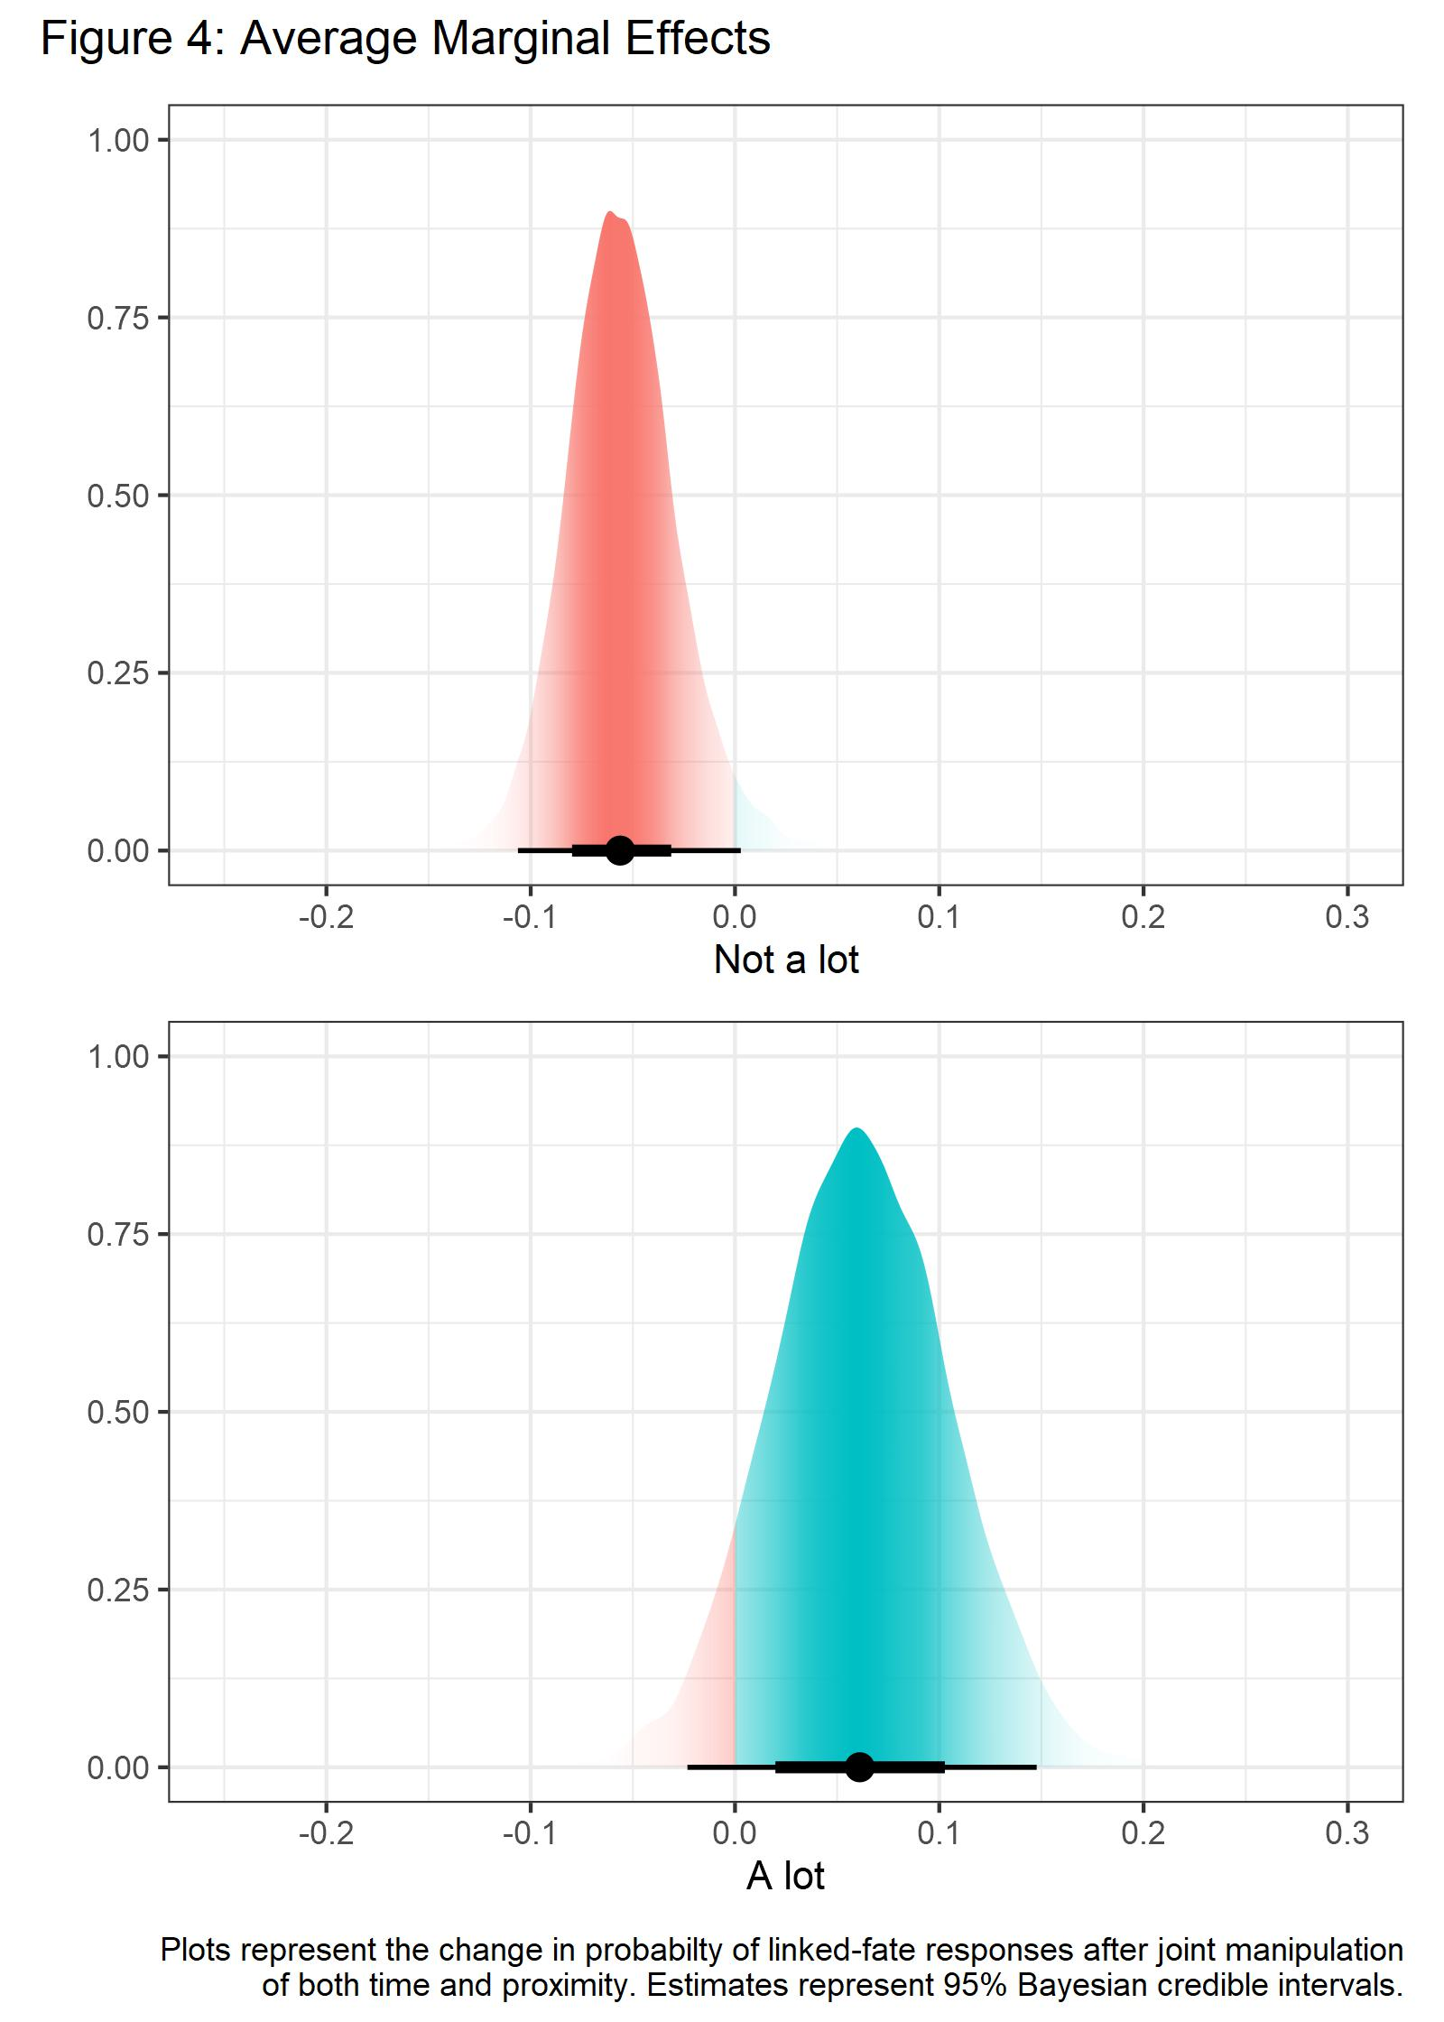

# Conclusion

This analysis attempts to bridge the bodies of literature surrounding climate politics and minority political behavior. I argue that because structural inequality is so tightly linked to the impacts of environmental degradation, environmental degradation should have an impact on the political behavior of racially and ethnically marginalized groups. As environmental degradation makes climate politics a more impactful facet of human life, perceptions of group positionality and systemic environmental inequality will incentivize marginalized groups in affected areas to identify more strongly with their ethnic or racial identity and thus report a higher level of linked fate. Just as social identity influences environmental attitudes, so too should climate change influence identity and group consciousness. I find that over time, respondents who live closer to EPA Superfund cleanup sites have lower levels of linked fate, indicating that government aid in mitigating the impacts of environmental racism are likely to positively impact the way that minority groups view their relationship with the government and broader society. This research is limited in a few ways. Most notably, the measure that I use for proximity to EPA Superfund sites is flawed in that the ANES does not geocode their responses. As such, the closest estimate that I am able to use for the locations of each respondent relies on their legislative district. While center points of legislative districts allows for some variation in the proximity measure, ideally, I would be using the exact location, or something closer to city or county level geocoding. Secondly, this time series only utilizes 2 waves of the ANES. I would prefer to have a longer time series, however the linked fate question on the ANES has only been asked two times. The only alternative large scale political survey which might be a better alternative is the Collaborative Multiracial Post-Election Survey. While the CMPS is infinitely preferable to the ANES in terms of sample size (the CMPS oversamples Black, Asian, and Hispanic respondents and thus has an N 3x the size of the ANES for the linked fate question, which is only asked to those groups), the linked fate question changed significantly between the 2016 and 2020 waves, and as such is not comparable. So, for now, the two waves of the ANES is the better option of the two. Despite these limitations, these results are promising for scholars of climate politics and of racial and ethnic dynamics in the United States. The analysis is evidence that while marginalization and climate politics are intertwined, efforts on behalf of the government can mitigate the adverse effects of human centered changes to local ecosystems.

# References

Achen, Christopher H., and Larry M. Bartels. 2016. “[Blind Retrospection: Electoral Responses to Droughts, Floods, and Shark Attacks](https://doi.org/10.1515/9781400882731-007).” : 116–45.

Anderson, Craig A. et al. 2000. “[Temperature and Aggression](https://doi.org/10.1016/S0065-2601(00)80004-0).” : 63–133.

Barth, Fredrik. 1969. *Pathan Identity and Its Maintenance.*

Bechtel, Michael M., and Massimo Mannino. 2021. “[Ready When the Big One Comes? Natural Disasters and Mass Support for Preparedness Investment](https://doi.org/10.1007/s11109-021-09738-2).” *Political Behavior*.

Bell, Daniel. 1975. “Ethnicity and Social Change.” In *Ethnicity: Theory and Experience*,.

Blankenship, Brian, Ryan Kennedy, Johannes Urpelainen, and Joonseok Yang. 2020. “[Barking up the Wrong Tree: How Political Alignment Shapes Electoral Backlash from Natural Disasters](https://doi.org/10.1177/0010414020970211).” *Comparative Political Studies* 54(7): 1163–96.

Brass, Paul. 1996. “Ethnic Groups and Ethnic Identity Formation.” *Ethnicity*: 85–90.

Capstick, Stuart Bryce, and Nicholas Frank Pidgeon. 2014. “[Public Perception of Cold Weather Events as Evidence for and Against Climate Change](https://doi.org/10.1007/s10584-013-1003-1).” *Climatic Change* 122(4): 695–708.

Carlin, Ryan E., Gregory J. Love, and Elizabeth J. Zechmeister. 2013. “[Natural Disaster and Democratic Legitimacy](https://doi.org/10.1177/1065912913495592).” *Political Research Quarterly* 67(1): 3–15.

Carpenter, Bob et al. 2017. “[Stan: A Probabilistic Programming Language](https://doi.org/10.18637/jss.v076.i01).” *Journal of Statistical Software* 76.

Dawson, Michael C. 1995. *Behind the Mule: Race and Class in African-American Politics*. Princeton: Princeton University Press.

Egan, Patrick J., and Megan Mullin. 2017. “[Climate Change: US Public Opinion](https://doi.org/10.1146/annurev-polisci-051215-022857).” *Annual Review of Political Science* 20(1): 209–27.

Eller, Jack David, and Reed M. Coughlan. 1993. “[The Poverty of Primordialism: The Demystification of Ethnic Attachments](https://doi.org/10.1080/01419870.1993.9993779).” *Ethnic and Racial Studies* 16(2): 183–202.

EPA, US. “Future of Climate Change.” <https://climatechange.chicago.gov/climate-change-science/future-climate-change#:~:text=Key U.S. projections,-Northern areas are&text=Heavy precipitation events will likely,by 2100, depending on location.>

Fearon, James D. 2009. “[Ethnic Mobilization and Ethnic Violence](https://doi.org/10.1093/oxfordhb/9780199548477.003.0047).” : 852–68.

Fielding, Kelly S., and Matthew J. Hornsey. 2016. “[A Social Identity Analysis of Climate Change and Environmental Attitudes and Behaviors: Insights and Opportunities](https://doi.org/10.3389/fpsyg.2016.00121).” *Frontiers in Psychology* 7.

Gasper, John T., and Andrew Reeves. 2011. “[Make It Rain? Retrospection and the Attentive Electorate in the Context of Natural Disasters](https://doi.org/10.1111/j.1540-5907.2010.00503.x).” *American Journal of Political Science* 55(2): 340–55.

Gelman, Andrew et al. 2014. *Bayesian Data Analysis*. Third Edition. CRC Press.

Gelman, Andrew, and Jennifer Hill. 2007. *Data Analysis Using Regression and Multilevel/Hierarchical Models*. New York: Cambridge University Press.

Gomez, Brad T., Thomas G. Hansford, and George A. Krause. 2007. “[The Republicans Should Pray for Rain: Weather, Turnout, and Voting in u.s. Presidential Elections](https://doi.org/10.1111/j.1468-2508.2007.00565.x).” *The Journal of Politics* 69(3): 649–63.

Harth, Nicole S. 2021. “[Affect, (Group-Based) Emotions, and Climate Change Action](https://doi.org/10.1016/j.copsyc.2021.07.018).” *Current Opinion in Psychology* 42: 140–44.

Hazlett, Chad, and Matto Mildenberger. 2019. “[Wildfire Exposure Increases Pro-Climate Political Behaviors](https://doi.org/10.2139/ssrn.3452958).” *SSRN Electronic Journal*.

Healy, Andrew, and Neil Malhotra. 2009. “[Myopic Voters and Natural Disaster Policy](https://doi.org/10.1017/S0003055409990104).” *American Political Science Review* 103(3): 387–406.

Hill, Austin Bradford. 1965. “[The Environment and Disease: Association or Causation?](https://doi.org/10.1177/003591576505800503)” *Proceedings of the Royal Society of Medicine* 58(5): 295–300.

Hoffman, Matthew D., and Andrew Gelman. 2014. “The No-u-Turn Sampler: Adaptively Setting Path Lengths in Hamiltonian Monte Carlo.” *Journal of Machine Learning Research* 15: 1593–623.

Johnson, Martin, Paul Brace, and Kevin Arceneaux. 2005. “[Public Opinion and Dynamic Representation in the American States: The Case of Environmental Attitudes](https://doi.org/10.1111/j.0038-4941.2005.00292.x).” *Social Science Quarterly* 86(1): 87–108.

Junn, Jane. 2007. “From Coolie to Model Minority: US Immigration Policy and the Construction of Racial Identity.” *Du Bois Review* 4: 335–37.

Kramar, David E. et al. 2018. “[A Spatially Informed Analysis of Environmental Justice: Analyzing the Effects of Gerrymandering and the Proximity of Minority Populations to u.s. Superfund Sites](https://doi.org/10.1089/env.2017.0031).” *Environmental Justice* 11(1): 29–39.

Lake, David A., and Donald Rothchild. 1996. “Containing Fear: The Origins and Management of Ethnic Conflict.” *International Security* 21: 41–75.

Leighley, Jan E. 2001. *Strength in Numbers: The Political Mobilization of Ethnic and Racial Minorities*. Princeton University Press.

Lewandowski, Daniel, Dorota Kurowicka, and Harry Joe. 2009. “[Generating Random Correlation Matrices Based on Vines and Extended Onion Method](https://doi.org/10.1016/j.jmva.2009.04.008).” *Journal of Multivariate Analysis* 100(9): 1989–2001.

LI, QUAN, and RAFAEL REUVENY. 2006. “[Democracy and Environmental Degradation](https://doi.org/10.1111/j.1468-2478.2006.00432.x).” *International Studies Quarterly* 50(4): 935–56.

Mackay, Caroline M. L., Michael T. Schmitt, Annika E. Lutz, and Jonathan Mendel. 2021. “[Recent Developments in the Social Identity Approach to the Psychology of Climate Change](https://doi.org/10.1016/j.copsyc.2021.04.009).” *Current Opinion in Psychology* 42: 95–101.

McCright, Aaron M., and Riley E. Dunlap. 2011. “[The Politicization of Climate Change and Polarization in the American Publics Views of Global Warming, 20012010](https://doi.org/10.1111/j.1533-8525.2011.01198.x).” *The Sociological Quarterly* 52(2): 155–94.

McElreath, Richard. 2020. *Statistical Rethinking: A Bayesian Course with Examples in r and Stan*. Second Edition. Boca Raton, FL: CRC Press.

McLeman, Robert. 2018. “[Migration and Displacement Risks Due to Mean Sea-Level Rise](https://doi.org/10.1080/00963402.2018.1461951).” *Bulletin of the Atomic Scientists* 74(3): 148–54.

Michael, Richard P., and Doris Zumpe. 1983. “[Annual Rhythms in Human Violence and Sexual Aggression in the United States and the Role of Temperature](https://doi.org/10.1080/19485565.1983.9988541).” *Biodemography and Social Biology* 30(3): 263–78.

Muro, Mark, David G. Victor, and Jacob Whiton. 2022. *How the Geography of Climate Damage Could Make the Politics Less Polarizing*. Brookings.

Nagel, Joane. 2012. “[Intersecting Identities and Global Climate Change](https://doi.org/10.1080/1070289X.2012.710550).” *Identities* 19(4): 467–76.

Nagel, Joanne. 1997. *American Indian Ethnic Renewal: Red Power and the Resurgence of Identity and Culture*. New York: Oxford University Press.

Nixon, Rob. 2011. *Slow Violence and the Environmentalism of the Poor*. Cambridge, MA: Harvard University Press.

O’Connell, Heather A. 2012. “[The Impact of Slavery on Racial Inequality in Poverty in the Contemporary u.s. South](https://doi.org/10.1093/sf/sor021).” *Social Forces* 90(3): 713–34.

OECD. “Glossary of Statistical Terms.” <https://stats.oecd.org/glossary/detail.asp?ID=821>.

Omi, Michael, and Howard Winant. 2014. *Racial Formation in the United States*. Routledge.

Piguet, Etienne, Antoine Pécoud, Paul De Guchteneire, and Paul FA Guchteneire. 2011. *Migration and Climate Change*. ed. Cambridge University Press.

Ramirez, A Susana, Steven Ramondt, Karina Van Bogart, and Raquel Perez-Zuniga. 2019. “[Public Awareness of Air Pollution and Health Threats: Challenges and Opportunities for Communication Strategies to Improve Environmental Health Literacy](https://doi.org/10.1080/10810730.2019.1574320).” *Journal of Health Communication* 24(1): 75–83.

Roston, Eric. 2010. *The Carbon Age: How Life’s Care Element Has Become Civilization’s Greatest Threat*. Bloomsbury Publishing USA.

Sanchez, Gabriel R., and Natalie Masuoka. 2010. “[Brown-Utility Heuristic? The Presence and Contributing Factors of Latino Linked Fate](https://doi.org/10.1177/0739986310383129).” *Hispanic Journal of Behavioral Sciences* 32: 519–31.

Silva, Andrea, Diego Esparza, Valerie Martinez-Ebers, and Regina Branton. 2020. “[Perceived Police Performance, Racial Experiences, and Trust in Local Government](https://doi.org/10.1080/21565503.2020.1824122).” *Politics, Groups, and Identities* 10(3): 343–66.

Soyapi, Caiphas, and Louis J. Kotzé. 2016. “[Environmental Justice and Slow Violence: Marikana and the Post-Apartheid South African Mining Industry in Context](https://doi.org/10.5771/0506-7286-2016-4-393).” *Verfassung in Recht und Übersee* 49(4): 393–415.

Spisak, Brian R. et al. 2022. “[Large-Scale Decrease in the Social Salience of Climate Change During the COVID-19 Pandemic](https://doi.org/10.1371/journal.pone.0256082)” ed. Anat Gesser-Edelsburg. *PLOS ONE* 17(1): e0256082.

Stock, Paul V. 2007. “[Katrina and Anarchy: A Content Analysis of a New Disaster Myth](https://doi.org/10.1080/02732170701534218).” *Sociological Spectrum* 27(6): 705–26.

Talukder, Byomkesh et al. 2021. “[Climate Change-Triggered Land Degradation and Planetary Health: A Review](https://doi.org/10.1002/ldr.4056).” *Land Degradation; Development* 32(16): 4509–22.

Tierney, Kathleen, Christine Bevc, and Erica Kuligowski. 2006. “[Metaphors Matter: Disaster Myths, Media Frames, and Their Consequences in Hurricane Katrina](https://doi.org/10.1177/0002716205285589).” *The ANNALS of the American Academy of Political and Social Science* 604(1): 57–81.

[Tomaskovic-Devey, Donald, and Vincent J. Roscigno. 1997.](https://doi.org/10.1023/A:1022174707289) *[Sociological Forum](https://doi.org/10.1023/A:1022174707289)* [12(4): 565–97.](https://doi.org/10.1023/A:1022174707289)

Tyson, Alek, Brian Kennedy, and Cary Funk. 2021. *Gen z, Millennials Stand Out for Climate Change Activism, Social Media Engagement with Issue*. Pew Research Center Science & Society. [https://www.pewresearch.org/science /2021/05/26/gen-z-millennials-stand-out-for-climate-change-activism-social-media-engagement-with-issue/](https://www.pewresearch.org/science%20%20/2021/05/26/gen-z-millennials-stand-out-for-climate-change-activism-social-media-engagement-with-issue/).

Vermeersch, Peter. 2012. “[Theories of Ethnic Mobilization: Overview and Recent Trends](https://doi.org/10.4337/9781781006313.00022).” *Elgar Handbook of Civil War and Fragile States*: 223–39.

Weber, Max. 1978. 2 *Economy and Society: An Outline of Interpretive Sociology*. University of California press.

Williams, Neal Jesse AND Kristen. 2011. *Ethnic Conflict: A Systematic Approach to Cases of Conflict*.

**Appendix 1: Epa Site Signage**

Photo Credit: Kimberly Chandler, E&E NEWS

Photo Credit: Len Barcousky, Post-Gazette

Photo Credit: US Environmental Protections Agency

**Appendix 2: Posterior Predictive Check**

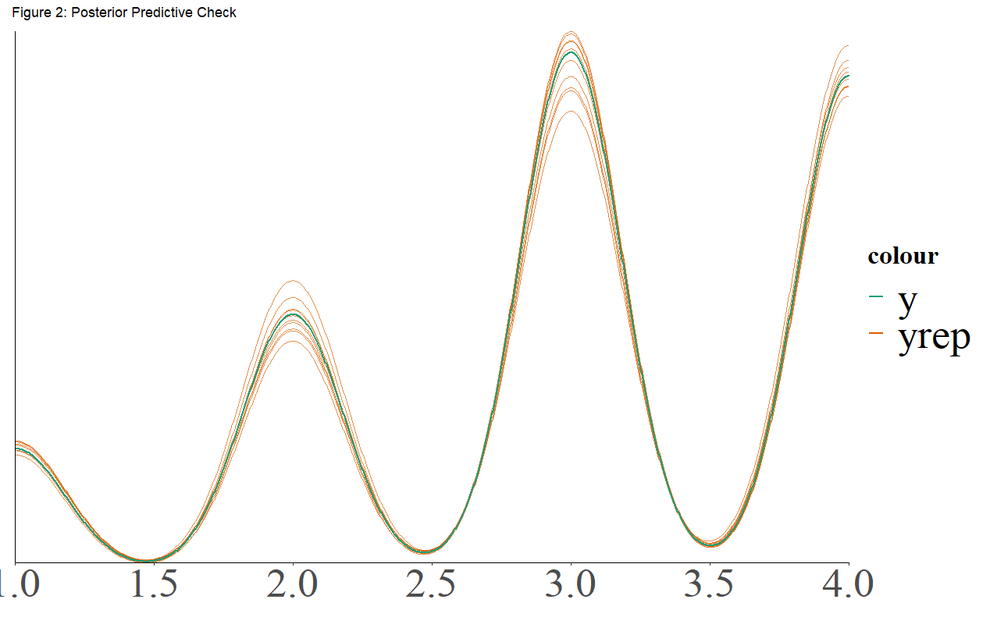

The posterior predictive check should be interpreted by comparing the dark green line, representing y, the observed data, to yrep, the fitted model based on the 12,000 iterations of simulated data. As the general shape, including both the frequency and amplitude, of the two are so similar, we can conclude that this model has a good fit.

1. This implies a non-centered parameterization for the random effects which aids in the convergence of more complex hierarchical models (McElreath 2020, 446–71).
2. Centroids and proximity are calculated via the sf package in R (Pebesma et al 2022).
3. Centroids and proximity are calculated via the sf package in R (Pebesma et al 2022).
4. This implies a non-centered parameterization for the random effects which aids in the convergence of more complex hierarchical models (McElreath 2020, 446–71).
5. Estimation is performed under R version 4.2.1 using the brms package (Bürkner 2017, 2018; R Core Team 2021), which serves as a front-end for regression models using Stan’s implementation of Hamiltonian Markov Chain MonteCarlo.