Overcooked 2 Level 1.6

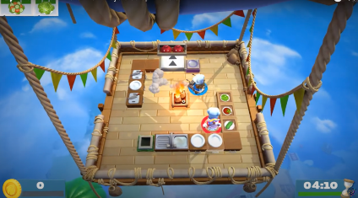

Level Demographics - Scores and Times
Level Time (mm:ss) | 4:10
Does Clock start at "Go" ? | Yes
Score for 1 Star (2 Players) | 260
Points given for completing Composite Challenge 1 | 68
Points given for completing Composite Challenge 2 | NA
Tip Multiplier (x1) | 8
Tip Multiplier (x2) | 16
Tip Multiplier (x3) | 24

Level Demographics - Environment
Is Environment Fixed? | No
Is Recipe (Composite Challenge) Order Fixed? | No
Number of Recipes | 2 (3 variations)
Dish Washer? | Yes
Number of Dishes | 3(1st half) 4(2nd half)
Chopping Board? | Yes
Number of Chopping Boards | 2(1st half) and 4 (2nd half)
Oven? | No
Number of Ovens | NA
Stove-Tops? | Yes
Number of Stove-Tops? | 2 (2nd half)
Mixers? | No
Number of Mixers? | NA

Composite Challenge (Recipe) 1: Salad (Lettuce, Tomato, Cucumber)
Step | Atomic Challenge | Average Time to Complete (seconds)
1 | Pick Up Lettuce | 0.3
2 | Chop Lettuce | 7.25
3 | Plate Lettuce | 0.3
4 | Pick up Tomato (and/or Cucumber) | 0.3
5 | Chop Tomato (and/or Cucumber) | 7.25
6 | Plate Tomato (and/or Cucumber | 0.3
7 | Serve | 0.3
Total Average Time to Complete (seconds) |  | 16

Composite Challenge (Recipe) 2: Sushi (Fish or Cucumber)
Step | Atomic Challenge | Average Time to Complete (seconds)
1 | Pick Up Nori | 0.3
2 | Plate Nori | 0.3
3 | Pick up Rice | 0.3
4 | Boil Rice | 12.41
5 | Plate Rice | 0.3
6 | Pick up Fish (or Cucumber) | 0.3
8 | Plate Fish (or Cucumber) | 0.3
9 | Serve | 0.3
Total Average Time to Complete (seconds) |  | 14.51

Level Obstacles
Obstacle Type | Steps Affected (Composite Challenge 1) | Average Penalty Per Infraction (N = 5)
Fire | 1,2,3,4,5,6 | 10-14 seconds
Overcooking | 4 (2nd half) | 7-10 seconds
Moving Platforms | 1,2,3,4,5,6 (1st half)

Environment Changes
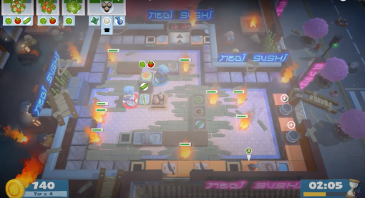

Change Phase 1: Change in environment
Description of Change | The environment and recipe changes after a certain time in the level.
Fixed Interval? | No
How often? | This occurs at the 2:05 mark in the level.
Does this cause changes in tasking? | No
If Yes, Describe changes | At the 2:05 mark, the environment changes from the hot air balloon to a fixed area with conveyor belts and new recipes.

Level Analysis
Number of Completed Composite Challenges needed to achieve 1 Star (2 Players) | 5
Penalty for failing a Composite Challenge | - 30 points

Additional Notes

