Overcooked 2 Level 1.2
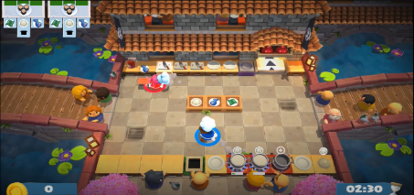

Level Demographics - Scores and Times
Level Time (mm:ss) | 2:30
Does Clock start at "Go" ? | No
Score for 1 Star (2 Players) | 60
Points given for completing Composite Challenge 1 | 68
Points given for completing Composite Challenge 2 | NA
Tip Multiplier (x1) | 8
Tip Multiplier (x2) | 16
Tip Multiplier (x3) | 24

Level Demographics - Environment
Is Environment Fixed? | Yes
Is Recipe (Composite Challenge) Order Fixed? | Yes
Number of Recipes | 1
Dish Washer? | No
Number of Dishes | 4
Chopping Board? | Yes
Number of Chopping Boards | 3
Oven? | No
Number of Ovens | NA
Stove-Tops? | Yes
Number of Stove-Tops? | 3
Mixers? | No
Number of Mixers? | NA

Composite Challenge (Recipe) 1: Sushi
Step | Atomic Challenge | Average Time to Complete (seconds)
1 | Pick Up Nori | 0.3
2 | Plate Nori | 0.3
3 | Pick Up Rice | 0.3
4 | Cook Rice | 12.41
5 | Plate Rice | 0.3
6 | Pick Up Fish | 0.3
7 | Chop Fish | 7.25
8 | Plate Fish | 0.3
9 | Serve | 0.3
Total Average Time to Complete (seconds) |  | 21.76

Level Obstacles
Obstacle Type | Steps Affected (Composite Challenge 1) | Average Penalty Per Infraction (N = 5)
Pedestrians walking through the level environment | 1,2,3,5,6,8,9 | 1 - 3 seconds
Overcooking | 4 | 7 - 20 seconds

Level Analysis
Percent Collaboration Needed to Complete Composite Challenges | 0%
Number of Completed Composite Challenges needed to achieve 1 Star (2 Players) | 1
Penalty for failing a Composite Challenge | - 30 points

Additional Notes

