

Network Programming (IE2102)
2nd Year, 2 Semester

Assignment

Design and Implementation of a Secure Multiprocessor TCP Application Server with Custom
Protocol and Session Management

Submitted to
Sri Lanka Institute of Information Technology

IT24103938
Premathilaka S. W. G. A. S

In partial fulfillment of the requirements for the
Bachelor of Science Special Honors Degree in Cyber Security

<<08/02/2026>>

Declaration

I certify that this report does not incorporate without acknowledgement any material previously submitted for a degree or diploma in any university, and to the best of my knowledge and belief it does not contain any material previously published or written by another person, except where due reference is made in text.

Table of Contents

- Introduction
- System Setup
  - Hostname Configuration
  - Network Configuration
- Server Execution
- Client Interaction
- Security Features
- Multiprocessing
- Logging System
- Zombie Process Handling
- Conclusion

1.Introduction

This report describes the design and implementation of a secure multiprocessor TCP server application developed for the IE2102 Network Programming module. The system is implemented using the C programming language for the server component (server_3938.c) and Python for the client application (client_3938.py) and is compiled and managed using Makefile_3938.

The server operates over the TCP protocol and listens to port number 50938. A custom application-level protocol with explicit message framing is implemented to ensure reliable and structured communication between the client and server. In addition, each server response includes a unique server identifier (SID:1039), which enables consistent identification of server-side operations.

To support concurrent client connections, the server utilizes multiprocessing through the fork () system call. This design allows the server to handle multiple clients simultaneously while maintaining process isolation and system stability. Furthermore, secure authentication is implemented using salted password hashing, along with session token generation and validation to manage user sessions securely.

The system also incorporates several security and abuse prevention mechanisms, including rate limiting, login attempt lockout, username validation, and payload size restrictions. These features are designed to protect the server from common network-based attacks and misuse.

In addition, a persistent audit logging mechanism is implemented to record all client interactions. The log file (server_IT24103938.log) stores important details such as timestamps, client information, process identifiers, executed commands, and results, ensuring traceability and accountability.

Overall, this report presents the system architecture, implementation approach, configuration process, and testing results, supported by relevant screenshots demonstrating the functionality of the application

2. System Setup

2.1: Hostname Configuration
The hostname of the Linux system was configured to identify the server environment
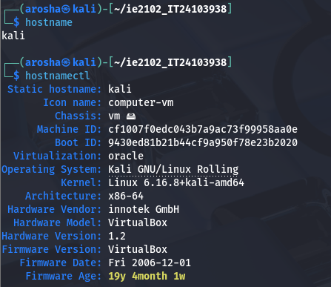
Figure 2.1: Hostname Configuration

2.2 Network Configuration
The network configuration was verified using system commands to ensure proper IP address and connectivity.
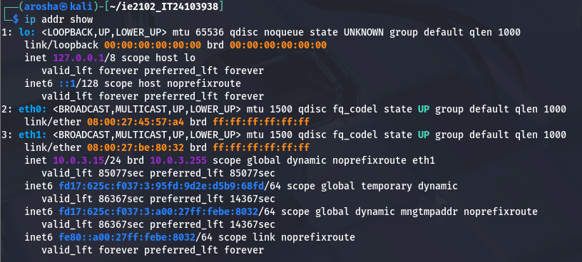
Figure 2.2: Network Configuration

3. Server Execution

The server was compiled using gcc and executed successfully. The server listens on port number 50938, and it is based on my registration number.
The active port was verified using system command ss
Figure 3.1 Server Running with Port

4. Client Interaction

4.1: Successful Register
The following terminal output shows both successful user registration and login operations. Initially, the REGISTER command is used to create a new user account, where the provided credentials are validated and securely stored on the server. The server responds with an OK message along with the server identifier (SID), confirming that the registration process has been completed successfully.
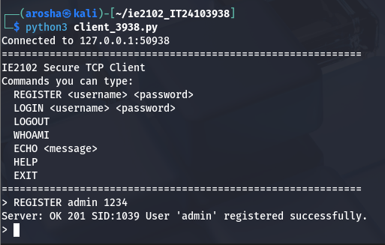
Figure 4.1.1: Successful Register-Client Terminal

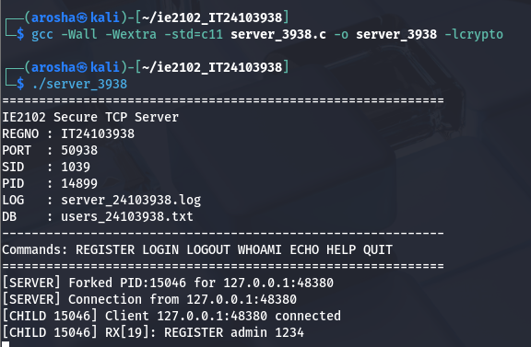
Figure 4.1.2: Successful Register-Server Terminal

4.2 Successful Login Terminal
The LOGIN command is executed using the registered credentials. After successful verification, the server generates a unique session token and sends it to the client. This token is required to access protected commands and enables secure session management within the server
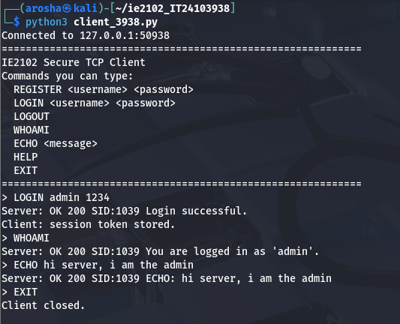
Figure 4.2.1: Successful Login-Client Terminal

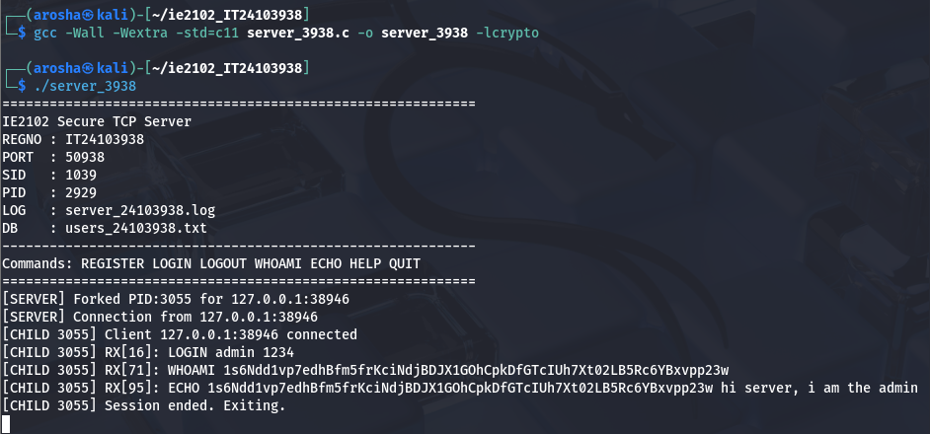
Figure 4.2.2: Successful Login-Server Terminal

5. Security Features
Failed Login and Lockout Proof
The following terminal output shows failed login attempts using 3 incorrect credentials. After multiple unsuccessful attempts, the server enforces a temporary lockout mechanism to prevent brute-force attacks. This demonstrates the implemented security feature that restricts further login attempts after exceeding the allowed limit.

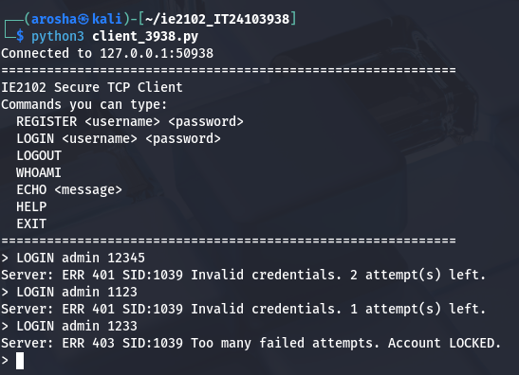
Figure 5.1: Failed Login-Client Terminal

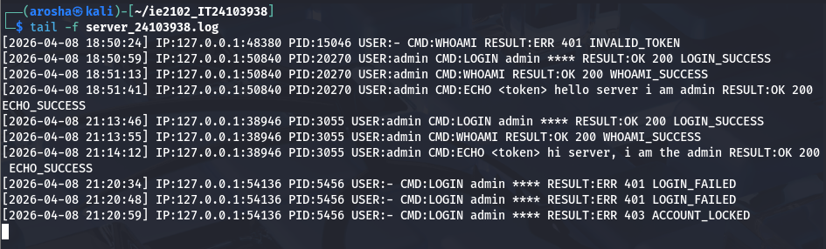
Figure 5.2: Failed Login-Log Terminal
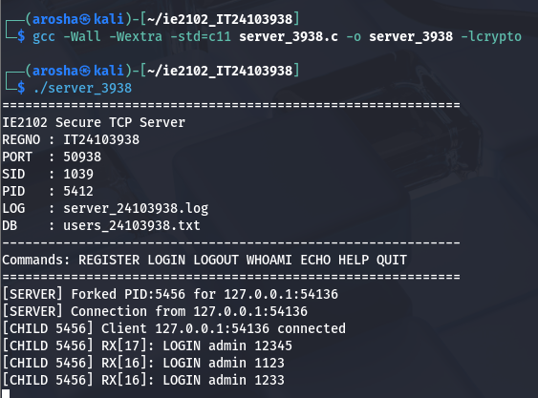
Figure 5.3: Failed Login-Server Terminal

6. Multiprocessing

Multiple Forked Process
The following terminal output shows multiple child processes created using the fork() system call to handle concurrent client connections. Each client is managed by a separate process, allowing the server to support multiple users simultaneously while ensuring efficient and isolated execution.
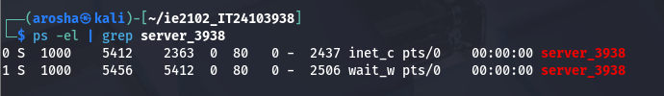
Figure 6.1: Log File Entries

7. Logging System
The following output shows the server’s persistent log file, which records all client interactions in detail. Each entry includes the timestamp, client IP address and port, process ID (PID), username, executed command, and the corresponding result.
The log demonstrates various system activities such as successful and failed login attempts, user registrations, command executions (e.g., ECHO, WHOAMI), and security events like invalid passwords, duplicate users, and account lockouts. It also shows how different client requests are handled by separate processes, identified by unique PIDs.
Overall, the logging system ensures proper monitoring, traceability, and auditing of all operations performed on the server.
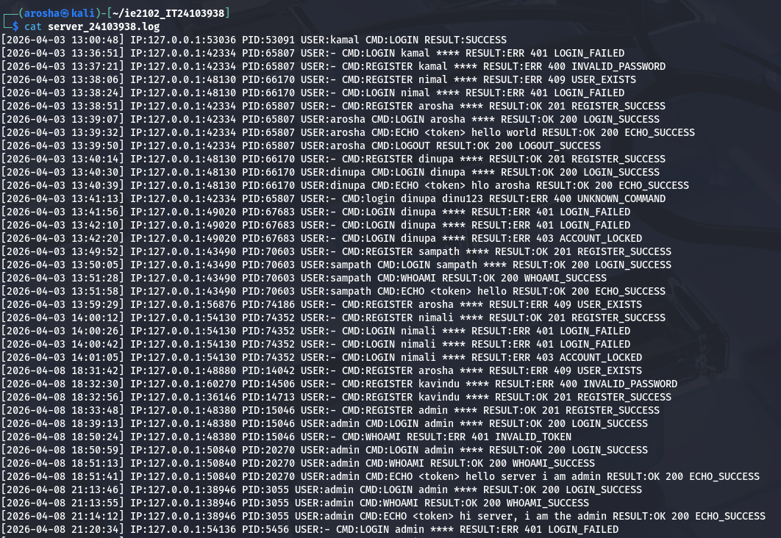
Figure 7.1: Log File

8. Zombie Process Handling

The following terminal output shows the result of checking for zombie processes using the “ps aux | grep defunct” command. Since no defunct (zombie) processes are displayed, it confirms that the server correctly handles terminated child processes using waitpid(). This ensures proper cleanup of child processes and prevents resource leakage in the system.

Figure 8.1: Find Zombie Process

10. Conclusion
In conclusion, this project successfully demonstrates the design and implementation of a secure multiprocessor TCP server application using socket programming concepts. The system effectively handles multiple client connections concurrently through the use of the fork() system call, ensuring efficient and scalable performance.

The implementation of a custom TCP protocol with explicit message framing ensures reliable communication between the client and server. Additionally, secure authentication mechanisms such as salted password hashing and session token management enhance the overall security of the system.

The incorporation of abuse protection features, including rate limiting, login lockout, and input validation, further strengthens the robustness of the application. The persistent logging system provides comprehensive monitoring and auditing capabilities by recording all client activities with relevant details.

Furthermore, proper process management techniques such as handling child processes using waitpid() ensure that no zombie processes are created, maintaining system stability.

Overall, this assignment provided valuable hands-on experience in network programming, process management, and system security, and demonstrates a complete and functional client-server architecture that meets all specified requirements.

